RFPD Clean and Bake Procedure
Richard Abbott
17 May, 2013
E1300449-v2

- Overview
Radio Frequency Photodetectors (RFPDs) have been designed in hermetic enclosures for use in the aLIGO vacuum volumes. These detectors provide sensing for length (LSC) and alignment (ASC) degrees of freedom. This procedure details the required steps to clean the exterior of these detectors to class-A vacuum cleanliness levels as derived from the procedures outlined in LIGO-E960022.

Figure 1 Front view of LSC and ASC Detectors

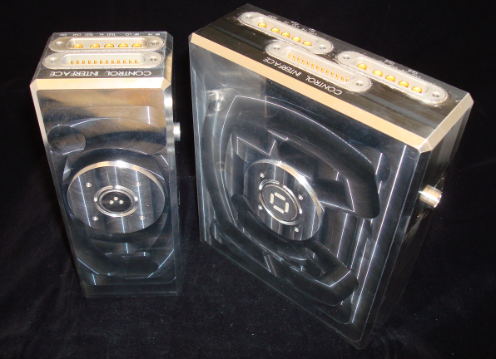

Figure 2 Rear view of ASC and LSC prior to welding

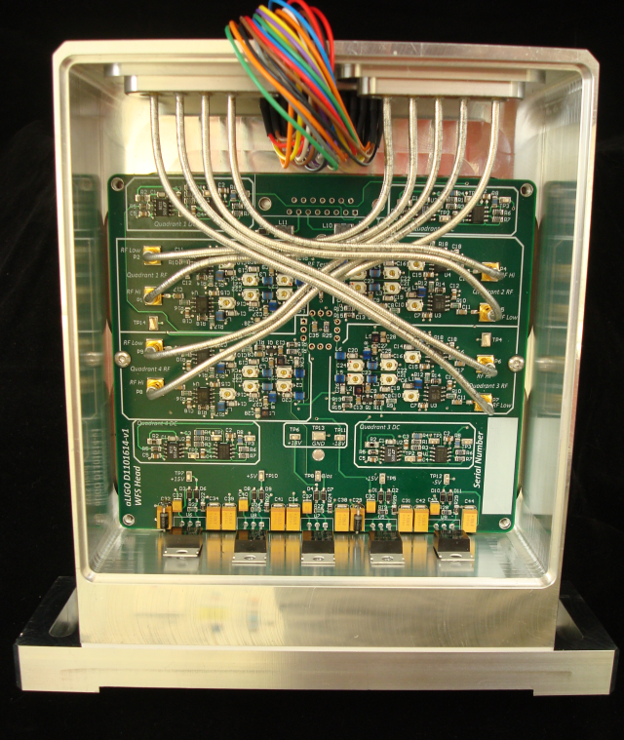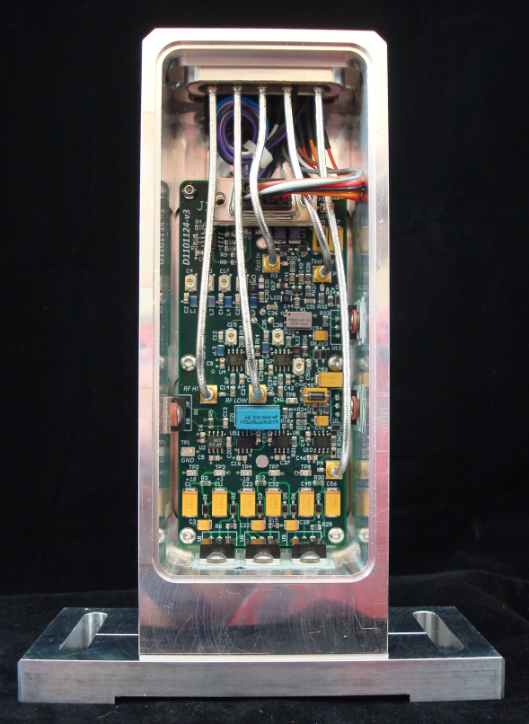

- Overall Big Picture Workflow
The standard process in the production of in-vacuum RFPDs requires each of the following steps:
  - Electronic circuitry is loaded into the inside of the hermetic enclosure and a full electrical test (in accordance with the approved RFPD test procedure) has been conducted to verify proper operation of the circuit.
  - The tested unit is shipped to the enclosure manufacturer to have the rear cover laser welded in place. While at the manufacturer, the unit is filled with helium at 1 atmosphere, and a final seal is welded in place. The unit is checked by the manufacturer to be hermetically sealed to a leak rate of less than 10⁻⁹ cc/sec, of helium flow.
  - The sealed unit is sent back to LIGO, and is electrically tested to ensure that no damage occurred during the welding process.
  - The tested unit is cleaned to class-A cleanliness level
  - The class-A cleaned unit undergoes a final electrical test and is ready for installation in the LIGO vacuum volume

- Class-A Cleaning Workflow (Derived from LIGO-E960022)
  - Gross Cleaning – Per E960022, Section 7.3 the RFPDs can be cleaned by the outlined process with the following restrictions:
    - The RFPD heads contain devices (tuning capacitors) that are potentially sensitive to vibration. This precludes full immersion into an ultrasonic cleaning bath. An acceptable alternative would be to use the ultrasonic wand for cleaning tapped holes.
    - The external surfaces of the RFPD are mainly aluminum. There is a PEEK insert inside the photodiode socket. All cleaning solutions that are suitable for PEEK and aluminum are acceptable for use on the RFPD.
    - In general, the RFPD should not be exposed to significant mechanical shock as there are sensitive components inside the detectors. The RFPDs are roughly similar to a camera in terms of mechanical sensitivity; they exhibit reasonable, but not extreme tolerance to shock.
  - Precision Cleaning – Per E960022, Section 7.4 the RFPDs can be cleaned by the outlined process, but must adhere to the same restrictions as outlined in the Gross Cleaning section above. An additional constraint is that Electropolishing must not be used on the RFPDS.
  - Baking – Per E960022, Section 8, and Appendix 4, the RFPDs will undergo a vacuum bake at 120 C due to the presence of welded aluminum, SnPb soldered joints and semiconductors inside the RFPD enclosure. The RFPDs each contain 1 atmosphere of helium that was put inside to provide a clear signature of a failure in the hermetic enclosure. Special attention should be paid to the presence of helium during a vacuum bake as it is a likely indicator of a leak.

