*LIGO Laboratory / LIGO Scientific Collaboration*

LIGO-E1300482-v2 *advanced LIGO* 10/15/2013

ALS Laser Locking Library

Sheila Dwyer

Distribution of this document:

LIGO Scientific Collaboration

This is an internal working note  
of the LIGO Laboratory.

|  |  |
| --- | --- |
| **California Institute of Technology**  **LIGO Project – MS 18-34**  **1200 E. California Blvd.**  **Pasadena, CA 91125**  Phone (626) 395-2129  Fax (626) 304-9834  E-mail: info@ligo.caltech.edu | **Massachusetts Institute of Technology**  **LIGO Project – NW22-295**  **185 Albany St**  **Cambridge, MA 02139**  Phone (617) 253-4824  Fax (617) 253-7014  E-mail: info@ligo.mit.edu |
| **LIGO Hanford Observatory**  **P.O. Box 159**  **Richland WA 99352**  Phone 509-372-8106  Fax 509-372-8137 | **LIGO Livingston Observatory**  **P.O. Box 940**  **Livingston, LA 70754**  Phone 225-686-3100  Fax 225-686-7189 |

http://www.ligo.caltech.edu/

|  |  |
| --- | --- |
| **Library** | |
| Title | ALSLaserLocking |
| Version | 2 |
| TwinCAT version | V2.11.0 |
| Name space |  |
| Author | Sheila Dwyer |
| Description | Autolocking for ALS PLL at end station. See following section for more details. |
| Error Code | 1 — Communications error (lost communication from corner PLC1 or cornerPLC2, or there is an error from the timing system)  2 — Reference cavity transmission PD error  4 — Reference cavity transmission below the limit (limit set in this autolocker)  8 — Fiber launch PD (in the fiber distribution box, internal.DC) error  16 — Fiber launch power below the limit (limit set in this autolocker)  32 — Fiber trans PD error (the limits are enforced in the DC PD library for the local PDs)  64 — Fiber trans PD limits not set, they need to be set correctly  128 — Fiber rejected polarization PD error  32768 — Fiber rejected PD limits not set  256 — % of the fiber light that is in the wrong polarization is too large  512 — Power transmitted by fiber in the correct polarization to interfere with ALS laser is too small  1024 — ALS Laser IR power PD error  65536 — ALS Laser IR power PD limits not set  2048 — Phase Frequency Discriminator Error  4096 — Beat note power too low  8192 — Beat note out of range of frequency comparator  131072 — ALS Laser Error  262144 — AutoLocker Failed |
| Library Dependencies | ErrorHandler, SaveRestore, ReadADC, WriteDAC, ALSCommunication, ALSStateMachine, DCPower, Demodulator, CommonModeServo, ALSLaser |

**1. Library Description:**

This library includes an autolocker for the ALS end station lasers, as well as a function block called temperature controls taken from Alexa Staley’s ALSLaser library that implements a slow servo feeding back to the laser crystal temperature.

It implements the following equation, which results in a 1/f filter if TemperatureControls.PF is zero OR a 1/f response with a zero at Pf, which is intended to compensate for the thermal pole of the laser crystal:

$u_{i}=u_{i-1}+g×\left\{\begin{matrix}e_{i} & h≤0 \\ (e_{i}-e_{i-1})/h & h>0\end{matrix}\right.$ with

$g=πf_{ugf}∆t$ and $h= πf_{Pf}∆t$.

$∆t$: sampling interval,

$f_{ugf}$: unity gain frequency of integrator,

$f_{Pf}$: Knee frequency of proportional gain.

There is also a polarity switch that reverses the sign of the feedback, and an enum (TemperatureControls.ErrorSignal) which allows the user to choose what to use as an error signal: the options are the beat note frequency error measured by the frequency comparator (beat.frequency-beat.vcofrequency/2), the signal sent to the laser PZT calibrated in MHz, or the fast mon from the servo, also calibrated in MHz. There is also a reset that clears the integrator, and range limits for the output of the slow feedback.

The library also includes an error checking function block called locking conditions, which checks for a large number of error conditions that may prevent the PLL from locking, and sets the bit Logic.Conditions to FALSE if any of the locking conditions are not met.

The variable ‘locked’ is set to true if the common mode servo is not saturated and the beatnote is within tolerance.

A state diagram for the autolocker is below. The user can enable the autolocker so that it will run when the locking conditions are met, or force it so that it will disregard errors from the locking conditions function block. The user can also choose a polarity to lock the ALS laser above or below the PSL in frequency. This sets the polarity on the servo, the phase frequency discriminator, and the temperature feedback.

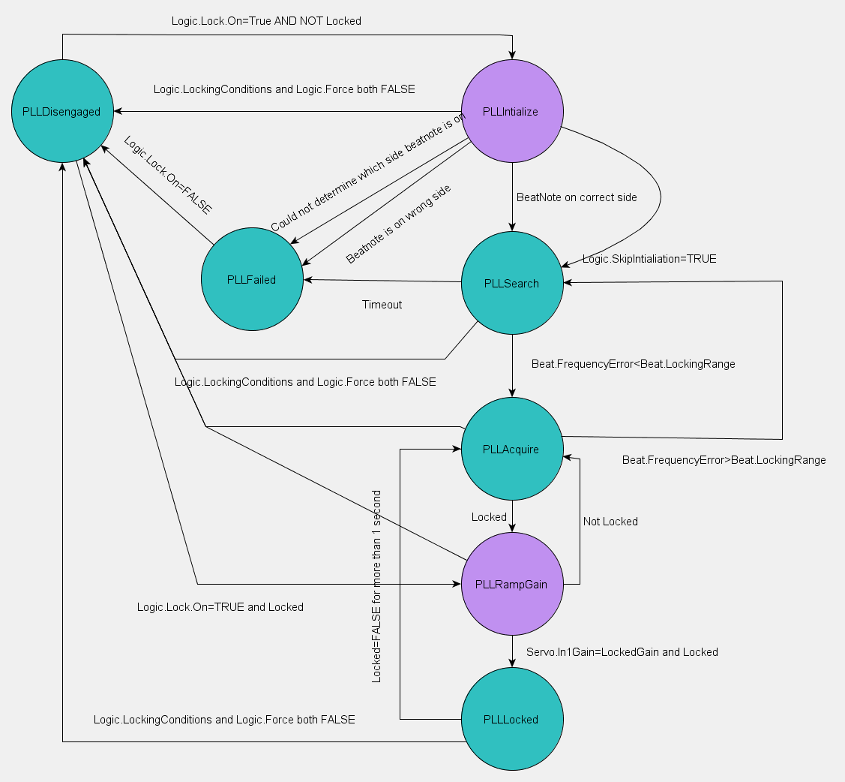

Figure : State diagram for PLL autolocking, transitional states in purple

When the autolocker state machine begins running, it either passes to the PLLInitialize state if the pll is unlocked or to the PLLGainRamp state if it is locked.

The user can choose to skip initialization or to initialize the autolocker, in which case it begins by increasing the laser crystal temperature, waiting 30 seconds and determining based on the response of the beat note measured by the frequency comparator if the laser is above or below the PSL in frequency. If the laser is on the wrong side, or the autolocker cannot determine what side it is on, it goes to the failed state, and the user needs to manually tune the crystal temperature. Once the temperature is manually tuned the user can disengage the autolocker and re-engage it to begin the locking process.

When the laser is on the correct side, the autolocker passes to the PLLSearch state, and uses the temperature servo with the beat note measured by the frequency comparator as an error signal, with the common mode board feedback to the PZT disengaged. If the beat note error become less than beat.LockingRange the state machine passes to PLLacquire, or if 20 minutes pass without the beatnote coming into range the autolocker goes to the PLLfailed state.

In the PLLacquire state the common mode board feedsback to the laser PZT with low gain and the temperature servo continues to use the beatnote error as measured by the frequency comparator as an error signal. If the beat notes goes out of the locking range, the state returns to PLLSearch, if the PLL locks it passes to PLLRampGain.

In PLLRampGain the temperature servo error signal is switched to the PZT feedback, and the input gain of the common mode board is ramped at 1dB per second until it reaches the gain used for locking. If the PLL is locked at the locking gain for 1 second, the state transitions to PLLLocked,

It will stay in the locked state unless the PLL becomes unlocked for more than 1 second, in which case it passes to PLLaquire, or if the locking conditions are no longer met it will pass to disengaged.

**2. Example Usage:**

AlsEndFibrLockFB (

FromCornerPLC1:=RecieveFromCornerPLC1,

FromCornerPLC2:=RecieveFromCornerPLC2,

ALSLaserLocking := Ifo.ALS.End.Fibr.Lock,

ALSLaser:=Ifo.ALS.End.Laser.Head,

Request := Request,

ALSLaserLockingInit := AlsEndFibrLockInit,

FiberTrans:=Ifo.ALS.End.Fibr.Trans.Dc,

FiberRejected:=Ifo.ALS.End.Fibr.Rejected.Dc,

LaserIR:=Ifo.ALS.End.Laser.Ir.Dc,

Demod := Ifo.ALS.End.Fibr_A.Demod,

CommunicationsError:= Ifo.Sys.Communication.Y.Error,

Servo := Ifo.ALS.End.Fibr.Servo);

|  |  |
| --- | --- |
| **ALS Laser Locking Type**  TYPE ALSLaserLockingEnum : (PLLDisengaged, PLLInitialize, PLLSearch, PLLAcquire, PLLRampGain, PLLLocked, PLLFailed)  END_TYPE; | |
| Type Name | ALSLaserLockingEnum |
| Description | Specifies the state for the PLL |
| Definition | ENUM |
| Element | Name: PLLDisengaged  Description: The autolocker is disengaged |
| Element | Name: PLLInitialize  Description: Initialize the PLL autolocker |
| Element | Name: PLLSearch  Description: Searching for resonance |
| Element | Name: PLLAcquire  Description: PLL lock is acquired |
| Element | Name: PLLRampGain  Description: Increase the gain of the PLL Common Mode Board |
| Element | Name: PLLLocked  Description: PLL is locked |
| Element | Name: PLLFailed  Description: Autolocker has failed to lock the auxiliary laser |

|  |  |
| --- | --- |
| **User Interface Type**  TYPE ALSLaserLockingBeatNoteStruct :  STRUCT  RFMin: LREAL;  Frequency: LREAL;  VcoFrequency: LREAL;  Tolerance: LREAL;  LockingRange: LREAL;  Low: LREAL;  High: LREAL;  Sign: BOOL;  FrequencyError: LREAL;  SmoothedFrequencyError: LREAL;  END_STRUCT;  END_TYPE; | |
| Type Name | ALSLaserLockingBeatNoteStruct |
| Description | Structure used in the user interface type to control the autolocker |
| Definition | STRUCT |
| Output Tag | Name: RFMin  Type: LREAL  Description: Beat note threshold |
| Output Tag | Name: Frequency  Type: LREAL  Description: Beat note frequency |
| Output Tag | Name: VcoFrequency  Type: LREAL  Description: VCO frequency |
| Output Tag | Name: Tolerance  Type: LREAL  Description: Beat note frequency tolerance |
| Output Tag | Name: LockingRange  Type: LREAL  Description: Frequency range for locking |
| Output Tag | Name: Low  Type: LREAL  Description: Low cut-off for acquisition |
| Output Tag | Name: High  Type: LREAL  Description: High cut-off for acquisition |
| Input Tag | Name: Sign  Type: BOOL  Description: Sign of laser frequency |
| Input Tag | Name: FrequencyError  Type: LREAL  Description: Frequency error of beat note |
| Input Tag | Name: SmoothedFrequencyError  Type: LREAL  Description: Frequency error of beat note smoothed |

|  |  |
| --- | --- |
| **User Interface Type**  TYPE ALSLaserLockingFiberStruct :  STRUCT  LaunchLim: LREAL;  PolarizationPercent: LREAL;  PolLim: LREAL = 30;  TransRightPol: LREAL;  TransRightPolLim: LREAL;  END_STRUCT;  END_TYPE; | |
| Type Name | ALSLaserLockingFiberStruct |
| Description | Structure used in the user interface type to control the fiber |
| Definition | STRUCT |
| Input Tag | Name: LaunchLim  Type: LREAL  Description: Lower limit for launched fiber power |
| Input Tag | Name: PolarizationPercent  Type: LREAL  Description: Fiber trans in the wrong polarization |
| Input Tag | Name: PolLim  Type: LREAL  Description: Limit for wrong polarization light |
| Output Tag | Name: TransRightPol  Type: LREAL  Description: Fiber trans power in right polarization |
| Input Tag | Name: TransRightPolLim  Type: LREAL  Description: Fiber trans power in right polarization limit |

|  |  |
| --- | --- |
| **User Interface Type**  TYPE ALSLaserLockingLogicStruct :  STRUCT  Conditions: BOOL;  Enable: BOOL;  Force: BOOL;  On: BOOL;  TemperatureForce: BOOL;  TemperatureOn: BOOL;  Polarity: BOOL;  SkipInitialization: BOOL;  END_STRUCT;  END_TYPE; | |
| Type Name | ALSLaserLockingLogicStruct |
| Description | Structure used in the user interface type to control the laser locking logic |
| Definition | STRUCT |
| Output Tag | Name: Conditions  Type: BOOL  Description: Pre-conditions for locking |
| Input Tag | Name: Enable  Type: BOOL  Description: Enable autolocker |
| Input Tag | Name: Force  Type: BOOL  Description: Force autolocker on even if conditions are not met |
| Input Tag | Name: On  Type: BOOL  Description: Autolocker on |
| Input Tag | Name: TemperatureForce  Type: BOOL  Description: Force autolocker on despite temperature |
| Input Tag | Name: TemperatureOn  Type: BOOL  Description: Slow servo on |
| Output Tag | Name: Polarity  Type: BOOL  Description: Polarity for ALS Laser PLL |
| Input Tag | Name: SkipInitialization  Type: BOOL  Description: Check laser on right size |

|  |  |
| --- | --- |
| **User Interface Type**  TYPE ALSLaserLockingStruct :  STRUCT  Error: ErrorStruct;  State: ALSLaserLockingEnum;  RefCavTransLim: LREAL;  Fiber: ALSLaserLockingFIberStruct;  Beat: ALSLaserLockingBeatNoteStruct;  Logic: ALSLaserLockingLogicStruct;  TemperatureControls: TemperatureControlsStruct;  LockLosses: INT;  ResetLockLosses: BOOL;  END_STRUCT;  END_TYPE; | |
| Type Name | ALSLaserLockingStruct |
| Description | Structure used in the user interface type to control the laser locking |
| Definition | STRUCT |
| Input/Output Tag | Name: Error  Type: ErrorStruct  Description: Calls error handler |
| Input/Output Tag | Name: State  Type: ALSLaserLockingEnum  Description: Autolocker state |
| Input/Output Tag | Name: RefCavTransLim  Type: LREAL  Description: Lower limit for reference cavity transmission |
| Input/Output Tag | Name: Fiber  Type: ALSLaserLockingFiberStruct  Description: Structure of limits and calculations for fiber transmission |
| Input/Output Tag | Name: Beat  Type: ALSLaserLockingBeatNoteStruct  Description: Structure for achieving a beat note |
| Input/Output Tag | Name: Logic  Type: ALSLaserLockingLogicStruct  Description: Structure for logic behind autolocker |
| Input/Output Tag | Name: TemperatureControls  Type: TemperatureControlsStruct  Description: Temperature controls structure |
| Output Tag | Name: LockLosses  Type: INT  Description: Counts the number of times lock has been lost |
| Input Tag | Name: ResetLockLosses  Type: BOOL  Description: Resets the lock loss counter |

|  |  |
| --- | --- |
| **User Interface Type**  TYPE TemperatureControlsStruct :  STRUCT  On: BOOL;  Enabled: BOOL;  Run: BOOL;  Reset: BOOL;  Low: LREAL;  High: LREAL;  Range: BOOL;  Ugf: LREAL;  Pf: LREAL;  Polarity: BOOL;  ErrorSignal: TemperatureErrorSignalEnum;  END_STRUCT;  END_TYPE; | |
| Type Name | TemperatureControlsStruct |
| Description | Structure used in the user interface type to control the laser temperature |
| Definition | STRUCT |
| Input Tag | Name: On  Type: BOOL  Description: On/off button |
| Input Tag | Name: Enabled  Type: BOOL  Description: Controls enabled button |
| Output Tag | Name: Run  Type: BOOL  Description: Temperature feedback running |
| Input Tag | Name: Reset  Type: BOOL  Description: Reset the integrator |
| Input Tag | Name: Low  Type: LREAL  Description: Low control value in Hz |
| Input Tag | Name: High  Type: LREAL  Description: High control value in Hz |
| Input Tag | Name: Range  Type: BOOL  Description: Controls range exceeded |
| Output Tag | Name: Ugf  Type: LREAL  Description: Unity gain frequency in Hz |
| Output Tag | Name: Pf  Type: LREAL  Description: Knee of proportional gain in Hz |
| Output Tag | Name: Polarity  Type: BOOL  Description: Polarity of slow feedback |
| Input/Output Tag | Name: ErrorSignal  Type: TemerpatureErrorSignalEnum  Description: Error signal for temperature feedback |

|  |  |
| --- | --- |
| **ALS Laser Locking Type**  TYPE TemperatureErrorSignalEnum : (PZTfrequency, BeatNoteError, SplitMon)  END_TYPE; | |
| Type Name | TemperatureErrorSignalEnum |
| Description | Allows the user to specify what to use as an error signal for the temperature feedback |
| Definition | ENUM |
| Element | Name: PZTFrequency  Description: Laser PZT actuation |
| Element | Name: BeatNoteError  Description: Difference between the beat neat and half the VCO frequency |
| Element | Name: SplitMon  Description: Split mon of the common mode board which can be used when fast feedback is engaged |

|  |  |
| --- | --- |
| **Function Block**  TYPE ALSLaserLockingFB :  VAR_INPUT  Request: SaveRestoreEnum;  Demod: DemodulatorLscStruct;  FromCornerPLC2: CornerPLC2toEndStruct;  FromCornerPLC1: CornerPLC1toEndStruct;  FiberTrans: DCPowerStruct;  FiberRejected: DCPowerStruct;  LaserIR: DCPowerStruct;  Fibr_A: DCPowerStruct;  PDHServo: CommonModeStruct;  END_VAR;  VAR_IN_OUT  ALSLaser: ALSLaserStruct;  ALSLaserLockingInit: ALSLaserLockingStruct;  ALSLaserLocking: ALSLaserLockingStruct;  Servo: CommonModeStruct;  END_VAR;  END_TYPE; | |
| Type Name | ALSLaserLockingFB |
| Description | Function block for the autolocker |
| Definition | Function Block |
| Input Argument | Name: Request  Type: SaveRestoreEnum  Description: Request save/restore/safemood or noop |
| Input Argument | Name: Demod  Type: DemodulatorLscStruct  Description: User interfce structure |
| Input Argument | Name: FromCornerPLC2  Type: CornerPLC2toEndStruct  Description: Communication between corner PLC2 and end station |
| Input Argument | Name: FromCornerPLC1  Type: CornerPLC2toEndStruct  Description: Communication between corner PLC1 and end station |
| Input Argument | Name: FiberTrans  Type: DCPowerStruct  Description: PD monitoring total fiber transmission power |
| Input Argument | Name: FiberRejected  Type: DCPower Struct  Description: PD monitoring total fiber rejected power |
| Input Argument | Name: LaserIR  Type: DCPowerStruct  Description: PD monitoring the ALS laser power in IR path |
| Input Argument | Name: Fibr_A  Type: DCPowerStruct  Description: DC output of broad band PD |
| Input Argument | Name: PDHServo  Type: CommonModeStruct  Description: User interface structure |
| In/Out Argument | Name: ALSLaser  Type: ALSlaserStruct  Description: User interface structure |
| In/Out Argument | Name: ALSLaserLockingInit  Type: AlsLaserLockingStruct  Description: Save/restore variable in persistent memory |
| In/Out Argument | Name: ALSLaserLocking  Type: ALSLaserLockingStruct  Description: User interface structure |
| In/Out Argument | Name: Servo  Type: CommonModeStruct  Description: User interface structure |

|  |  |
| --- | --- |
| **Function Block**  TYPE LockingConidtionsFB :  VAR_INPUT  CommunicationsError: ErrorStruct;  Demod: DemodulatorLscStruct;  FromCornerPLC2: CornerPLC2toEndStruct;  FiberTrans: DCPowerStruct;  FiberRejected: DCPowerStruct;  LaserIR: DCPowerStruct;  Fibr_A: DCPowerStruct;  Servo: CommonModeStruct;  Laser: ALSLaserStruct;  END_VAR;  VAR_IN_OUT  ErrorHandler: ErrorHandlerFB;  ALSLaserLocking: ALSLaserLockingStruct;  END_VAR;  END_TYPE; | |
| Type Name | LockingConditionsFB |
| Description | Function block for the conditions of the autolocker |
| Definition | Function Block |
| Input Argument | Name: CommunicationsError  Type: ErrorStruct  Description: Checks for a communications error |
| Input Argument | Name: Demod  Type: DemodulatorLscStruct  Description: User interface structure |
| Input Argument | Name: FromCornerPLC2  Type: CornerPLC2toEndStruct  Description: Communication between corner PLC2 and end station |
| Input Argument | Name: FiberTrans  Type: DCPowerStruct  Description: PD monitoring total fiber transmission power |
| Input Argument | Name: FiberRejected  Type: DCPower Struct  Description: PD monitoring total fiber rejected power |
| Input Argument | Name: LaserIR  Type: DCPowerStruct  Description: PD monitoring the ALS laser power in IR path |
| Input Argument | Name: Fibr_A  Type: DCPowerStruct  Description: DC output of broad band PD |
| Input Argument | Name: Servo  Type: CommonModeStruct  Description: User interace structure |
| Input Argument | Name: Laser  Type: ALSlaserStruct  Description: User interface structure |
| In/Out Argument | Name: ALSLaserLocking  Type: ALSLaserLockingStruct  Description: User interface structure |
| In/Out Argument | Name: ErrorHandler  Type: ErrorHandlerFB  Description: Calls error handler FB |

|  |  |
| --- | --- |
| **Function Block**  TYPE PfLoopFB :  VAR_INPUT  Input: LREAL;  Auto: BOOL;  Polarity: BOOL;  END_VAR;  VAR_IN_OUT  Reset: BOOL;  Ratio: LREAL;  PropConst: LREAL;  IntConst: LREAL;  END_VAR;  VAR_OUTPUT  Output: LREAL;  Error: BOOL;  Message: STRING:  END_VAR;  END_TYPE; | |
| Type Name | PFLoopFB |
| Description | This object represents a simple PI Loop |
| Definition | Function Block |
| Input Argument | Name: Input  Type: LREAL  Description: Main input variable |
| Input Argument | Name: Auto  Type: BOOL  Description: Default values flag |
| Input Argument | Name: Polarity  Type: BOOL  Description: Polarity flaf |
| In/out Argument | Name: Reset  Type: BOOL  Description: Reset flag |
| In/out Argument | Name: Ratio  Type: LREAL  Description: Manual entry for P/I mixing ratio |
| In/out Argument | Name: PropConst  Type: LREAL  Description: Manual entry for proportionality constant |
| In/out Argument | Name: IntConst  Type: LREAL  Description: Manual entry for integration constant |
| Output Argument | Name: Output  Type: LREAL  Description: Main output variable |
| Output Argument | Name: Error  Type: BOOL  Description: Error flag |
| Output Argument | Name: Message  Type: STRING  Description: Information message out |

|  |  |
| --- | --- |
| **Function Block**  TYPE TemperatureControlsFB :  VAR_INPUT  Request: SaveRestoreEnum;  FromCornerPLC1: CornerPLC1toEndStruct;  Servo: CommonModeStruct;  END_VAR;  VAR_IN_OUT  ALSLaser: ALSLaserStruct;  ALSLaserLocking: ALSLaserLockingStruct;  END_VAR;  END_TYPE; | |
| Type Name | TemperatureControlsFB |
| Description | Function block for temperature readback |
| Definition | Function Block |
| Input Argument | Name: Request  Type: SaveRestoreEnum  Description: Request save/restore/safemood or noop |
| Input Argument | Name: FromCornerPLC1  Type: CornerPLC1toEndStruct  Description: Communication from corner PLC1 to end station |
| Input Argument | Name: Servo  Type: CommonModeStruct  Description: User interface type |
| In/out Argument | Name: ALSLaser  Type: ALSLaserStruct  Description: User interface type |
| In/out Argument | Name: ALSLaserLocking  Type: ALSLaserLockingStruct  Description: User interface type |