Test Date | May 15-16, 2013
Author(S) | Liyuan Zhang, Margot Phelps, GariLynn Billingsley
Approval(s)
Specification Doc. | LIGO-E0900068 | Specification | 5 ± 1 ppm
Procedure Doc. | LIGO-E1000863 | Mean ± Error* | 3.6 ± 0.2 ppm
Conclusion | Qualified.
*Error is the calibration error.
Discussions and Comments:
The scan was done over a 160 mm diameter aperture with the beam and step sizes of 1 mm and an orientation that the arrow at barrel is at Y+ direction as shown in Fig.1. The calibration is done by normalizing the transmitted signal to the signal without mirror and the variation of power during the scan is monitored and corrected.

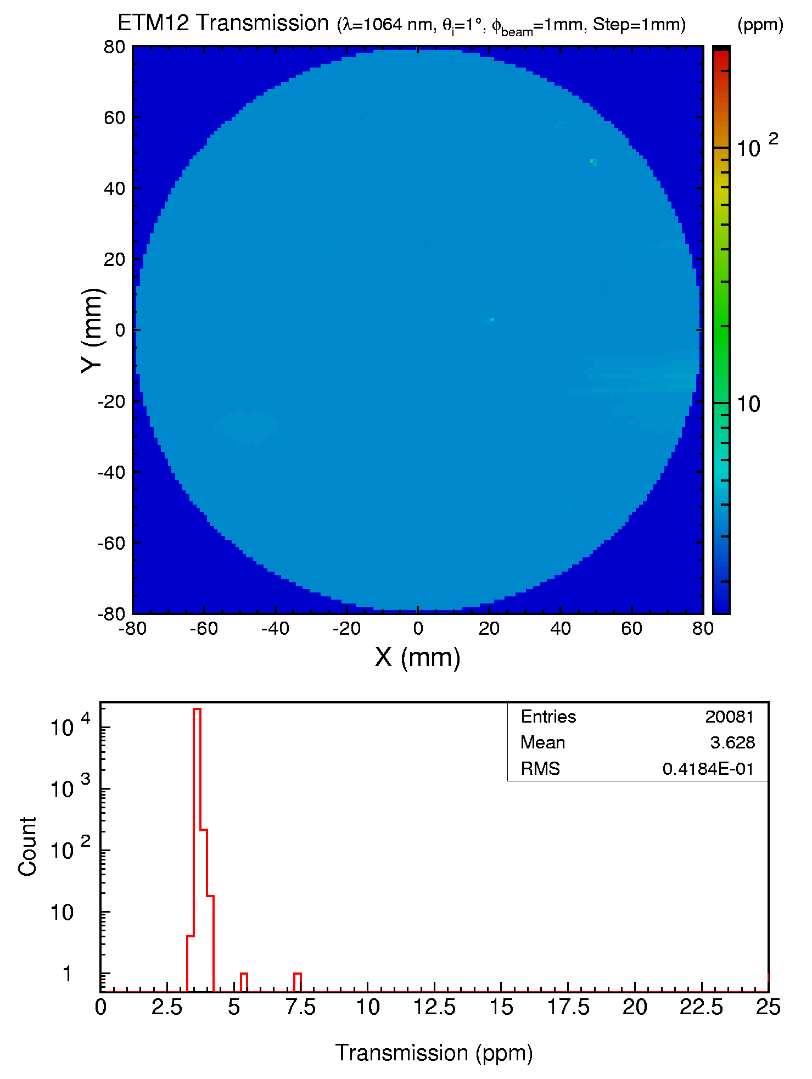
Fig. 1 ETM12 transmission over a 160 mm diameter aperture.

