*LIGO Laboratory / LIGO Scientific Collaboration*

LIGO-E1300587-v2 *ADVANCED LIGO*

HAUX H1-IM3 test report

Giacomo Ciani

Distribution of this document:

LIGO Science Collaboration

This is an internal working note

of the LIGO Project.

|  |  |
| --- | --- |
| **California Institute of Technology**  **LIGO Project – MS 18-34**  **1200 E. California Blvd.**  **Pasadena, CA 91125**  Phone (626) 395-2129  Fax (626) 304-9834  E-mail: [info@ligo.caltech.edu](mailto:info@ligo.caltech.edu) | **Massachusetts Institute of Technology**  **LIGO Project – NW17-161**  **175 Albany St**  **Cambridge, MA 02139**  Phone (617) 253-4824  Fax (617) 253-7014  E-mail: [info@ligo.mit.edu](mailto:info@ligo.mit.edu) |
| **LIGO Hanford Observatory**  **P.O. Box 1970**  **Mail Stop S9-02**  **Richland WA 99352**  Phone 509-372-8106  Fax 509-372-8137 | **LIGO Livingston Observatory**  **P.O. Box 940**  **Livingston, LA 70754**  Phone 225-686-3100  Fax 225-686-7189 |

<http://www.ligo.caltech.edu/>

Contents

1 Introduction 3

1.1 Suspension data 3

1.2 Applicable Documents 3

1.2.1 LIGO Documents 3

2 Summary of tests 4

3 Tests results 5

3.1 OSEMs OLV 5

3.2 DC Pointing 5

3.3 OSEMs range and linearity 5

3.3.1 Mirror rotation Vs Actuation 6

3.3.2 OSEMs readout Vs Displacement 6

3.4 Linear spectra, no ECDs 7

3.5 Measured resonances 7

3.6 Transfer functions, no ECDs 8

3.6.1 Length excitation 9

3.6.2 Pitch excitation 10

3.6.3 Yaw excitation 10

3.7 Linear spectra, with ECDs 12

3.8 Transfer functions, with ECDs 13

3.8.1 Length excitation 14

3.8.2 Pitch excitation 15

3.8.3 Yaw excitation 16

3.9 Quality factors with ECDs 16

3.9.1 Bounce 16

3.9.2 Trans 16

3.9.3 Roll 16

3.10 Structural resonances 17

# Introduction

This document summarizes the results of tests conducted to verify L1 HAM Auxiliary suspensions’ compliance with requirements, as well as other useful information.

## Suspension data

*IFO:* H1

Suspension name: IM3

*Suspension SN:* 008

*Installed optics:* PMMT2-02

*UL OSEM SN:* 377

*LL OSEM SN:* 292

*UR OSEM SN:* 404

*LR OSEM SN:* 309

*https://ics-redux.ligo-la.caltech.edu/JIRA/browse/ASSY-D1000120-008*

## Applicable Documents

### LIGO Documents

[LIGO-T1200469](https://dcc.ligo.org/cgi-bin/private/DocDB/ShowDocument?docid=97066), “HAUX test procedure and acceptance criteria”

# Summary of tests

The following table helps to quickly identify in which condition the results of the tests reported in this document refer to.

Gray cells represent the minimum required condition for final testing. “X” indicates the conditions of the test which results are reported in this document.

|  |  |  |  |  |  |  |  |  |  |
| --- | --- | --- | --- | --- | --- | --- | --- | --- | --- |
|  | **Table** | | **Electronics** | | **Cables** | | **Pressure** | | **Result** |
| **Test** | **HAM** | **Test** | **Final** | **Test** | **Final** | **Air** | **Vac** |  |
| **OSEMs OLV** |  | X |  | X |  | X | X |  | Passed |
| **DC pointing** | X |  |  | X | X |  | X |  | Passed |
| **OSEMs calibr.** | X |  |  | X | X |  | X |  | Passed |
| **PSDs, no ECDs** | X |  |  | X | X |  | X |  | Passed |
| **TFs, no ECDs** | X |  |  | X | X |  | X |  | Passed |
| **PSDs, with ECDs** |  | X |  | X |  | X | X |  | Passed |
| **TFs, with ECDs** |  | X |  | X |  | X | X |  | Passed |
| **Q measurements** |  |  |  |  |  |  |  |  | **Pending** |
| **B&K Hammering** |  | X |  |  |  |  | X |  | Passed |

# Tests results

## OSEMs OLV

These measurements have been performed on HAM table with final electronics and cables in date 29-Nov-2012.

|  |  |  |  |  |
| --- | --- | --- | --- | --- |
|  | **UL Channel** | **LL Channel** | **UR Channel** | **LR Channel** |
| **UL OSEM** | 24080 |  |  |  |
| **LL OSEM** |  | 24298 |  |  |
| **UR OSEM** |  |  | 25009 |  |
| **LR OSEM** |  |  |  | 22990 |

Requirements (from [T1200469](https://dcc.ligo.org/LIGO-T1200469), § 2.2.4):

* >25k optimal, >20K acceptable ***Passed***

## DC Pointing

This has been measured and corrected chamber-side in date 05-Sep-2012. See LHO aLog [4081](https://alog.ligo-wa.caltech.edu/aLOG/index.php?callRep=4081).

Measured value: 0 0.5 mrad

Requirements (from [T1200469](https://dcc.ligo.org/LIGO-T1200469), § 2.1.1):

* Nominal value (0) 1 mrad ***Passed***

## OSEMs range and linearity

These measurements have been taken chamber-side in date 04-Sep-2012. See LHO aLog [4054](https://alog.ligo-wa.caltech.edu/aLOG/index.php?callRep=4054).

Please note: these measurements have been taken with the HAUX coil driver ([D1100117-v2](https://dcc.ligo.org/LIGO-D1100117-v2) HAM-A coil drivers ) “as designed”. During commissioning, proposals have been made to reduce the electronics output gain such that the actuation range of the HAUX would better correspond to what is actually needed (see for example LLO aLog [5213](https://alog.ligo-la.caltech.edu/aLOG/index.php?callRep=5213)). However, as of the time of writing this document, modifications have not yet been definitively approved or applied to all coil driver boxes and are not considered part of these acceptance tests.

### Mirror rotation Vs Actuation



Requirements (from [T1200469](https://dcc.ligo.org/LIGO-T1200469), § 2.1.1):

* > 10 mrad for full actuation (32000 counts) ***Passed***

### OSEMs readout Vs Displacement



There are no requirements associated with this measurement. It is rather intended to be a sanity check looking for strange (e.g. non linear) behaviors and differences between OSEMs. ***Passed***

## Linear spectra, no ECDs

These measurements have been taken chamber-side in date 31-Aug-2012. See aLog [4034](https://alog.ligo-wa.caltech.edu/aLOG/index.php?callRep=4034).

Data is stored in the SUS SVN repository:

HAUX\H1\Common\1030461878_IMall_PSD_2mHz_ECDno_DAMPno_Barrel.xml



There are no requirements associated with this measurement. It is rather intended to be a sanity check looking for strange behaviors and differences between OSEMs. As a reference, high frequency electronic noise is expect to be ~10-4 µm/Hz1/2. ***Passed***

## Measured resonances

These have been measured chamber-side in date 04-Sep-2012. See LHO aLog [4054](https://alog.ligo-wa.caltech.edu/aLOG/index.php?callRep=4054).

Yaw: 0.740 Hz

Pitch/Length 1: 0.910 Hz

Pitch/Length 2: 1.021 Hz

Transverse: 0.996 Hz

Bounce: 6.14 Hz

Roll: 9.03 Hz

Requirements (from [T1200469](https://dcc.ligo.org/LIGO-T1200469), § 2.1.1):

* Pitch, Yaw, Length < 10 Hz (mandatory) ***Passed***
* Transverse, Bounce, Roll < 10 Hz (recommended) ***Passed***

## Transfer functions, no ECDs

These have been measured chamber side in date 31-Aug-2012. See LHO aLog [4034](https://alog.ligo-wa.caltech.edu/aLOG/index.php?callRep=4034).

Data is stored in the SUS SVN repository:

HAUX\H1\Common\1030842823_IMall_TF-L_1e5_5mHz_ECD2_DAMPno_OSEMoffset_Barrel.txt

HAUX\H1\Common\1030844369_IMall_TF-P_5e3_5mHz_ECD2_DAMPno_OSEMoffset_Barrel.txt

HAUX\H1\Common\1030845884_IMall_TF-Y_5e3_5mHz_ECD2_DAMPno_OSEMoffset_Barrel.txt

Please note:

* Proper diagonalization of AOSEMs actuation and readout had not been performed at this stage; thus, cross-coupling between different DoF is visible.
* The “model” curve represents the TF obtained from the Mathematica model using nominal values for all parameters.
* Calibration of the measured data is done using nominal values for all elements involved in the actuation/readout chain.
* Due to the small weight of the HAUX optics and the need to perform testing in a clean environment under flowing filtered air, many TFs are affected by a comparatively high level of noise.

There is no quantitative requirement associated with this measurement. TFs are expected to be consistent with the model (see, [T1200469](https://dcc.ligo.org/LIGO-T1200469), § 2.1.5), although close matching of resonances is not necessarily expected.

In general, all resonances appear to be lower than predicted by the model. This is common to all HAUX instances and does not pose a problem from a performance point of view. The TFs are considered acceptable as long as they do not show abnormal behaviors that can suggest rubbing or similar problems.

### Length excitation





No abnormal behavior observed. ***Passed***

### Pitch excitation





No abnormal behavior observed. ***Passed***

### Yaw excitation



No abnormal behavior observed. ***Passed***

## Linear spectra, with ECDs

These measurements have been taken on the HAM table, with purge air on, in date 06-Dec-2012.

Data is stored in the SUS SVN repository:

HAUX\H1\Common\1038891763_IMall_PSD_2mHz_ECD2_DAMPno_AlignOffset_PurgeAirOn.xml

**These measurements need to be repeated in vacuum when the occasion arises.**



There are no requirements associated with this measurement. It is rather intended to be a sanity check looking for strange behaviors and differences between OSEMs. As a reference, high frequency electronic noise is expect to be ~10-4 µm/Hz1/2. ***Passed***

## Transfer functions, with ECDs

These measurements have been taken on the HAM table, with purge air on, in date 06-Dec-2012.

Data is stored in the SUS SVN repository:

HAUX\H1\Common\1038897341_IMall_TF-L_1e5_5mHz_ECD2_DAMPno_AlignOffset_PurgeAirOn.xml

HAUX\H1\Common\1038901324_IMall_TF-P_5e3_5mHz_ECD2_DAMPno_AlignOffset_PurgeAirOn.xml

HAUX\H1\Common\1038899227_IMall_TF-Y_5e3_5mHz_ECD2_DAMPno_AlignOffset_PurgeAirOn.xml

**These measurements need to be repeated in vacuum when the occasion arises.**

Please note:

* Proper diagonalization of AOSEMs actuation and readout had not been performed at this stage; thus, cross-coupling between different DoF can be visible.
* The “reference” curve represents the TF measured with no ECDs; it is the same plotted in section 3.6.
* Due to the small weight of the HAUX optics and the need to perform testing in a clean environment under flowing filtered air, many TFs are affected by a comparatively high level of noise.
* In principle, we are not interested in any passive damping of yaw, pitch and length, as they can be controlled actively. However, coupling with these DoFs is a known issue of the ECD system designed to damp the other DoFs.

There is no quantitative requirement associated with this measurement, which is mostly intended as a sanity check.

### Length excitation





No abnormal behavior observed. ***Passed***

### Pitch excitation





No abnormal behavior observed. ***Passed***

### Yaw excitation



No abnormal behavior observed. ***Passed***

## Quality factors with ECDs

Data for these measurements have been taken with different techniques and yielded mixed results. They need to be measured again in a more controlled and uniform way. This can be easily repeated without physically accessing the suspensions, but requires waiting for the right window of opportunity while the IFO is being commissioned.

### Bounce

### Trans

### Roll

## Structural resonances

Measurements have been taken on the HAM table, in final clamping configuration, in date 05-Mar-2013. See LHO aLog [5652](https://alog.ligo-wa.caltech.edu/aLOG/index.php?callRep=5652).

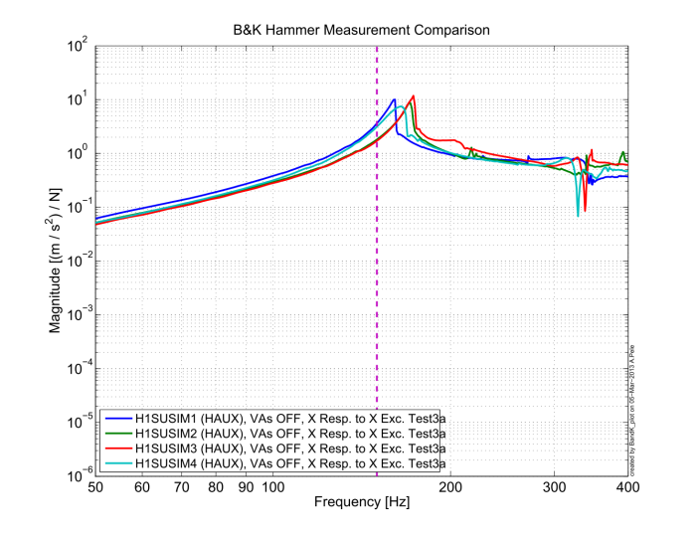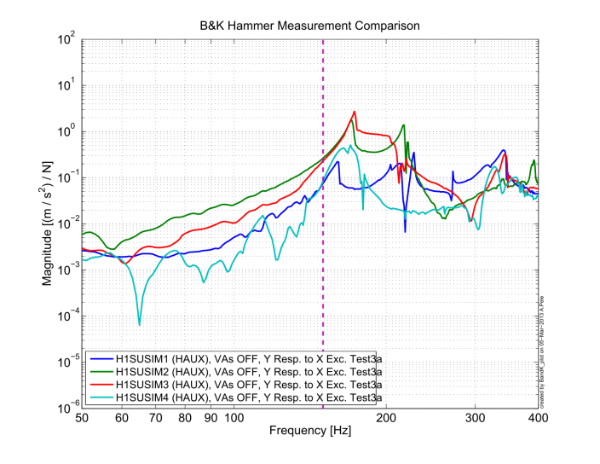 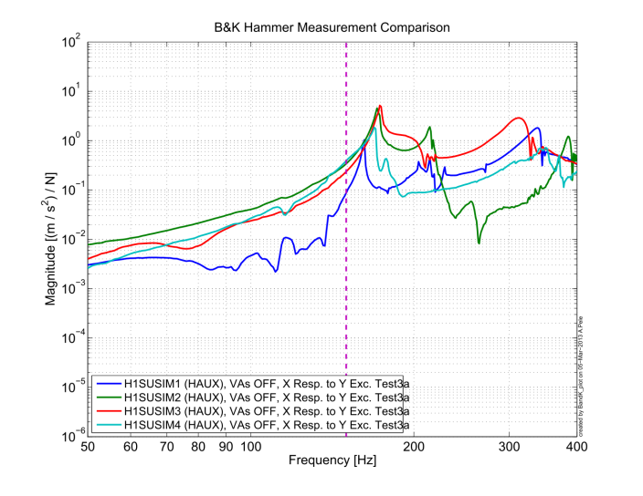 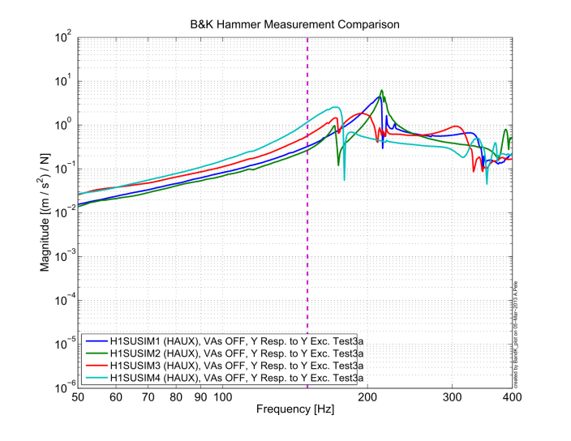

Requirements (from [T1200469](https://dcc.ligo.org/LIGO-T1200469), § 2.1.4):

* All resonances >150 Hz ***Passed***