LIGO Laboratory / LIGO Scientific Collaboration

LIGO- E1300593-v2 LIGO 10/8/13

aLIGO Installation Procedure- Pcal Receiver Mounting Blocks

C. Conley, R. Savage

Distribution of this document:
LIGO Scientific Collaboration

This is an internal working note
of the LIGO Laboratory.

California Institute of Technology  LIGO Project – MS 18-34  1200 E. California Blvd.  Pasadena, CA 91125  Phone (626) 395-2129  Fax (626) 304-9834  E-mail: info@ligo.caltech.edu | Massachusetts Institute of Technology  LIGO Project – NW22-295  185 Albany St  Cambridge, MA 02139  Phone (617) 253-4824  Fax (617) 253-7014  E-mail: info@ligo.mit.edu
LIGO Hanford Observatory  P.O. Box 159  Richland WA 99352  Phone 509-372-8106  Fax 509-372-8137 | LIGO Livingston Observatory  P.O. Box 940  Livingston, LA 70754  Phone 225-686-3100  Fax 225-686-7189
http://www.ligo.caltech.edu/

Introduction
This document outlines Addition (welding) of Pcal Receiver Mounting Blocks (D1300499-v2) onto Oplev/Pcal Receiver Pylon Weldments D1001292 & D1001297 using tooling fixture D1300525-v1. These additions are necessary for mounting of the Pcal Receiver Module. This document depicts the D1001297 (Right Handed) Pylon Weldment and the applied Receiver Mounting Block Tooling Fixture. The D1001292 (Left Handed) Pylon Weldment and Receiver Mounting Block pattern are symmetrically similar, and the tooling fixture is convertible to fit either.
Figure 1: Unmodified Right Handed Oplev/Pcal Receiver Pylon Weldment D1001297

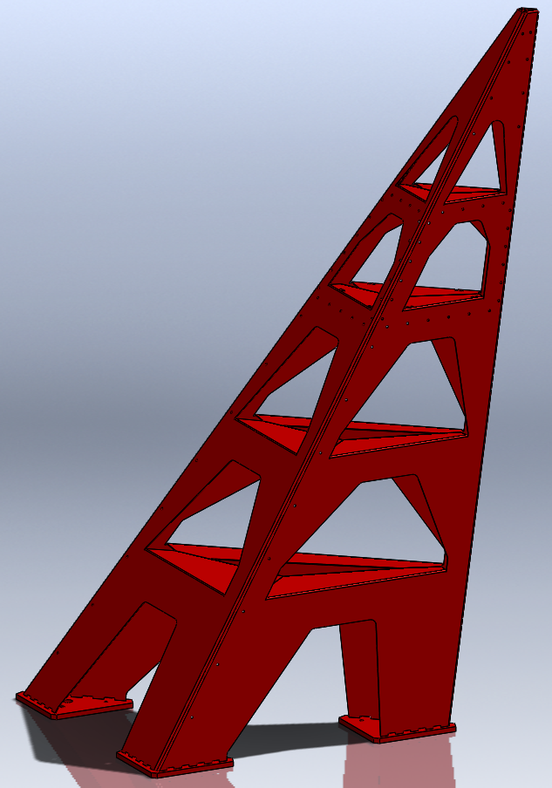
VIEWPORT FACING PANEL

Orienting the Receiver Pylon Weldment
Figure 2

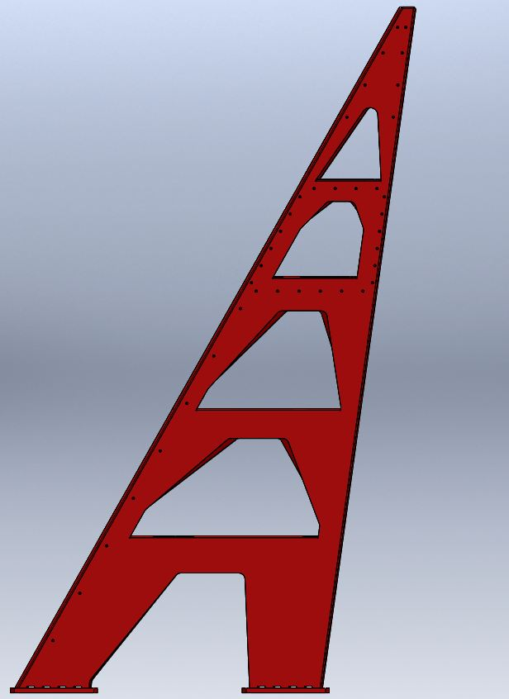
LEVEL THE PATTERN OF THREE PYLON FEET, OR GROUT PLATE IF ATTACHED

Level the three pylon foot pattern, or grout plate if attached. A carpenter’s level is sufficient.

Applying the Fixture and Welding the Mounts
Figure 3

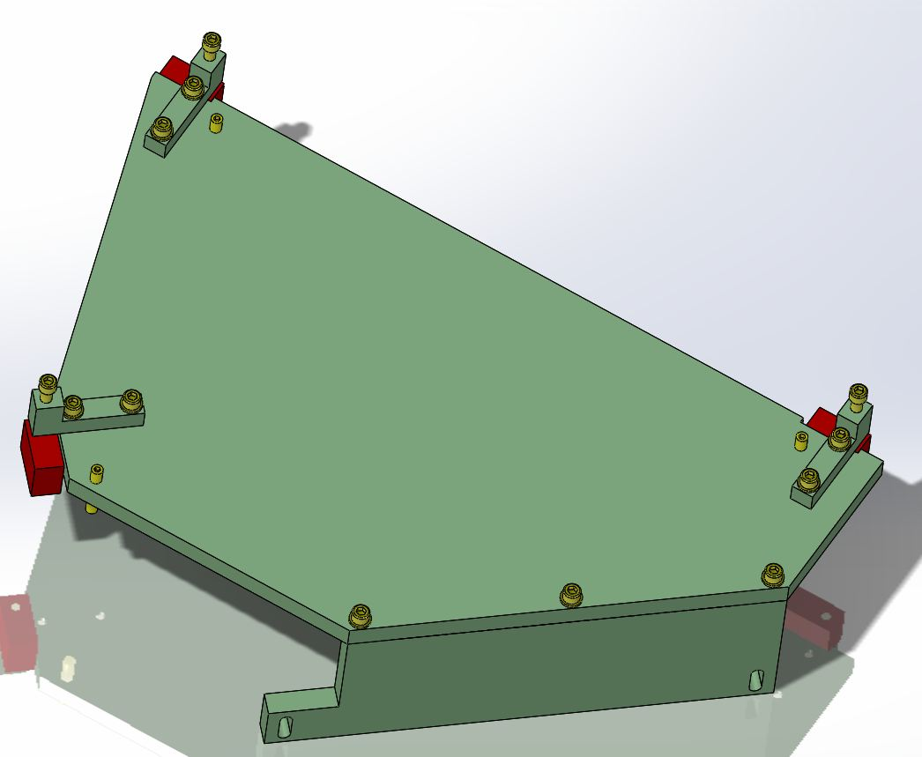
THREAD SCREWS INTO MOUNTING BLOCKS APPROXIMATELY .80” DEEP
PCAL RECEIVER MOUNTING BLOCKS
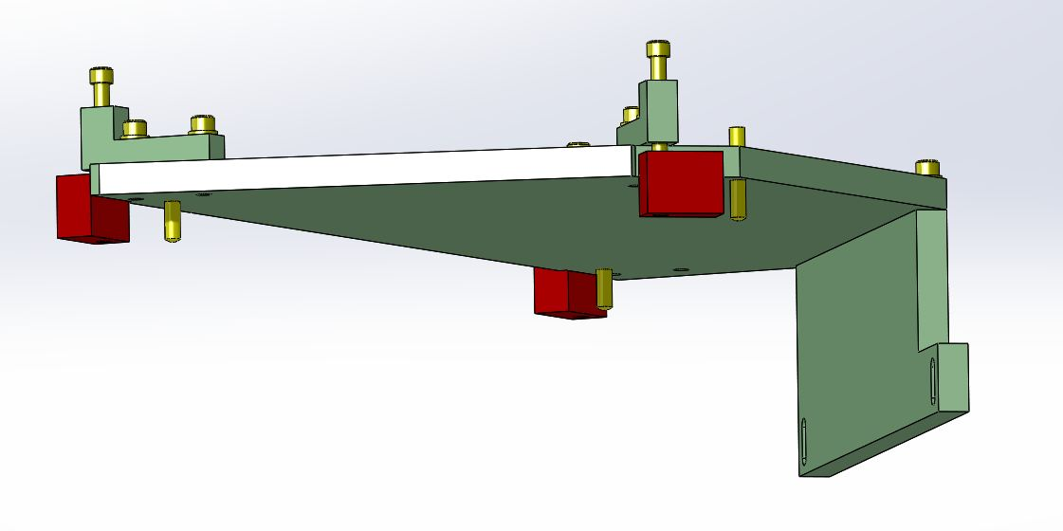
BRACKETS HAVE SLIP HOLES FOR THE MOUNTING BLOCK SCREWS
PCAL RECEIVER MOUNTING BLOCKS
Fixture D1300525 with Pcal Receiver Mounting Blocks attached. The fixture will hold the Mounting Blocks in orientation while allowing them to drop onto the pylon.

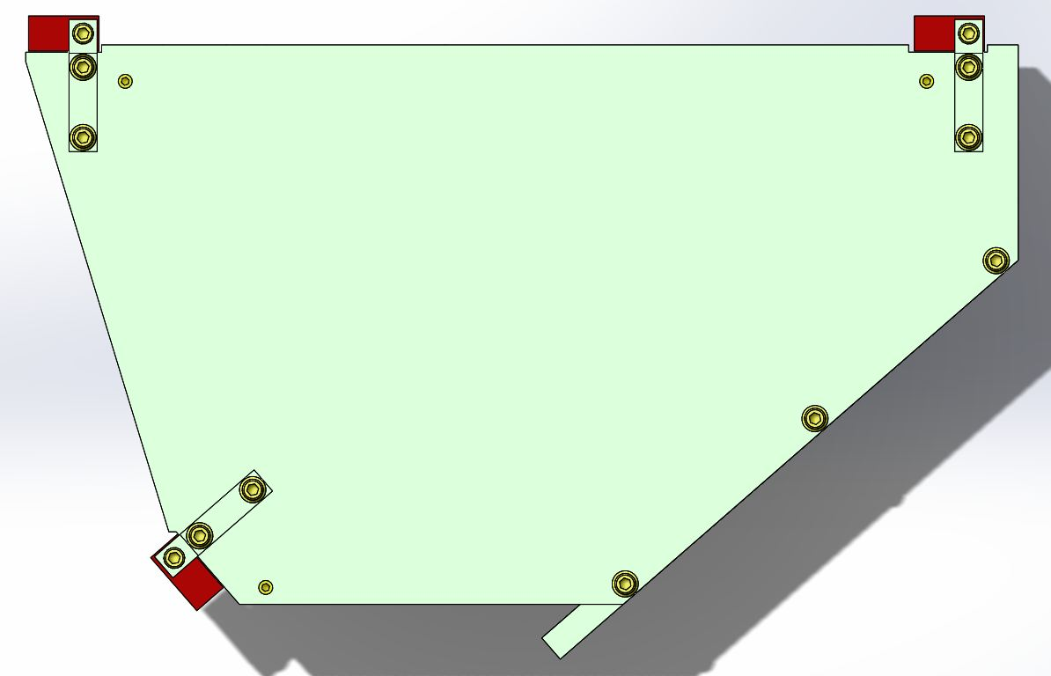
Top view of fixture D1300525-v1 with Pcal Receiver Mounting Blocks attached.
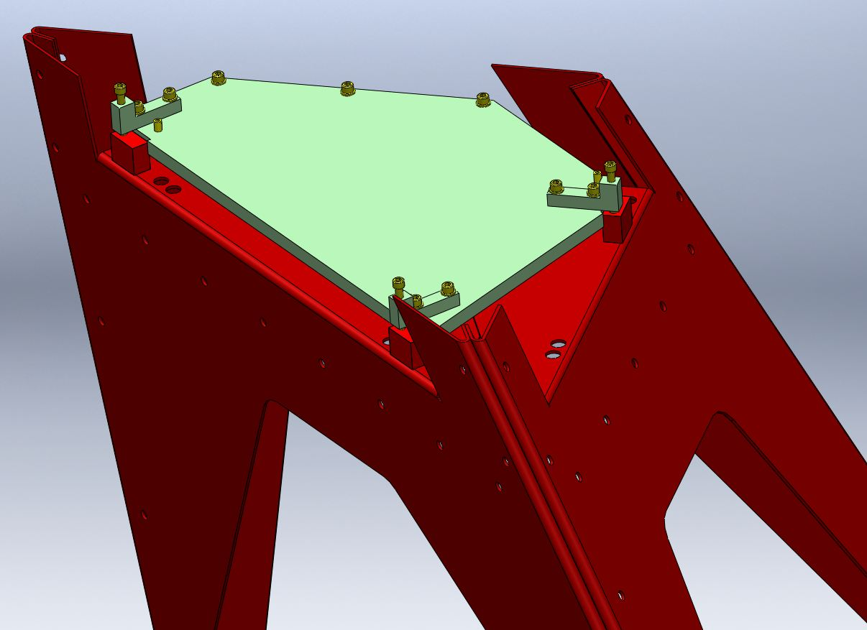
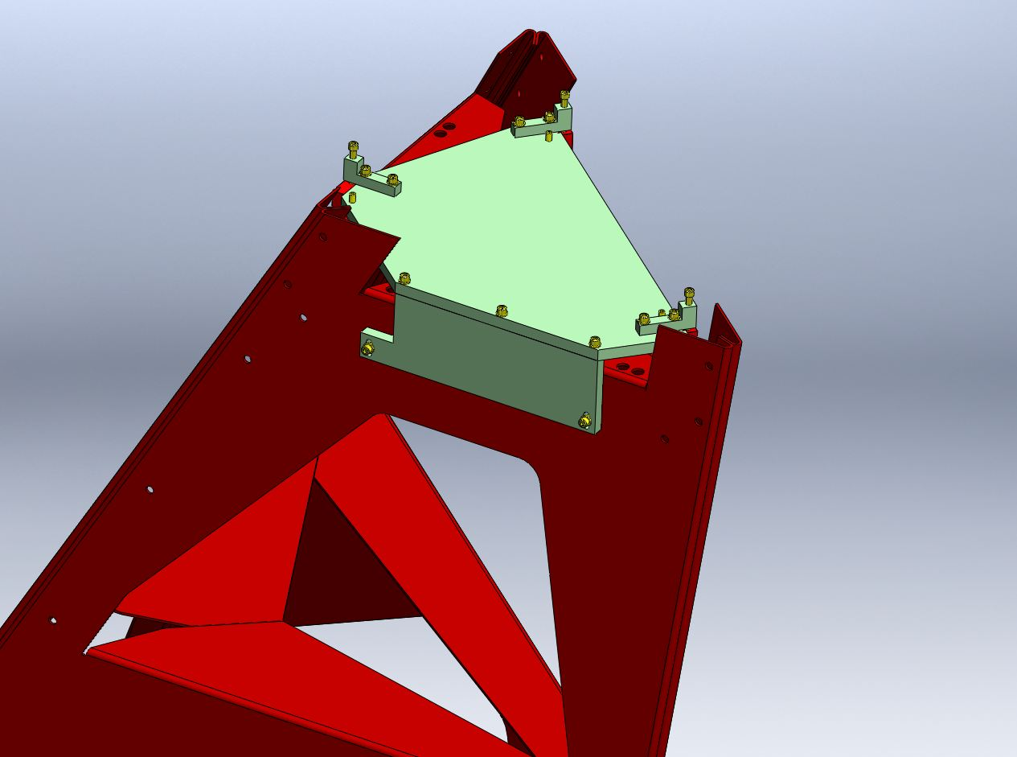
PLACE LEVEL WITHIN THE TRIANGLE OF THE THREE SET SCREWS. WEIGHT MAY BE ADDED HERE ALSO, IF NEEDED.
FIXTURE SITS ON THREE SET SCREWS. ADJUST THESE FOR LEVELING AND HEIGHT.
Cutaway views of Pylon Weldment D1001297 with D1300525-v1 fixture and D1300499-v2 Mounting Blocks in place, ready for welding.
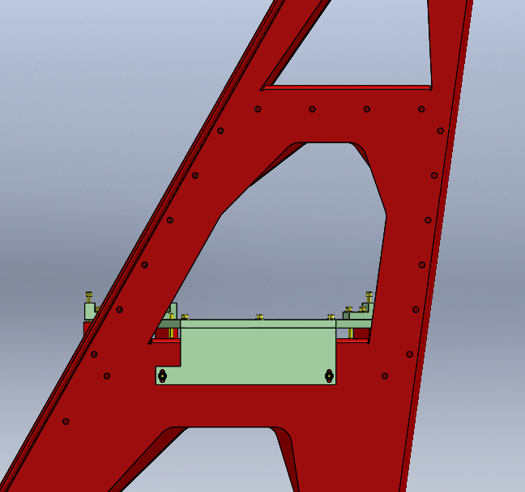
~.75”
(THE FIXTURE SHOULD NOT REST ON THE MOUNTING BLOCKS)
¼-20 X 1” SCREWS, FLAT WASHERS.
SEECURE SNUGLY AFTER LEVELING & HEIGHT ADJUSTMENTS
- Build the fixture for X or Y Arm as needed, see drawing D1300522. Thread the Mounting Blocks onto the fixture screws as shown in Figure 3, approximately .80” deep.
- Set the fixture onto the pylon as shown. Secure its position loosely with ¼-20 x 1” or longer screws into the viewport facing panel of the pylon as shown in Figure 3. The
- .75” as shown in Figure 3. Adjust using the three set screws. The fixture should float above the three Mounting Blocks.
- Place a level on top of the fixture within the triangle of the three set screws. A disc bubble level is adequate if known to be of fair accuracy. Adjust the set screws to achieve level. The fixture should remain floating above the three Mounting Blocks.
- Tighten the two ¼-20 screws snugly holding the fixture into the viewport facing panel of the pylon.
- If helpful, place a weight on top of the fixture within the triangle of the three set screws.
- Weld each Mounting Block to the pylon at the two corners on the sheet bend, ant the third and fourth corners if accessible while fixtured.
- To avoid damage to the three fixture brackets, remove the two mounting screws from each bracket before removing the long screws from the Mounting Blocks if binding is noticed.
- Remove the fixture and weld any remaining Mounting Block corners to the pylon.
- Using all appropriate mounting hardware (see D1001292-v2, D1001297-v2), perform a test-fit of a Pcal Receiver Breadboard D1300193 TYPE -02 for Pylon D1001292, D1300193 TYPE -01 for Pylon D1001297.
- Once fit checks successfully, use an engraver to strike out the pylon’s marked revision number (v1) and re-mark “v2”. Below the marked P/N & S/N, mark “TYPE -02”.
- Once the full complement of modified (TYPE -02) Pylons is complete (three of D1001292, three of D1001297), similarly re-mark the revision numbers (also to v2) of all unmodified leaner pylons (three of D1001292, three of D1001297). And, below the marked P/N & S/N, mark “TYPE -01”.

Figure 4

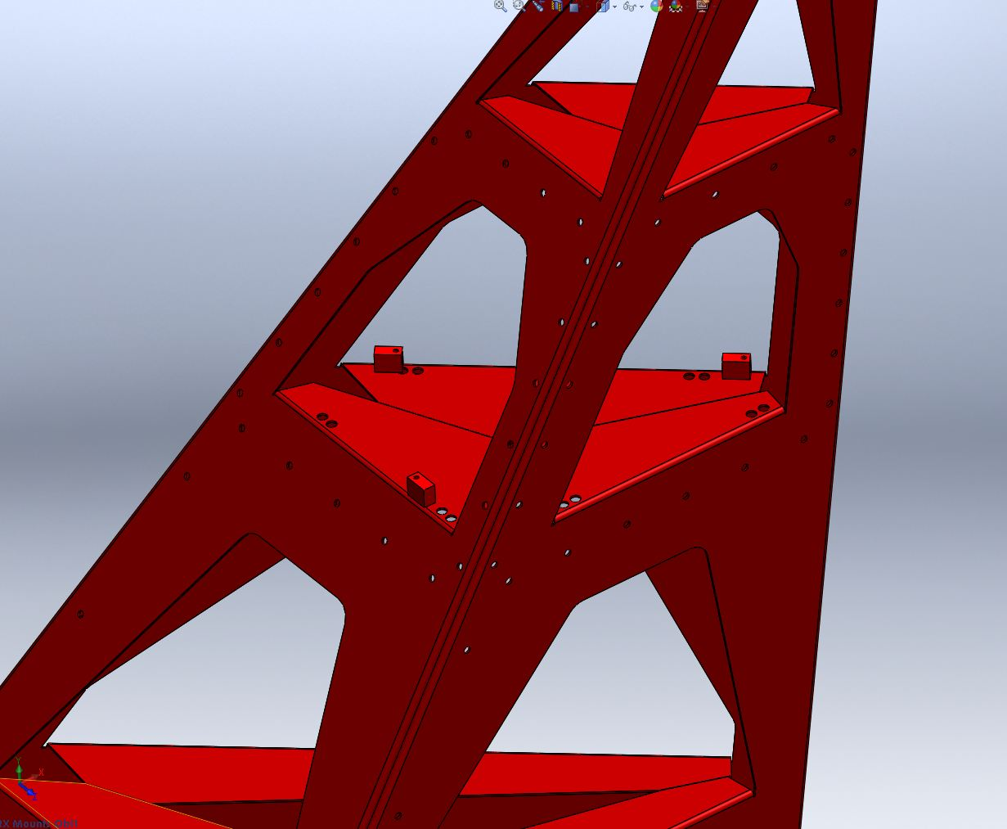
MOUNTS WELDED IN PLACE

Completed D1001297-v2, TYPE -02 Pylon.

