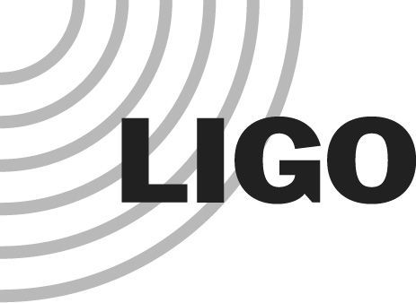
LIGO HANFORD OBSERVATORY
PO BOX 159
RICHLAND WA 99352

TEL: 509.372.8106
FAX: 509.372.8137

MEMORANDUM

DATE: August 27, 2013

TO: | Advanced LIGO
FROM: | Daniel Sigg
SUBJECT: | Electronics and Optics Change Request from the HIFO-Y Test
Refer to: | LIGO-E1300656

The HIFO-Y test concluded with a set of recommendations. They include adding a second frequency difference divider and adding a PLL circuit to lock the VCOs to the green beat note. They include adding an additional oscillator source to drive the fiber AOM. And, they include a change in the optics path on HAM1 and ISCT1 to direct both the green beams and the laser beam through the same periscope. This is covered by the following ECRs:

ECR | Description | Estimate
E1300657-v1 | Adding a second frequency difference divider for the common and differential VCOs | 6,500
E1300658-v1 | Adding PLLs to lock the common and differential VCOs | 8,000
E1300659-v1 | Implement an additional oscillator source to drive the fiber | 6,000
E1300676-v1 | Periscope changes for acoustic mitigation of ALS frequency noise | 1,000
 | Total | 21,500

We ask for $22k from the Advanced LIGO project.

