*LIGO Laboratory / LIGO Scientific Collaboration*

LIGO- **T1300685**-v1 *LIGO* 8/12/13

ITM Elliptical Baffle

Scattered Light Interference Effects

Michael Smith

Distribution of this document:

LIGO Scientific Collaboration

This is an internal working note

of the LIGO Laboratory.

|  |  |
| --- | --- |
| **California Institute of Technology**  **LIGO Project – MS 18-34**  **1200 E. California Blvd.**  **Pasadena, CA 91125**  Phone (626) 395-2129  Fax (626) 304-9834  E-mail: info@ligo.caltech.edu | **Massachusetts Institute of Technology**  **LIGO Project – NW22-295**  **185 Albany St**  **Cambridge, MA 02139**  Phone (617) 253-4824  Fax (617) 253-7014  E-mail: info@ligo.mit.edu |
| **LIGO Hanford Observatory**  **P.O. Box 159**  **Richland WA 99352**  Phone 509-372-8106  Fax 509-372-8137 | **LIGO Livingston Observatory**  **P.O. Box 940**  **Livingston, LA 70754**  Phone 225-686-3100  Fax 225-686-7189 |

<http://www.ligo.caltech.edu/>

**CHANGE LOG**

|  |  |
| --- | --- |
| **Date, version** | **Summary of Changes** |
| 8/12/13  V1 | * New document * Corrected baffle aperture, see T1300324-v4 |

**Table of Contents**

1 INTRODUCTION 5

1.1 Scope 5

2 BAFFLE DESCRIPTIONS 5

2.1 ITM ELLIPTICAL BAFFLE 5

3 SCATTERED LIGHT DISPLACEMENT NOISE 8

3.1 Source of Scattered Light Field 9

3.2 Scattered Light Parameters 9

3.3 Scattered Light with Phase Interference 11

3.3.1 Total Scattered Light Field with Phase Interference 12

3.3.2 Displacement Noise with Phase Interference 13

3.4 Scattered Light with No Phase Interference 13

3.4.1 Scattered Light Field with No Phase Interference 14

3.4.2 Displacement Noise with No Phase Interference 14

3.5 Summary 14

**Table of Figures**

Figure 1: BSC2: ITM Elliptical Baffles 5

Figure 2: ITM Elliptical Baffle 7

Figure 3: Scattered Light Noise Transfer Functions 9

Figure 4: Scattered Light Displacement Noise Calculations With and Without Phase Interference Effects 15

# 

# INTRODUCTION

## Scope

This document describes the reduction in scattered light displacement noise that occurs because of destructive interference effects of the combined scattered light field, caused by path length differences within the scattering surfaces of the ITM Elliptical Baffle.

The scattered light noise theory presented here has not been validated by comparison with a mode overlap integral calculation.

# BAFFLE DESCRIPTIONS

## ITM ELLIPTICAL BAFFLE

The scattering surface of the ITM Elliptical Baffle is inclined at 33 degree incidence to the axis of the power recycling cavity beam impinging from the ITM AR surface, as shown in Figure 1. The inclined scattering surface creates a different round trip scattering path length for every component of the scattered light.



From ITM

From ITM

BS

ITM Ellip Baf

ITM Ellip Baf

Figure : BSC2: ITM Elliptical Baffles

The ITM Elliptical Baffle is suspended from the ISI Stage 0 by a vertical blade spring and pendulum flexure, as shown in Figure 2.

The motion of the suspended baffle is damped in six degrees of freedom by the eddy current damping apparatus.

The size of the ITM Elliptical Baffle hole was chosen to be 7mm larger on all sides than the limiting aperture of the BS Elliptical Baffle, 210 x 260 mm--Ref: [T1000090](https://dcc.ligo.org/LIGO-T1000090-v5)-v5, aLIGO Baffle Design using SIS.

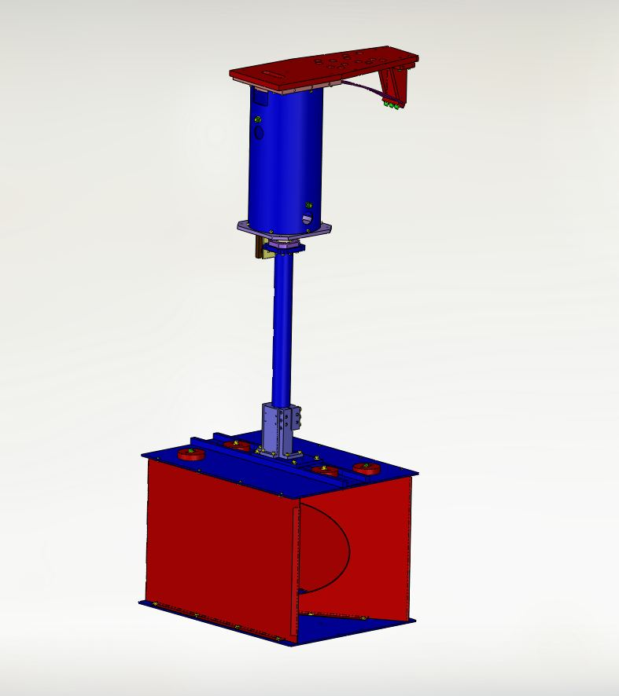

Figure : ITM Elliptical Baffle

# SCATTERED LIGHT DISPLACEMENT NOISE

A DARM signal is obtained when the differential arm length is modulated as a result of a gravity wave strain. The DARM signal was calculated in reference­­­, T060073-00 Transfer Functions of Injected Noise, and is defined by the following expression:



Where L is the arm length, hSRD is the minimum SRD gravity wave strain spectral density requirement, P0 is the input laser power into the IFO, and DARM is the signal transfer function.

In a similar manner, an apparent signal (scattered light noise) occurs when a scattered light field with a phase shift is injected into the IFO at some particular location, e.g. through the AR surface of the ITM mirror. The scattered light noise is defined by the following expression:



PSNi is the scattered light power injected into the IFO mode, δSN is the phase shift of the injected field, and SNXXX is the noise transfer function for that particular injection location.



The phase shift spectral density of the injected field due to the motion of the scattering surface is given by

where xs is the spectral density of the longitudinal motion of the scattering surface.

In general, the different scattering sources are not coherent and must be added in quadrature. The requirement for total scattered light displacement noise can be stated with the following inequality:



The SNXXX/DARM scattered light noise transfer function ratios for various injection locations within the IFO are shown in Figure 7: Scattered Light Noise Transfer Functions.



Figure : Scattered Light Noise Transfer Functions

## Source of Scattered Light Field

When the source of the scattered light field is a direct portion of the interferometer (IFO) beam--e.g. the edges of the power recycling cavity beam hitting the ITM Elliptical Baffle, it is assumed that the scattered light re-enters the IFO mode by scattering into the full solid angle of the IFO mode at the location of the scattering surface.

For scattering by the ITM Elliptical Baffle, the IFO mode solid angle is determined by the virtual beam waist radius created by the optical surfaces of the ITM mirror as viewed from outside the AR surface.

## Scattered Light Parameters

BRDF of ellip baf, sr^-1



Motion of suspended baffle @ 100 Hz, m/rt Hz



laser wavelength, m



wave number, m^-1





Transfer function @ 100 Hz, ITM AR



ITM beam radius, m



virtual beam waist looking toward ITM AR

(see H1 Signal Recycling Cavity beam size_8-12-13)



distance from ITM AR to virtual beam waist, m



solid angle of ITM AR virtual beam waist, sr





baffle incidence angle, rad



elliptical baffle horizontal

semi-axis, m





elliptical baffle vertical

semi-axis, m





Transmissivity of ITM HR



**Ref. T070247**

input laser power, W





arm cavity gain





arm cavity power, W

**Ref. Hiro e-mail 8/29/11**

power in power recycling cavity arm, W





Gaussian power parameter

in recycling cavity



radius of ITM, mm



exitance function from ITM



## Scattered Light with Phase Interference

**ITM ELLIPTICAL BAFFLE**

Power hitting ITM Ellip Baf, direct integration, W





distance from scattering point to virtual ITM AR beam waist



The differential scattered power from a differential area of the baffle is given by the following.

**Scattered electric field into IFO with round trip phase difference**





The scattered field from each differential element recombines at the virtual beam waist of ITM AR.



The scattered power from the ITM Elliptical Baffle is calculated by integrating the incident power across the surface of the baffle; the integration is broken up into three parts.



### Total Scattered Light Field with Phase Interference

scattered power integral 1



scattered power integral 2



scattered power integral 3



Total scattered field per baffle





total scattered power from two baffles





### Displacement Noise with Phase Interference

displacement noise @ 100 Hz, m/rtHz





## Scattered Light with No Phase Interference



### Scattered Light Field with No Phase Interference

Total scattered field





total scattered power from two baffles





### Displacement Noise with No Phase Interference

displacement noise @ 100 Hz, m/rtHz





compare with phase calculation





## Summary

Interference effects within the scattered light field reduce the scattered light displacement noise by more than a factor 5, as seen in Figure 4.



Figure : Scattered Light Displacement Noise Calculations With and Without Phase Interference Effects