ASER INTERFEROMETER GRAVITATIONAL WAVE OBSERVATORY
LIGO
CALIFORNIA INSTITUTE OF TECHNOLOGY
MASSACHUSETTS INSTITUTE OF TECHNOLOGY
LIGO- T1300731 -v1 13 September 2013
Low-Scatter Coating for Stainless Steel Baffles

Michael Smith

LIGO Hanford Observatory LIGO Livingston Observatory
P.O. Box 1970; Mail Stop S9-02 19100 LIGO Lane
Richland, WA 99352 Livingston, LA 70754
Phone (509) 37208106 Phone (225) 686-3100
Fax (509) 372-8137 Fax (225) 686-7189
E-mail: info@ligo.caltech.edu E-mail: info@ligo.caltech.edu

California Institute of Technology Massachusetts Institute of Technology
LIGO – MS 100-36 LIGO – MS NW22-295
Pasadena, CA 91125 Cambridge, MA 02139
Phone (626) 395-2129 Phone (617) 253-4824
Fax (626) 304-9834 Fax (617) 253-7014
E-mail: info@ligo.caltech.edu E-mail: info@ligo.mit.edu

CHANGE LOG

Date, version | Summary of Changes
8/27/13  V1 | - New document

Table of Contents
1 Introduction 6
1.1 ACB Scattering Surfaces 7
2 Scattering Analysis 12
2.1 Scattering Parameters 12
2.2 Oxidized Stainless Steel Baffle 15
2.2.1 Scatter from Photodetectors 15
2.2.2 Scatter from Screw Heads 16
2.2.3 BRDF of Oxidized Stainless Steel 17
2.2.4 Scatter by Oxidized SS Baffle Hole Edge 18
2.2.5 Scatter by Oxidized SS Baffle Center Plate Edge 19
2.2.6 Scatter by Oxidized SS Baffle Bend 19
2.2.7 Scatter by Oxidized SS Louver Baffle Portion 20
2.2.8 Total Scatter by Oxidized SS ACB 21
2.3 Multilayer AR Coating on Stainless Steel 22
2.3.1 BRDF and Reflectivity of Multilayer AR Coating 22
2.3.2 Scatter by Multilayer AR Coating on SS Baffle Hole Edge 24
2.3.3 Scatter by Multilayer AR Coating on SS Center Plate Edge 25
2.3.4 Scatter by Multilayer AR Coating on SS Louver Bend 25
2.3.5 Scatter by Multilayer AR Coating on SS Louver Baffle Portion 26
2.3.6 Scatter from Screw Heads 27
2.3.7 Scatter from Photodetectors 27
2.3.8 Total Scatter by Multilayer AR Coating on SS ACB 27
2.4 DLC Coating on Stainless Steel 30
2.4.1 BRDF and Reflectivity of DLC Coating 30
2.4.2 Scatter by DLC Coating on SS Baffle Hole Edge 33
2.4.3 Scatter by DLC Coating on SS Center Plate Edge 34
2.4.4 Scatter by DLC Coating on SS Baffle Bend 35
2.4.5 Scatter by DLC Coating on SS Louver Baffle Portion 35
2.4.6 Scatter from Screw Heads 36
2.4.7 Scatter from Photodetectors 36
2.4.8 Total Scatter by DLC Coating on SS ACB 36
3 Conclusions 38
3.1 Comparison of Scattered Light Displacement Noise, m/rtHz from Multilayer AR Coating ACB and DLC Coating ACB with Default aLIGO Oxidized SS ACB 38
3.2 Limiting Scattering Sources 38
3.2.1 Edge Scatter 38
3.2.2 Screw Head Scatter 38
3.3 BRDF 38
3.4 Reflectivity 38
4 Reference Data 39

Table of Figures
Figure 1: Arm Cavity Baffle Showing Principal Scattering Surfaces 7
Figure 2: Frontal Area of ACB Hit by Narrow Angle Scatter from Far Test Mass Mirror 8
Figure 3: Cross-section of ACB 8
Figure 4: Bend Radius of ACB Used in the Scattered Light Calculation 9
Figure 5: Edge Radius of Central Plate Used in the Scattered Light Calculation 10
Figure 6: Actual Cross Section of ACB SS Hole Beveled Edge 11
Figure 7: Measured BRDF Data, Oxidized Stainless Steel, with Parametric Fit 17
Figure 8: Parametric BRDF Functions, as Best Fit to CASI Data 18
Figure 9: Total Scattered Power, W, by Oxidized SS ACB vs Plate Edge Radius, m 21
Figure 10: Measured BRDF Data, Multilayer AR Coating on SS, with Parametric Fit 22
Figure 11: Parametric Functions for Multilayer AR Coating BRDF as Best Fit to CASI Data 23
Figure 12: Multilayer AR Coating Backscatter BRDF sr^-1 vs Incidence Angle, Deg 23
Figure 13: Reflectivity of Multilayer AR Coating vs Incidence Angle 24
Figure 14: Total Scattered Power, W, by Multilayer AR Coating on SS ACB vs Screw Head BRDF, sr^-1 27
Figure 15: Total Scattered Power, W, by Multilayer AR Coating on SS ACB vs Tilt Angle, Deg 28
Figure 16: Total Scattered Power, W, by Multilayer AR Coating on SS ACB vs Center Plate Edge Radius, m 28
Figure 17: Measured BRDF Data, DLC Coating on SS, with Parametric Fit 30
Figure 18: Parametric DLC Coating BRDF Functions, as Best Fit to CASI Data 31
Figure 19: Backscatter BRDF, sr^-1, DLC Coating as a Function of Incidence Angle, Deg 32
Figure 20: Reflectivity DLC Coating as a Function of Incidence Angle, Deg 33
Figure 21: Total Scattered Power, W, by DLC Coating on SS ACB vs Tilt Angle, Deg 36
Figure 22: Total Scattered Power, W, by DLC Coating on SS ACB vs Center Plate Edge Radius, m 37

Introduction
An improved low-scattering and low-reflectivity coating for polished stainless steel was developed using a multilayer dielectric antireflection coating; the coating was applied by a commercial coating vendor using an ion assisted physical vapor deposition (PVD) process, in which an electron beam was used to evaporate the coating materials.
The BRDF and reflectance properties of the sample film were measured. The back-scatter BRDF at 57 deg incidence angle of the multilayer AR coating on SS is <1E-5 sr^-1 for p-polarization. The reflectivity of the multilayer AR coating on SS for 57 deg incidence angle is <1E-3 for both polarizations--i.e. > 99.9% of the incident power striking the louver portion of the ACB will be absorbed. This would be a very efficient baffle surface.
As an example of the use of this coating, the calculated scattered light noise from the aLIGO stainless steel Arm Cavity Baffle (ACB) with this multi-layer dielectric antireflection coating (mAR) is compared with a diamond-like coating (DLC), and with the aLIGO default oxidized stainless steel. An 80 times reduction in scattered light displacement noise could be obtained with the multilayer AR coating over the default oxidized SS ACB; whereas, a 19 times reduction in scattered light displacement noise could be achieved with the DLC coating.
One caveat of the use of the multi-layer dielectric antireflection coating is that it probably will be restricted to a planar surface; whereas, the DLC coating can be applied to an arbitrarily shaped surface.

ACB Scattering Surfaces
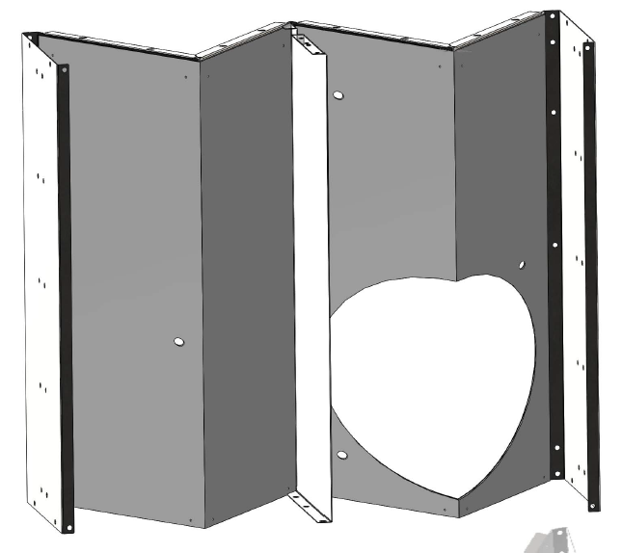
Baffle Plate Hole Edge
Baffle Louver Bend
Center Plate
Edge
Photoconductor with 3 screw heads
Baffle Louver
Figure 1: Arm Cavity Baffle Showing Principal Scattering Surfaces

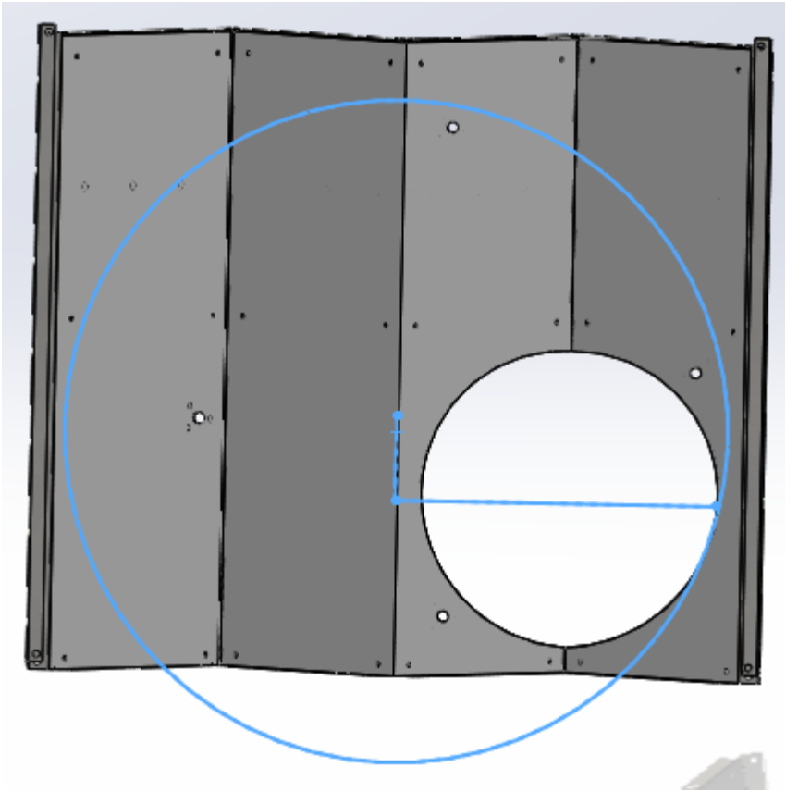
Cryo Baffle Opening
Figure 2: Frontal Area of ACB Hit by Narrow Angle Scatter from Far Test Mass Mirror

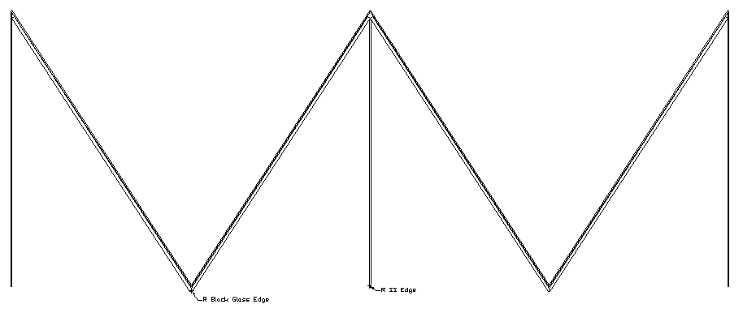

Figure 3: Cross-section of ACB

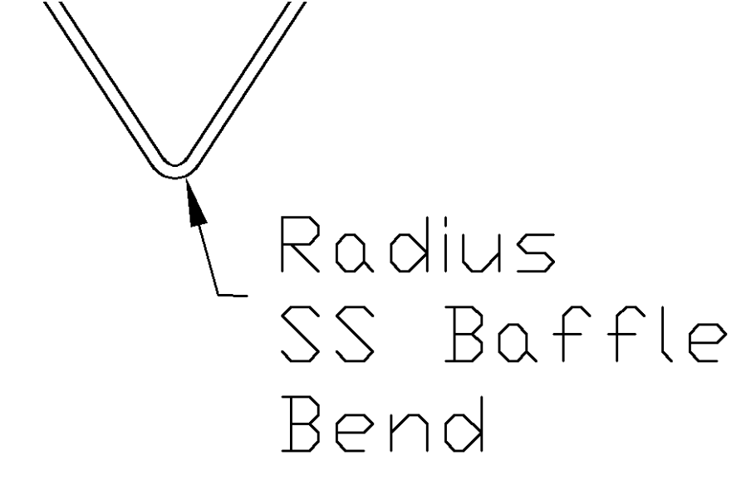
Figure 4: Bend Radius of ACB Used in the Scattered Light Calculation

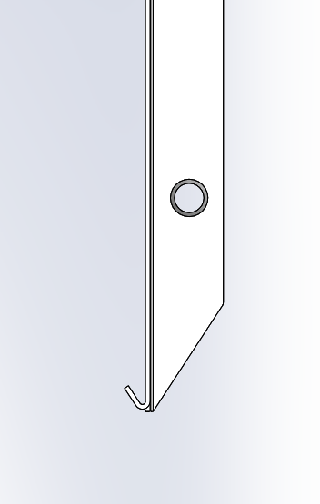
Central plate edge radius

Figure 5: Edge Radius of Central Plate Used in the Scattered Light Calculation

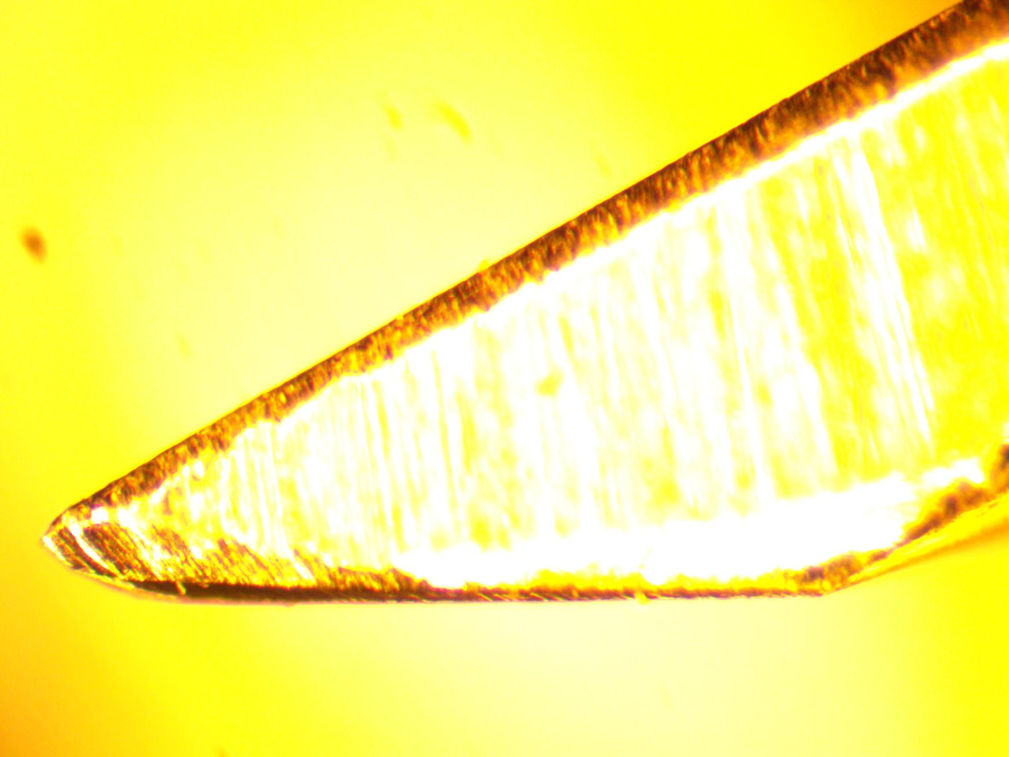
Radius = 0.1 mm

Figure 6: Actual Cross Section of ACB SS Hole Beveled Edge

Scattering Analysis
The scattered light from the surface of the far test mass mirror will pass down the interferometer arm, through the Manifold/Cryopump Baffle, and hit the Arm Cavity Baffle (ACB) in front of the near test mass.

Scattering Parameters

Arm Power, W
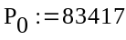

radius of SS baffle edge, m
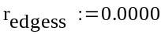
radius of SS baffle bend, m
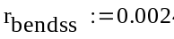
length of baffle plate edge, m
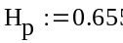
length of baffle bend, m
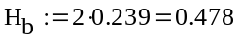
Frontal area of SS center plate cut edge, m^2
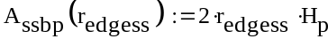
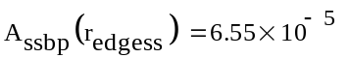

Frontal area of SS baffle bend edge, m^2
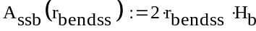
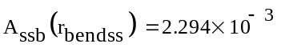
BRDF of SS cut edge, sr^-1
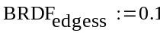
BRDF of photodetector, sr^-1
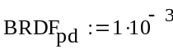
BRDF of screw head sr^-1
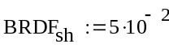
number of photodetector
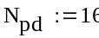
number of screw heads
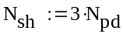
radius of photodetector ring, m
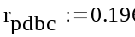

Photoconductor radius, m
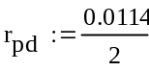
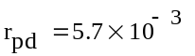

photoconductor area, m^2
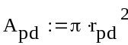
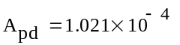
Screw head radius (#10), m
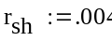
Screw head area, m^2
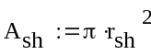
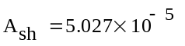

laser wavelength, m
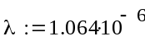
wave number, m^-1
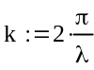
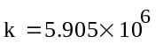
ACB displacement @ 100 HZ, m/rt HZ
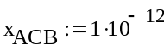
IFO waist size, m
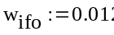
solid angle of IFO mode, sr
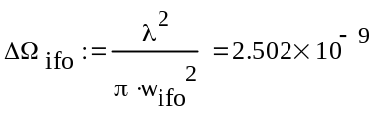

Transfer function @ 100 Hz, ITM HR
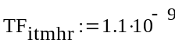
IFO arm length, m
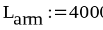
PSL laser power, W
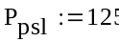
Arm Power, W
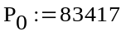
radius of Cryopump aperture, m
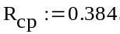
half-angle from centerline to Rcp, rad
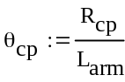

half-angle from centerline to Rcp, rad (see ACB_PD_scatter_8-29-12)
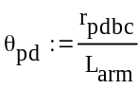

BRDF, sr^-1; CSIRO, surface 2, S/N 2
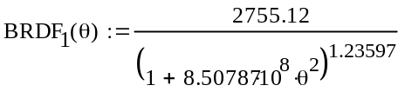

radius of manifold/cryo baffle, m
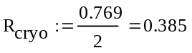
height of ledge, m
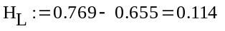
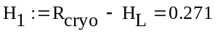
radius of ACB hole, m
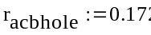
area of ACB hole, m^2
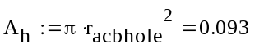
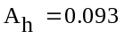

thickness of baffle plate, m
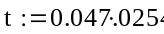
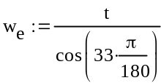
maximum width of exposed edge, m
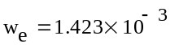
exposed area of baffle plate hole edge, m^2
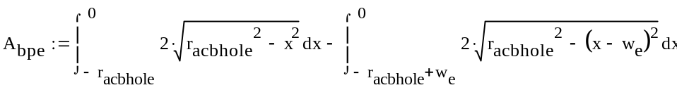
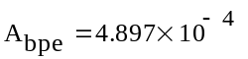

area of manifold/cryo baffle ledge, m^2
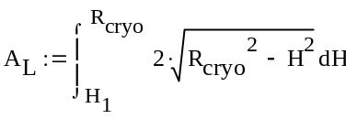
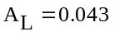

area of exposed ACB, m^2
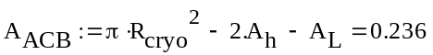
The intensity of the light incident on the ACB surface is calculated.

power through the cryopump baffle aperture
(hits the arm cavity baffle), W
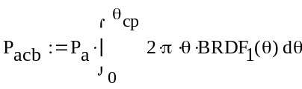
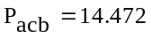

Area of cryopump baf aperture, m^2
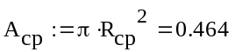
incident intensity, W/m^2
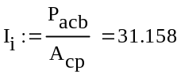

Oxidized Stainless Steel Baffle

Scatter from Photodetectors

Scatter from photodetectors
number of photodetector
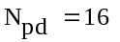
photoconductor area, m^2

COC Scattered power hitting the PD, W
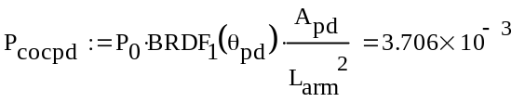
power scattered by photodetector,
into IFO mode, W
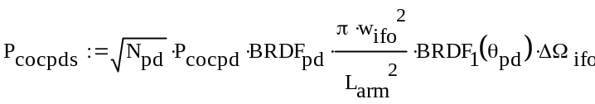
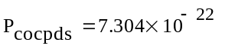

displacement noise @ 100 Hz, m/rtHz
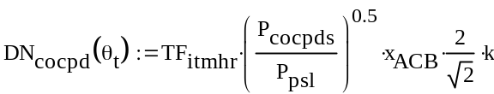
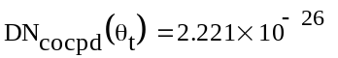

Scatter from Screw Heads

Scatter from screw heads
number of screw heads
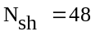
Screw head area, m^2

COC Scattered power hitting
the screw head W
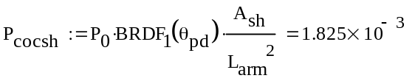

power scattered by screw head
into IFO mode, W
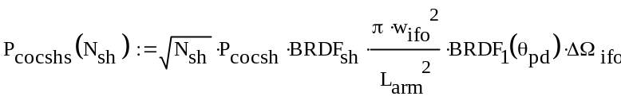
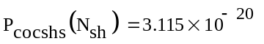
displacement noise @ 100 Hz, m/rtHz
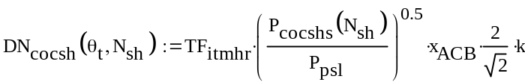
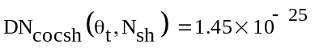

BRDF of Oxidized Stainless Steel
The incident angle of the light hitting the louver portion of the ACB is 57 deg, and the incident angle hitting the edge of the central plate and the hole of the baffle is centered at approximately 0 deg.
The BRDF, sr^-1 of oxidized polished stainless steel was measured with a CASI scatterometer at incidence angles of 57 deg and 3 deg as a function of the angle away from the specular direction.

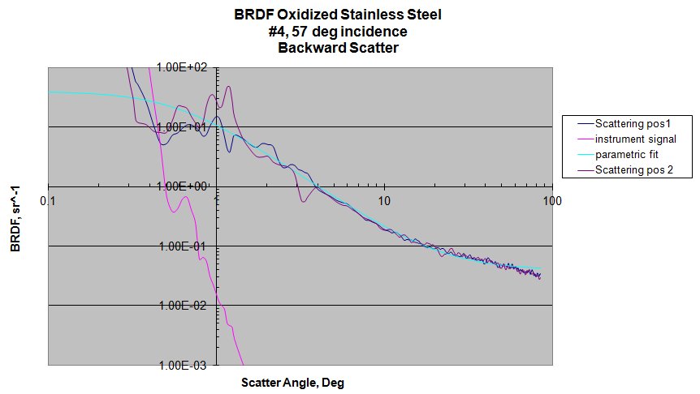

Figure 7: Measured BRDF Data, Oxidized Stainless Steel, with Parametric Fit

The parametric curves shown below were fit to the CASI BRDF data.
The 3 deg data will be used for computing the normal incidence BRDF values. The BRDF data is approximately symmetrical for plus and minus angles about the specular direction.

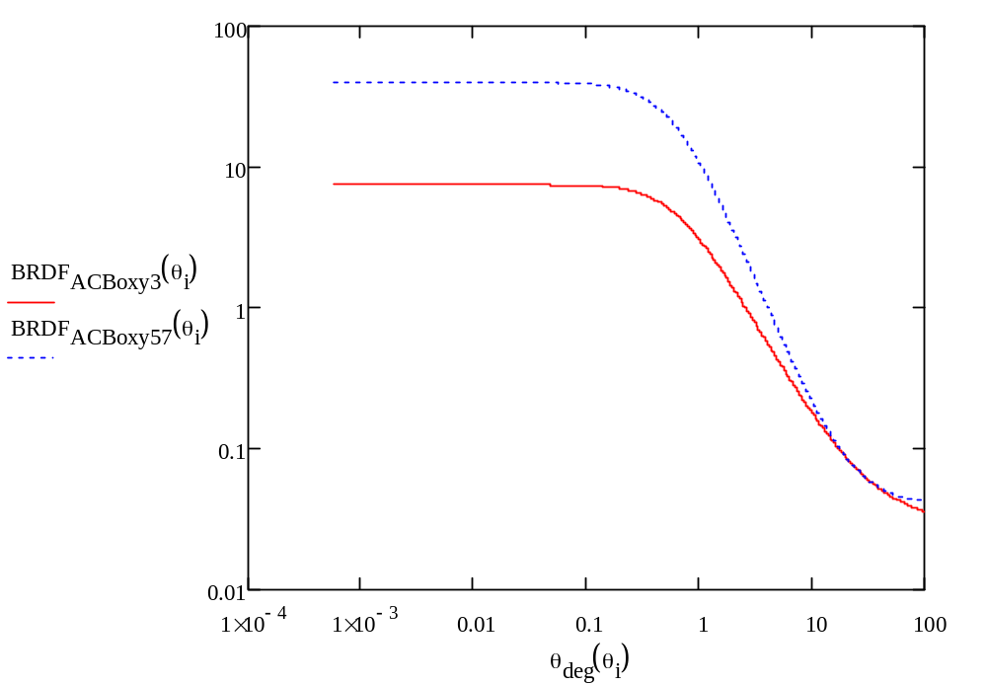
Figure 8: Parametric BRDF Functions, as Best Fit to CASI Data

Scatter by Oxidized SS Baffle Hole Edge

BRDF geometric scatter function from baffle hole edge
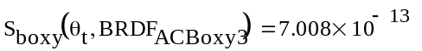
Scattered power into IFO from baffle hole edge
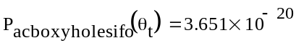
displacement noise @ 100 Hz, m/rtHz
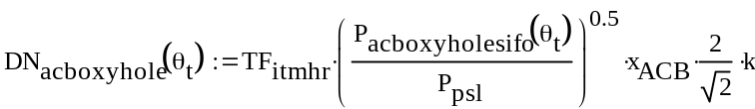
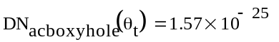

Scatter by Oxidized SS Baffle Center Plate Edge

Scatter from SS center plate edge
power incident on SS center plate edge, W
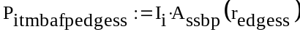
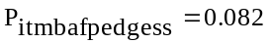

Scattered power into IFO from oxy SS center plate edge
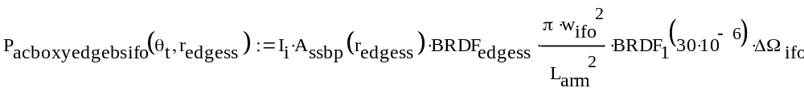
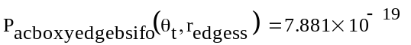

displacement noise @ 100 Hz, m/rtHz
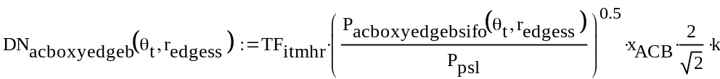
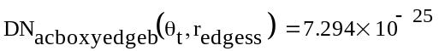

Scatter by Oxidized SS Baffle Bend

BRDF geometric scatter function from oxy baffle bend
Scattered power into IFO from oxy SS baffle bend
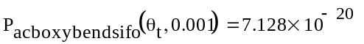

displacement noise @ 100 Hz, m/rtHz
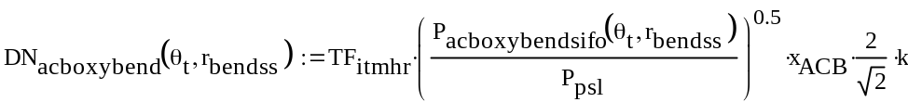
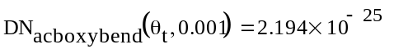

Scatter by Oxidized SS Louver Baffle Portion

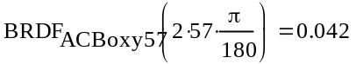
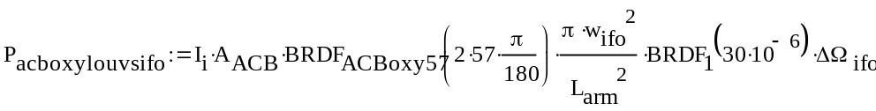
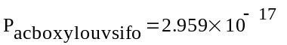

displacement noise @ 100 Hz, m/rtHz
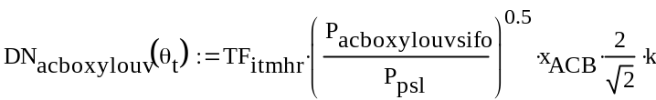
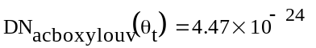

Total Scatter by Oxidized SS ACB

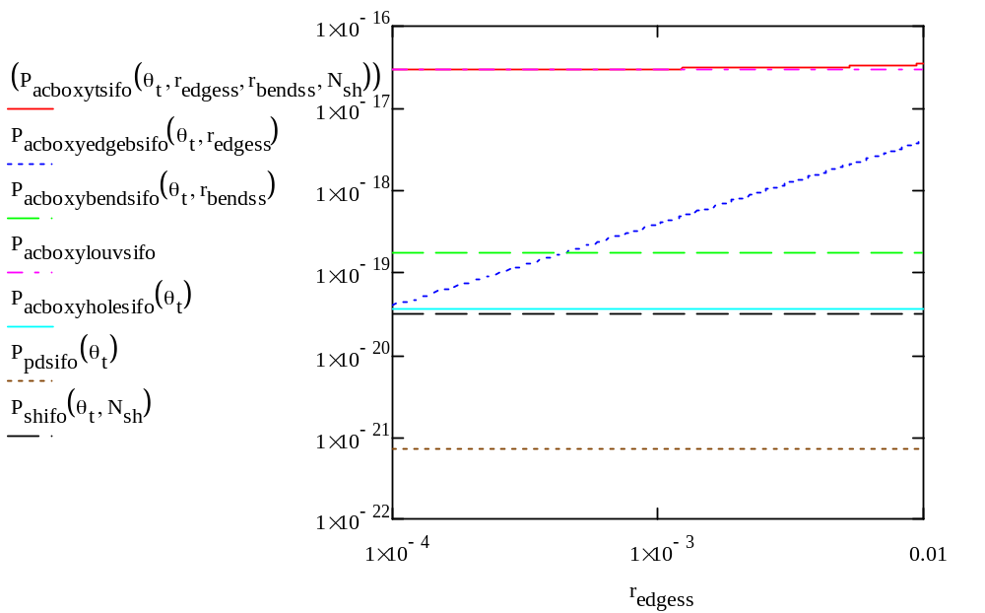
Figure 9: Total Scattered Power, W, by Oxidized SS ACB vs Plate Edge Radius, m

Note: the SS edge scatter does not dominate for edge radius < 0.003 m
total displacement noise @ 100 Hz, m/rtHz

Multilayer AR Coating on Stainless Steel

BRDF and Reflectivity of Multilayer AR Coating
The incident angle of the light hitting the louver portion of the ACB is 57 deg, and the incident angle hitting the edge of the central plate and the hole of the baffle is centered at approximately 0 deg.
The BRDF was measured for multilayer AR coating on SS at incidence angles of 57 deg, 30 deg, 15 deg, 10 deg, and 3 deg, as a function of the angle away from the specular direction. The 57 deg data with the parametric fit is shown below.

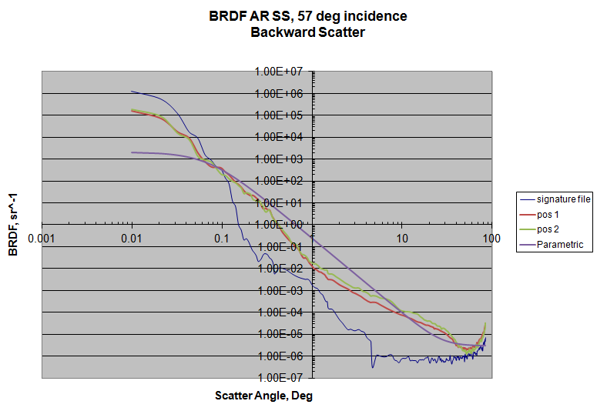

Figure 10: Measured BRDF Data, Multilayer AR Coating on SS, with Parametric Fit

The parametric curves shown below were fit to the CASI BRDF data.
The 3 deg data will be used for computing the normal incidence BRDF values. The BRDF data is approximately symmetrical for plus and minus angles about the specular direction.

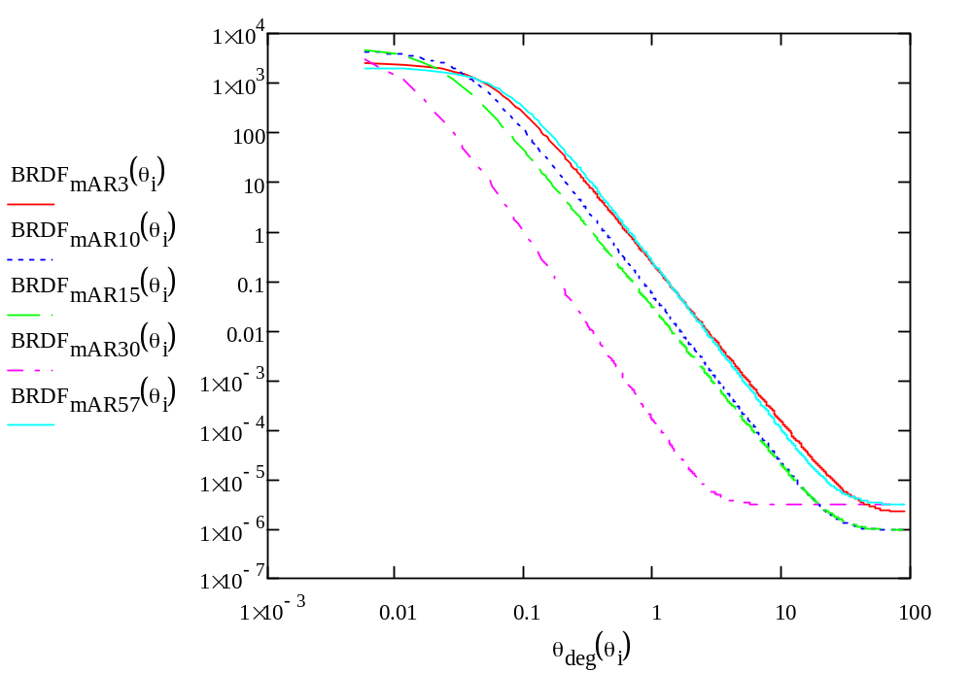
Figure 11: Parametric Functions for Multilayer AR Coating BRDF as Best Fit to CASI Data

Back-scatter BRDF, sr^-1, as a function of incidence angle, deg, is presented below.

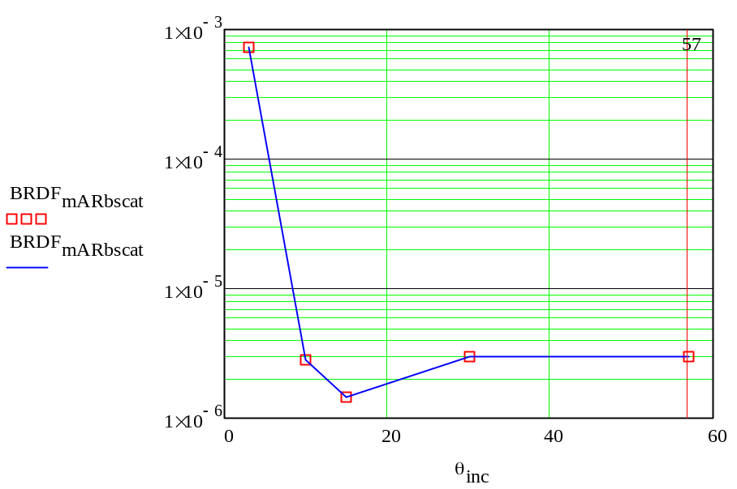

Figure 12: Multilayer AR Coating Backscatter BRDF sr^-1 vs Incidence Angle, Deg

Summary of reflectivity as a function of incidence angle is presented below.

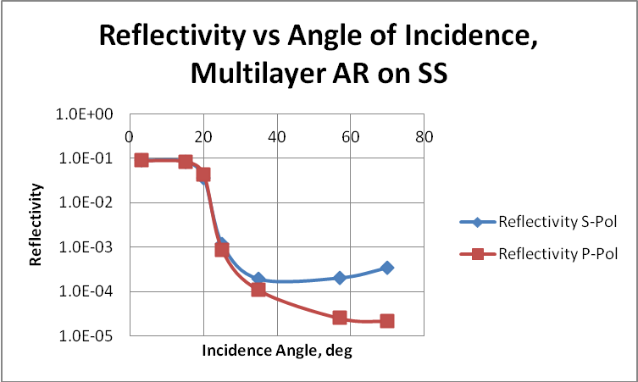

Figure 13: Reflectivity of Multilayer AR Coating vs Incidence Angle

Scatter by Multilayer AR Coating on SS Baffle Hole Edge

Scatter from oxy SS baffle hole edge
BRDF geometric scatter function from baffle hole edge

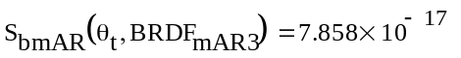
Scattered power into IFO from baffle hole edge
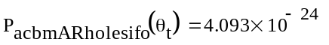

displacement noise @ 100 Hz, m/rtHz
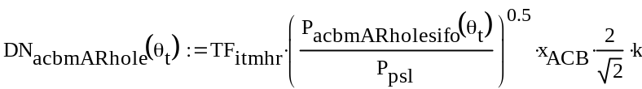
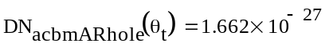

Scatter by Multilayer AR Coating on SS Center Plate Edge

Scatter from mAR-SS center plate edge
BRDF geometric scatter function from mAR-SS center plate edge

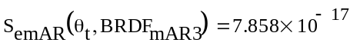
Scattered power into IFO from mAR-SS baffle center plate edge
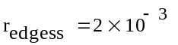
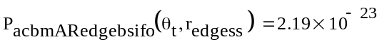

displacement noise @ 100 Hz, m/rtHz
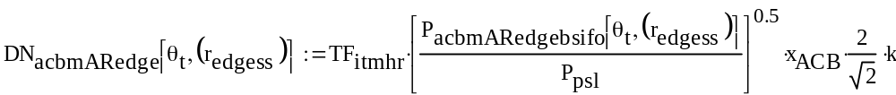
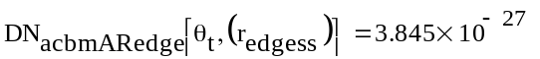

Scatter by Multilayer AR Coating on SS Louver Bend

BRDF geometric scatter function from mAR-SS baffle bend

Scattered power into IFO from mAR-SS baffle bend
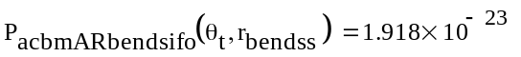

displacement noise @ 100 Hz, m/rtHz
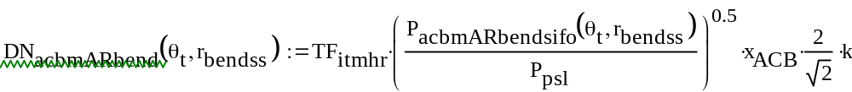
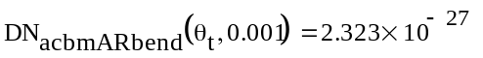

Scatter by Multilayer AR Coating on SS Louver Baffle Portion

Power Scattered from the mAR-SS louver portion of baffle
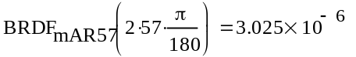
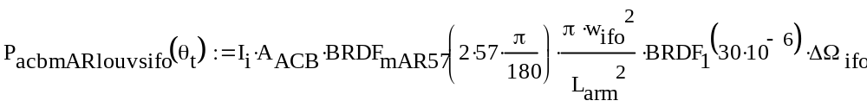
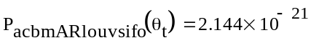

displacement noise @ 100 Hz, m/rtHz
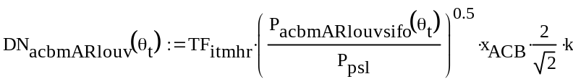
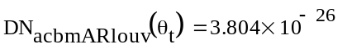

Scatter from Screw Heads
See section 2.2.1

Scatter from Photodetectors
See section 2.2.2

Total Scatter by Multilayer AR Coating on SS ACB

Reduce screw head BRDF by polishing so that louver dominates the scatter

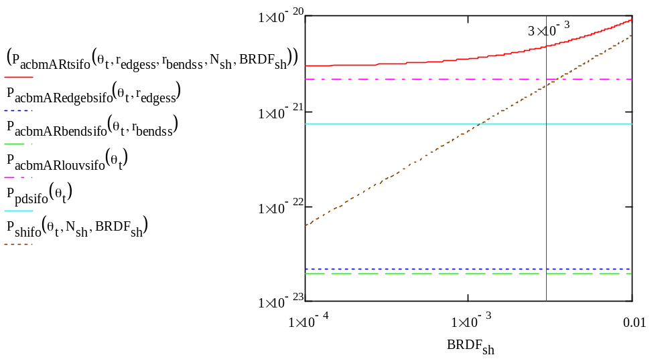
Figure 14: Total Scattered Power, W, by Multilayer AR Coating on SS ACB vs Screw Head BRDF, sr^-1

Note: the screw head BRDF must be < 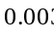 sr^-1 for louver scatter to dominate

Tilt the baffle so that edge scatter does not dominate

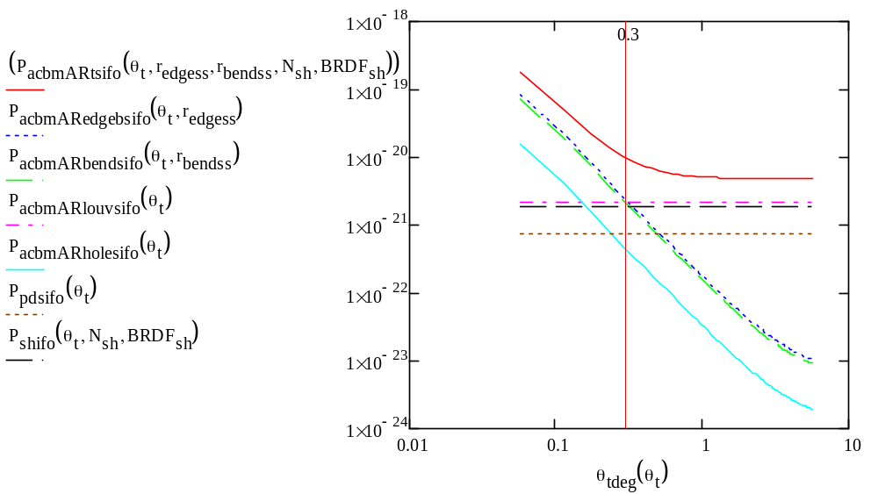
Figure 15: Total Scattered Power, W, by Multilayer AR Coating on SS ACB vs Tilt Angle, Deg
Note: the edge scatter does not dominate for tilt angles >0.3 deg

Figure 16: Total Scattered Power, W, by Multilayer AR Coating on SS ACB vs Center Plate Edge Radius, m
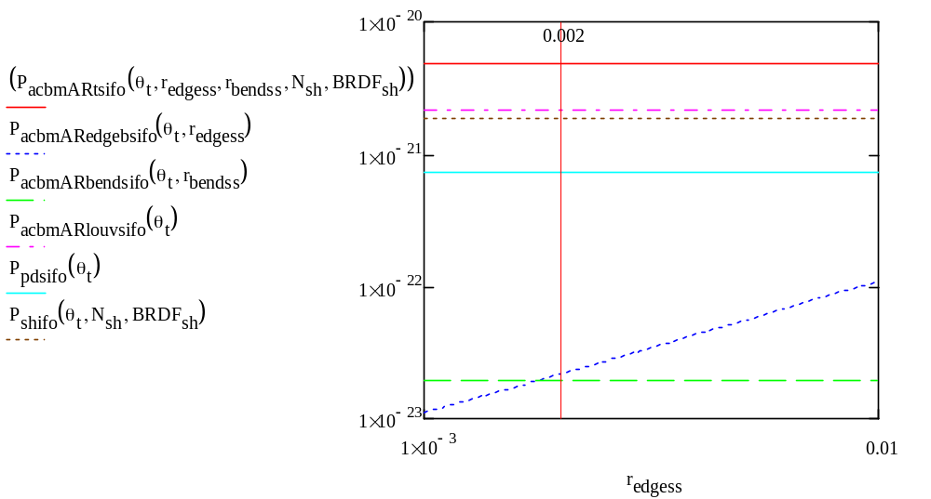

Note: the DLC edge scatter does not dominate for edge radius < 0.01 m
total displacement noise @ 100 Hz, m/rtHz
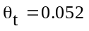
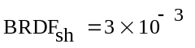

DLC Coating on Stainless Steel

BRDF and Reflectivity of DLC Coating
The incident angle of the light hitting the louver portion of the ACB is 57 deg, and the incident angle hitting the edge of the central plate and the hole of the baffle is centered at approximately 0 deg.
A DLC AR coating on SS was obtained from R. Takahashi of the KAGRA group. The
properties of this coating were previously reported by R. Takahashi et al. The film was deposited using direct current plasma chemical vapor deposition (CVD), 120 mA @ 500V.
The BRDF was measured for DLC coating on SS at incidence angles of 57 deg and 3 deg as a function of the angle away from the specular directions.

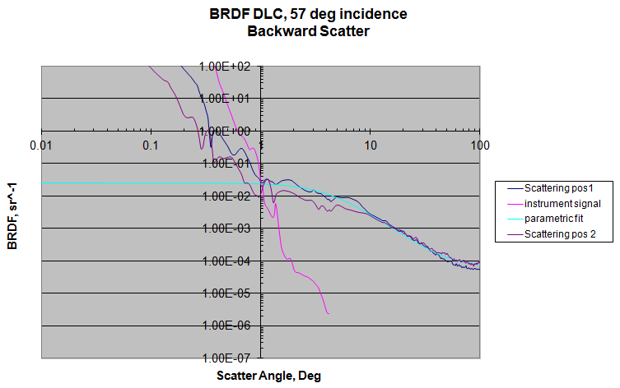

Figure 17: Measured BRDF Data, DLC Coating on SS, with Parametric Fit

The parametric curves shown below were fit to the CASI BRDF data.
The 5 deg data will be used for computing the normal incidence BRDF values. The BRDF data is approximately symmetrical for plus and minus angles about the specular direction.

Figure 18: Parametric DLC Coating BRDF Functions, as Best Fit to CASI Data
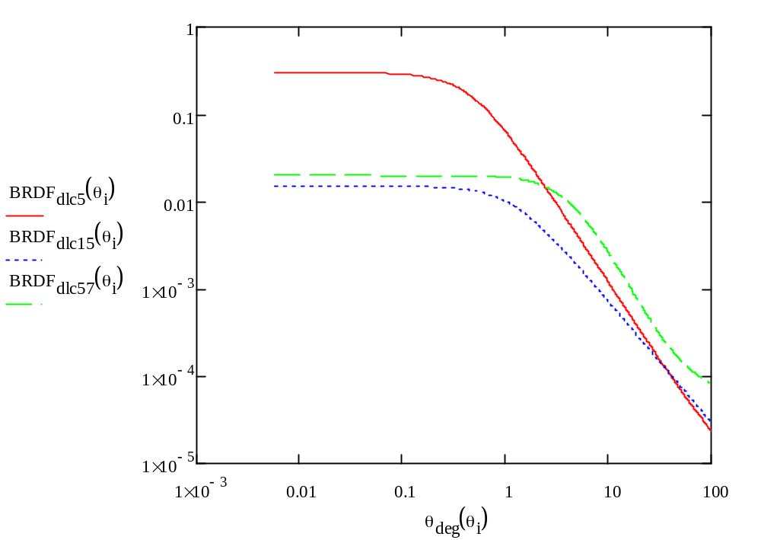

Back-scatter BRDF, sr^-1, as a function of incidence angle is presented below.

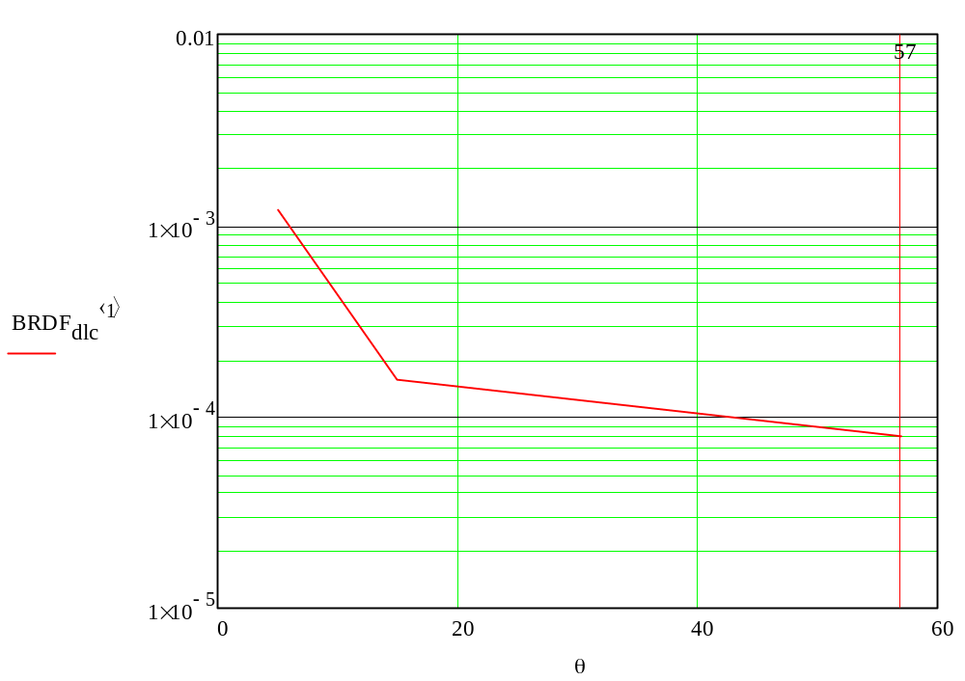
Figure 19: Backscatter BRDF, sr^-1, DLC Coating as a Function of Incidence Angle, Deg

Summary of reflectivity as a function of incidence angle is presented below.

Figure 20: Reflectivity DLC Coating as a Function of Incidence Angle, Deg
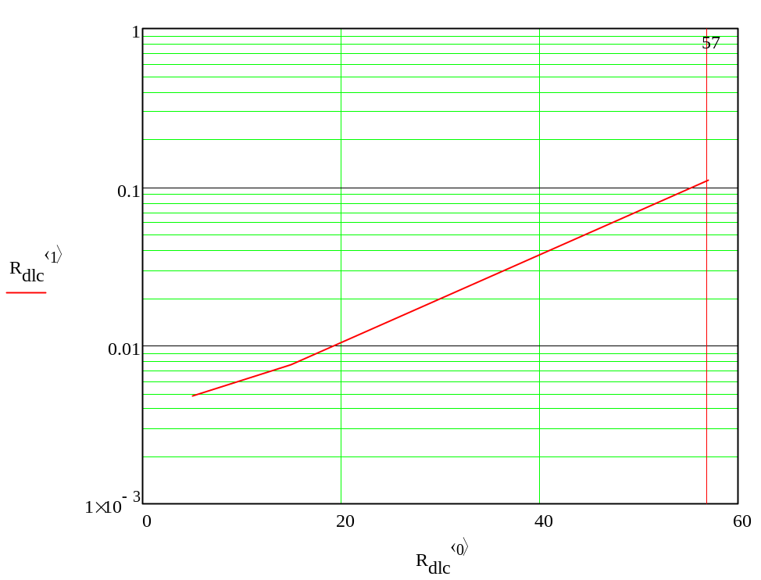

Scatter by DLC Coating on SS Baffle Hole Edge

Scatter from DLC SS baffle hole edge
BRDF geometric scatter function from baffle hole edge

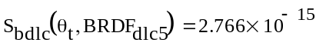
Scattered power into IFO from baffle hole edge
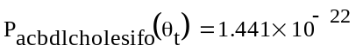

displacement noise @ 100 Hz, m/rtHz
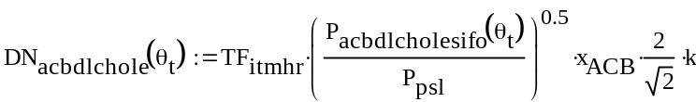
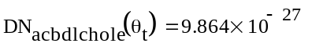

Scatter by DLC Coating on SS Center Plate Edge

Scatter from DLC-SS center plate edge
BRDF geometric scatter function from DLC-SS center plate edge

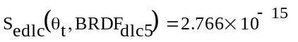
Scattered power into IFO from DLC-SS baffle center plate edge
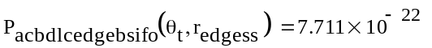

displacement noise @ 100 Hz, m/rtHz
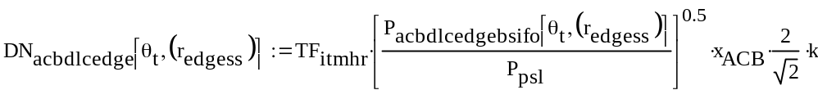
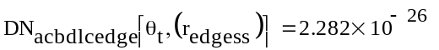

Scatter by DLC Coating on SS Baffle Bend

Scatter from DLC-SS baffle bend
BRDF geometric scatter function from DLC-SS baffle bend

Scattered power into IFO from DLC-SS baffle bend
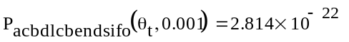

displacement noise @ 100 Hz, m/rtHz
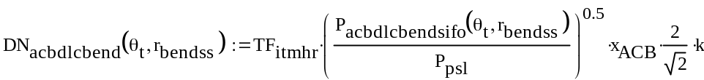
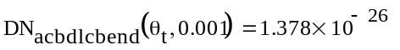

Scatter by DLC Coating on SS Louver Baffle Portion

Power Scattered from the DLC-SS louver portion of baffle
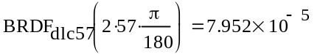
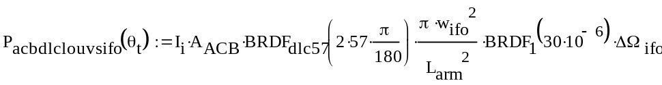
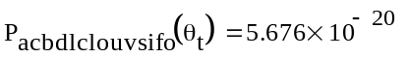

displacement noise @ 100 Hz, m/rtHz
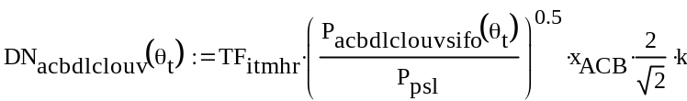
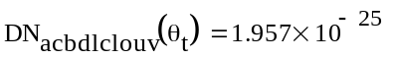

Scatter from Screw Heads
See section 2.2.2

Scatter from Photodetectors
See section 2.2.1.

Total Scatter by DLC Coating on SS ACB

Tilt the baffle so that edge scatter does not dominate

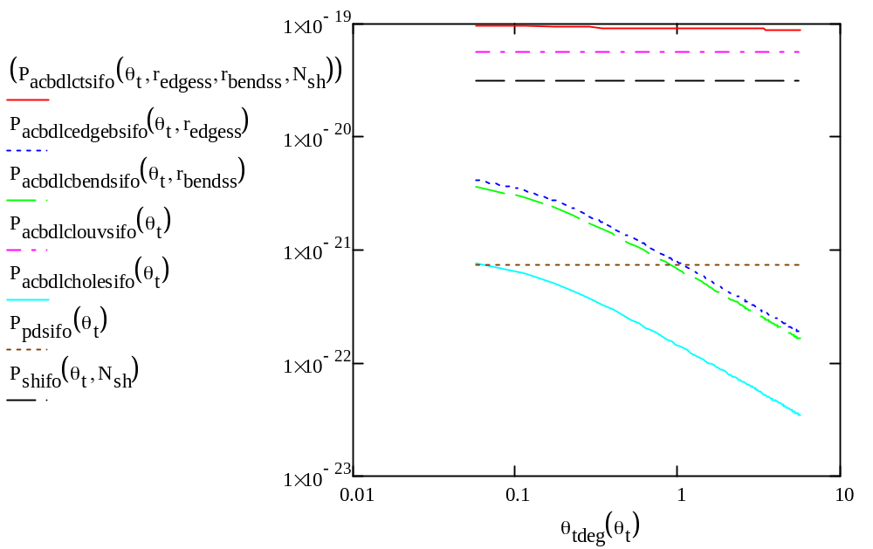
Figure 21: Total Scattered Power, W, by DLC Coating on SS ACB vs Tilt Angle, Deg

Note: the edge scatter does not dominate for tilt angles >1 deg
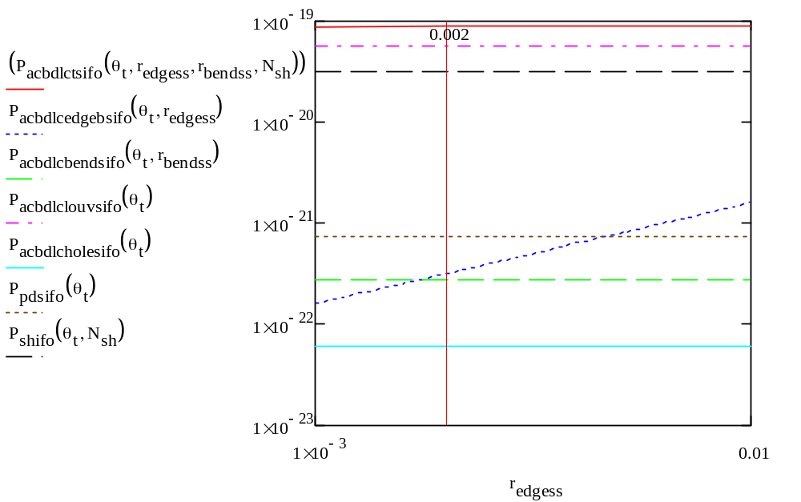
Figure 22: Total Scattered Power, W, by DLC Coating on SS ACB vs Center Plate Edge Radius, m

Note: the DLC edge scatter does not dominate for edge radius < 0.01 m

total displacement noise @ 100 Hz, m/rtHz

Conclusions

Comparison of Scattered Light Displacement Noise, m/rtHz from Multilayer AR Coating ACB and DLC Coating ACB with Default aLIGO Oxidized SS ACB

Comparison of mAR coated SS to oxidized SS baffle
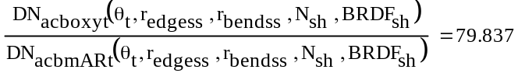

Comparison of DLC coated SS to oxidized SS baffle
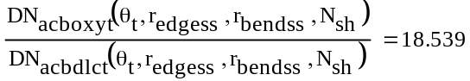

Based on measured BRDF data, a 19 times reduction in scattered light displacement noise could be achieved with the DLC coating, and an 80 times reduction in scattered light displacement noise could be obtained with the multilayer AR coating, in comparison with the default oxidized SS ACB.

Limiting Scattering Sources

Edge Scatter
The limiting scatter from the frontal edges of the baffle is effectively eliminated by tilting the baffle > 1 deg in the pitch direction.

Screw Head Scatter
Scatter from the three screw heads around the periphery of each photodetector is a limiting scattering source for the case of the multilayer AR coated SS. This limiting scattering source can be eliminated by polishing the surfaces of the flat screw heads to achieve a BRDF <0.003 sr^-1.

BRDF
The back-scatter BRDF at 57 deg incidence angle of the multilayer AR coating on SS is <1E-5 sr^-1 for p-polarization.

Reflectivity
The reflectivity at 57 deg incidence angle of the multilayer AR coating on SS is <1E-3 for both polarizations.

Reference Data

T1300716-v1_ACB Multi-AR coating on SS
T1300717-v1_BRDF Multi-AR SS 3 deg inc
T1300718-v1_BRDF Multi-AR SS 15 deg inc
T1300719-v1_BRDF Multi-AR SS 57 deg inc
T1300765-v1_BRDF Multi-AR SS 30 deg inc
T1300766-v1_BRDF Multi-AR SS 10 deg inc
T1300768-v1_DLC 5 deg inc
T1300767-v1_DLC 15 deg inc
T1300764-v1_DLC 57 deg inc

