LIGO Laboratory / LIGO Scientific Collaboration

LIGO- E1300828 LIGO Oct 31, 2013

aLIGO HEPI H1 HAM2
Assembly Validation Report

E1300828

Hugo Paris, Fabrice Matichard for the SEI Team

Distribution of this document:
Advanced LIGO Project

This is an internal working note
of the LIGO Laboratory

California Institute of Technology  LIGO Project – MS 18-34  1200 E. California Blvd.  Pasadena, CA 91125  Phone (626) 395-2129  Fax (626) 304-9834  E-mail: info@ligo.caltech.edu | Massachusetts Institute of Technology  LIGO Project – NW22-295  185 Albany St  Cambridge, MA 02139  Phone (617) 253-4824  Fax (617) 253-7014  E-mail: info@ligo.mit.edu
LIGO Hanford Observatory  P.O. Box 1970  Mail Stop S9-02  Richland WA 99352  Phone 509-372-8106  Fax 509-372-8137 | LIGO Livingston Observatory  P.O. Box 940  Livingston, LA 70754  Phone 225-686-3100  Fax 225-686-7189

Contents

1. Introduction 3
2. Sub-Components Testing 3
3. Load Cells assembly 3
4. Boot Location 4
5. Check Stops Gaps 4
6. Gaps check 5
7. IPS Centering 5
8. Sensor ASD 6
9. SUS-watchdogs interaction test 7
10. Static Test local drive 7
11. Linearity Test/Range of motion in the local basis 8
12. Actuator Plate to Shields gap 9
13. Valve Check 9
14. Local-to-local measurements 10
15. Alignment offsets: 12

Introduction

This document summarizes the steps to be done to validate HEPI assemblies. Corresponding reports must be posted in :

LIGO-E1300454: aLIGO HEPI Testing Reports

Sub-Components Testing

- Kaman Inductive Position Sensors: calibration, linearity, factory data, noise measurements (E0900426 – HEPI Kaman Sensor Receiving Analysis - Results posted in the SVN )
- HEPI actuator linearity test (E1100338 – aLIGO HEPI Actuators Test Results)
- L4C test (Q0900007)

Load Cells assembly

BSC HEPI load cell capacity → 3000 lbs
HAM HEPI load cell capacity → 2000 lbs

 | Left Spring (lbs) | Right Spring (lbs)
Pier 1
Pier 2
Pier 3
Pier 4

Acceptance criteria:
- The values must not exceed 80% of the load cell capacity (2400lbs for BSC and 1600lbs for HAM).

Test result: Passed: Failed: .

Boot Location

 | Pier 1 | Pier 2 | Pier 3 | Pier 4
Point 1a (Tangential)
Point 1b (Tangential)
Point 2a (Tangential)
Point 2b (Tangential)
Point 3 (Radial Back)
Point 4 (Radial Front)
Point 5 (Vertical)

 | Pier 1 | Pier 2 | Pier 3 | Pier 4
Point 1a (Tangential)
Point 1b (Tangential)
Point 2a (Tangential)
Point 2b (Tangential)
Point 3 (Radial Back)
Point 4 (Radial Front)
Point 5 (Vertical)

Acceptance criteria:

Test result: Passed: Failed: .

Check Stops Gaps
The stops must not touch the boot. There is 15 stops per boot, 5 per F bracket.

 | Bracket 1 |  |  |  |  |  | Bracket 2 |  |  |  |  |  | Bracket 3
 | Gap1 | Gap2 | Gap3 | Gap4 above | Gap4 under | Gap5 | Gap1 | Gap2 | Gap3 | Gap4 above | Gap4 under | Gap5 | Gap1 | Gap2 | Gap3 | Gap4 above | Gap4 under | Gap5
Pier 1
Pier 2
Pier 3
Pier 4

Test result: Passed: Failed:

Gaps check

Four particular gaps need to be check.

Acceptance criteria:
- a 0.08” shim must fit in these two gaps

Issues/difficulties/comments regarding this test: Gap#1 is tricky to reach. At LASTI, the solution found was to tape the shim to an extension (rod, rigid ruler, etc.).
Gap#2 should be reachable by hand.
Gap#3 and 4 are tricky, but should also be doable (no picture)

 | Gap#1 | Gap#2 | Gap#3 | Gap#4
Pier 1
Pier 2
Pier 3
Pier 4

Test result: Passed: Failed: .

IPS Centering

Scripts files for processing and plotting in SVN at:
/SeiSVN/seismic/HEPI/Common/Testing_Functions_HEPI/Offset_STD_IPS_HEPI.m

Data in SVN at:
/ligo/svncommon/SeiSVN/seismic/HEPI/H1/HAM2/Data/Static_Tests/
_IPS_Read_Back__20131031_15:23.mat

All the loops must be turned off during this test.

The test was performed on October 31st 2013, with HEPI Locked.

 | H1 | H2 | H3 | H4 | V1 | V2 | V3 | V4
Mean (counts) | 5801.1 | 771.1 | -1873.1 | -1737.9 | -3931 | -3650.1 | -1845.9 | -4244.2
Acceptance | +/- 15000 | +/- 15000 | +/- 15000 | +/- 15000 | +/- 15000 | +/- 15000 | +/- 15000 | +/- 15000

Test result: Passed: X Failed:

Sensor ASD
Scripts files for processing and plotting in SVN at:
/SeiSVN/seismic/HEPI/Common/Testing_Functions_HEPI/ASD_Measurements_Local_HEPI.m

Data in SVN at:
SeiSVN/seismic/HEPI/H1/HAM2/Data/Spectra/Undamped/
LHO_HPI_HAM2_ASD_m_IPS_L4C_2020_09_07_3 6:1:.mat

Figures in SVN at:
/SeiSVN/seismic/HEPI/H1/HAM2/Data/Figures/Spectra/Undamped/
LHO_HPI_HAM2_ASD_m_IPS_L4C_2020_09_07_3_6_1_.fig

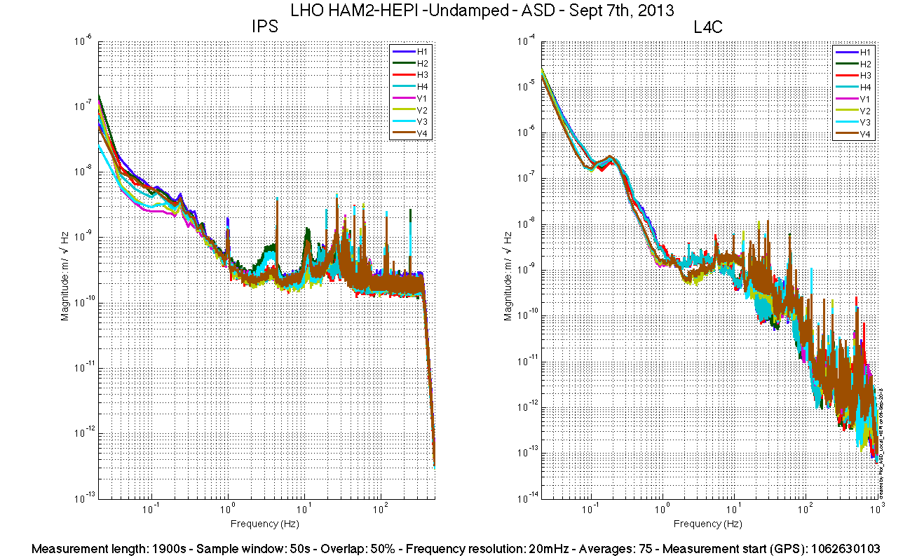

Issues/difficulties/comments regarding this test:
Measurements were performed with all PreFilters ON.

Acceptance criteria:

Test result: Passed: X Failed: .

SUS-watchdogs interaction test

This test will be obsolete very soon, as the payload-HEPI WD connection is planned for removal.
. Set up a zero value on the payload watchogs.
. Check that the payload watchdog screen of HEPI tripped.
. In the payload watchdog screen, click on the OVERRIDE button and reset the watchdog.
. Do the same process for all the payloads
Acceptance criteria:
- The HEPI must trip when the payload watchdogs are tripped
- The HEPI watchdogs could be reset when the OVERRIDE button is ON
Test result: Passed: Failed: .
When this test is done, reset everything (OVERRIDE button OFF, put back the value on the payload watchdog).

Static Test local drive
Scripts files for processing in SVN at:
/SeiSVN/seismic/HEPI/Common/Testing_Functions_HEPI/Static_Test_Local_Basis_HEPI.m

. Drive of 5000 counts
 | H1 | H2 | H3 | H4 | V1 | V2 | V3 | V4
H1 | 8350.9418 | -5056.1049 | -327.0384 | -1879.51872 | -178.9088 | 209.3388 | 192.18836 | -370.0864
H2 | -4104.049 | 8306.5349 | -1822.531974 | -448.11792 | 134.8916 | -100.465 | -301.80668 | 139.7868
H3 | -233.5984 | -2065.5751 | 8170.4572 | -4615.56692 | 178.7694 | -183.7838 | -239.1095 | 118.1154
H4 | -1807.7793 | -701.3897 | -4558.2268 | 9000.50088 | -488.2914 | 367.591 | -1.00976 | -441.0128
V1 | -87.0864 | 1.56718 | 302.0506 | -174.51156 | 7490.8344 | 918.82254 | -1656.35338 | 784.3534
V2 | 182.2748 | -404.56522 | -128.0876 | 486.57564 | 833.8752 | 7402.042 | 675.00182 | -1629.1482
V3 | 309.8688 | -477.33554 | -80.087 | 272.82164 | -1436.731 | 1099.12212 | 7236.42762 | 695.124
V4 | -177.839 | 74.78868 | 291.7698 | -126.46464 | 955.694 | -1414.8926 | 824.44686 | 7487.4108

Table - Main couplings and cross couplings

. Drive of 1000 counts
Table - Main couplings and cross couplings
. Drive of 2500 counts
Table - Main couplings and cross couplings

Issues/difficulties encountered during this test:
Drive of 1000 and 2500 counts were skipped. Static_Test_Local_Basis_HEPI.m drives at 5000 counts only.

Acceptance criteria:
- The results in these three tables must be the same (within xxx%)

Test result: Passed: X Failed: .

Linearity Test/Range of motion in the local basis
Scripts files for processing and plotting in SVN at:
/SeiSVN/seismic/HEPI/Common/Testing_Functions_HEPI/Linearity_Test_Awgstream_HEPI.m

Data in SVN at:
SeiSVN/seismic/HEPI/H1/HAM2/Data/Linearity_Test/ LHO_HPI_HAM2_Linearity_test_20130903T135532.mat

Figures in SVN at:
/SeiSVN/seismic/HEPI/H1/HAM2/Data/Figures/Linearity_Test/

 | Slopes | Offsets
H1 | 1.63 | 1800.40
H2 | 1.88 | -522.55
H3 | 1.63 | 1959.94
H4 | 1.76 | -177.98
V1 | 1.54 | -4082.29
V2 | 1.54 | -1558.79
V3 | 1.42 | -516.54
V4 | 1.56 | -5144.56

Issues/difficulties encountered during this test:
The autosave failed and the plots saved under the SVN are empty.

Acceptance criteria:

Test result: Passed: ? Failed: .

Actuator Plate to Shields gap

Perform this test ONLY if the range of motion test failed.

Three gaps per actuator need to be checked.
Acceptance criteria:
- A 0.1” shim must fit into the gap #1
- A 0.05 shim must fit into gap #2 and #3

 | Horizontal |  |  | Vertical
 | Gap #1 | Gap #2 | Gap #3 | Gap #1 | Gap #2 | Gap #3
Pier 1
Pier 2
Pier 3
Pier 4

Test result: Passed: Failed:

Valve Check
Scripts files for processing and plotting in SVN at:
/SeiSVN/seismic/HEPI/H1/HAM2/Scripts/Valve_Check/plot_valve_check.m

Data in SVN at:
SeiSVN/seismic/HEPI/H1/HAM2/Data/Spectra/Undamped/
/SeiSVN/seismic/HEPI/H1/HAM2/Scripts/Valve_Check

Figures in SVN at:
/SeiSVN/seismic/HEPI/H1/HAM2/Scripts/Valve_Check

Acceptance criteria:

Test result: Passed: Failed: .

Local-to-local measurements

Band (Hz) | Resolution | Amplitude | Nreps | Time (s) | Time (min) | Time (h)
500-1000 |  | 4000 – 4000* | 250 | 4176* | 4176 | 1*
100 - 500 | 0.5 | 4000 – 4000* | 250 | 4176* | 69.6 | 1.2*
10 - 100 | 0.25 | 4000 – 4000* | 200 | 6592* | 109.9 | 1.8*
0.7 - 10 | 0.05 | 4000 – 4000* | 75 | 12320* | 205.3 | 3.4*
0.1 - 0.7 | 0.025 | 4000 – 4000* | 30 | 10080* | 168.0 | 2.8*
0.01 - 0.1 | 0.01 | 4000 – 4000* | 10 | 8960* | 149.3 | 2.5*
0.002 - 0.01 | 0.002 | 4000 – 4000* | 2 | 12160* | 202.7 | 3.4*
 |  |  |  |  |  | 16.1*
*: Values Need to be updated

Data files in SVN at:
/SeiSVN/seismic/HEPI/H1/HAM2/Data/Transfer_Functions/Measurements/Undamped/
- LHO_HPI_HAM2_Data_L2L_500Hz_1000Hz_20130903-153845.mat
- LHO_HPI_HAM2_Data_L2L_100Hz_500Hz_20130903-175509.mat
- LHO_HPI_HAM2_Data_L2L_10Hz_100Hz_20130903-190426.mat
- LHO_HPI_HAM2_Data_L2L_700mHz_10Hz_20130904-164150.mat
- LHO_HPI_HAM2_Data_L2L_100mHz_700mHz_20130904-200912.mat
- LHO_HPI_HAM2_Data_L2L_10mHz_100mHz_20130904-230152.mat
- LHO_HPI_HAM2_Data_L2L_2mHz_10mHz_20130905-014352.mat'

Data is called by Case #2 of:
/ligo/svncommon/SeiSVN/seismic/HEPI/H1/HAM2/Data/Figures/Transfer_Functions/Measurements/
Measurements_List_H1_HPI_HAM2.m

Data collection script files:
/SeiSVN/seismic/HEPI/Common//Transfer_Function_Scripts/
- Run_TF_L2L_10mHz_100mHz.m
- Run_TF_L2L_100mHz_500mHz.m
- Run_TF_L2L_500mHz_5Hz.m
- Run_TF_L2L_5Hz_100Hz.m
- Run_TF_L2L_100Hz_1000Hz.m
Scripts files for processing and plotting in SVN at:
/SeiSVN/seismic/HEPI/H1/HAM2/Scripts/Control_Scripts/release/
- Step_1_TF_Loc_to_Loc_H1_HEPI_HAM2.m
Figures in SVN at:
/SeiSVN/seismic/HEPI/H1/HAM2/Data/ Figures/Transfer_Functions/Measurements/Undamped/
- H1_HPI_HAM2_TF_L2L_Raw_from_ACT_to_IPS_2013_09_04.fig
- H1_HPI_HAM2_TF_L2L_Raw_from_ACT_to_IPS_2013_09_04.fig
Storage of measured transfer functions in the SVN at:
/SeiSVN/seismic/HEPI/H1/HAM2/Data/Transfer_functions/ Simulations/Undamped/
- H1_HPI_HAM2_TF_L2L_Sym_2013_09_04.mat

The local-to-local transfer functions are presented below.

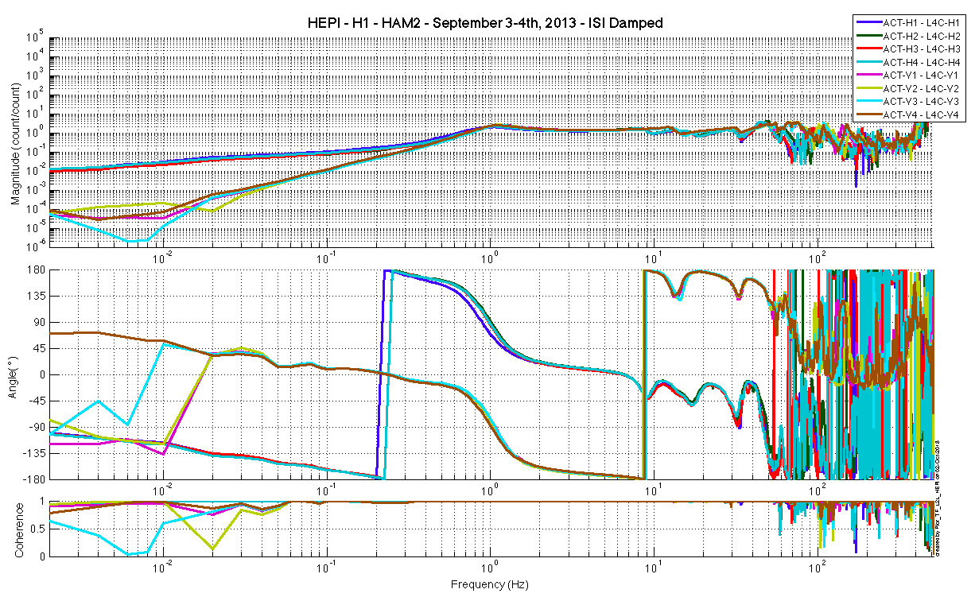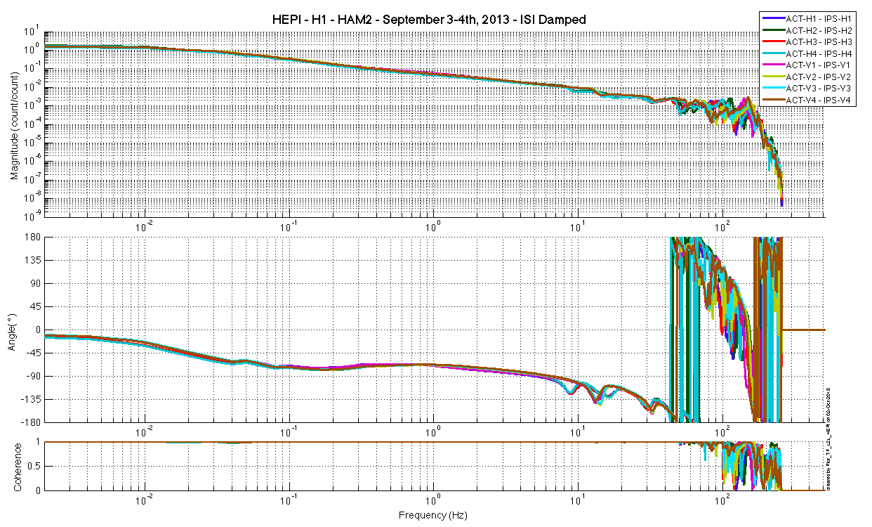
Issues/difficulties/comments regarding this test:

Acceptance criteria:
- On IPS, the phase must be 0º at DC
- On geophones, the phase must be 90º at DC
- Identical shape in each corner

Test result: Passed: X Failed: .

Alignment offsets:
Those are the IPS readouts that were recorded with HEPI locked, after aligment work was performed. The opposite of those values is to be installed as offset of the IPS filter banks when the Isolation loops are turned on. This way, HEPI will be operating in its preferred alignment state.

 | IPS Readouts HEPI Locked | Offset Value
H1 | 1331.1 | -1331.1
H2 | 957.72 | -957.72
H3 | 2157.4 | -2157.4
H4 | -1303.6 | 1303.6
V1 | -2742.7 | 2742.7
V2 | -511.83 | 511.83
V3 | 1034 | -1034
V4 | -2882.9 | 2882.9
Issues/difficulties encountered during this test:
Offest were retrieved from LHO aLog # 7180

Acceptance criteria:
Offsets were recorded.

Test result: Passed: X Failed: .

