LIGO Laboratory / LIGO Scientific Collaboration

LIGO- E1300841-v2 LIGO Date (fixed)

aLIGO HEPI H1 ETMY
Assembly Validation Report

E1300841

Hugh Radkins, Hugo Paris, Fabrice Matichard for the SEI Team

Distribution of this document:
Advanced LIGO Project

This is an internal working note
of the LIGO Laboratory

California Institute of Technology  LIGO Project – MS 18-34  1200 E. California Blvd.  Pasadena, CA 91125  Phone (626) 395-2129  Fax (626) 304-9834  E-mail: info@ligo.caltech.edu | Massachusetts Institute of Technology  LIGO Project – NW22-295  185 Albany St  Cambridge, MA 02139  Phone (617) 253-4824  Fax (617) 253-7014  E-mail: info@ligo.mit.edu
LIGO Hanford Observatory  P.O. Box 1970  Mail Stop S9-02  Richland WA 99352  Phone 509-372-8106  Fax 509-372-8137 | LIGO Livingston Observatory  P.O. Box 940  Livingston, LA 70754  Phone 225-686-3100  Fax 225-686-7189

Contents

1.Introduction 4
2.Sub-Components Testing 4
3.Load Cells assembly--BSC10 4
4.Boot Location—Test Not Performed, HR 6
5.Check Stops Gaps—Test Not Performed, HR 7
6.Gaps check—Test Not Performed, HR 7
7.IPS Centering-BSC10 8
8.Sensor ASD 9
9.SUS-watchdogs interaction test—BSC10 Test not performed 10
10.Static Test local drive-BSC10 10
11.Linearity Test/Range of motion in the local basis 11
12.Actuator Plate to Shields gap—Test Not Performed, HR 12
13.Valve Check—BSC-10, Test Not Performed 13
14.Local-to-local measurements 13
15. Alignment offsets: 16

Introduction

This document summarizes the steps to be done to validate HEPI assemblies. Corresponding reports must be posted in :

LIGO-E1300454: aLIGO HEPI Testing Reports

Sub-Components Testing

- Kaman Inductive Position Sensors: calibration, linearity, factory data, noise measurements (E0900426 – HEPI Kaman Sensor Receiving Analysis - Results posted in the SVN )
- HEPI actuator linearity test (E1100338 – aLIGO HEPI Actuators Test Results)
- L4C test (Q0900007)

Load Cells assembly--BSC10

BSC HEPI load cell capacity → 3000 lbs
HAM HEPI load cell capacity → 2000 lbs

 | Left Spring (lbs) | Right Spring (lbs)
Pier 1 | 1900 | 2110
Pier 2 | 2185 | 2090
Pier 3 | 2145 | 2260
Pier 4 | 1990 | 2250

Acceptance criteria:
- The values must not exceed 80% of the load cell capacity (2400lbs for BSC and 1600lbs for HAM).

Test result: Passed: X Failed: .

Boot Location—Test Not Performed, HR

 | Pier 1 | Pier 2 | Pier 3 | Pier 4
Point 1a (Tangential)
Point 1b (Tangential)
Point 2a (Tangential)
Point 2b (Tangential)
Point 3 (Radial Back)
Point 4 (Radial Front)
Point 5 (Vertical)

 | Pier 1 | Pier 2 | Pier 3 | Pier 4
Point 1a (Tangential)
Point 1b (Tangential)
Point 2a (Tangential)
Point 2b (Tangential)
Point 3 (Radial Back)
Point 4 (Radial Front)
Point 5 (Vertical)

Acceptance criteria:

Test result: Passed: Failed: .

Check Stops Gaps—Test Not Performed, HR
The stops must not touch the boot. There is 15 stops per boot, 5 per F bracket.

 | Bracket 1 | Bracket 2 | Bracket 3
 | Gap1 | Gap2 | Gap3 | Gap4 above | Gap4 under | Gap5 | Gap1 | Gap2 | Gap3 | Gap4 above | Gap4 under | Gap5 | Gap1 | Gap2 | Gap3 | Gap4 above | Gap4 under | Gap5
Pier 1
Pier 2
Pier 3
Pier 4

Test result: Passed: Failed:

Gaps check—Test Not Performed, HR

Four particular gaps need to be check.

Acceptance criteria:
- a 0.08” shim must fit in these two gaps

Issues/difficulties/comments regarding this test: Gap#1 is tricky to reach. At LASTI, the solution found was to tape the shim to an extension (rod, rigid ruler, etc.).
Gap#2 should be reachable by hand.
Gap#3 and 4 are tricky, but should also be doable (no picture)

 | Gap#1 | Gap#2 | Gap#3 | Gap#4
Pier 1
Pier 2
Pier 3
Pier 4

Test result: Passed: Failed: .

IPS Centering-BSC10

Scripts files for processing and plotting in SVN at:
/SeiSVN/seismic/HEPI/Common/Testing_Functions_HEPI/
Offset_STD_IPS_Readback_HEPI.m

Data in SVN at:
/ligo/svncommon/SeiSVN/seismic/HEPI/H1/ETMY/Data/Static_Tests/
LHO_HPI_ETMY_IPS_Read_Back_Unlocked_20140312_11:30.mat

All the loops must be turned off during this test.

 | H1 | H2 | H3 | H4 | V1 | V2 | V3 | V4
Mean (counts) | -335 | -252 | -281 | -293 | 129 | 136 | 69 | 283
Acceptance | +/- 15000 | +/- 15000 | +/- 15000 | +/- 15000 | +/- 15000 | +/- 15000 | +/- 15000 | +/- 15000

Test result: Passed: X Failed:

Sensor ASD
Scripts files for processing and plotting in SVN at:
/SeiSVN/seismic/HEPI/Common/Testing_Functions_HEPI/ASD_Measurements_Local_HEPI.m

Data in SVN at:
SeiSVN/seismic/HEPI/H1/ETMY/Data/Spectra/Undamped/
H1_HPI_BSC10_ASD_m_IPS_L4C_20140318_08:04:50.mat
Figures in SVN at:
/SeiSVN/seismic/HEPI/H1/ETMY/Data/Figures/Spectra/Undamped/
H1_HPI_BSC10_ASD_m_IPS_L4C_20140318_08:04:50.fig
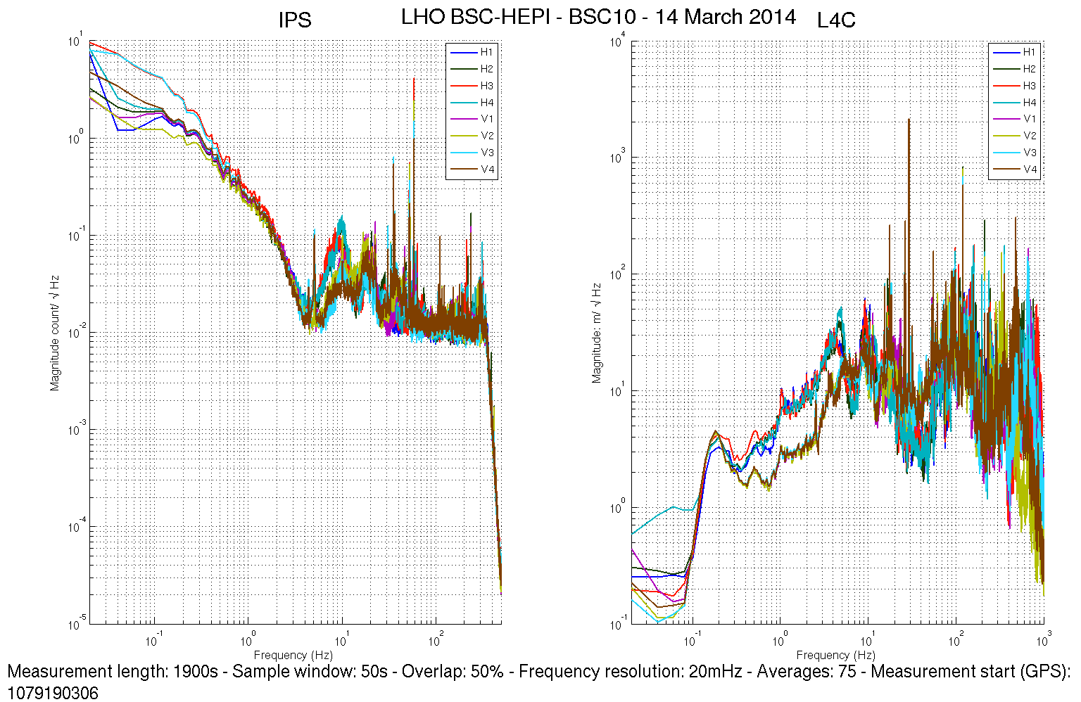

Issues/difficulties/comments regarding this test:
Measurements were performed with ISI Lock.

Acceptance criteria: ??????

Test result: Passed: ? Failed: .

SUS-watchdogs interaction test—BSC10 Test not performed

This test will be obsolete very soon, as the payload-HEPI WD connection is planned for removal.
. Set up a zero value on the payload watchogs.
. Check that the payload watchdog screen of HEPI tripped.
. In the payload watchdog screen, click on the OVERRIDE button and reset the watchdog.
. Do the same process for all the payloads
Acceptance criteria:
- The HEPI must trip when the payload watchdogs are tripped
- The HEPI watchdogs could be reset when the OVERRIDE button is ON
Test result: Passed: Failed: .
When this test is done, reset everything (OVERRIDE button OFF, put back the value on the payload watchdog).

Static Test local drive-BSC10
Scripts files for processing in SVN at:
/SeiSVN/seismic/HEPI/Common/Testing_Functions_HEPI/Static_Test_Local_Basis_HEPI.m
Data File: /SeiSVN/seismic/HEPI/H1/ETMY/Data/Static_tests/
LHO_HPI_BSC10_Offset_Local_Drive_20140313.mat

. Drive of 5000 counts
 | H1 | H2 | H3 | H4 | V1 | V2 | V3 | V4
H1 | 9811 | -3311 | -821 | -3436 | -74 | -239 | 78 | 112
H2 | -3051 | 9704 | -3725 | -755 | -193 | 144 | 202 | 50
H3 | -737 | -3358 | 9810 | -3162 | 72 | 56 | -88 | -256
H4 | -3396 | -771 | -3409 | 9894 | 159 | 77 | -302 | -58
V1 | -104 | -160 | 84 | 176 | 6810 | 1449 | -1794 | 1037
V2 | -236 | 182 | 47 | 64 | 1510 | 7036 | 1046 | -1836
V3 | 132 | 243 | -100 | -279 | -1803 | 1088 | 6788 | 1402
V4 | 168 | 103 | -299 | -5 | 1196 | -1960 | 1554 | 7382
Table - Main couplings and cross couplings

Issues/difficulties encountered during this test:

Acceptance criteria:

Test result: Passed: X Failed: .

Linearity Test/Range of motion in the local basis
Ran Range of Motion Script and it reported 'Short Range of Motion on V2'
However, the data viewer suggests all the IPS respond very similarly and I'd say the script is not evaluating this properly. Using possibly an old version (Vincent era, from H2 ETMy.)
Scripts files for processing and plotting in SVN at:
/SeiSVN/seismic/HEPI/Common/Testing_Functions_HEPI/Linearity_Test_Awgstream_HEPI.m
Data in SVN at:
SeiSVN/seismic/HEPI/H1/ETMY/Data/Linearity_Test/ LHO_HPI_BSC10_Linearity_test_20140319T115413.mat
Figures in SVN at:
/SeiSVN/seismic/HEPI/H1/ETMY/Data/Figures/Linearity_Test/
 | Slopes | Offsets
H1 | 1.910 | -757
H2 | 2.081 | 2180
H3 | 2.071 | -837
H4 | 2.003 | 8
V1 | 1.383 | 529
V2 | 1.409 | 911
V3 | 1.526 | 358
V4 | 1.425 | 837
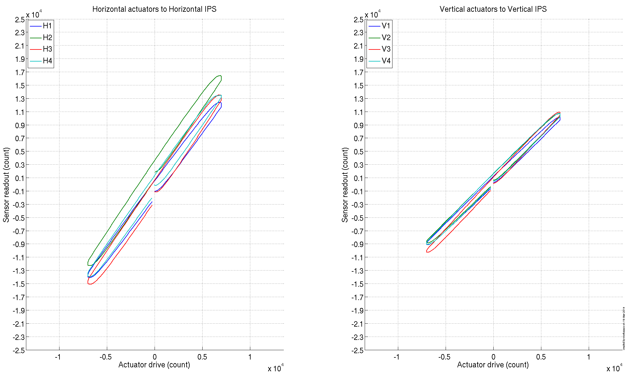

Issues/difficulties encountered during this test:
Acceptance criteria:
- ???????

Test result: Looks Good Passed: ? Failed: .

Actuator Plate to Shields gap—Test Not Performed, HR

Perform this test ONLY if the range of motion test failed.

Three gaps per actuator need to be checked.
Acceptance criteria:
- A 0.1” shim must fit into the gap #1
- A 0.05 shim must fit into gap #2 and #3

 | Horizontal | Vertical
 | Gap #1 | Gap #2 | Gap #3 | Gap #1 | Gap #2 | Gap #3
Pier 1
Pier 2
Pier 3
Pier 4

Test result: Passed: Failed:

Valve Check—BSC-10, Test Not Performed
Scripts files for processing and plotting in SVN at:
/SeiSVN/seismic/HEPI/H1//Scripts/Valve_Check/plot_valve_check.m

Data in SVN at:
SeiSVN/seismic/HEPI/H1//Data/Spectra/Undamped/
/SeiSVN/seismic/HEPI/H1//Scripts/Valve_Check

Figures in SVN at:
/SeiSVN/seismic/HEPI/H1//Scripts/Valve_Check

Acceptance criteria: ????

Test result: Passed: Failed: .

Local-to-local measurements

Band (Hz) | Res | Amplitude | Nreps | Time (s) | Time (min) | Time (h)
500-1000 | 0.25 | 1.0x1500 – 1500 | 250 | 4176* | 69.6 | 1*
100 - 500 | 0.5 | 1.0x4000 – 4000 | 250 | 4176* | 69.6 | 1.2*
10 - 100 | 0.25 | 1.0x4000 – 4000 | 200 | 6592* | 109.9 | 1.8*
0.7 - 10 | 0.05 | 1.0x4000 – 4000 | 75 | 12320* | 205.3 | 3.4*
0.1 - 0.7 | 0.025 | 1.0x4000 – 4000 | 30 | 10080* | 168.0 | 2.8*
0.01 - 0.1 | 0.01 | 1.0x4000 – 4000 | 10 | 8960* | 149.3 | 2.5*
0.002 - 0.01 | 0.002 | 1.0x4000 – 4000 | 2 | 12160* | 202.7 | 3.4*
 |  |  |  |  |  | 16.1*
*: Values Need to be updated

Data files in SVN at:
/SeiSVN/seismic/HEPI/H1/ETMY/Data/Transfer_Functions/Measurements/Undamped/
LHO_HPI_BSC10_Data_L2L_2mHz_10mHz_20140322-071150.mat
LHO_HPI_BSC10_Data_L2L_10mHz_100mHz_20140322-042942.mat
LHO_HPI_BSC10_Data_L2L_100mHz_700mHz_20140322-013656.mat
LHO_HPI_BSC10_Data_L2L_700mHz_10Hz_20140321-220929.mat
LHO_HPI_BSC10_Data_L2L_10Hz_100Hz_20140321-201940.mat
LHO_HPI_BSC10_Data_L2L_100Hz_500Hz_20140321-191021.mat
LHO_HPI_BSC10_Data_L2L_500Hz_1000Hz_20140321-165354.mat

Data is called by Case #4 of:
/ligo/svncommon/SeiSVN/seismic/HEPI/H1/ETMY/Data/Transfer_Functions/Measurements/
Undamped/Measurements_List_H1_HPI_ETMY.m

Data collection script files:
/SeiSVN/seismic/HEPI/Common//Transfer_Function_Scripts/
- Run_TF_L2L_500Hz_1000Hz_HEPI.m
- Run_TF_L2L_100Hz_500Hz_HEPI.m
- Run_TF_L2L_10Hz_100Hz_HEPI.m
- Run_TF_L2L_700mHz_10Hz_HEPI.m
- Run_TF_L2L_100mHz_700mHz_HEPI.m
- Run_TF_L2L_10mHz_100mHz_HEPI.m
- Run_TF_L2L_2mHz_10mHz_HEPI.m
Scripts files for processing and plotting in SVN at:
/SeiSVN/seismic/HEPI/H1/ETMY/Scripts/Control_Scripts/Version_5/
- Step_1_TF_Loc_to_Loc_H1_HEPI_ETMY.m
Figures in SVN at:
/SeiSVN/seismic/HEPI/H1/ETMY/Data/ Figures/Transfer_Functions/Measurements/Undamped/
- H1_HPI_ETMY_TF_L2L_Raw_from_ACT_to_IPS_2014_03_21.fig
- H1_HPI_ETMY_TF_L2L_Raw_from_ACT_to_L4C_2014_03_21.fig
Storage of measured transfer functions in the SVN at:
/SeiSVN/seismic/HEPI/H1/ETMY/Data/Transfer_Functions/Simulations/Undamped/
- H1_HPI_ETMY_TF_L2L_Raw_2014_03_21.mat

The local-to-local transfer functions are presented below.

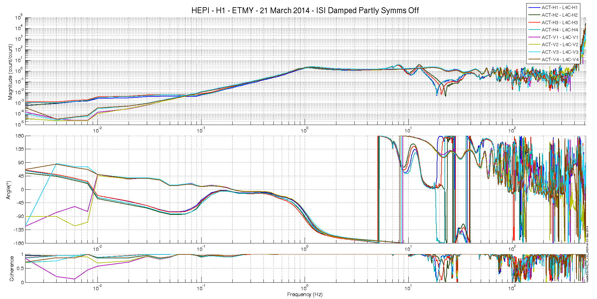

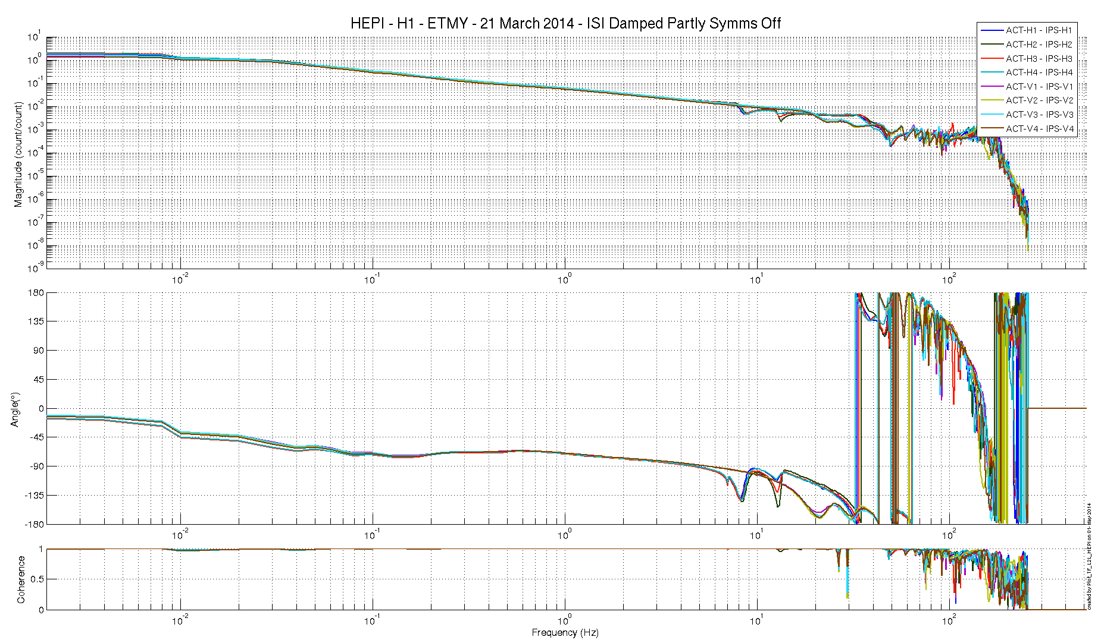

Issues/difficulties/comments regarding this test: – BSC10, SYM filters on—this may be an issue? Also, started ISI damped but Stage2 tripped at the beginning of the H1 .7—10Hz band, and Stage1 tripped during the V2 2-10mHz TF. Will rerun w/o sym filter if possible.
Version2-- Updating TFs with Symm filters off.

Acceptance criteria:
- On IPS, the phase must be 0º at DC
- On geophones, the phase must be 90º at DC—Not sure if this is true, HR
- Identical shape in each corner

Test result: Passed: X Failed: .

Alignment offsets:
Those are the IPS readouts that were recorded, after alignment work was performed—These numbers would nominally be all zero because after alignment and we attached the actuator and got a confirm that alignment was good, the IPS would be set to zero. However, once testing commences, the platforms will settle more, splay out if you will etc.
The numbers below are with the platform now in its nominal alignment and where the system operates. These values are good for the performance of the IPS. Much above 15000 would start to approach badness where the response loses linearity

 | IPS Readouts HEPI Isolated | Cartesian DOF | TARGET
H1 | -2575 | X | 145400
H2 | 2020 | Y | 29500
H3 | 1650 | Z | -144800
H4 | -4360 | RX | -10900
V1 | -4060 | RY | 8400
V2 | -2650 | RZ | 6700
V3 | -2640 | HP | -24200
V4 | -2450 | VP | -9900
Issues/difficulties encountered during this test:
Readings were retrieved from medms 9 Feb 2015.

Acceptance criteria:
Values near and certainly above 15000 should be reduced by centering or other action.

Test result: Passed: X Failed: .

