LIGO Laboratory / LIGO Scientific Collaboration

LIGO- E1300929 LIGO December 9th, 2013

aLIGO HEPI L1 BS (BSC2) Assembly Validation Report
E1300929

Joe Hanson, Jeremy Birch, Michael Vargas, Rich Mittleman, Ryan DeRosa, Céline Ramet for the SEI Team

Distribution of this document:
Advanced LIGO Project

This is an internal working note
of the LIGO Laboratory

California Institute of Technology  LIGO Project – MS 18-34  1200 E. California Blvd.  Pasadena, CA 91125  Phone (626) 395-2129  Fax (626) 304-9834  E-mail: info@ligo.caltech.edu | Massachusetts Institute of Technology  LIGO Project – NW22-295  185 Albany St  Cambridge, MA 02139  Phone (617) 253-4824  Fax (617) 253-7014  E-mail: info@ligo.mit.edu
LIGO Hanford Observatory  P.O. Box 1970  Mail Stop S9-02  Richland WA 99352  Phone 509-372-8106  Fax 509-372-8137 | LIGO Livingston Observatory  P.O. Box 940  Livingston, LA 70754  Phone 225-686-3100  Fax 225-686-7189

Contents
Contents 2
Introduction 3
Sub-Components Testing 4
Assembly Validation 4
1.1 Load Cells assembly 4
1.2 Bellows 5
1.3 Boot Location 5
1.4 Check Stops Gaps 5
1.5 Gaps check 5
1.6 IPS Centering 6
1.7 Sensor ASD 6
1.8 SUS-watchdogs interaction test 9
1.9 Static Test local drive 9
1.10 Linearity Test/Range of motion in the local basis 11
1.11 Actuator Plate to Shields gap 12
1.12 Valve Check 13
1.13 Local-to-local measurements 14
1.14 Alignment offsets: 17
Conclusion 18

\

Introduction

This document summarizes the tests done to validate the HEPI L1 BS (BSC2) assembly. As all L1 HEPI BSC, it had been installed since 2004 at Livingston. However, it had been grounded for the 2 to 3 years of aLIGO install. All electronics has been updated since, and more importantly, the position of the BS support tubes (i.e. the position of the HEPI BS boot), as well as the position of all 4 housings, were adjusted to accommodate the position needed for aLIGO alignment. Those adjustments were completed in May 2013.

Sub-Components Testing
- Kaman Inductive Position Sensors: calibration, linearity, factory data, noise measurements (E0900426 – HEPI Kaman Sensor Receiving Analysis - Results posted in the SVN )
The IPS sensors on this chamber haven’t been changed since original installation in 2004. No specific individual testing had been done then or since.
- HEPI actuator linearity test (E1100338 – aLIGO HEPI Actuators Test Results)
The HEPI actuators on this chamber haven’t been changed since original installation in 2004. No specific individual testing had been done then or since.
- L4C test (Q0900007)
The L4C sensors on this chamber haven’t been changed since their original installation in 2004, with the exception of H1. No specific individual testing had been done at the time or since on the “old units”. The new units were tested but unfortunately that data was not properly recorded.

Assembly Validation

Load Cells assembly
- Spring attachment
For the BSC HEPI springs, check the assembly per D030320-v4. See LLO aLOG 7162 for more details.
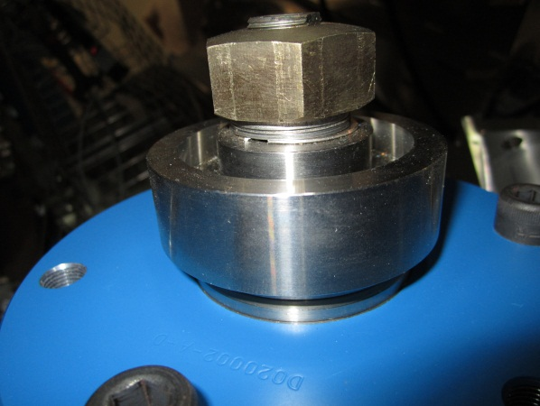
- Load cell values
BSC HEPI load cell capacity → 3000 lbs

 | Spring | Left Spring (lbs)
Pier 1 | 1 | 2137
 | 2 | 2053
Pier 2 | 3 | 2245
 | 4 | 2223
Pier 3 | 5 | 1238
 | 6 | 2027
Pier 4 | 7 | 1893
 | 8 | 2241

Acceptance criteria:
- The values must not exceed 80% of the load cell capacity (2400lbs for BSC and 1600lbs for HAM).

Test result: Passed: X Failed: .

Bellows

The bellows are hard to access and tests are hard to proceed. After several discussions and brainstorming sessions, it has been decided not to measure the gaps on HEPI-HAM and HEPI-BSC.

Test result: Passed: X Failed: Waived: _ X_

Boot Location

Test result: Passed: X Failed: Waived: _ X_

Check Stops Gaps
The stops must not touch the boot.
If the valve check test is a success, we are sure there is no touching against the boot.
Test result: Passed: X Failed:

Gaps check
If the valve check test is a success, we are sure there is no touching against the boot.

Test result: Passed: X Failed: .

IPS Centering
Scripts files for processing and plotting in SVN at:
/SeiSVN/seismic/HEPI/Common/Testing_Functions_HEPI/Offset_STD_IPS_HEPI.m

All the loops must be turned off during this test.

 | H1 | H2 | H3 | H4 | V1 | V2 | V3 | V4
Mean (counts)
Acceptance | +/- 15000 | +/- 15000 | +/- 15000 | +/- 15000 | +/- 15000 | +/- 15000 | +/- 15000 | +/- 15000

Test result: Passed: X Failed:

Sensor ASD
Scripts files for processing and plotting in SVN at:
/SeiSVN/seismic/HEPI/L1/BS/Scripts/Perf_Analysis/

Data in SVN at:
SeiSVN/seismic/HEPI/L1/BS/Data/Figures/Perf_Analysis/2013-06-20-Level2/
L1_HPI_BS_Test_1_2013-06-20-Level2.mat

Figures in SVN at:
/SeiSVN/seismic/HEPI/L1/BS/Data/Figures/Perf_Analysis/2013-06-20-Level2/
- HEPI_L1_BS_Test_1_Fig_a_HPI_L4C_Hor_2013-06-20-Level2.fig
- HEPI_L1_BS_Test_1_Fig_b_HPI_L4C_Vert_2013-06-20-Level2.fig
- HEPI_L1_BS_Test_1_Fig_c_HPI_IPS_Hor_2013-06-20-Level2.fig
- HEPI_L1_BS_Test_1_Fig_d_HPI_IPS_Vert_2013-06-20-Level2.fig

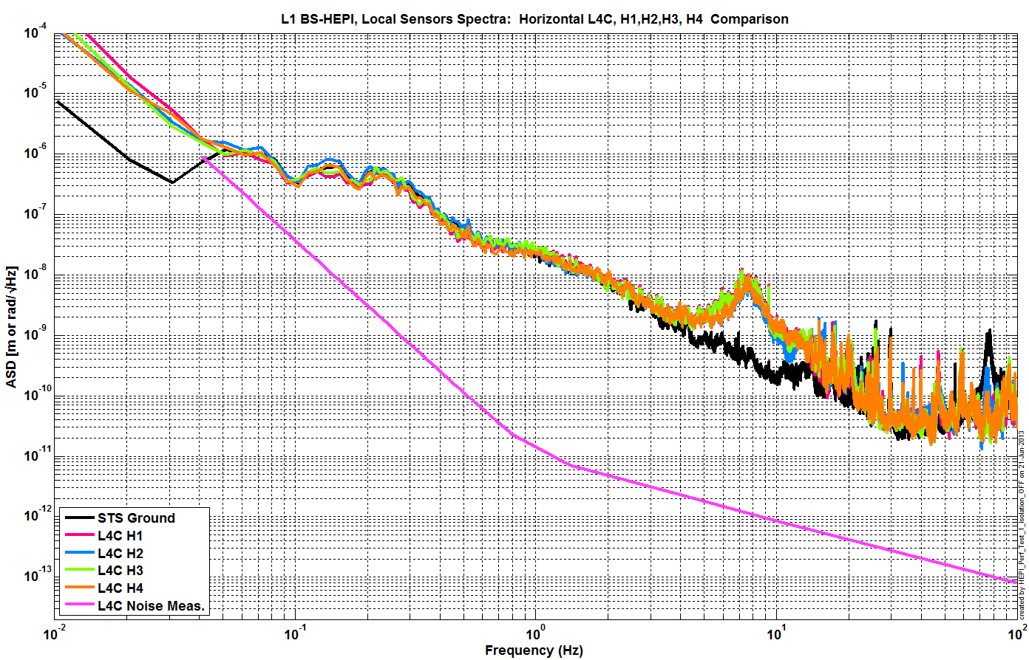
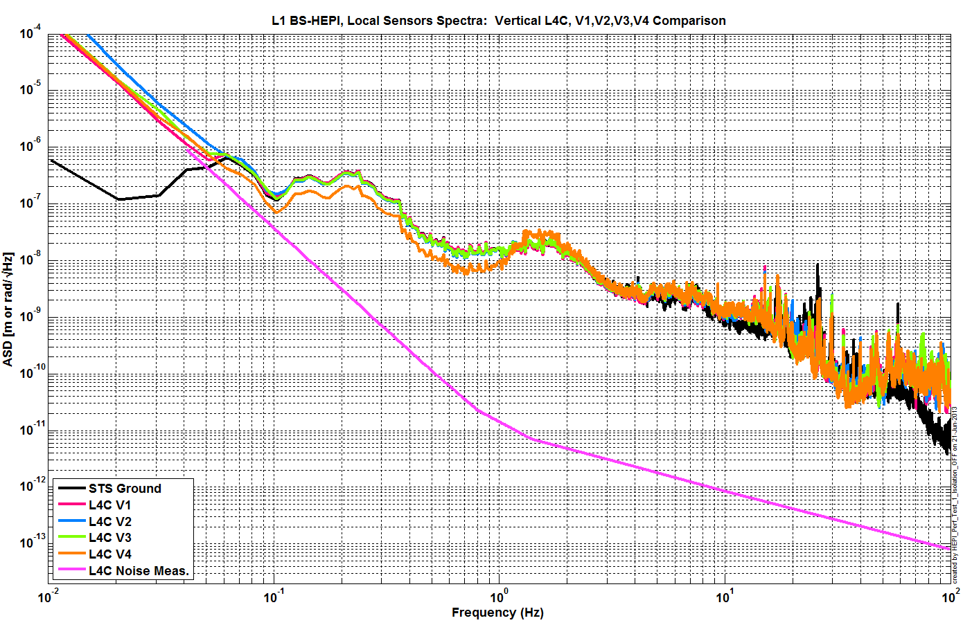
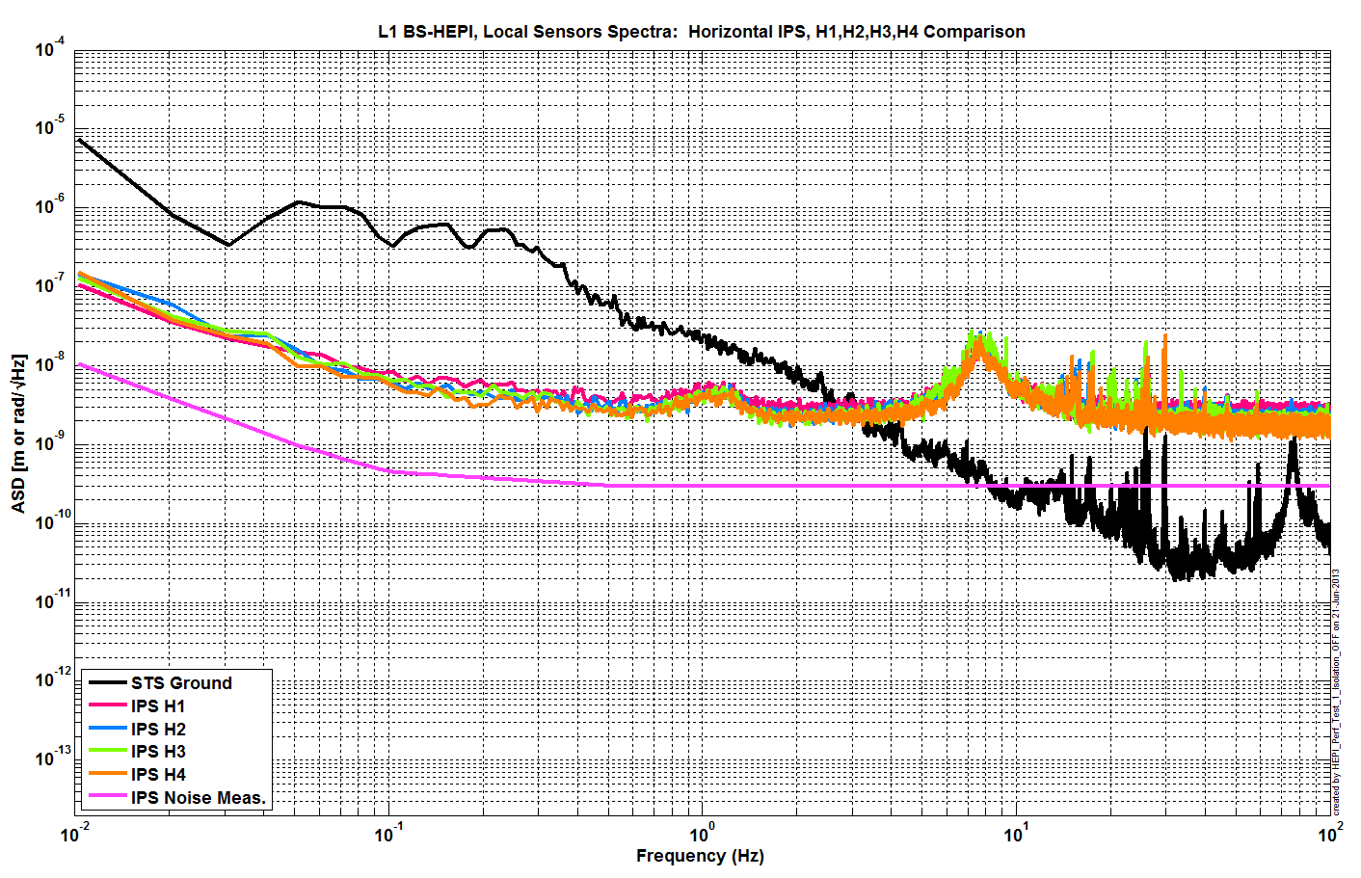

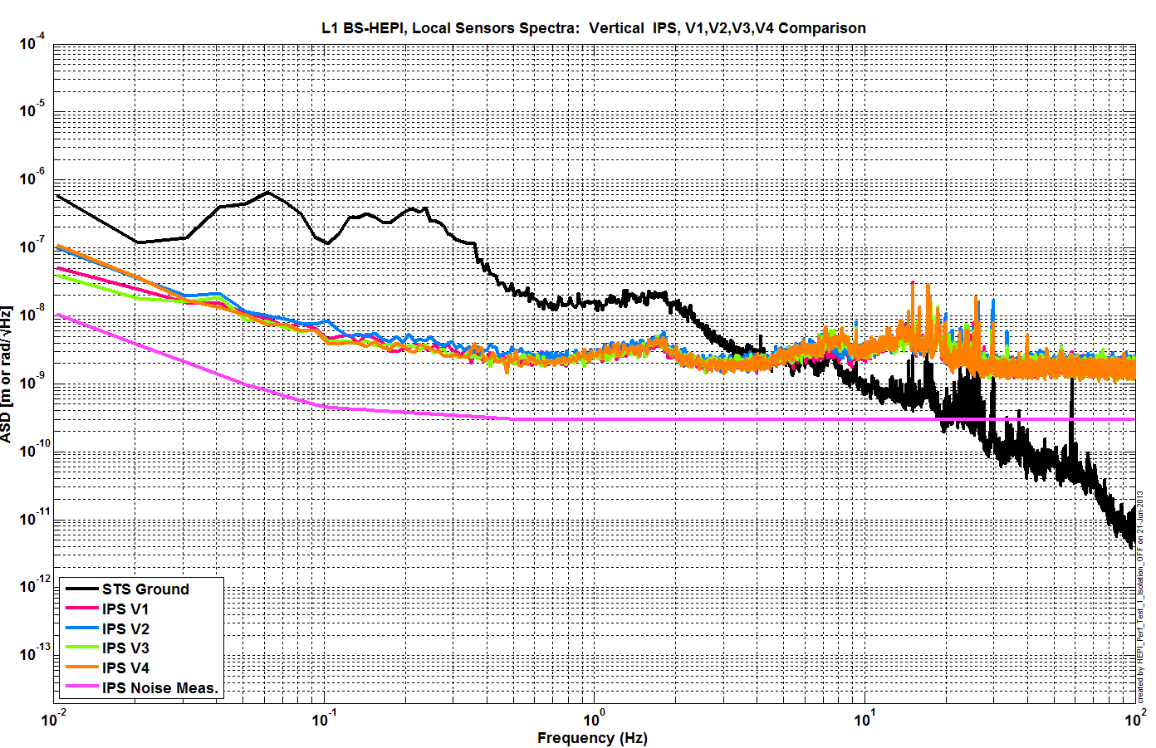
Issues/difficulties/comments regarding this test:
Calibration of IPS on those plots is slightly off I believe. However, those are enough to ensure proper functioning of all sensors
Acceptance criteria:

Test result: Passed: X Failed: .

SUS-watchdogs interaction test
This test will be obsolete very soon, as the payload-HEPI WD connection is planned for removal.

. Set up a zero value on the payload watchogs.
. Check that the payload watchdog screen of HEPI tripped.
. In the payload watchdog screen, click on the OVERRIDE button and reset the watchdog.
. Do the same process for all the payloads
Acceptance criteria:
- The HEPI must trip when the payload watchdogs are tripped
- The HEPI watchdogs could be reset when the OVERRIDE button is ON
Test result: Passed: X Failed: .
When this test is done, reset everything (OVERRIDE button OFF, put back the value on the payload watchdog).

Static Test local drive
Scripts files for processing in SVN at:
/SeiSVN/seismic/HEPI/Common/Testing_Functions_HEPI/Static_Test_Local_Basis_HEPI.m

Data files in SVN at:
/SeiSVN/seismic/HEPI/L1/BS/Data/ /Static_Tests/LLO_HPI_BS_Offset_Local_Drive_20130429.mat

Drive of 5000 counts (Nominal value handled by testing script)
 | H1 | H2 | H3 | H4 | V1 | V2 | V3 | V4
H1 | -10347.8 | 4054.0 | 1032.3 | 3696.3 | -14.1 | -52.3 | -86.2 | 235.3
H2 | 2213.6 | -8271.2 | 2921.5 | 864.8 | -150.3 | 56.7 | 227.5 | -90.3
H3 | 410.9 | 3475.1 | -10313.7 | 3685.4 | -122.6 | 282.6 | -73.4 | -228.5
H4 | 2333.9 | 1018.0 | 2954.0 | -8909.2 | 108.2 | -3.9 | -205.5 | -55.9
V1 | -377.7 | 141.2 | -221.0 | 230.6 | -5924.4 | -863.5 | 1601.3 | -1299.0
V2 | -493.0 | 259.9 | -10.4 | 30.5 | -913.1 | -5415.2 | -1149.8 | 1344.2
V3 | -462.6 | 524.7 | -214.3 | -69.6 | 1342.6 | -2132.2 | -6899.4 | -793.5
V4 | -188.1 | 220.0 | -324.8 | 105.5 | -1461.9 | 777.0 | -1571.8 | -6540.9

. Drive of 100 counts (in progress)
 | H1 | H2 | H3 | H4 | V1 | V2 | V3 | V4
H1 | 8350.9418 | -5056.1049 | -327.0384 | -1879.51872 | -178.9088 | 209.3388 | 192.18836 | -370.0864
H2 | -4104.049 | 8306.5349 | -1822.531974 | -448.11792 | 134.8916 | -100.465 | -301.80668 | 139.7868
H3 | -233.5984 | -2065.5751 | 8170.4572 | -4615.56692 | 178.7694 | -183.7838 | -239.1095 | 118.1154
H4 | -1807.7793 | -701.3897 | -4558.2268 | 9000.50088 | -488.2914 | 367.591 | -1.00976 | -441.0128
V1 | -87.0864 | 1.56718 | 302.0506 | -174.51156 | 7490.8344 | 918.82254 | -1656.35338 | 784.3534
V2 | 182.2748 | -404.56522 | -128.0876 | 486.57564 | 833.8752 | 7402.042 | 675.00182 | -1629.1482
V3 | 309.8688 | -477.33554 | -80.087 | 272.82164 | -1436.731 | 1099.12212 | 7236.42762 | 695.124
V4 | -177.839 | 74.78868 | 291.7698 | -126.46464 | 955.694 | -1414.8926 | 824.44686 | 7487.4108

. Drive of 1000 counts (in progress)
 | H1 | H2 | H3 | H4 | V1 | V2 | V3 | V4
H1 | 8350.9418 | -5056.1049 | -327.0384 | -1879.51872 | -178.9088 | 209.3388 | 192.18836 | -370.0864
H2 | -4104.049 | 8306.5349 | -1822.531974 | -448.11792 | 134.8916 | -100.465 | -301.80668 | 139.7868
H3 | -233.5984 | -2065.5751 | 8170.4572 | -4615.56692 | 178.7694 | -183.7838 | -239.1095 | 118.1154
H4 | -1807.7793 | -701.3897 | -4558.2268 | 9000.50088 | -488.2914 | 367.591 | -1.00976 | -441.0128
V1 | -87.0864 | 1.56718 | 302.0506 | -174.51156 | 7490.8344 | 918.82254 | -1656.35338 | 784.3534
V2 | 182.2748 | -404.56522 | -128.0876 | 486.57564 | 833.8752 | 7402.042 | 675.00182 | -1629.1482
V3 | 309.8688 | -477.33554 | -80.087 | 272.82164 | -1436.731 | 1099.12212 | 7236.42762 | 695.124
V4 | -177.839 | 74.78868 | 291.7698 | -126.46464 | 955.694 | -1414.8926 | 824.44686 | 7487.4108

Table - Main couplings and cross couplings

Issues/difficulties encountered during this test:

Acceptance criteria:
- The results in these three tables must be the same (within xxx%)

Test result: Passed: Failed: .

Linearity Test/Range of motion in the local basis
Scripts files for processing and plotting in SVN at:
/SeiSVN/seismic/HEPI/Common/Testing_Functions_HEPI/Linearity_Test_Awgstream_HEPI.m

Data in SVN at:
SeiSVN/seismic/HEPI/L1/BS/Data/Linearity_Test/
LLO_HPI_BS_Linearity_test_20130430T162439.mat

Figures in SVN at:
/SeiSVN/seismic/HEPI/L1/BS/Data/Figures/Linearity_Test/

 | Slopes | Offsets | Average | % error
H1 | -1.93 | 12572.14 | -1.91 | 0.91
H2 | -1.77 | 5607.30 |  | -7.55
H3 | -2.10 | -5713.96 |  | 9.57
H4 | -1.86 | -5189.01 |  | -2.93
V1 | -1.21 | 1497.05 | -1.16 | 4.46
V2 | -0.84 | 2817.85 |  | -27.80
V3 | -1.27 | 374.84 |  | 9.68
V4 | -1.32 | -1728.48 |  | 13.66

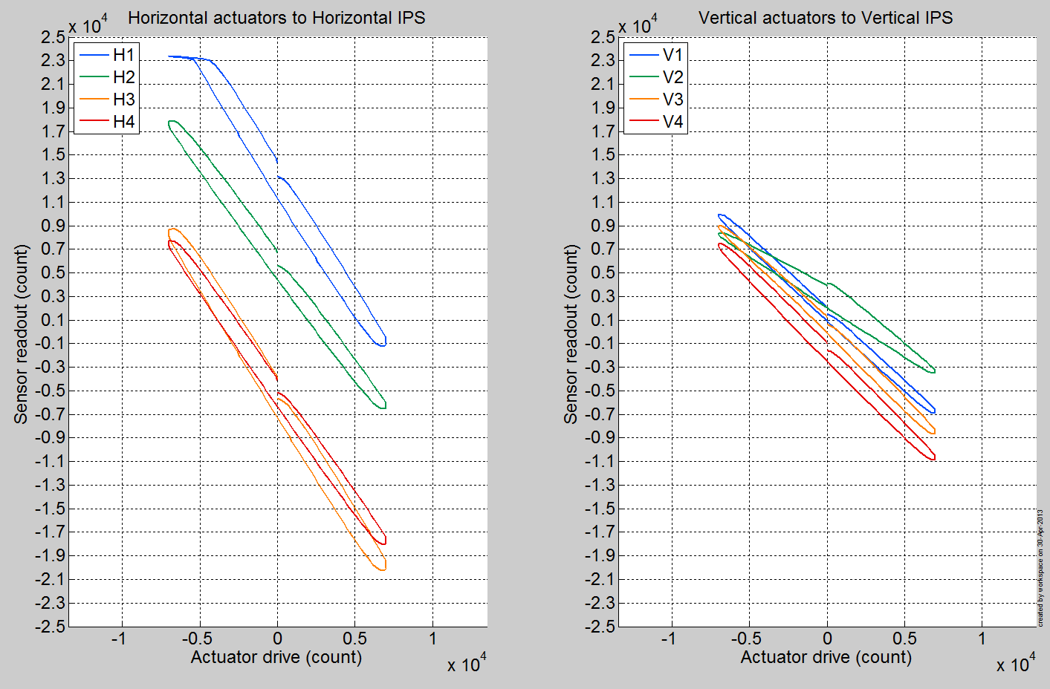

Issues/difficulties encountered during this test:
First, we can notice that H1 is hitting a maximum displacement before -7000 counts of actuation. This is due to the fact that H1 has a large offset when HEPI is at its rest position (it was verified that it is not a valve issue).
Additionally, V2 shows a clearly different response. This was solved after this test was taken by changing that valve. (It was going bad as we were taking this test) See next test for confirmation of the improved V2 response after the end of April.

Acceptance criteria:

Test result: Passed: Failed: Waived: _ X_

Actuator Plate to Shields gap

Perform this test ONLY if the range of motion test failed.

Test result: Passed: Failed: Waived: _ X_

Valve Check
Scripts files for processing and plotting in SVN at:
/SeiSVN/seismic//HEPI/L1/BS/Scripts/Valve_Check/plot_valve_check.m
/SeiSVN/seismic/HEPI/L1/BS/Scripts/Valve_Check/dtt2mlab_Valve_Check.m

Data in SVN at:
/SeiSVN/seismic/HEPI/L1/BS/Data/Spectra/Undamped/
/SeiSVN/seismic/HEPI/L1/BS/Scripts/Valve_Check/

Figures in SVN at:
/SeiSVN/seismic/HEPI/L1/BS/Scripts/Valve_Check/
/SeiSVN/seismic/HEPI/L1/BS/Scripts/Evolution/

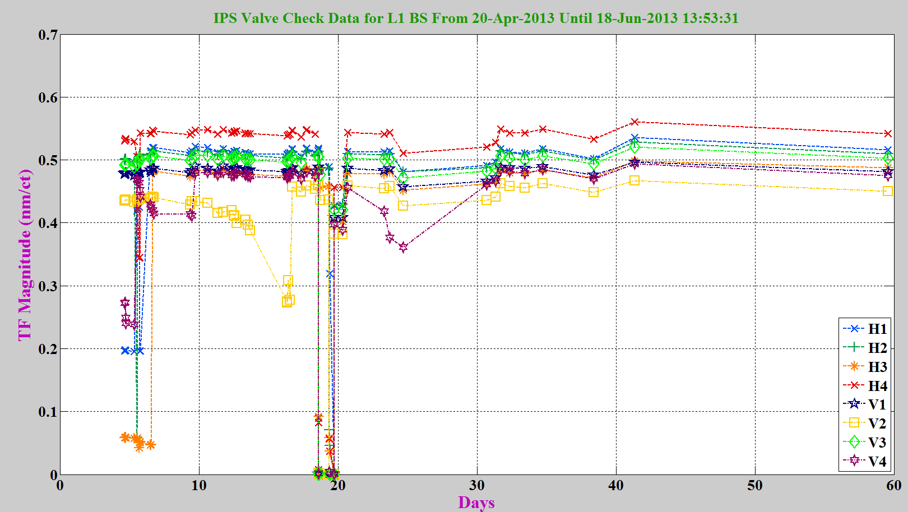

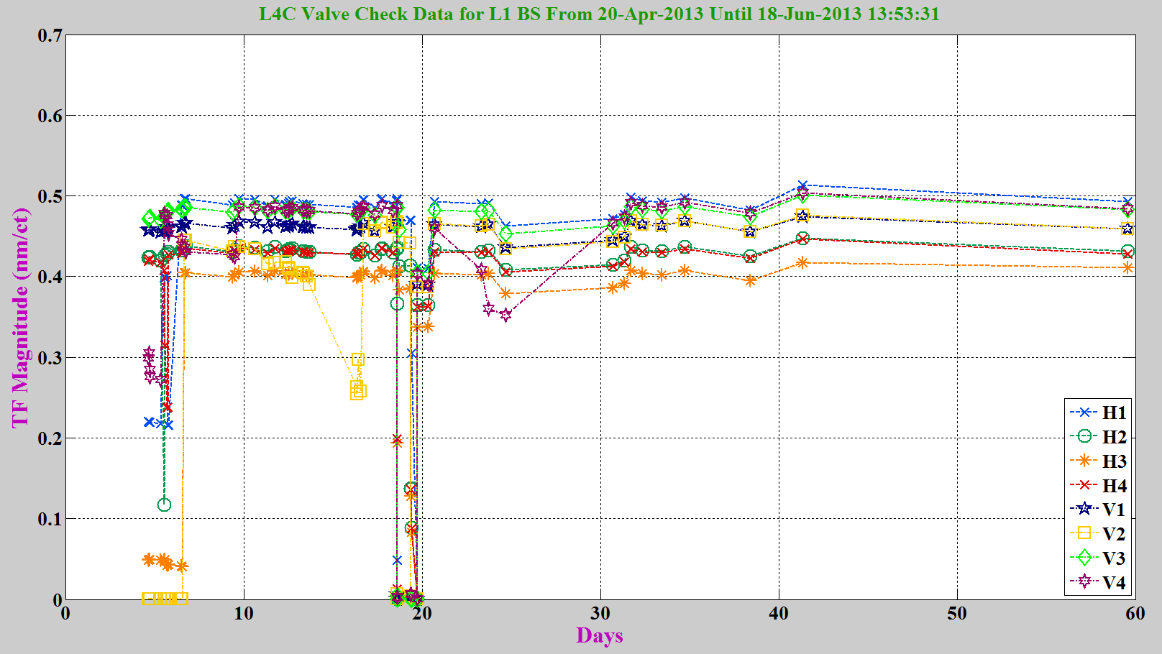

Acceptance criteria:
- All corners should behave consistently (usually displacement > 0.4 nm/ct)

Test result: Passed: X Failed: .

Local-to-local measurements

Data files in SVN at:
/SeiSVN/seismic/HEPI/L1/BS/Data/Transfer_Functions/Measurements/Undamped/
- L1_HEPI_BSC2_100_to_250Hz_20130522-052553.mat
- L1_HEPI_BSC2_20_to_100Hz_20130522-030914.mat
- L1_HEPI_BSC2_2_to_20Hz_20130522-002155.mat
- L1_HEPI_BSC2_0p05_to_0p5Hz_20130524-175147.mat
Data collection script files:
/SeiSVN/seismic/HEPI/Common//Transfer_Function_Scripts/
- Run_TF_L2L_10mHz_100mHz.m
- Run_TF_L2L_100mHz_500mHz.m
- Run_TF_L2L_500mHz_5Hz.m
- Run_TF_L2L_5Hz_100Hz.m
- Run_TF_L2L_100Hz_1000Hz.m
Scripts files for processing and plotting in SVN at:
/SeiSVN/seismic/HEPI/L1/BS/Scripts/Control_Scripts/release/
- Step_1_TF_Loc_to_Loc_L1_HEPI_BS.m
Figures in SVN at:
/SeiSVN/seismic/HEPI/L1/BS/Data/Figures/Transfer_Functions/Measurements/Undamped/
- L1_HPI_BS_TF_L2L_Raw_from_ACT_to_IPS_2013_05_23.fig
- L1_HPI_BS_TF_L2L_Raw_from_ACT_to_L4C_2013_05_23.fig
Storage of measured transfer functions in the SVN at:
/SeiSVN/seismic/HEPI/L1/BS/Data/Transfer_functions/Simulations/Undamped/
L1_HPI_BS_TF_L2L_Raw_2013_05_23.mat

The local-to-local transfer functions are presented below.
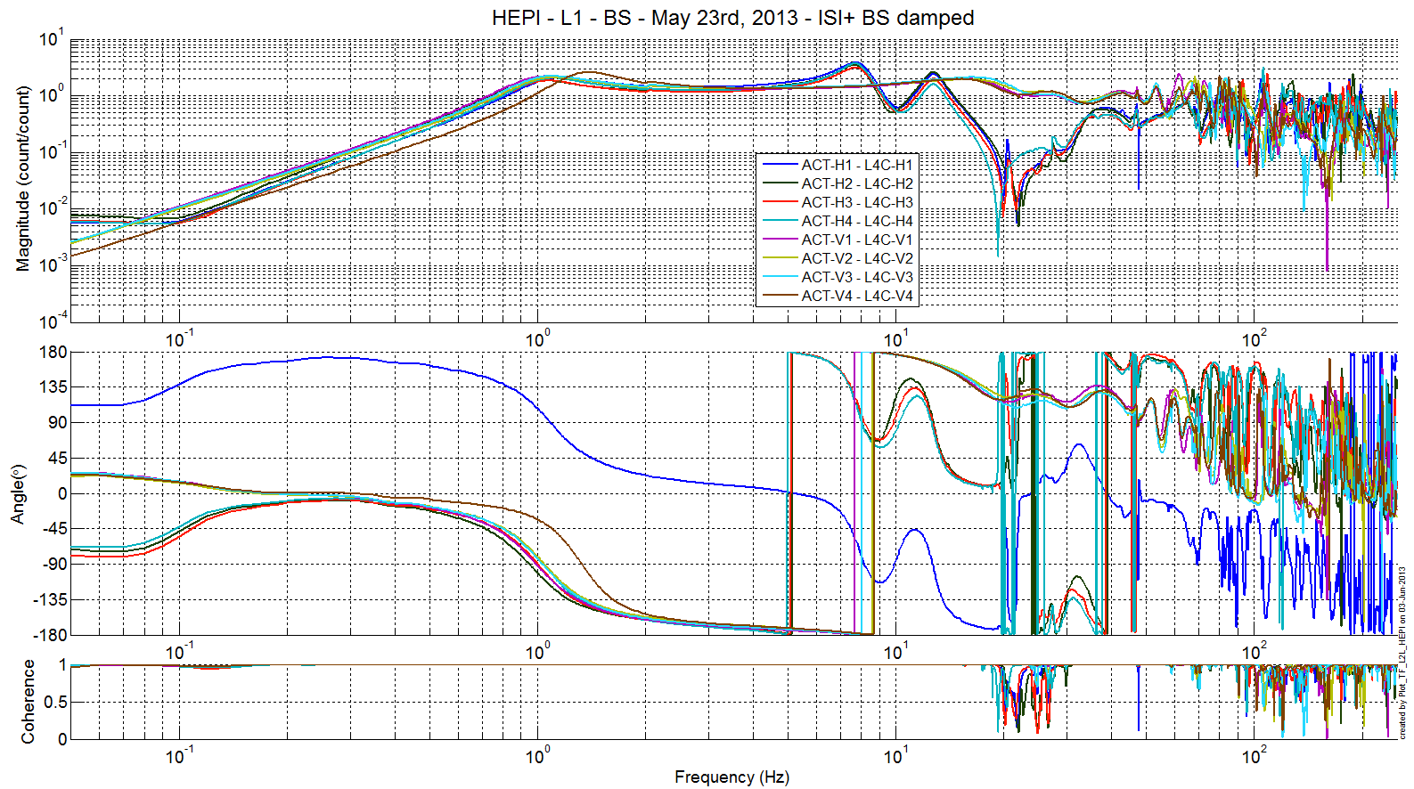
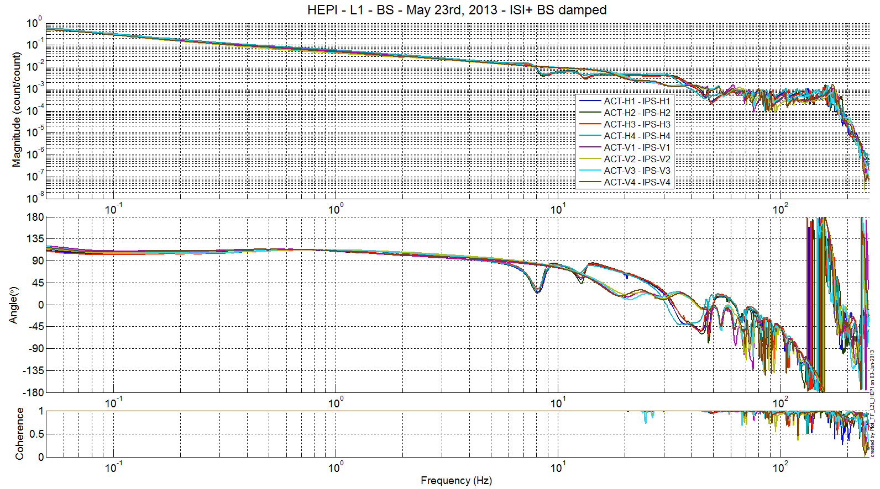
Issues/difficulties/comments regarding this test:
One can notice two things on the L4C seismometers, H1 has a different sign and V4 corner frequency is significantly higher than the other. The first difference is due to the fact that this L4C has a new aLIGO cable, whereas all other sensors still have iLIGO cables. The 2nd one is likely due to that boot being tilted, but it is unclear how to solve the issue.

Acceptance criteria:
- On IPS, the phase must be 0º at DC
- On geophones, the phase must be 90º at DC
- Identical shape in each corner

Test result: Passed: Waived: X Failed: .

Alignment offsets:
The IPS readouts recorded below are for HEPI unlocked, when on 06/12/13, the commissioning crew made their first attempt at DRMI alignment check (cf LLO alog 7383)

 | IPS Readouts
H1 | 14035
H2 | 7762
H3 | -3935
H4 | -4238
V1 | 4471
V2 | 4476
V3 | 1976
V4 | 2145

Note at the moment, for this chamber, the offsets are re-computed every time HEPI loops are started.

Acceptance criteria:
Offsets were recorded.

Test result: Passed: X Failed: .

Conclusion

The only tests run for initial approval of this system were the valve checks, the sensors ASDs and the transfer functions. All have looked good since June 2013. Different tests (alignment offsets, linearity test,...) have shown that H1 actuator has a strong offset when HEPI is in its nominal position, the horizontal range of that chamber is therefore quite limited in one direction. Because it was unclear that the maximum range was necessary, and that releasing and readjusting that actuator untitled some risks for the alignment, this has been left unchanged at this time. Note that this can be addressed at any time though.
Position loops have been used routinely on this chamber since June 2013.

