LIGO Laboratory / LIGO Scientific Collaboration

LIGO- E1300930 LIGO December 9th, 2013

aLIGO HEPI L1 ITMY (BSC1) Assembly Validation Report
E1300930

Joe Hanson, Jeremy Birch, Michael Vargas, Rich Mittleman, Ryan DeRosa, Céline Ramet for the SEI Team

Distribution of this document:
Advanced LIGO Project

This is an internal working note
of the LIGO Laboratory

California Institute of Technology  LIGO Project – MS 18-34  1200 E. California Blvd.  Pasadena, CA 91125  Phone (626) 395-2129  Fax (626) 304-9834  E-mail: info@ligo.caltech.edu | Massachusetts Institute of Technology  LIGO Project – NW22-295  185 Albany St  Cambridge, MA 02139  Phone (617) 253-4824  Fax (617) 253-7014  E-mail: info@ligo.mit.edu
LIGO Hanford Observatory  P.O. Box 1970  Mail Stop S9-02  Richland WA 99352  Phone 509-372-8106  Fax 509-372-8137 | LIGO Livingston Observatory  P.O. Box 940  Livingston, LA 70754  Phone 225-686-3100  Fax 225-686-7189

Contents
Contents 2
Introduction 3
Sub-Components Testing 4
Assembly Validation 4
1.1 Load Cells assembly 4
1.2 Bellows 5
1.3 Boot Location 5
1.4 Check Stops Gaps 5
1.5 Gaps check 5
1.6 IPS Centering 6
1.7 Sensor ASD 6
1.8 SUS-watchdogs interaction test 9
1.9 Static Test local drive 9
1.10 Linearity Test/Range of motion in the local basis 11
1.11 Actuator Plate to Shields gap 12
1.12 Valve Check 12
1.13 Local-to-local measurements 13
1.14 Alignment offsets: 15
Conclusion 17

\

Introduction

This document summarizes the tests done to validate the HEPI L1 ITMY (BSC1) assembly. As all L1 HEPI BSC, it had been installed since 2004 at Livingston. However, it had been grounded for the 2 to 3 years of aLIGO install. All electronics has been updated since, and more importantly, the position of the ITMY support tubes (i.e. the position of the 4 HEPI ITMY boots), but not the one of the housings, were adjusted to accommodate the position needed for aLIGO alignment. Note that when HEPI was first released, we subsequently found out that there was some constant rubbing between the boot and the housing, due to some of the moves done for Initial Alignment. The boot assembly was adjusted to provide clearanceThose adjustments were completed in July 2013.

Sub-Components Testing
- Kaman Inductive Position Sensors: calibration, linearity, factory data, noise measurements
The IPS sensors on this chamber haven’t been changed since their original installation in 2004. No specific individual testing had been done then or since.
- HEPI actuator linearity test (E1100338 – aLIGO HEPI Actuators Test Results)
The HEPI actuators on this chamber haven’t been changed since their original installation in 2004. No specific individual testing had been done then or since.
- L4C test
The L4C sensors on this chamber haven’t been changed since their original installation in 2004. No specific individual testing had been done at the time or since on the “old units”.

Assembly Validation

Load Cells assembly
- Spring attachment
For the BSC HEPI springs, check the assembly per D030320-v4. See LLO aLOG 7162 for more details.
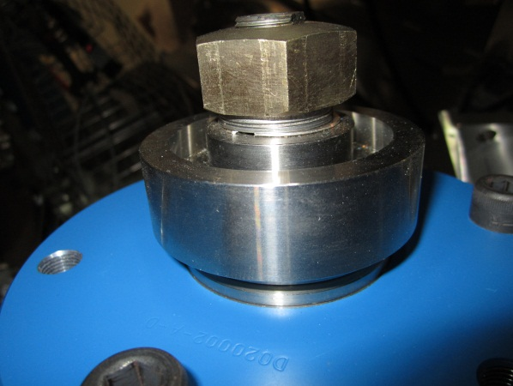
- Load cell values
BSC HEPI load cell capacity → 3000 lbs

 | Spring | Left Spring (lbs)
Pier 1 | 1 | 1737
 | 2 | 2251
Pier 2 | 3 | 2224
 | 4 | 2728
Pier 3 | 5 | 1593
 | 6 | 1894
Pier 4 | 7 | 1882
 | 8 | 2332

Acceptance criteria:
- The values must not exceed 80% of the load cell capacity (2400lbs for BSC and 1600lbs for HAM).

Test result: Passed: Failed: X .

Bellows

The bellows are hard to access and tests are hard to proceed. After several discussions and brainstorming sessions, it has been decided not to measure the gaps on HEPI-HAM and HEPI-BSC.

Test result: Passed: Failed: Waived: _ X_

Boot Location

Test result: Passed: Failed: Waived: _ X_

Check Stops Gaps
The stops must not touch the boot.
If the valve check test is a success, we are sure there is no touching against the boot.
Test result: Passed: X Failed:

Gaps check
If the valve check test is a success, we are sure there is no touching against the boot.

Test result: Passed: X Failed: .

IPS Centering
Scripts files for processing and plotting in SVN at:
/SeiSVN/seismic/HEPI/Common/Testing_Functions_HEPI/Offset_STD_IPS_HEPI.m

All the loops must be turned off during this test.

 | H1 | H2 | H3 | H4 | V1 | V2 | V3 | V4
Mean (counts)
Acceptance | +/- 15000 | +/- 15000 | +/- 15000 | +/- 15000 | +/- 15000 | +/- 15000 | +/- 15000 | +/- 15000

Test result: Passed: X Failed:

Sensor ASD
Scripts files for processing and plotting in SVN at:
/SeiSVN/seismic/HEPI/L1/ITMY/Scripts/Perf_Analysis/

Data in SVN at:
SeiSVN/seismic/HEPI/L1/ITMY/Data/Figures/Perf_Analysis/2013-06-21-Level2/
L1_HPI_ITMY_Test_1_2013-06-21-Level2.mat

Figures in SVN at:
/SeiSVN/seismic/HEPI/L1/ITMY/Data/Figures/Perf_Analysis/2013-06-21-Level2/
- HEPI_L1_ITMY_Test_1_Fig_a_HPI_L4C_Hor_2013-06-21-Level2.fig
- HEPI_L1_ITMY_Test_1_Fig_b_HPI_L4C_Vert_2013-06-21-Level2.fig
- HEPI_L1_ITMY_Test_1_Fig_c_HPI_IPS_Hor_2013-06-21-Level2.fig
- HEPI_L1_ITMY_Test_1_Fig_d_HPI_IPS_Vert_2013-06-21-Level2.fig

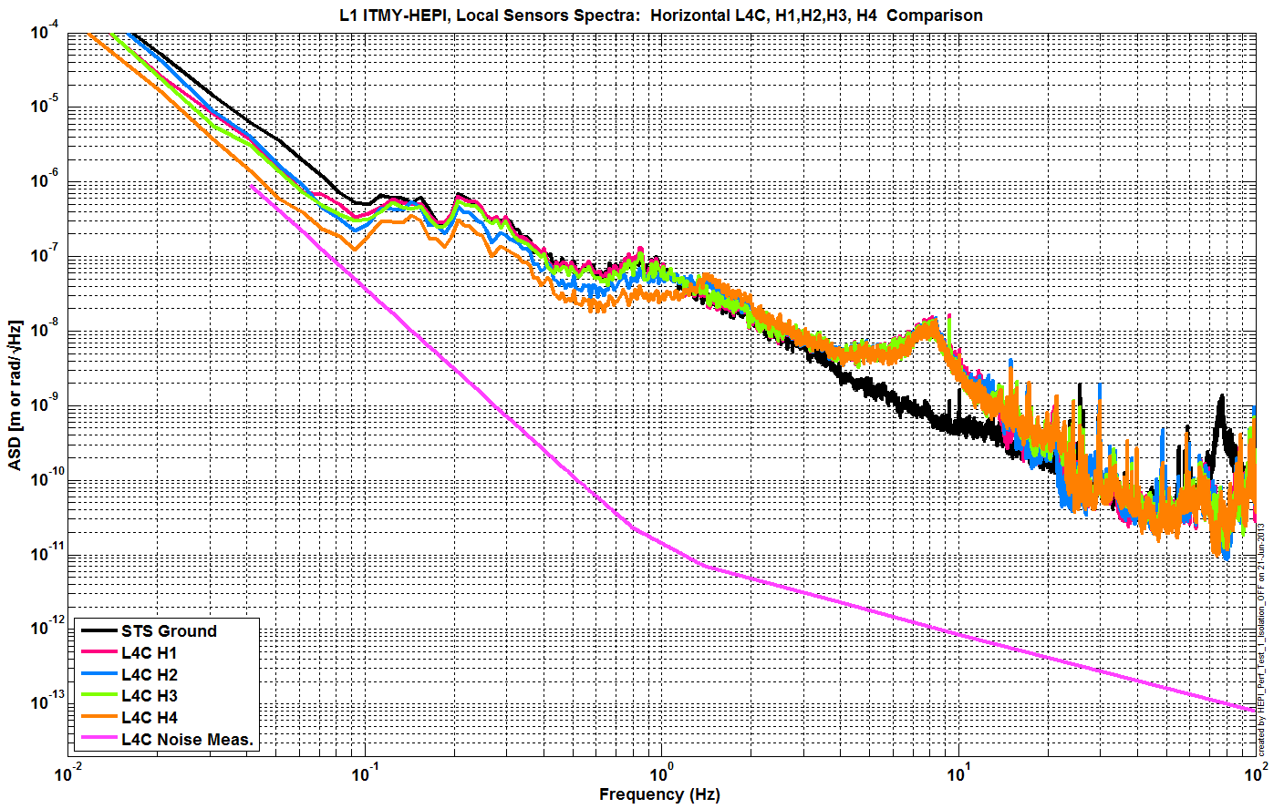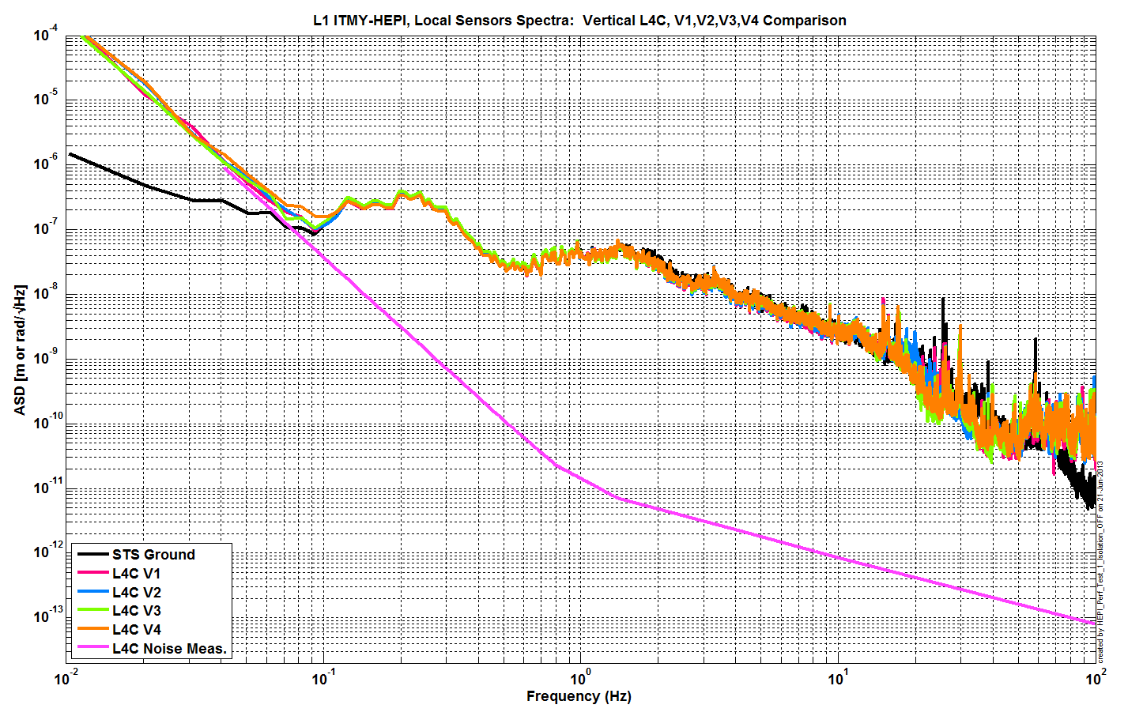

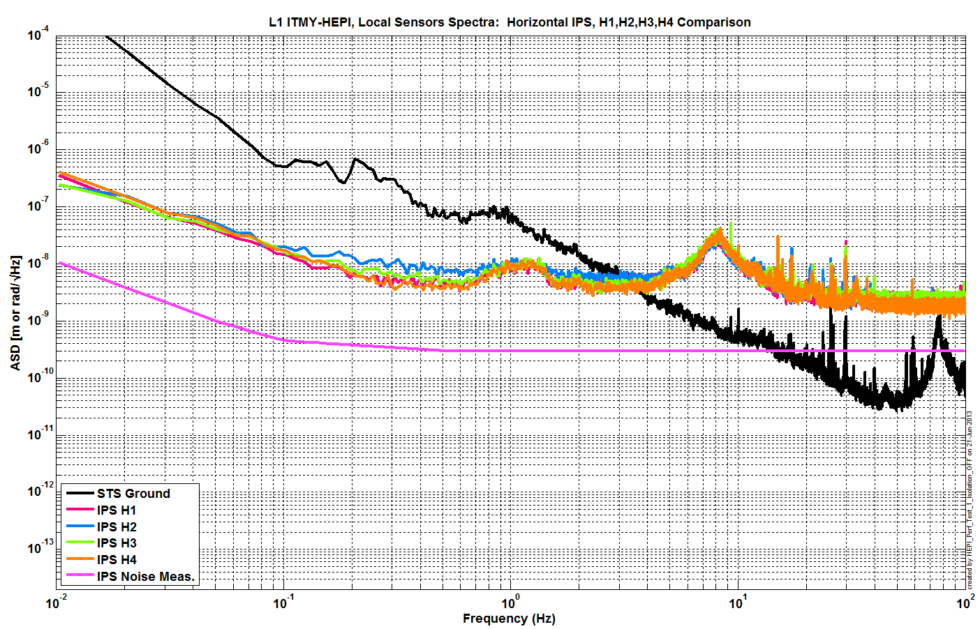
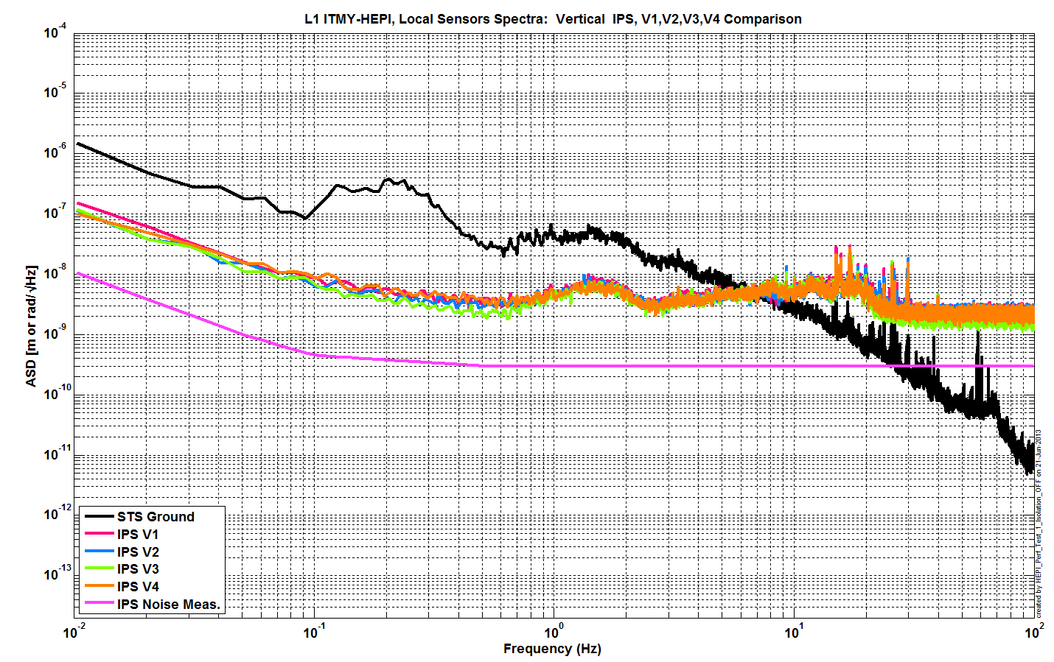
Issues/difficulties/comments regarding this test:
Calibration of IPS on those plots is slightly off I believe. However, those are enough to ensure proper functioning of all sensors.

Acceptance criteria:

Test result: Passed: X Failed: .

SUS-watchdogs interaction test
This test will be obsolete very soon, as the payload-HEPI WD connection is planned for removal.

. Set up a zero value on the payload watchogs.
. Check that the payload watchdog screen of HEPI tripped.
. In the payload watchdog screen, click on the OVERRIDE button and reset the watchdog.
. Do the same process for all the payloads
Acceptance criteria:
- The HEPI must trip when the payload watchdogs are tripped
- The HEPI watchdogs could be reset when the OVERRIDE button is ON
Test result: Passed: X Failed: .
When this test is done, reset everything (OVERRIDE button OFF, put back the value on the payload watchdog).

Static Test local drive
Scripts files for processing in SVN at:
/SeiSVN/seismic/HEPI/Common/Testing_Functions_HEPI/Static_Test_Local_Basis_HEPI.m

Data files in SVN at:
/SeiSVN/seismic/HEPI/L1/ITMY/Data/Static_Tests/

Drive of 5000 counts (Nominal value handled by testing script)
 | H1 | H2 | H3 | H4 | V1 | V2 | V3 | V4
H1 | -10347.8 | 4054.0 | 1032.3 | 3696.3 | -14.1 | -52.3 | -86.2 | 235.3
H2 | 2213.6 | -8271.2 | 2921.5 | 864.8 | -150.3 | 56.7 | 227.5 | -90.3
H3 | 410.9 | 3475.1 | -10313.7 | 3685.4 | -122.6 | 282.6 | -73.4 | -228.5
H4 | 2333.9 | 1018.0 | 2954.0 | -8909.2 | 108.2 | -3.9 | -205.5 | -55.9
V1 | -377.7 | 141.2 | -221.0 | 230.6 | -5924.4 | -863.5 | 1601.3 | -1299.0
V2 | -493.0 | 259.9 | -10.4 | 30.5 | -913.1 | -5415.2 | -1149.8 | 1344.2
V3 | -462.6 | 524.7 | -214.3 | -69.6 | 1342.6 | -2132.2 | -6899.4 | -793.5
V4 | -188.1 | 220.0 | -324.8 | 105.5 | -1461.9 | 777.0 | -1571.8 | -6540.9

. Drive of 100 counts (in progress)
 | H1 | H2 | H3 | H4 | V1 | V2 | V3 | V4
H1 | 8350.9418 | -5056.1049 | -327.0384 | -1879.51872 | -178.9088 | 209.3388 | 192.18836 | -370.0864
H2 | -4104.049 | 8306.5349 | -1822.531974 | -448.11792 | 134.8916 | -100.465 | -301.80668 | 139.7868
H3 | -233.5984 | -2065.5751 | 8170.4572 | -4615.56692 | 178.7694 | -183.7838 | -239.1095 | 118.1154
H4 | -1807.7793 | -701.3897 | -4558.2268 | 9000.50088 | -488.2914 | 367.591 | -1.00976 | -441.0128
V1 | -87.0864 | 1.56718 | 302.0506 | -174.51156 | 7490.8344 | 918.82254 | -1656.35338 | 784.3534
V2 | 182.2748 | -404.56522 | -128.0876 | 486.57564 | 833.8752 | 7402.042 | 675.00182 | -1629.1482
V3 | 309.8688 | -477.33554 | -80.087 | 272.82164 | -1436.731 | 1099.12212 | 7236.42762 | 695.124
V4 | -177.839 | 74.78868 | 291.7698 | -126.46464 | 955.694 | -1414.8926 | 824.44686 | 7487.4108

. Drive of 1000 counts (in progress)
 | H1 | H2 | H3 | H4 | V1 | V2 | V3 | V4
H1 | 8350.9418 | -5056.1049 | -327.0384 | -1879.51872 | -178.9088 | 209.3388 | 192.18836 | -370.0864
H2 | -4104.049 | 8306.5349 | -1822.531974 | -448.11792 | 134.8916 | -100.465 | -301.80668 | 139.7868
H3 | -233.5984 | -2065.5751 | 8170.4572 | -4615.56692 | 178.7694 | -183.7838 | -239.1095 | 118.1154
H4 | -1807.7793 | -701.3897 | -4558.2268 | 9000.50088 | -488.2914 | 367.591 | -1.00976 | -441.0128
V1 | -87.0864 | 1.56718 | 302.0506 | -174.51156 | 7490.8344 | 918.82254 | -1656.35338 | 784.3534
V2 | 182.2748 | -404.56522 | -128.0876 | 486.57564 | 833.8752 | 7402.042 | 675.00182 | -1629.1482
V3 | 309.8688 | -477.33554 | -80.087 | 272.82164 | -1436.731 | 1099.12212 | 7236.42762 | 695.124
V4 | -177.839 | 74.78868 | 291.7698 | -126.46464 | 955.694 | -1414.8926 | 824.44686 | 7487.4108

Table - Main couplings and cross couplings

Issues/difficulties encountered during this test:

Acceptance criteria:
- The results in these three tables must be the same (within xxx%)

Test result: Passed: Failed: .

Linearity Test/Range of motion in the local basis
Scripts files for processing and plotting in SVN at:
/SeiSVN/seismic/HEPI/Common/Testing_Functions_HEPI/Linearity_Test_Awgstream_HEPI.m

Data in SVN at:
SeiSVN/seismic/HEPI/L1/ITMY/Data/Spectra/Undamped/
L1_ISI_ITMY_ASD_m_CPS_T240_L4C_GS13_Locked_vs_Unlocked_2012_02_07.mat

Figures in SVN at:
/SeiSVN/seismic/HEPI/L1/ITMY/Data/Figures/Spectra/Undamped

 | Slopes | Offsets
H1 | 1.63 | 1800.40
H2 | 1.88 | -522.55
H3 | 1.63 | 1959.94
H4 | 1.76 | -177.98
V1 | 1.54 | -4082.29
V2 | 1.54 | -1558.79
V3 | 1.42 | -516.54
V4 | 1.56 | -5144.56

Issues/difficulties encountered during this test:

Acceptance criteria:

Test result: Passed: Failed: .

Actuator Plate to Shields gap

Perform this test ONLY if the range of motion test failed.

Test result: Passed: Failed: Waived: _ X_

Valve Check
Scripts files for processing and plotting in SVN at:
/SeiSVN/seismic//HEPI/L1/ITMY/Scripts/Valve_Check/plot_valve_check.m
/SeiSVN/seismic/HEPI/L1/ITMY/Scripts/Valve_Check/dtt2mlab_Valve_Check.m

Data in SVN at:
/SeiSVN/seismic/HEPI/L1/ITMY/Data/Spectra/Undamped/
/SeiSVN/seismic/HEPI/L1/ITMY/Scripts/Valve_Check/

Figures in SVN at:
/SeiSVN/seismic/HEPI/L1/ITMY/Scripts/Valve_Check/
/SeiSVN/seismic/HEPI/L1/ITMY/Scripts/Evolution/

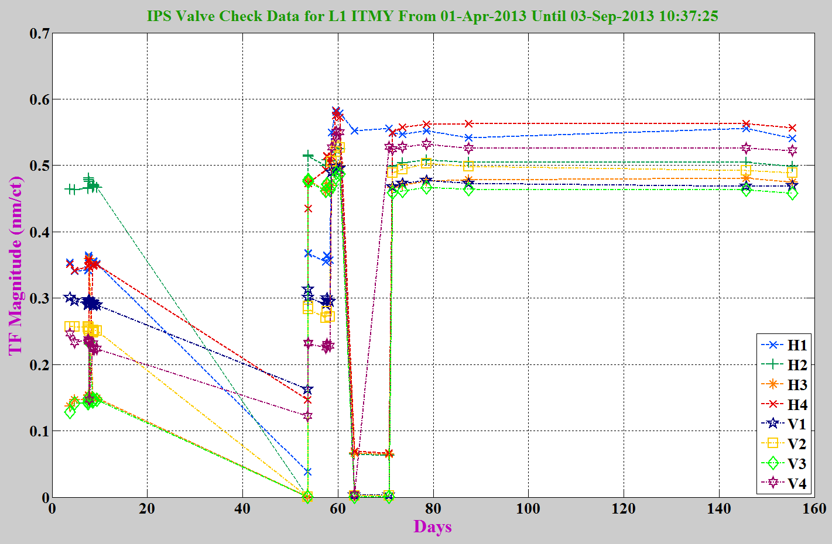

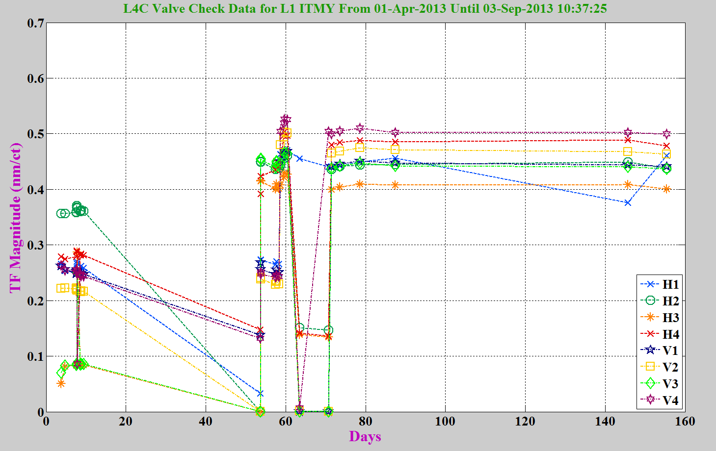
Issues/difficulties/comments regarding this test:
The one before last H1 point was a measurement issue, valve and L4C are ok.

Acceptance criteria:
- All corners should behave consistently (usually displacement > 0.4 nm/ct)

Test result: Passed: X Failed: .

Local-to-local measurements

Data files in SVN at:
/SeiSVN/seismic/HEPI/L1/ITMY/Data/Transfer_Functions/Measurements/Undamped/
- L1_HEPI_BSC1_100_to_250Hz_20130531-040811.mat
- L1_HEPI_BSC1_20_to_100Hz_20130531-015132.mat
- L1_HEPI_BSC1_2_to_20Hz_20130530-230413.mat
- L1_HEPI_BSC1_0p5_to_2Hz_20130530-171533.mat
- L1_HEPI_BSC1_0p5_to_2Hz_20130530-171533.mat
Data collection script files:
/SeiSVN/seismic/HEPI/Common//Transfer_Function_Scripts/
- Run_TF_L2L_10mHz_100mHz.m
- Run_TF_L2L_100mHz_500mHz.m
- Run_TF_L2L_500mHz_5Hz.m
- Run_TF_L2L_5Hz_100Hz.m
- Run_TF_L2L_100Hz_1000Hz.m
Scripts files for processing and plotting in SVN at:
/SeiSVN/seismic/HEPI/L1/BS/Scripts/Control_Scripts/release/
- Step_1_TF_Loc_to_Loc_L1_HEPI_ITMY.m
Figures in SVN at:
/SeiSVN/seismic/HEPI/L1/ITMY/Data/Figures/Transfer_Functions/Measurements/Undamped/
- L1_HPI_ITMY_TF_L2L_Raw_from_ACT_to_IPS_2013_05_31.fig
- L1_HPI_ITMY_TF_L2L_Raw_from_ACT_to_L4C_2013_05_31.fig
Storage of measured transfer functions in the SVN at:
/SeiSVN/seismic/HEPI/L1/ITMY/Data/Transfer_functions/Simulations/Undamped/
L1_HPI_ITMY_TF_L2L_Raw_2013_05_31.mat

The local-to-local transfer functions are presented below.
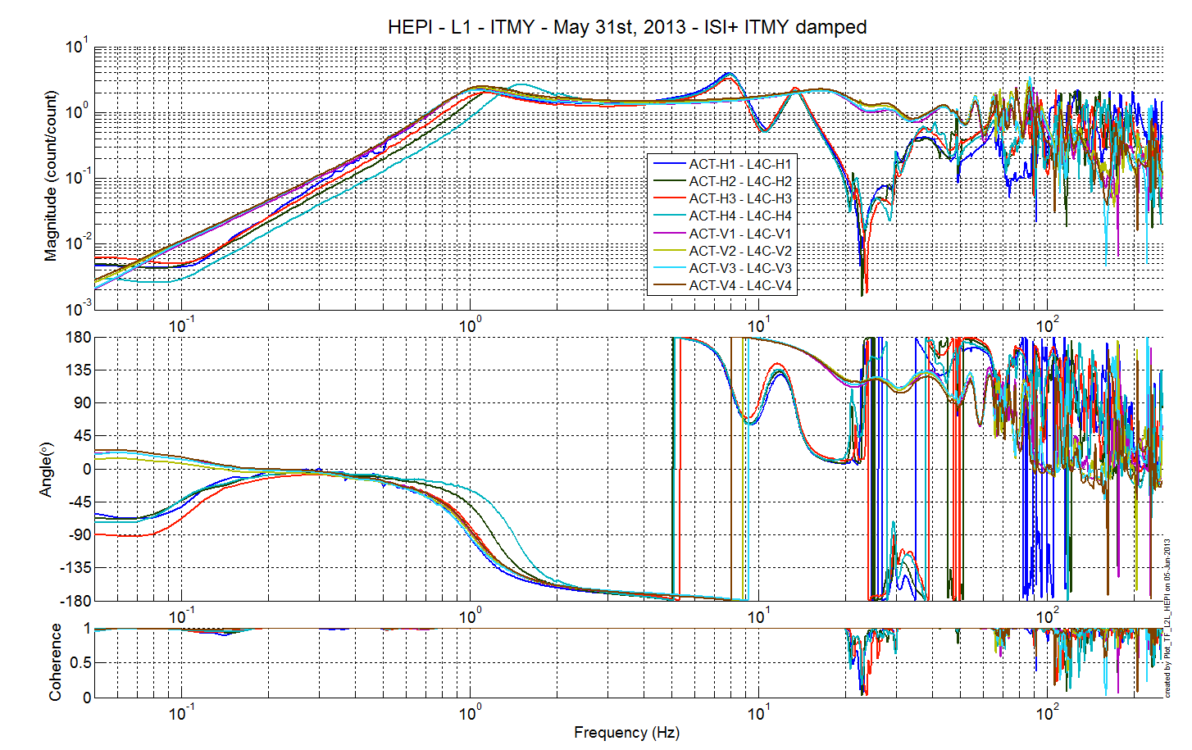
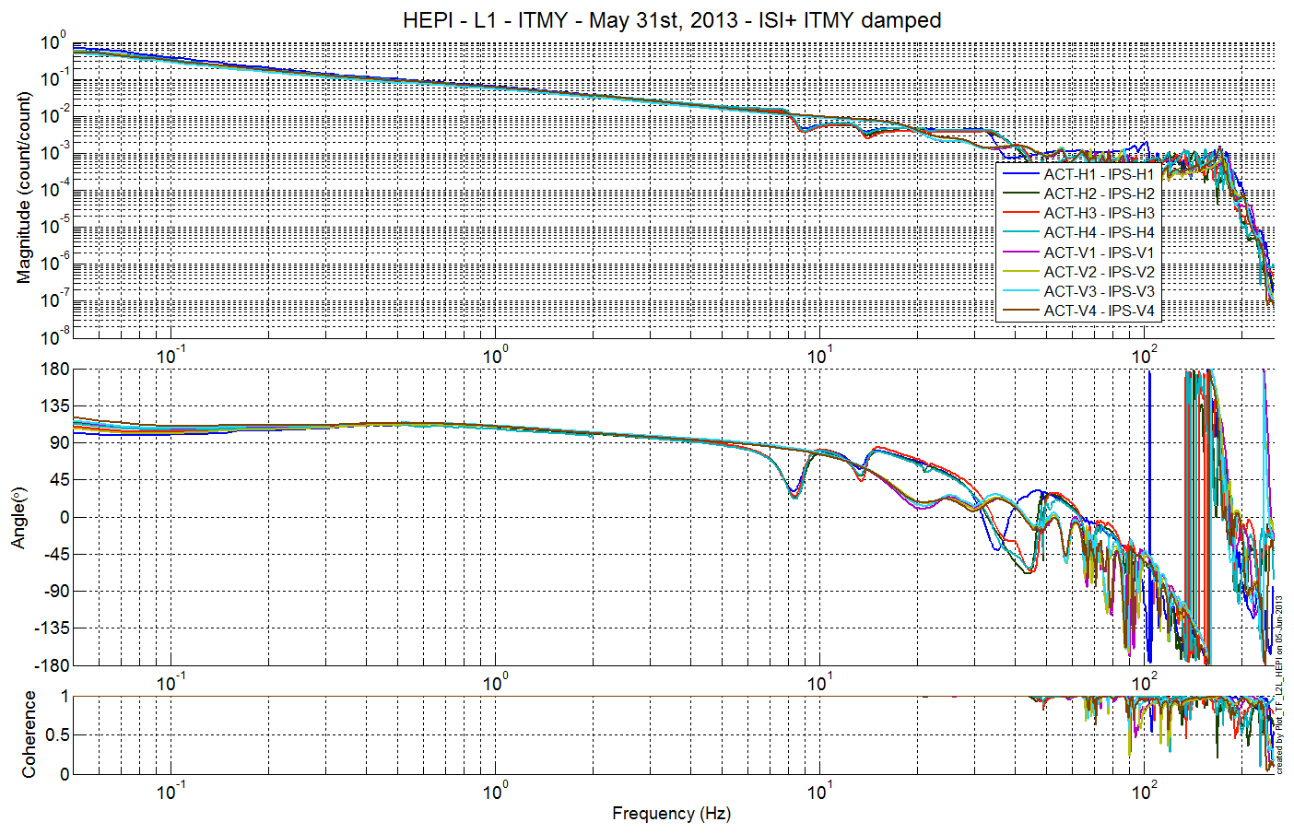
Issues/difficulties/comments regarding this test:
One can notice that and H4 L4C corner frequency is significantly higher than the other. This is likely due to that boot being tilted, but it is unclear how to solve the issue.
Note additionally that the L4C sign is opposed to expectations, this is due to the old L4C cables.

Acceptance criteria:
- On IPS, the phase must be 0º at DC
- On geophones, the phase must be 90º at DC
- Identical shape in each corner

Test result: Passed: Waived: X Failed: .

Alignment offsets:
The IPS readouts recorded below are for HEPI unlocked, when on 06/12/13, the commissioning crew made their first attempt at DRMI alignment check (cf LLO alog 7383)

 | IPS Readouts
H1 | 14945
H2 | 7703
H3 | 12857
H4 | -1459
V1 | 10952
V2 | -11214
V3 | -3438
V4 | 9980

Note at the moment, for this chamber, the offsets are re-computed every time HEPI loops are started.

Acceptance criteria:
Offsets were recorded.

Test result: Passed: X Failed: .

Conclusion
The only tests run for initial approval of this systems were the valve checks, the sensors ASDs and the transfer functions. All have looked good since July 2013. Position loops have been used routinely on this chamber.

