LIGO Laboratory / LIGO Scientific Collaboration

E1400060-v2 LIGO 2/10/14

Coating defects on ITM03 and ITM11

GariLynn Billingsley

Distribution of this document:
LIGO Scientific Collaboration

This is an internal working note
of the LIGO Laboratory.

California Institute of Technology  LIGO Project – MS 18-34  1200 E. California Blvd.  Pasadena, CA 91125  Phone (626) 395-2129  Fax (626) 304-9834  E-mail: info@ligo.caltech.edu | Massachusetts Institute of Technology  LIGO Project – NW22-295  185 Albany St  Cambridge, MA 02139  Phone (617) 253-4824  Fax (617) 253-7014  E-mail: info@ligo.mit.edu
LIGO Hanford Observatory  P.O. Box 159  Richland WA 99352  Phone 509-372-8106  Fax 509-372-8137 | LIGO Livingston Observatory  P.O. Box 940  Livingston, LA 70754  Phone 225-686-3100  Fax 225-686-7189
http://www.ligo.caltech.edu/

Introduction
ITM03 and ITM11 have roughly 50 and 30 coating defects respectively, counted over the entire surface. These defects were not spotted at LMA because they elected, to not perform the micromap measurement before shipment to LIGO. The visual inspection by LIGO finds 2 defects in the center 50 mm of ITM11 and 3 defects in the center 50 mm of ITM03. The following measurement summary and analysis indicate that the defects found on ITM03 and ITM11 should have little impact on the performance of the LIGO interferometer.

Measurements
LIGO performs several standard measurements internally before acceptance of an optic. These include; Transmission, scatter, absorption microroughness and figure measurement. A dark field microscope inspection is not usually performed, since the scatter measurement usually correlates well with the condition of the surface. We cannot say anything about absorption in this case, since our absorption map is not fully sampled.

Transmission
ITM03 Transmission data at LIGO-E1400008-v1 show no indication of transmission holes. The data are taken with a 1 mm beam in steps of 1 mm. Similarly for ITM11 data found at LIGO-E1400042-v1.

Scatter
Both sets of LIGO scatter data show high scatter peaks. These are traditionally considered to be dust, which occasionally gets onto the surface in spite of the laminar flow hood over the test setup. Average scatter in the center 50 mm is quite good for ITM03, at 5.6 ppm. Average scatter is acceptable for ITM11 at 11.7 ppm. These scatter numbers are consistent with the polisher’s microroughness measurement at 0.073 nm rms and 0.153 nm rms respectively.

Dark field microscope.
The dark field image from ITM11 shows one of the defect spots. The spots are typically ~1 mm in diameter measured from the edge of the visible ring structure.

Figure/microroughness measurement
We appear to have caught one of these defects in the microroughness data. Edge to edge on the blue “halo” is a little over 1 mm. The peak height is just over 1 nm, this is large for a 0.07 nm rms surface, but small with respect to the wavelength.
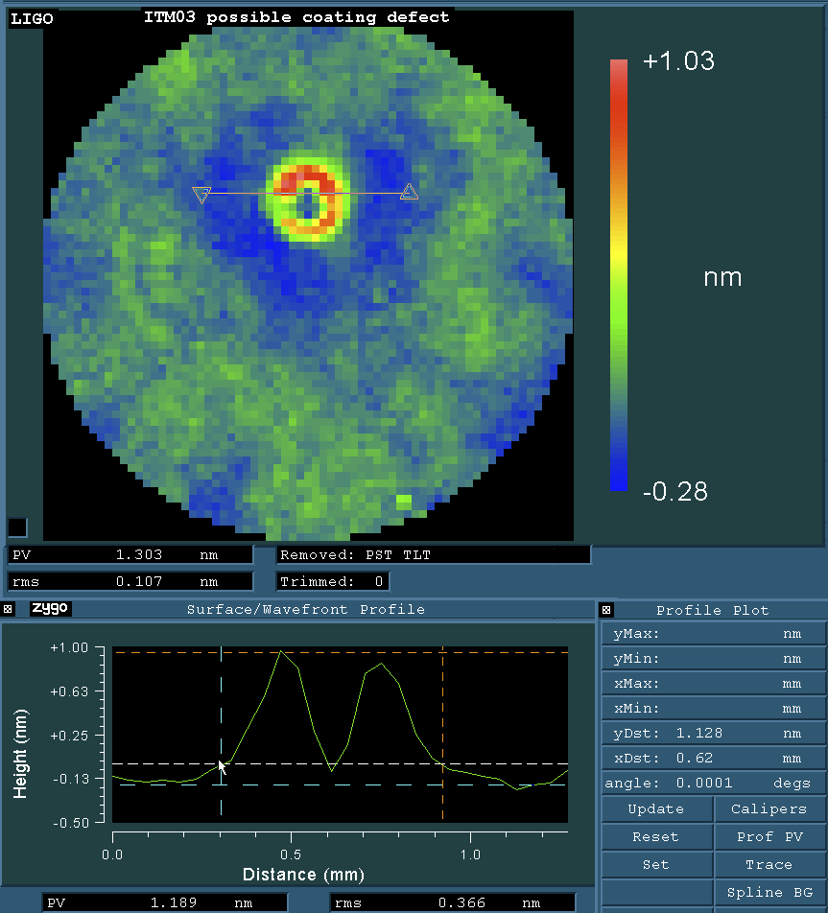

A larger field of view shows the small spot in relation to the spiral pattern along the left edge. The spiral pattern comes from the coating deposition. We know that this pattern peaks at a radius of 40 mm from the center of the optic.
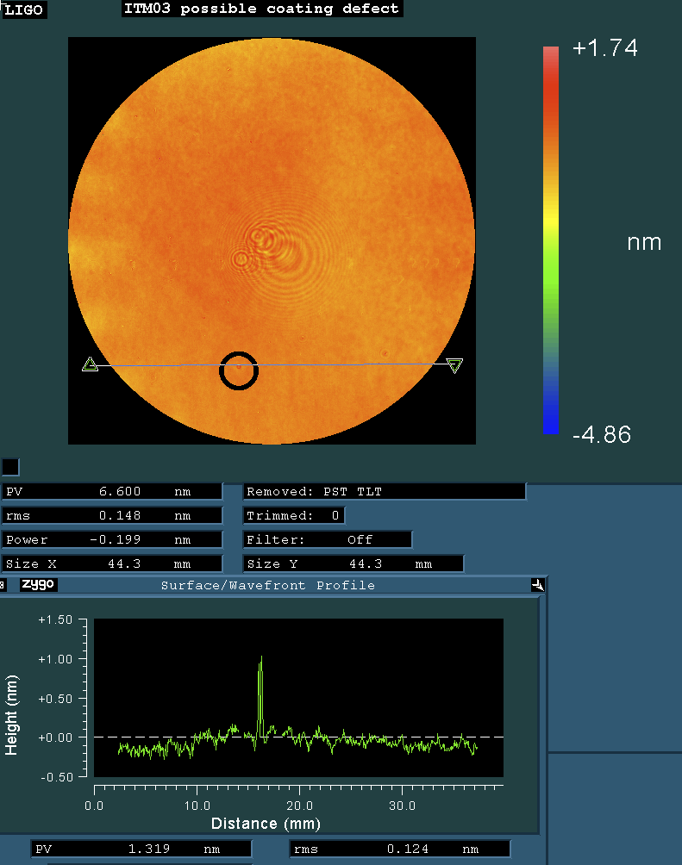

Scatter loss analysis
Let us assume that the density of defects remains constant over the entire beam area. On the worst optic, ITM03 there are three, 1 mm defects in the center 50 mm. When scaled, these become 17 defects in the center 120 mm. We know that the loss scales as a function of the height of the defect. As can be seen in the microroughness data above, the height is of order one nanometer.
total area in 120 mm dia CA (mm^2) | A_CA = pi/4*(120mm)^2 | 11310 | mm^2
total defect area in CA (um^2) | A_defect | 13.5E06 | um^2
geometric loss | geom_loss = A_defect / A_CA | 1,194 | ppm
defect depth / height h (um) | h | 0.001 | um
Loss scaling, valid for h << λ | scaled_loss=(4*pi*h/λ)^2 | 1.4E-04
Scaled Geometric loss | geom_loss * scaled_loss | 0.2 | ppm

