LIGO Laboratory / LIGO Scientific Collaboration

LIGO-T1400160-v8 LIGO Updated - December, 2014

H1 Optical Lever Inspection and Checklist

Doug Cook, Thomas Vo, Eric Gustafson, and V. Sandberg

Distribution of this document:
LIGO Scientific Collaboration
This is an internal working note
of the LIGO Laboratory.

California Institute of Technology  LIGO Project – MS 18-34  1200 E. California Blvd.  Pasadena, CA 91125  Phone (626) 395-2129  Fax (626) 304-9834  E-mail: info@ligo.caltech.edu | Massachusetts Institute of Technology  LIGO Project – NW22-295  185 Albany St  Cambridge, MA 02139  Phone (617) 253-4824  Fax (617) 253-7014  E-mail: info@ligo.mit.edu
LIGO Hanford Observatory  P.O. Box 159  Richland WA 99352  Phone 509-372-8106  Fax 509-372-8137 | LIGO Livingston Observatory  P.O. Box 940  Livingston, LA 70754  Phone 225-686-3100  Fax 225-686-7189

http://www.ligo.caltech.edu/

Document History:
V4 March 24, 2014 First draft
V5 April 4, 2014 LHO Corner Walk Around Inspection
V6 April 20, 2014 Revision
V7 June 27, 2014 LHO Corner, EX, and EY walk through inspection
V7 July 24, 2014 Standardized document to html format.
V8 December 10, 2014 LHO walk around inspection revision and notes

H1 Optical Lever Inspection and Checklist

Scope and Introduction
This document reviews and summarizes the work required to finish installing and commissioning the H1 Optical Levers. It is kept as a working document so that the task list can be updated as the work is completed. Section 1 pertains to all optical levers and sections 2 through 11 contain the work required for specific optical levers. This document also contains a summary page of most of the related issues affecting the fabrication and installation requirements.

Optical levers by target and location
There are eleven optical levers per interferometer. They are named for the optics they monitor, but the oplev laser and receiver are located tens of meters away from the named optic.
The table shown below was derived from LIGO-T1000517-v5, “Optical Levers Final Design Review”, R. Desalvo et al. The Beam Tube MC Tube Flanges are documented in:
T1200245-v1, “WA MC A1”
T1200246-v1, “WA MC B1”
T1200247-v1, “WA MC A2”
T1200248-v1, “WA MC B2”

aLIGO Optical Levers

OpLev # | IFO | Optic | Chamber | Flange Type | Flange Location | In Viewport | Out Viewport | Building
1 | H1 | IMTX | BSC3 | A1-A | CP-2 | VP3 | VP6 | LVEA
2 | H1 | ITMY | BSC1 | A1-B | CP-1 | VP4 | VP1 | LVEA
3 | H1 | ETMX | BSC9 | A1-A | Facing chamber | VP4 | VP1 | X END
4 | H1 | ETMY | BSC10 | A1-B | Facing chamber | VP3 | VP6 | Y END
5 | H1 | BS | BSC2 | -- | On chamber | G2 | G2 | LVEA
6 | H1 | PR3 | HAM2 | IMC Tube | WAMCB1 | VP7 | VP11 | LVEA
7 | H1 | SR3 | HAM5 | OMC Tube | WAMCB2 | VP5 | VP1 | LVEA
8 | H1 | HAM2 Mirror | HAM2 | IMC Tube | WAMCB1 | VP5 | VP5 | LVEA
9 | H1 | HAM3 Mirror | HAM3 | IMC Tube | WAMCA1 | VP5 | VP5 | LVEA
10 | H1 | HAM4 Mirror | HAM4 | OMC Tube | WAMCA2 | VP5 | VP5 | LVEA
11 | H1 | HAM5 Mirror | HAM5 | OMC Tube | WAMCB2 | VP7 | VP7 | LVEA

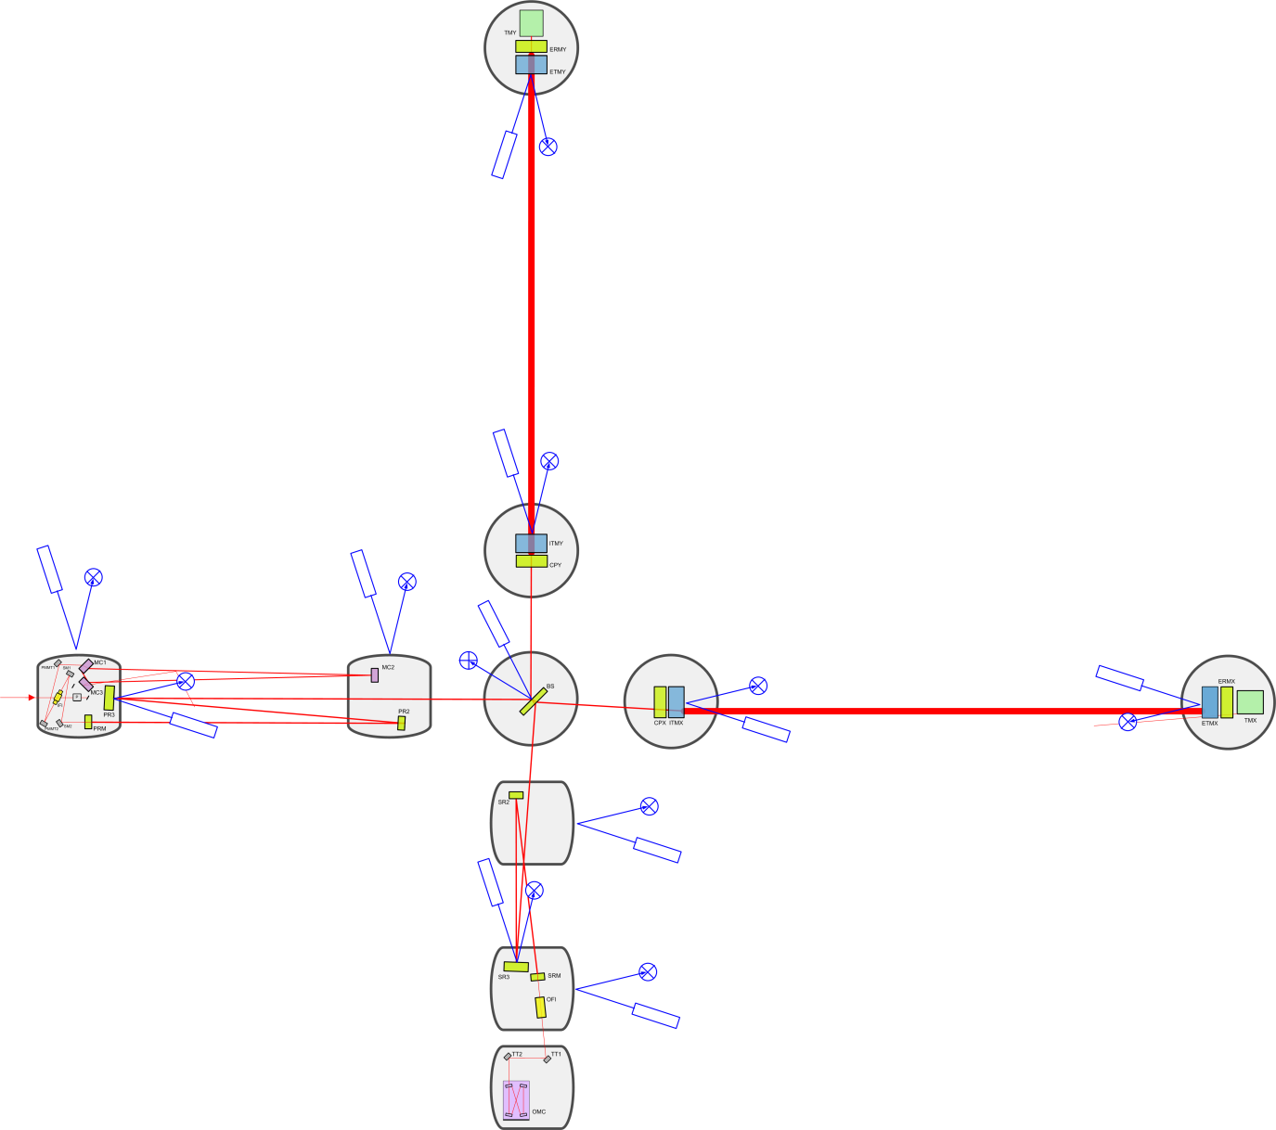
Fig. 1 Optical levers and associated optics

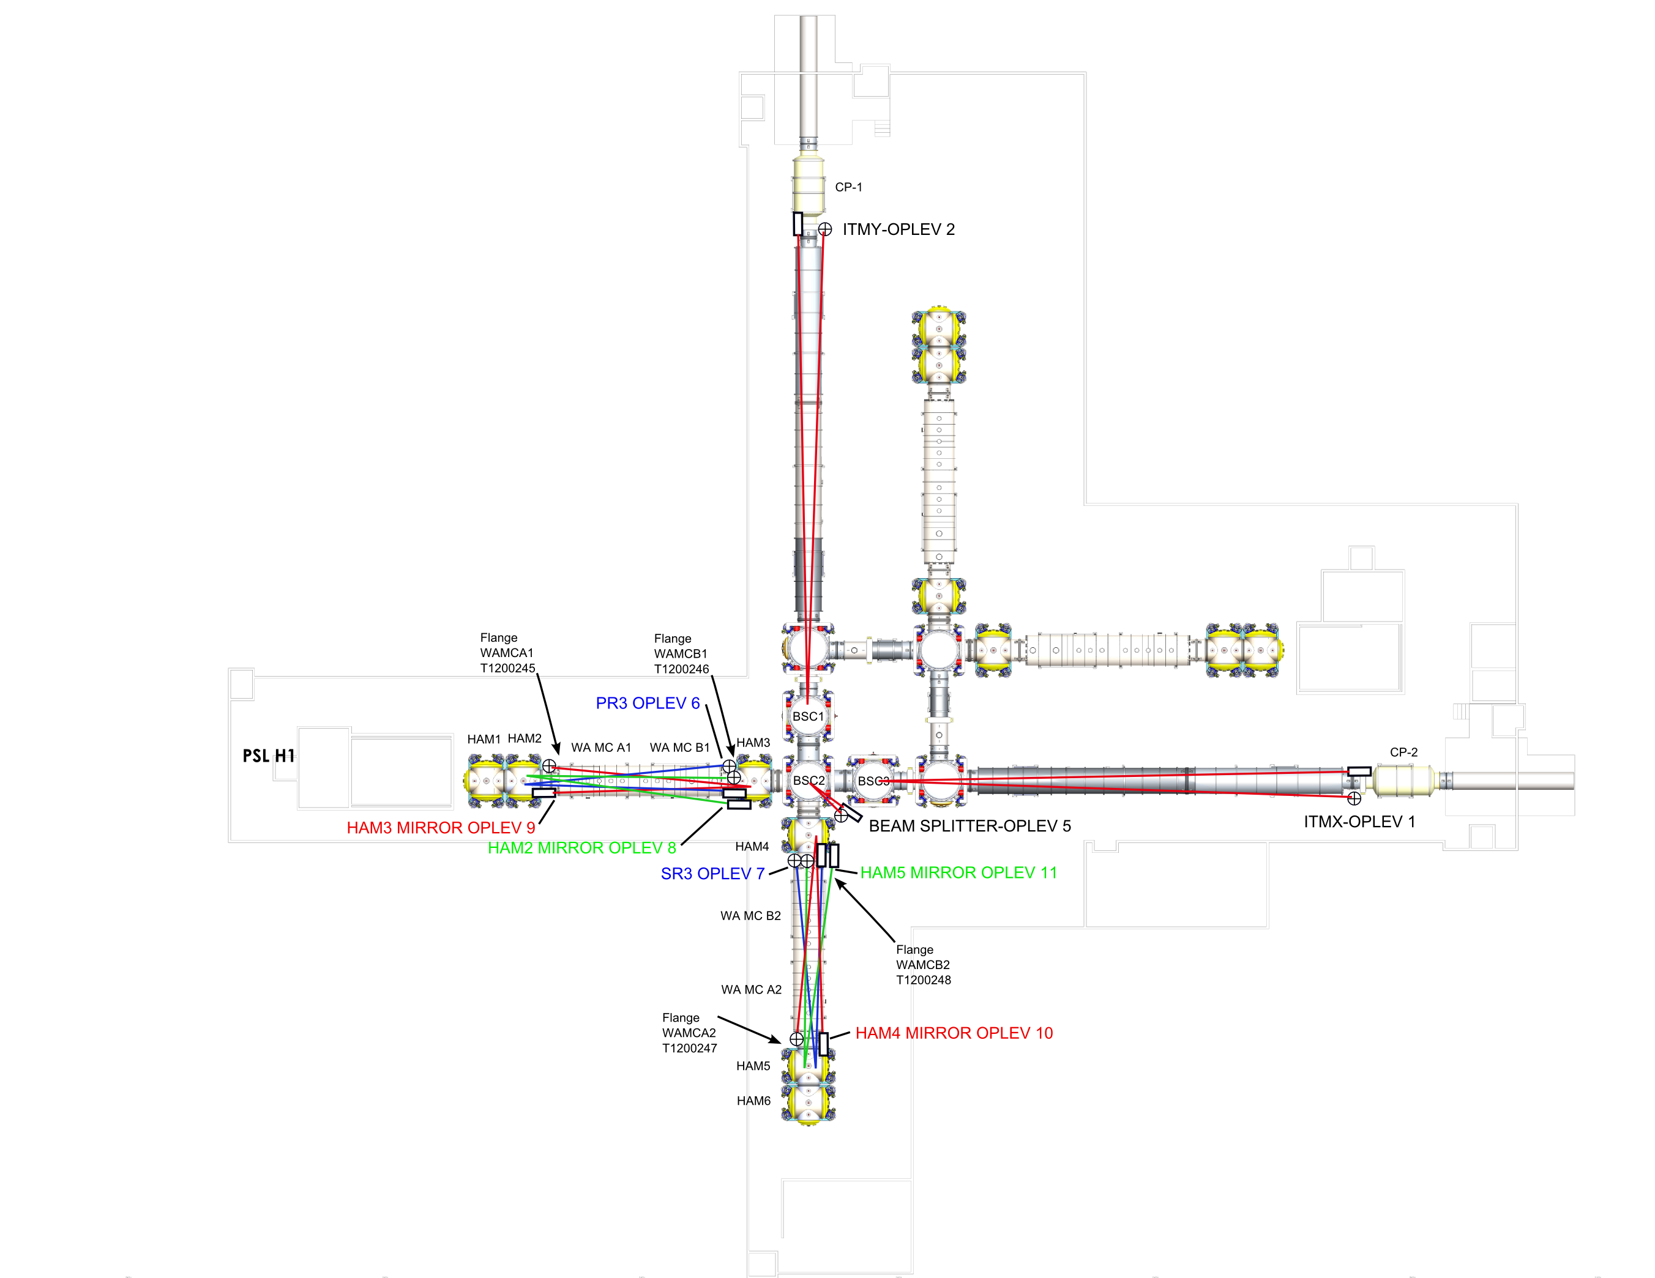
Fig 2 The physical layout and location with respect to mode cleaner flanges.

Installation Items Applicable to All Optical Levers on Site

Items that need to be completed before the Fabrication Acceptance Review can be completed.
- All fibers must be coiled (loops of diameter > 4 inch to avoid straining the fiber), the loop should be attached to the launching pier and they must be routed so there is no tripping hazard or damage to delicate fibers.
- All Laser modules must be converted to 18vdc/5vdc power supplies D1200461-v1.
- Remove extraneous equipment and trash from piers. Order/install warning labels for damping weights and “no step”; “no touch” for piers, “contains lead”.
- Check MEDM screens for correct orientation of QPD (i.e. pitch and yaw not flipped).
- Calibrations, units, pitch and yaw recording on proper channels with proper directional sign with respect to a ‘right hand rule’ should be set for all QPDs in the DAQ channels.
- Snap shot of the antialiasing filters and recording (photo as well) of the binary output modules for the whitening chassis.
- MEDM screens must indicate the transimpedance state of the QPD (e.g. either 10k or 100k – switch position)
- Check all Optical Levers chassis to make sure cable connectors are screwed in properly.

Items that need to be completed to complete the Installation Acceptance Review
- All laser power modules must be mounted in appropriate racks and off the floor.
- All pylons must be grouted to the floor (Mechanical fixes such as raising pier heights, bellow alignments with reduced seismic shorting. Adding grommets of the right sizes, purchasing/designing various racks for electronic support.
- Install damping weights on leaners and measure the resonances before and after (BK “hammer” probably starting with ITMx, including optical lever zeroing to a good ITM alignment and recording of any optical lever positional changes).Install lead dampers (complete builds of damping weight enclosures including lead)
- Create a noise budget for each optical lever (RIN). The “mode hop free” range should be adjusted as needed. Complete the written procedure
- All cables need to be labeled
- Design and fabricate PR3 and SR3 receiver light pipe mounting.

Longer term punch list items which are beyond the scope of aLIGO but are needed to improve aLIGO performance
- Cables entering laser and receiver boxes are strain relieved on the pier by proper clamping; i.e. not just cable ties. Inside the cable clamp should be soft enough to not damage fibers or cables.
- Cables entering boxes, must enter box through snug grommet holes to make the box more air tight.
- Add foam seals to boxes to reduce airflow through gaps.
- Wire up all lasers cooling fans to reduce acoustic noise by adding diodes to reduce RPM.
- Receiver boxes should be reasonably light tight. QPDs are sensitive to room lights.
- Whitening board dip switch control board needs screws to attach to whitening chassis. These are a kind of captured screw since both ends are threaded; Carl knows what it should be. Threaded holes need to be drilled out for screw clearance.
- Replace laser and QPD enclosure screws with thumb screws for easy box opening.
- Replace nuts on Optical Lever whitening chassis D-connectors with shorter nuts to allow firm seating of cable from QPD.
- Label all cables / chassis with what optic is connected to where.
- Coiled fiber should be covered by foam (e.g. Sorbothane) to shield from wind and acoustics.
- Check the electrical connections for screws that are too long per ALOG 11633.
- Change the whitening board gain settings: 10:1 whitening and 16 db gain on.
- Add thermal blankets to reduce effect external temperature fluctuation.
- The controller that moves the QPD translation stage broke so we needed to do an impromptu soldering job. This could have been avoided if we didn’t have to move this controller around to the end stations every time we want to re-align the various optical levers. We should investigate remote control of these stages from the control room (see Fig. 3).
- Spares analysis updates.

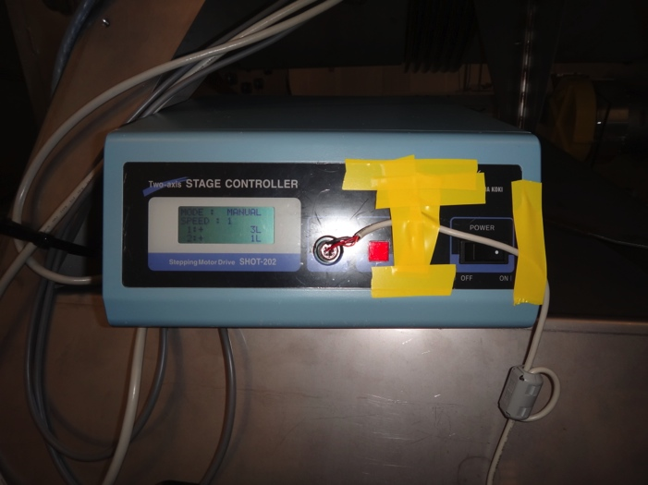
Fig. 3 Optical Lever stage controller and fragile electrical connection. Also should have “quick connect, connectors to reduce any further wear and tear to optical lever and or controller

1. ITMX

Transmitter:

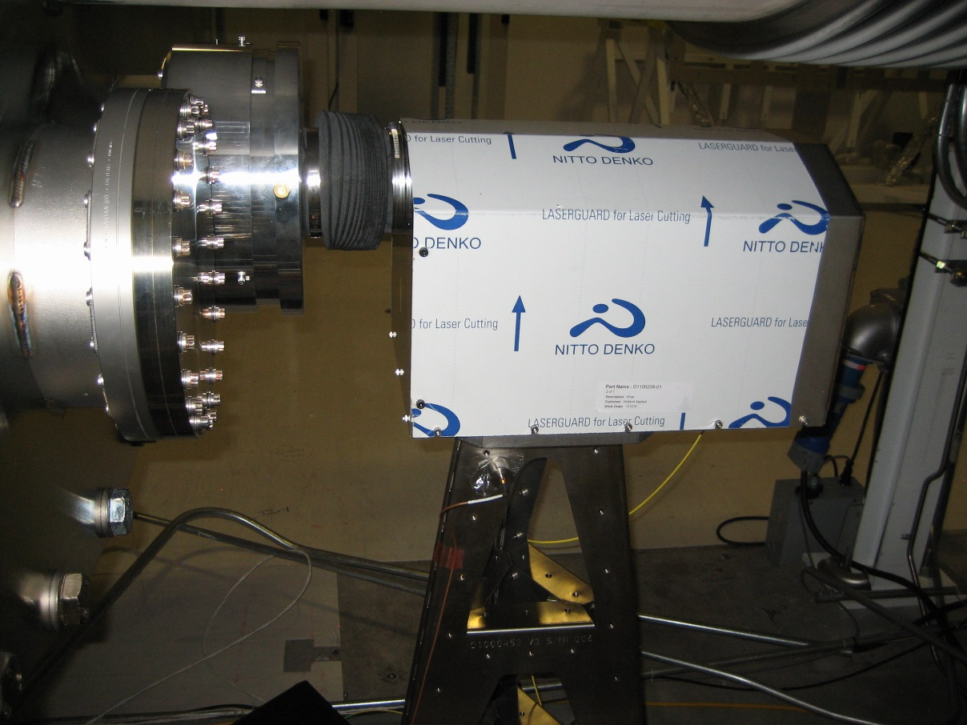

Electronics
- Needs laser mounting rack to get it off of the ground and needs to include the DC to DC converter. Needs to be designed or bought. (This may require more than one configuration as each installation has unique requirements).
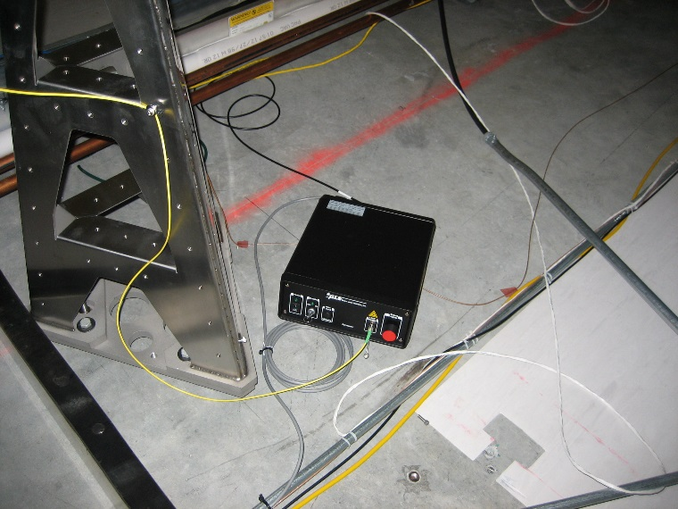
- Some cables need to be labeled.
- Laser needs to have the 18vdc to 5vdc daughter card installed outside of laser enclosure (heat issue).Separate box and pigtail.
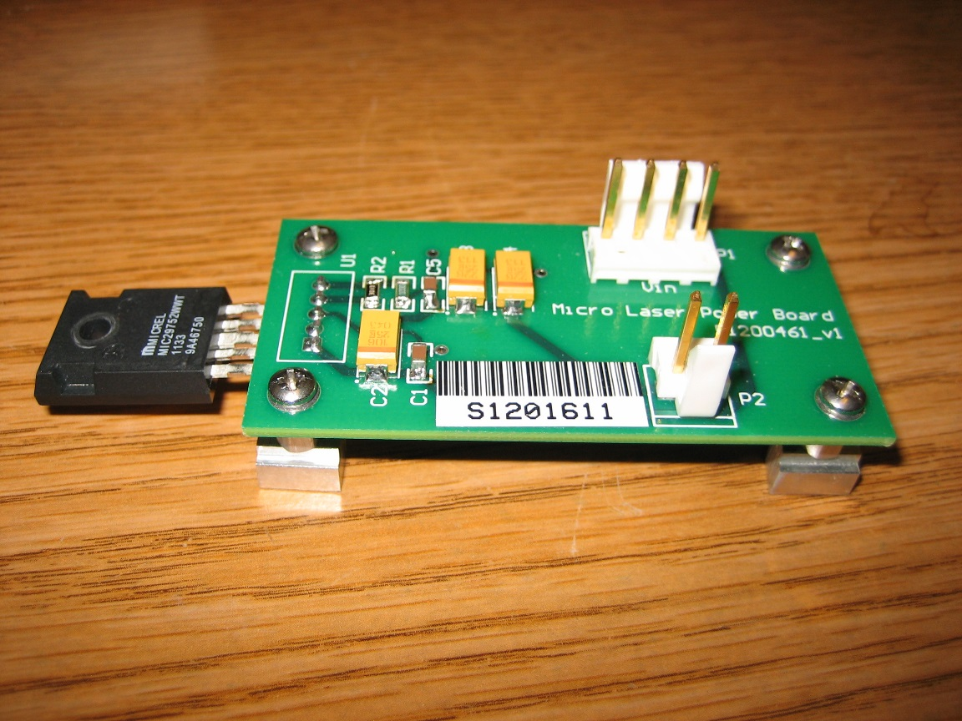
- Note: No ice chest enclosure (not aLIGO req).
- Reduced RPM on laser enclosure fan to reduce acoustic noise (add diodes) - Yes___, No____,? X
- Bench setting of mode hop free range – Yes___, No X

Optics
- The fiber must be rolled into a larger loop and secured to protect it.

Pier Location and Mechanical
- Pylon needs to be raised and grouted.
- Needs proper grommet.
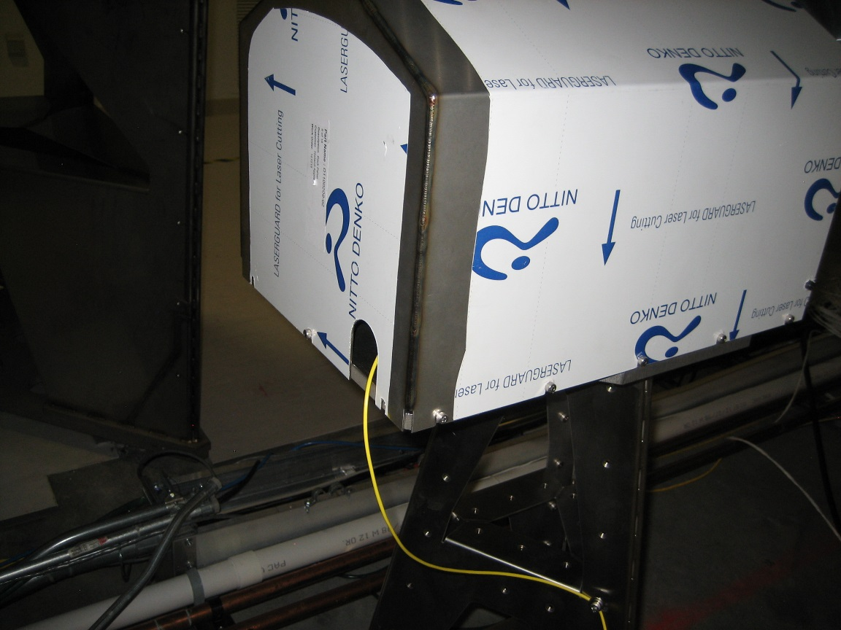
- Modify bellows to provide for a more mechanically compliant connection.
- Needs new proper sized grommet to prevent laser light exposure from the enclosure.
- Remove paper wrap on laser boxes.
- Remove extraneous equipment and trash from piers. Add labels to piers indicating 'No Step' and 'No Touch'

Receiver:

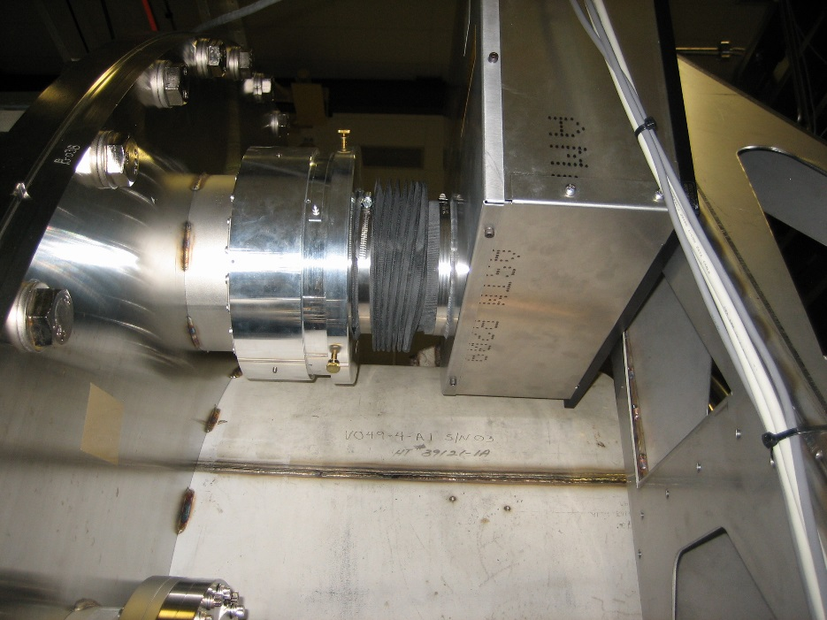
- Add “quick” connects to translation stage power and signal cables to save on wear and tear by having to hard wire each time a connection is needed.

Electronics
- Binary output modulator installed and gains set.
- Add “quick” connects to translation stage power and signal cables to save on wear and tear by having to hard wire each time a connection is needed.
- Some cables need to be labeled.
- Needs laser mounting rack to get it off of the ground and including the DC to DC converter. Needs to be designed or bought. (This may require more than one configuration as each installation has unique requirements).

Pier Location and Mechanical
- Need lead dampeners with enclosure.
- Modify bellows to provide for a more mechanically compliant connection.
- Pylon needs to be grouted.
- Remove paper cover on laser boxes.
- Remove extraneous equipment and trash from piers. Add labels to piers indicating 'No Step' and 'No Touch'.

Testing
- Recheck calibration.
- Beam profiled and power measured.
- Check MEDM screens for correct orientation of QPD (i.e. pitch and yaw not flipped).
- Calibrations, units, pitch and yaw recording on proper channels with proper directional sign with respect to a ‘right hand rule’ should be set for all QPDs in the DAQ channels.

2. ITMY

Transmitter:

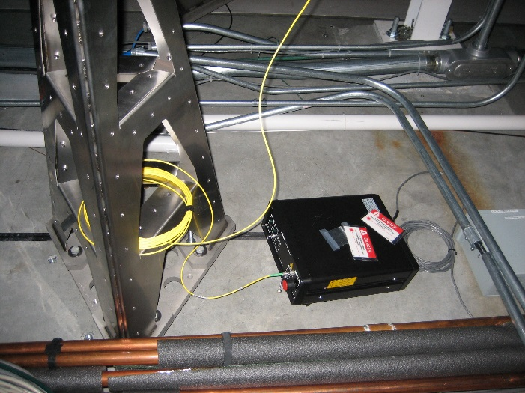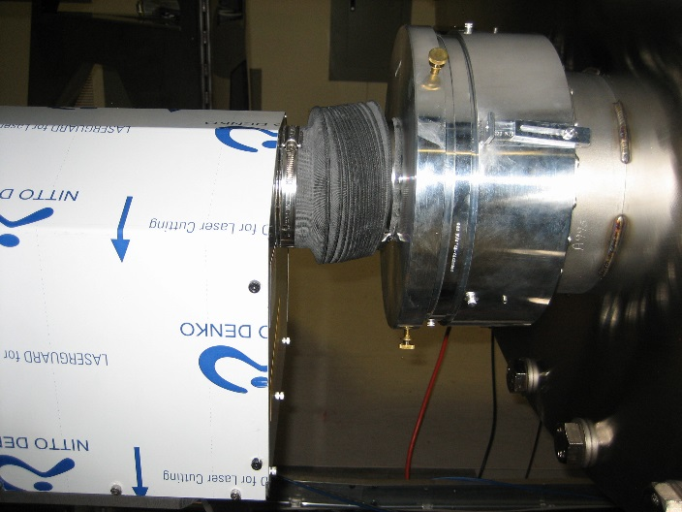

Electronics
- Needs laser mounting rack to get it off of the ground.
- Needs to be designed or bought. (This may require more than one configuration as each installation has unique requirements).
- Laser needs to have the 18vdc to 5vdc daughter card installed outside of laser enclosure (heat issue).
- Some cables need to be labeled.
- Note: No ice chest enclosure (not aLIGO req).
- Reduced RPM on laser enclosure fan (add diodes) - Yes___, No____,? X
- Bench setting of mode hop free range – Yes___, No X

Optics
- The fiber must be rolled into a larger loop and secured to protect it.

Pier Location and Mechanical
- Pylon needs to be raised and grouted.
- Modify bellows to provide for a more mechanically compliant connection.
- Needs new proper sized grommet to prevent laser light exposure from the enclosure.
- Remove paper cover on laser boxes.
- Remove extraneous equipment and trash from piers. Add labels to piers indicating 'No Step' and 'No Touch'

Receiver:

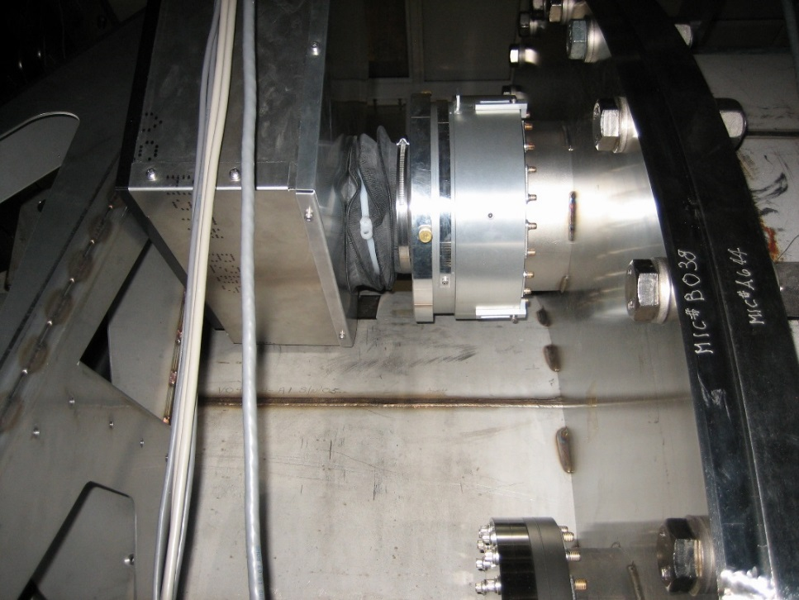

Electronics
- Binary output modulator installed and gains set.
- Add “quick” connects to translation stage power and signal cables to save on wear and tear by having to hard wire each time a connection is needed.
- Some cables need to be labeled.

Pier Location and Mechanical
- Need lead dampeners with enclosure.
- Modify bellows to provide for a more mechanically compliant connection.
- Pylon needs to be grouted.
- Remove paper cover on laser boxes.

Testing
- Recheck calibration.
- Beam profiled and power measured.
- Check MEDM screens for correct orientation of QPD (i.e. pitch and yaw not flipped).
- Calibrations, units, pitch and yaw recording on proper channels with proper directional sign with respect to a ‘right hand rule’ should be set for all QPDs in the DAQ channels.
- BK Hammer measurement

3. ETMX

Transmitter:

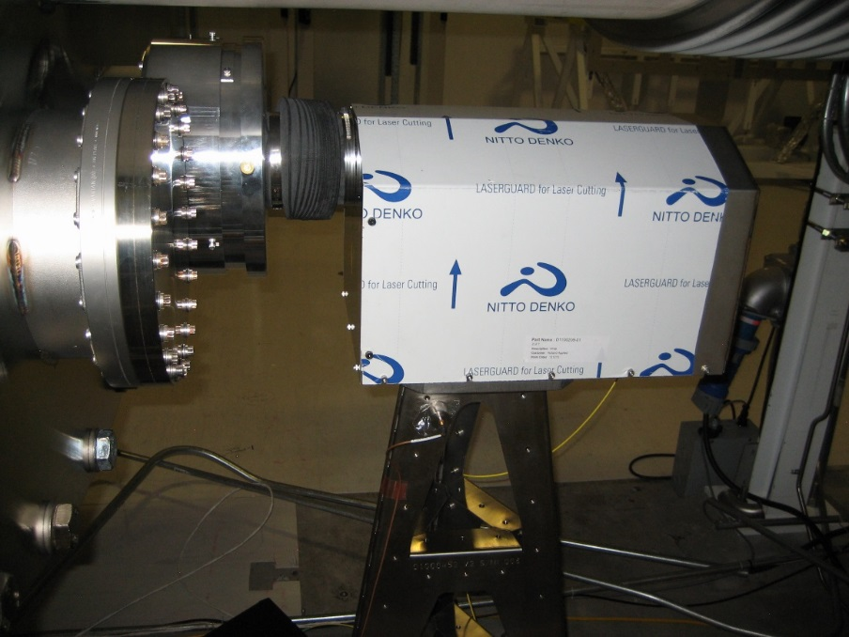

Electronics
- Needs laser mounting rack to get it off of the ground. Needs to be designed or bought. (This may require more than one configuration as each installation has unique requirements).
- Laser needs to have the 18vdc to 5vdc daughter card installed outside of laser enclosure (heat issue).
- Note: No ice chest enclosure (not aLIGO req).
- Reduced RPM on laser enclosure fan (add diodes) - Yes___, No____, ? X
- Bench setting of mode hop free range – Yes___, No X

Optics
- The fiber must be rolled into a larger loop and secured to protect it.

Pier Location and Mechanical
- Pylon needs to be grouted.
- Modify bellows to provide for a more mechanically compliant connection.
- Remove paper cover on laser boxes.
- Needs new proper sized grommet to prevent laser light exposure from the enclosure.
- Remove extraneous equipment and trash from piers. Add labels to piers indicating 'No Step' and 'No Touch'
- BK Hammer measurements

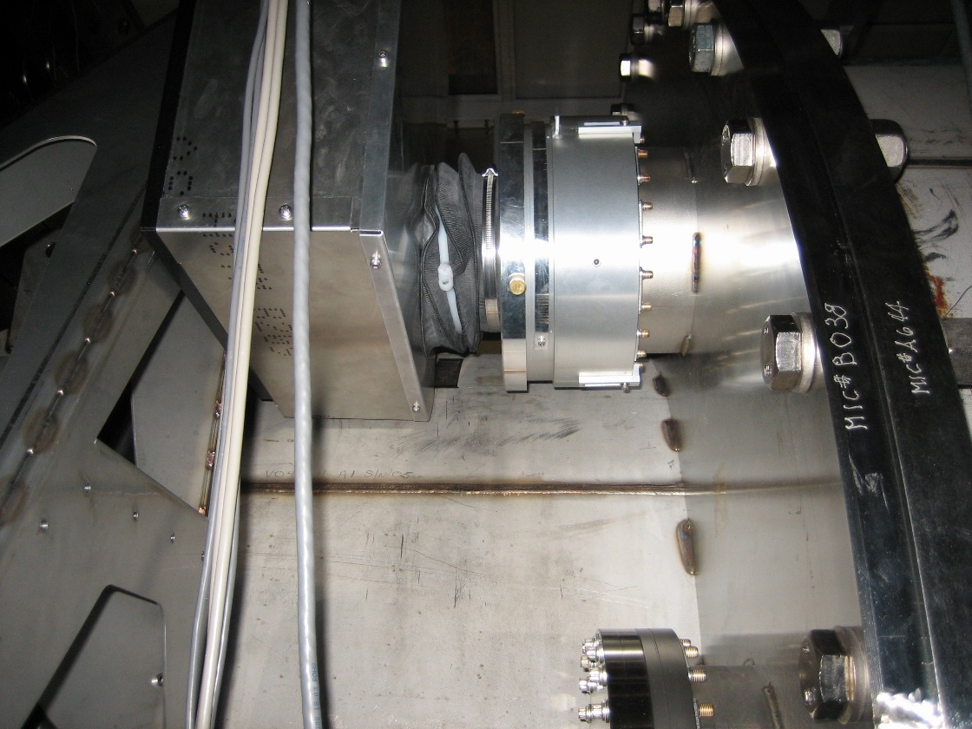
Receiver:

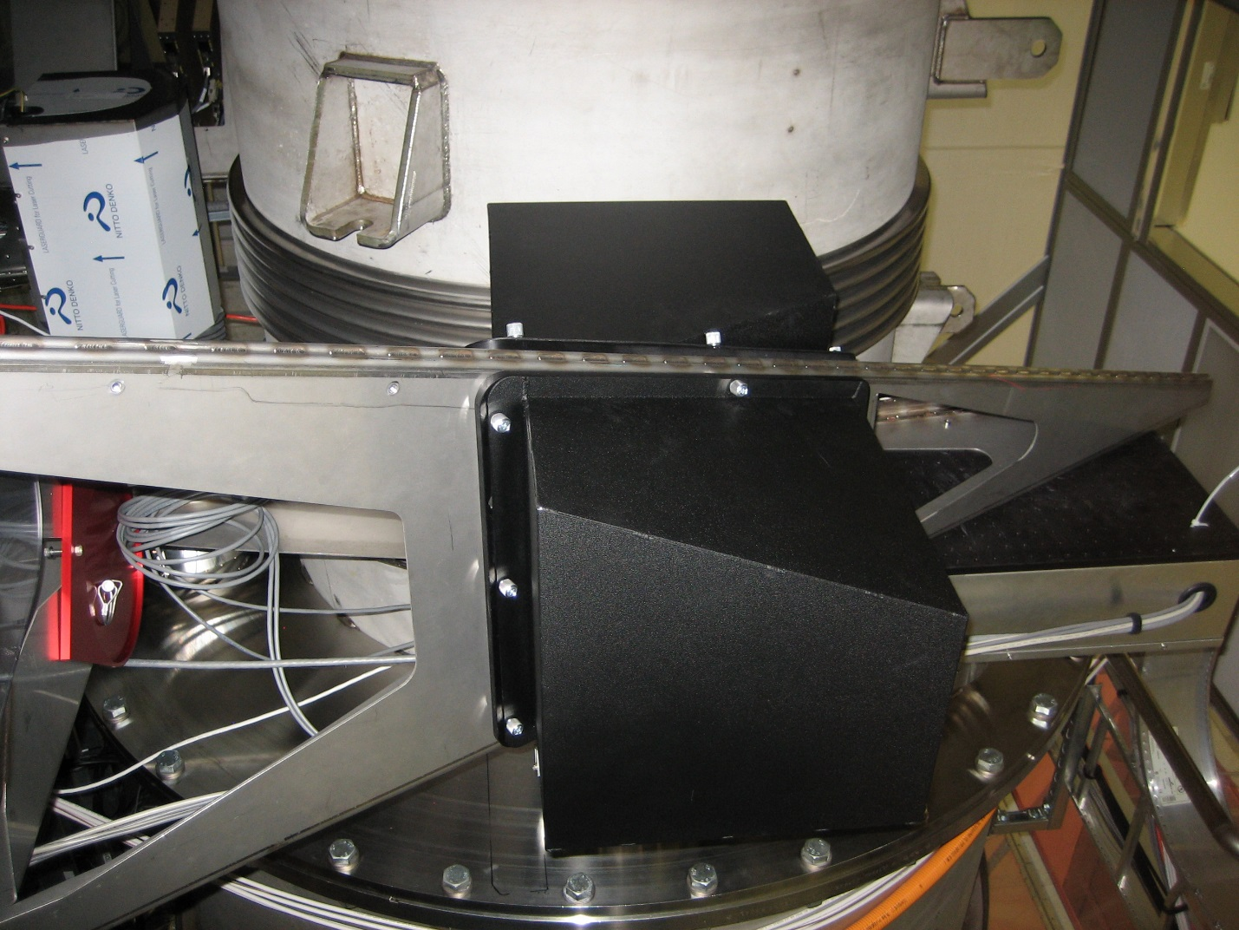
- Add “quick” connects to translation stage power and signal cables to save on wear and tear by having to hard wire each time a connection is needed.

Electronics
- Binary output modulator installed and gains set.
- Add “quick” connects to translation stage power and signal cables to save on wear and tear by having to hard wire each time a connection is needed.
- Replace the cable connecting the QPD to the whitening chassis with a shorter DB15.

Pier Location and Mechanical
- Need lead dampeners with enclosure.
- Modify bellows to provide for a more mechanically compliant connection.
- Remove paper cover on laser boxes.
- Remove paper cover on laser boxes.
- Pylon needs to be grouted.
- P-Cal complete and in final configuration.
- Remove extraneous equipment and trash from piers. Add labels to piers indicating 'No Step' and 'No Touch'.

Testing
- Recheck calibration.
- Beam profiled and power measured.
- Check MEDM screens for correct orientation of QPD (i.e. pitch and yaw not flipped).
- Calibrations, units, pitch and yaw recording on proper channels with proper directional sign with respect to a ‘right hand rule’ should be set for all QPDs in the DAQ channels.

4. ETMY

Transmitter:

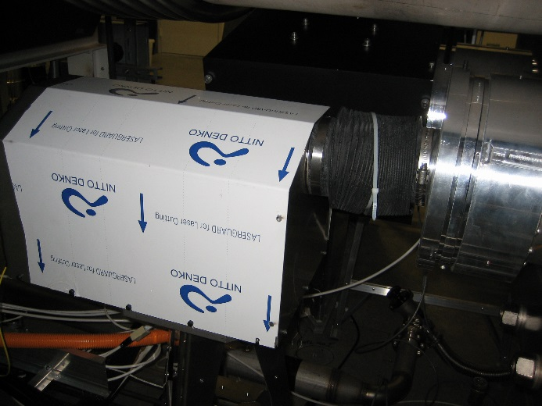
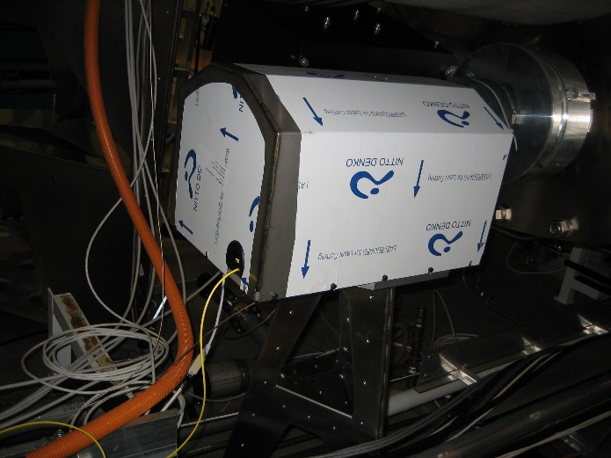
Pull plastic wrap and label the enclosure and add thumb screws

Electronics
- Needs laser mounting rack to get it off of the ground. Needs to be designed or bought. (This may require more than one configuration as each installation has unique requirements).
- Laser needs to have the 18vdc to 5vdc daughter card installed outside of laser enclosure (heat issue).
- No ice chest enclosure. Note: No ice chest enclosure (not aLIGO req).
- Reduced RPM on laser enclosure fan (add diodes) - Yes___, No____,? X
- Bench setting of mode hop free range – Yes___, No X

Optics
- The fiber must be rolled into a larger loop and secured to protect it.

Pier Location and Mechanical
- Pylon needs to be grouted.
- Modify bellows to provide for a more mechanically compliant connection.
- Needs new proper sized grommet to prevent laser light exposure from the enclosure.
- Remove paper cover on laser boxes.
- BK Hammer measurements
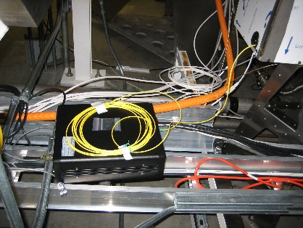

Receiver:

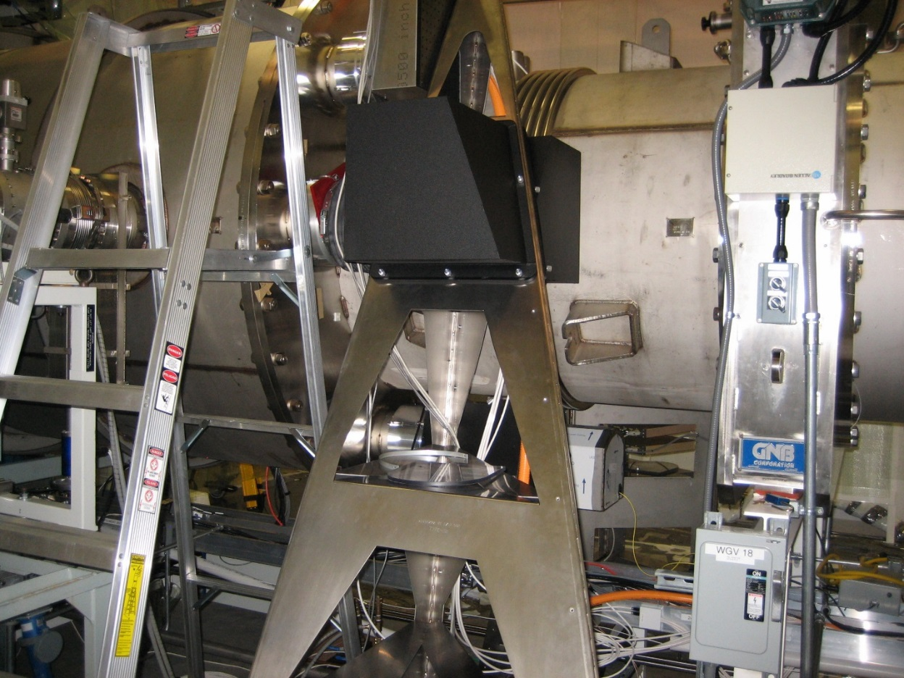

Electronics
- Binary output modulator installed and gains set.
- Add “quick” connects to translation stage power and signal cables to save on wear and tear by having to hard wire each time a connection is needed.
- Replace the cable connecting the QPD to the whitening chassis with a shorter DB15.

Pier Location and Mechanical
- Need lead dampeners with enclosure.
- Modify bellows to provide for a more mechanically compliant connection.
- Remove paper cover on laser boxes.
- Remove paper cover on laser boxes.
- Pylon needs to be grouted.
- P-Cal complete and in final configuration.
- Remove extraneous equipment and trash from piers. Add labels to piers indicating 'No Step' and 'No Touch'

Testing
- Recheck calibration.
- Beam profiled and power measurement
- Check MEDM screens for correct orientation of QPD (i.e. pitch and yaw not flipped).
- Calibrations, units, pitch and yaw recording on proper channels with proper directional sign with respect to a ‘right hand rule’ should be set for all QPDs in the DAQ channels.

5. Beam Splitter (BS)

Transmitter/Receiver (Transceiver):

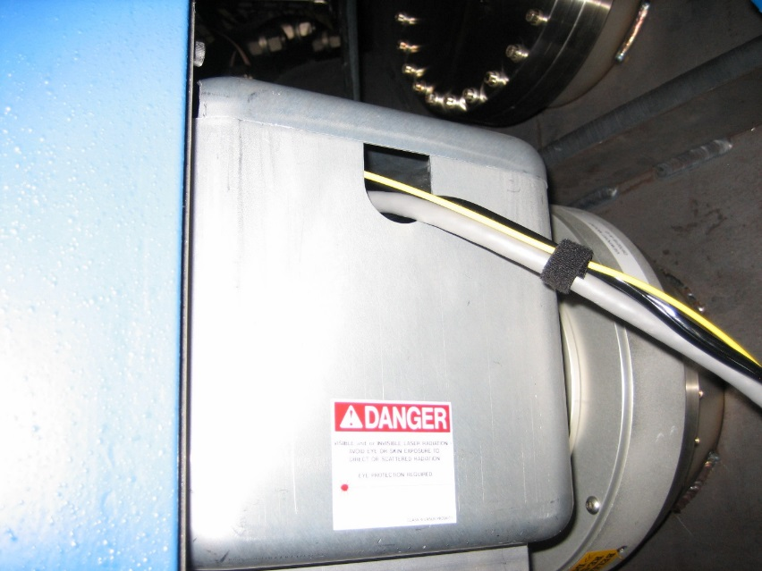

Electronics
- Needs laser mounting rack to get it off of the ground. Needs to be designed or bought. (This may require more than one configuration as each installation has unique requirements).
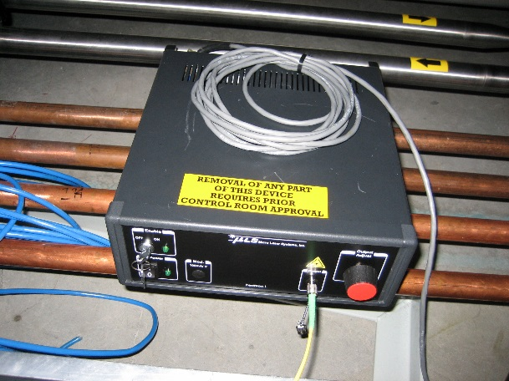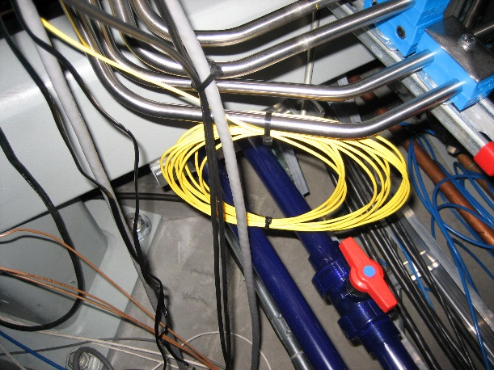
- Laser needs to have the 18vdc to 5vdc daughter card installed outside of laser enclosure (heat issue).
- Note: No ice chest enclosure (not aLIGO req).
- Reduced RPM on laser enclosure fan (add diodes) - Yes___, No____,? X
- Bench setting of mode hop free range – Yes___, No X

Optics
- The fiber must be rolled into a larger loop and secured to protect it.

Pier Location and Mechanical

Blue BSC Pier - complete

Electronics
- Binary output modulator installed and gains set.
- Add “quick” connects to translation stage power and signal cables to save on wear and tear by having to hard wire each time a connection is needed.

Pier Location and Mechanical
Mounted on grouted blue pier.Complete

Testing
- Recheck calibration.
- Beam profiled and power measured.
- Check MEDM screens for correct orientation of QPD (i.e. pitch and yaw not flipped).
- Calibrations, units, pitch and yaw recording on proper channels with proper directional sign with respect to a ‘right hand rule’ should be set for all QPDs in the DAQ channels.

6. PR3

Transmitter:

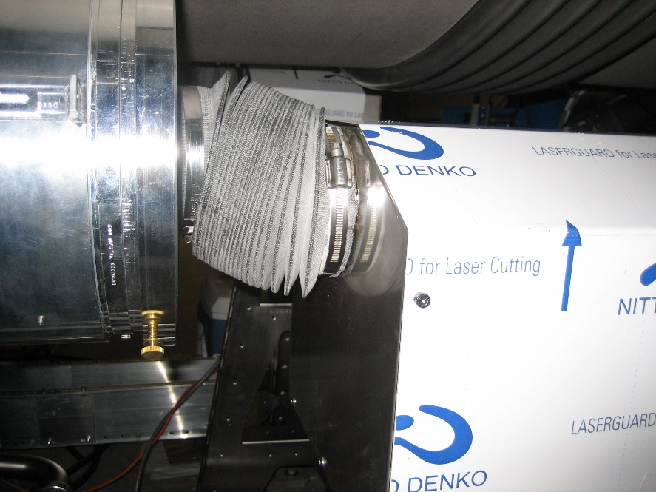

Electronics
- Needs laser mounting rack to get it off of the ground. Needs to be designed or bought. (This may require more than one configuration as each installation has unique requirements).
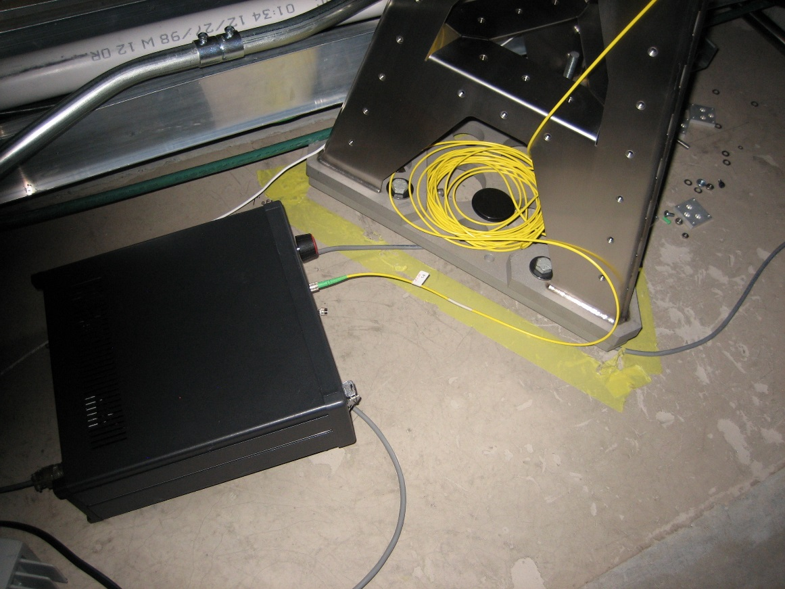
- Laser needs to have the 18vdc to 5vdc daughter card installed outside of laser enclosure (heat issue).
- Note: No ice chest enclosure. (not an aLIGO req).
- Reduced RPM on laser enclosure fan (add diodes) - Yes___, No____,? X
- Bench setting of mode hop free range – Yes, X , No _____

Optics
- The fiber must be rolled into a larger loop and secured to protect it.

Pier Location and Mechanical
- Pylon needs to be grouted.
- Modify bellows to provide for a more mechanically compliant connection.
- Needs new proper sized grommet to prevent laser light exposure from the enclosure.
- Remove paper cover on laser boxes.
- Remove extraneous equipment and trash from piers. Add labels to piers indicating 'No Step' and 'No Touch'.

Receiver:

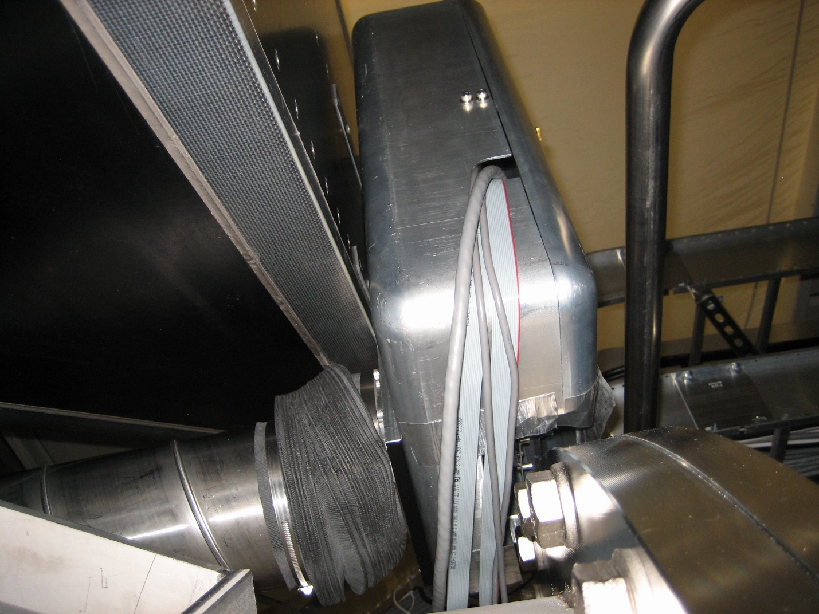

Electronics
- Binary output modulator installed and gains set.
- Add “quick” connects to translation stage power and signal cables to save on wear and tear by having to hard wire each time a connection is needed.

Pier Location and Mechanical
- Modify bellows to provide for a more mechanically compliant connection.
- Remove paper cover on laser boxes.
- Pylon needs to be grouted.
- We need to raise this pylon to reduce the amount of stretch on the bellow and reduce the seismic isolation coupling.
- Beam pipe needs some support (needs a design).
- Concern the large area of the support pier will act as a sounding board and conduct acoustical signals to the sensor head.
- Remove extraneous equipment and trash from piers. Add labels to piers indicating 'No Step' and 'No Touch'.

Testing
- Recheck calibration.
- Beam profiled and power measured.
- Check MEDM screens for correct orientation of QPD (i.e. pitch and yaw not flipped).
- Calibrations, units, pitch and yaw recording on proper channels with proper directional sign with respect to a ‘right hand rule’ should be set for all QPDs in the DAQ channels.

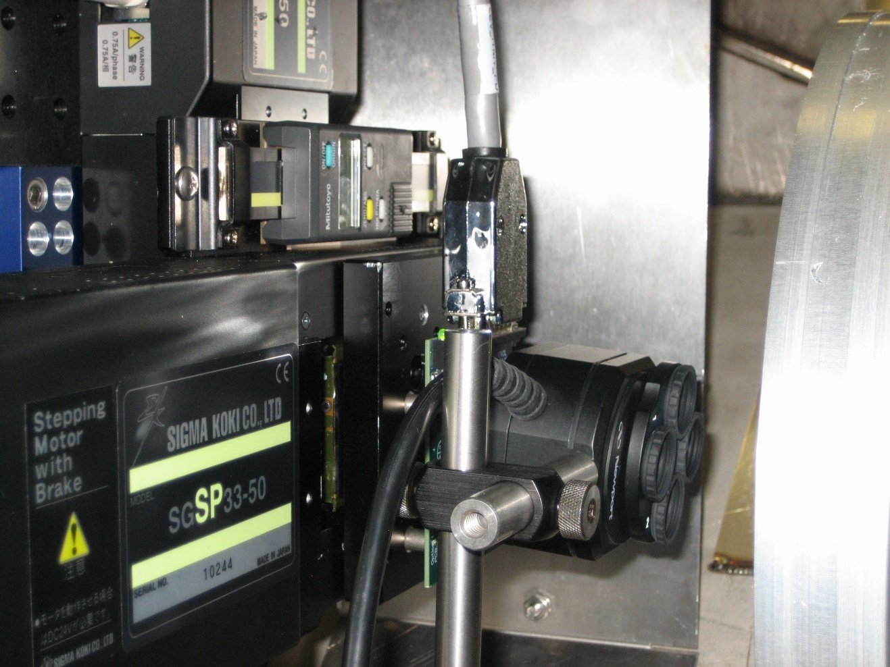
Profiler used to look at beam profile

7. SR3

Transmitter:

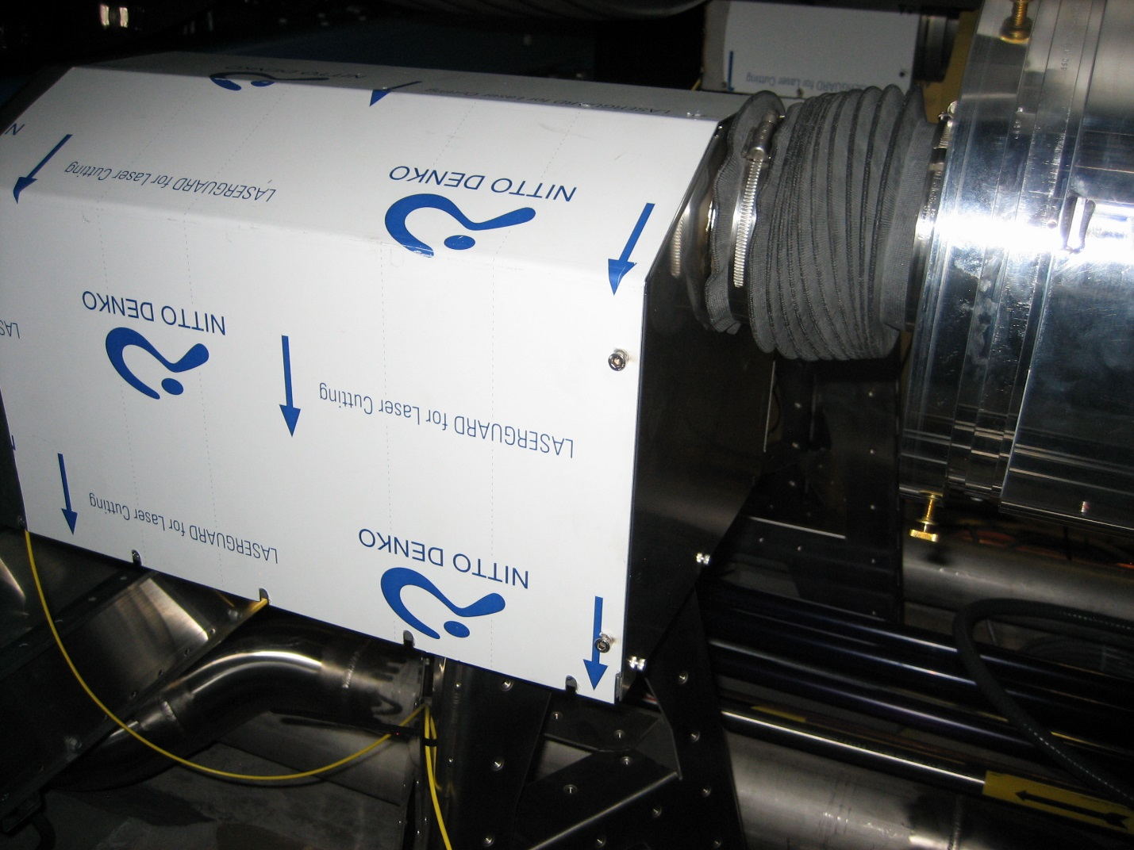

Electronics
- Needs laser mounting rack to get it off of the ground. Needs to be designed or bought. (This may require more than one configuration as each installation has unique requirements).
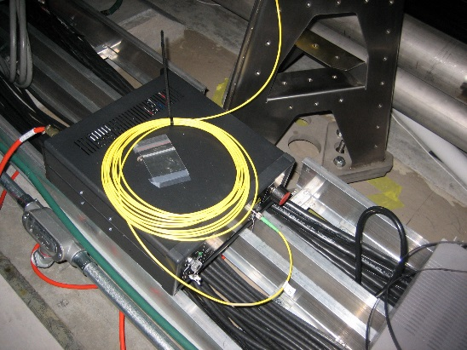
- Laser needs to have the 18vdc to 5vdc daughter card installed outside of laser enclosure (heat issue).
- Note: No ice chest enclosure (not aLIGO req).
- Reduced RPM on laser enclosure fan (add diodes) - Yes___, No____,? X
- Bench setting of mode hop free range – Yes,____, No X
- Needs light pipe support

Optics
- The fiber must be rolled into a larger loop and secured to protect it.

Pier Location and Mechanical
- Pylon needs to be grouted.
- Modify bellows to provide for a more mechanically compliant connection.
- Needs new proper sized grommet to prevent laser light exposure from the enclosure.
- Remove paper cover on laser boxes.
- Remove extraneous equipment and trash from piers. Add labels to piers indicating 'No Step' and 'No Touch'.

Receiver:

Add pic

Electronics
- Binary output modulator installed and gains set.
- Add “quick” connects to translation stage power and signal cables to save on wear and tear by having to hard wire each time a connection is needed.

Pier Location and Mechanical
- Modify bellows to provide for a more mechanically compliant connection.
- Remove paper cover on laser boxes.
- Pylon needs to be grouted.
- We need to raise this pylon to reduce the amount of stretch on the bellow and reduce the seismic isolation coupling.
- Remove extraneous equipment and trash from piers. Add labels to piers indicating 'No Step' and 'No Touch'.
- Beam pipe needs some support (needs a design).
- Concern the large area of the support pier will act as a sounding board and conduct acoustical signals to the sensor head.
- Support light pipe.
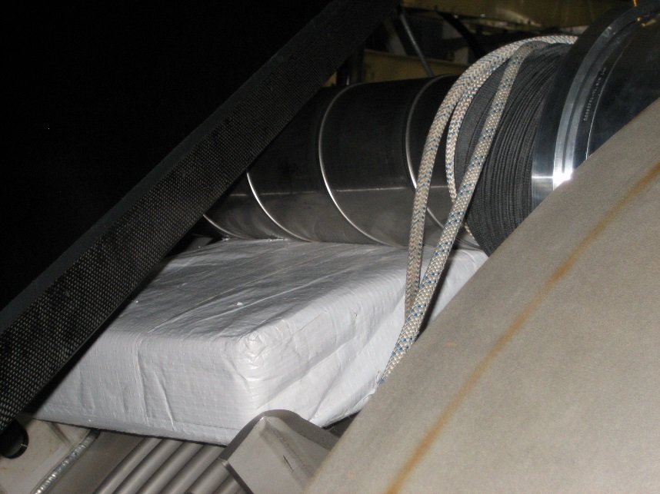

Testing
- Recheck calibration.
- Beam profiled and power measured.
- Check MEDM screens for correct orientation of QPD (i.e. pitch and yaw not flipped).
- Calibrations, units, pitch and yaw recording on proper channels with proper directional sign with respect to a ‘right hand rule’ should be set for all QPDs in the DAQ channels.

8. HAM2 Mirror

Transmitter/Receiver (Transceiver):

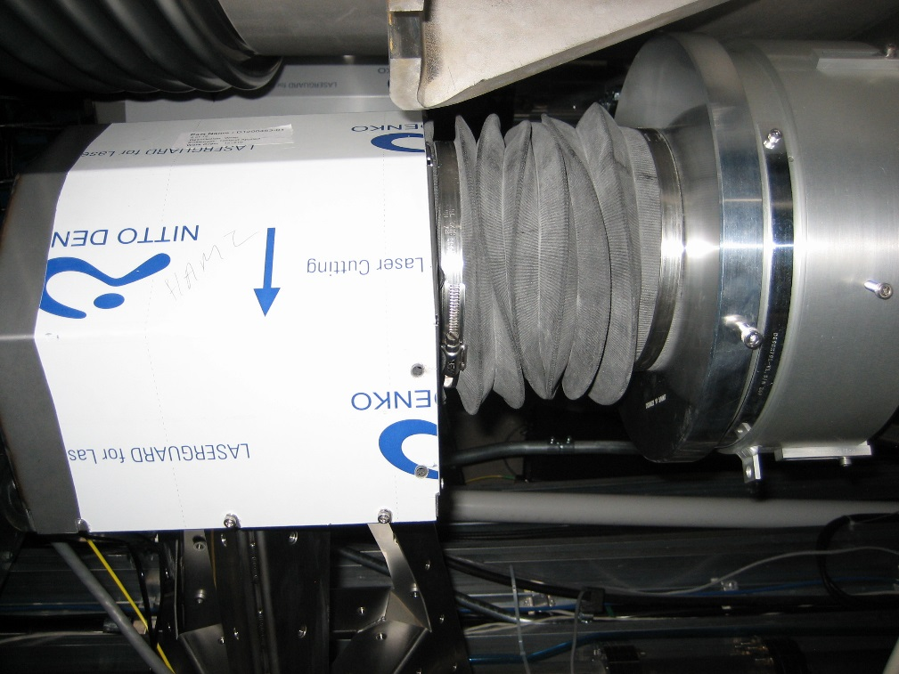

Electronics
- Needs laser mounting rack to get it off of the cable tray. Needs to be designed or bought. (This may require more than one configuration as each installation has unique requirements).
- Laser needs to have the 18vdc to 5vdc daughter card installed outside of laser enclosure (heat issue).
- Note: Has ice chest enclosure (not aLIGO req).
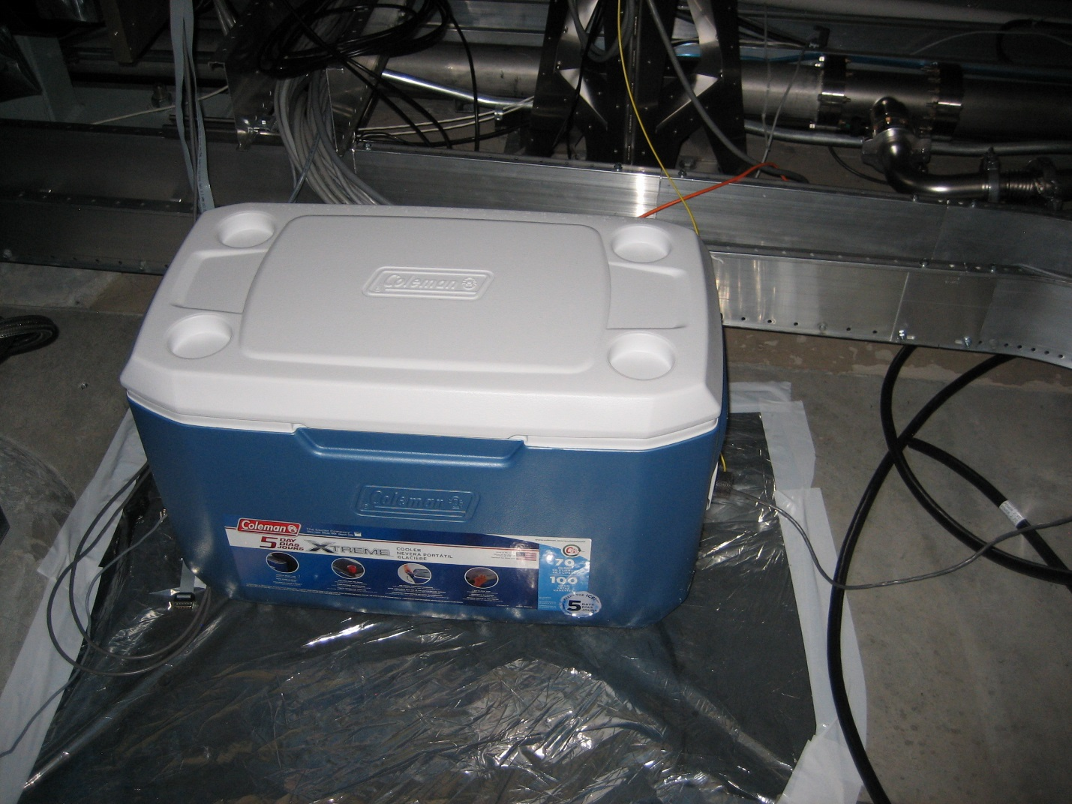
- Reduced RPM on laser enclosure fan (add diodes) - Yes___, No____, ? X
- Bench setting of mode hop free range – Yes___, No X
- Binary output modulator installed and gains set.

Optics
- The fiber must be rolled into a larger loop and secured to protect it.

Pier Location and Mechanical
- Remove extraneous equipment and trash from piers. Add labels to piers indicating 'No Step' and 'No Touch'.

Pier Location and Mechanical
- Remove extraneous equipment and trash from piers. Add labels to piers indicating 'No Step' and 'No Touch'.

Testing
- Recheck calibration.
- Beam profiled and power measured.
- Changed the matrix to get pitch and yaw DOF recording to the proper channels, right hand rule configuration, no scaling for units yet.

9. HAM3 Mirror

Transmitter/Receiver (Transceiver):

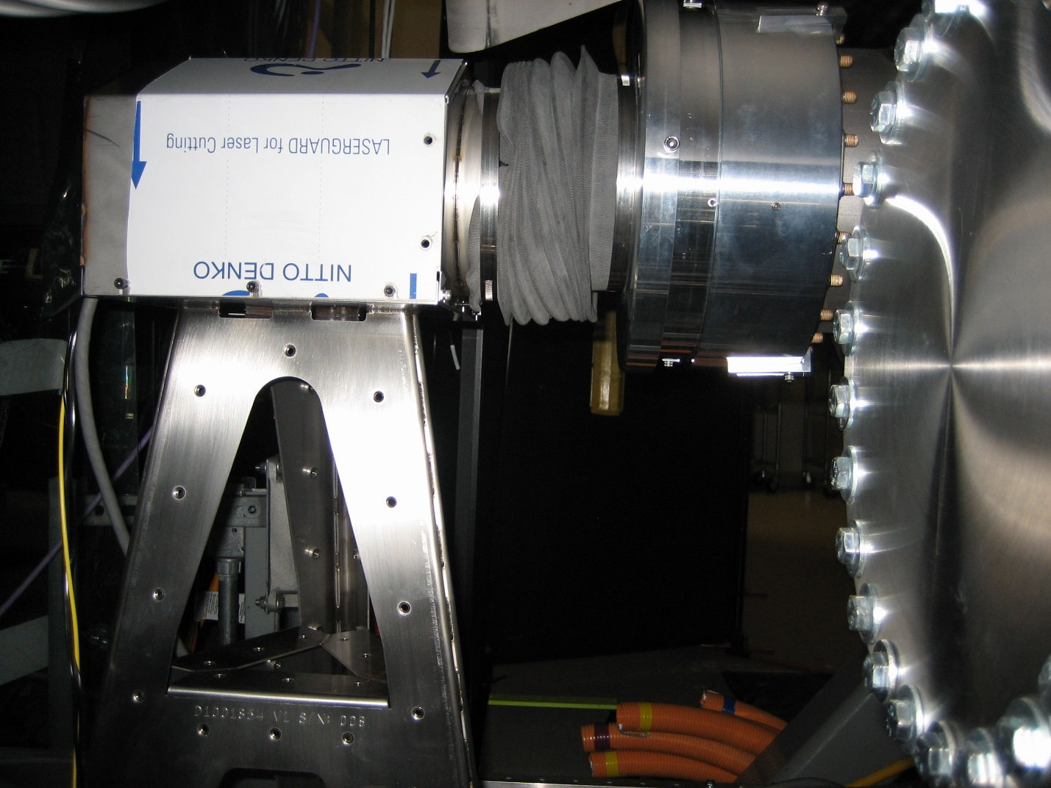

Electronics
- Needs laser mounting rack to get it and power supply off of the floor. Needs to be designed or bought. (This may require more than one configuration as each installation has unique requirements). 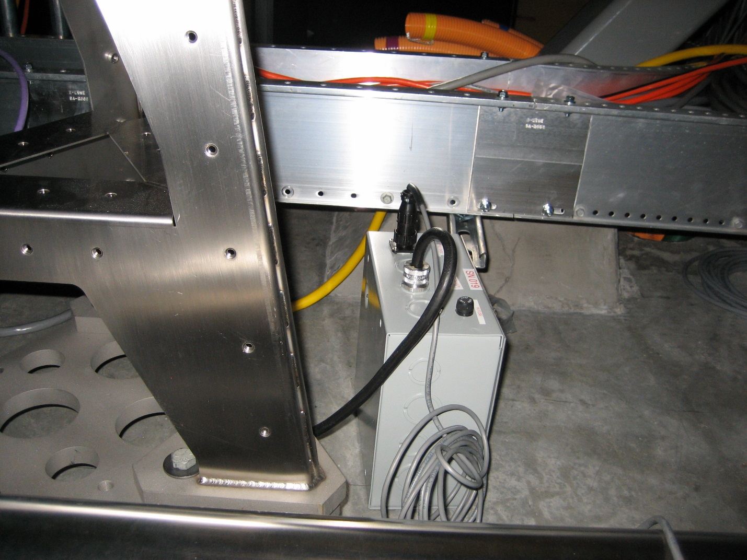
- Laser needs to have the 18vdc to 5vdc daughter card installed outside of laser enclosure (heat issue).
- Note: Has ice chest enclosure (not aLIGO req).
- Binary output modulator installed and gains set.
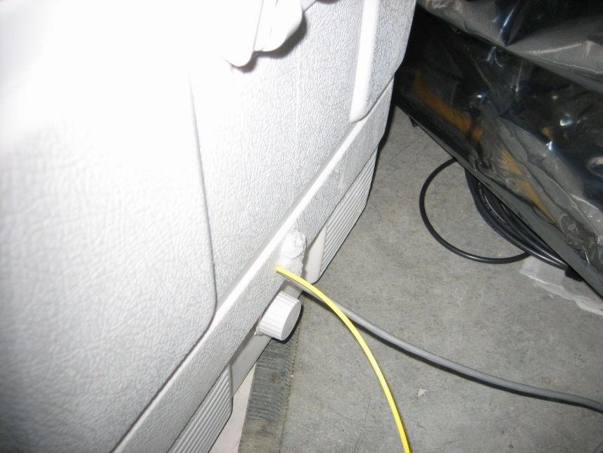
- Write ECR - Reduced RPM on laser enclosure fan (add diodes) – Yes X, No ? ___
- Bench setting of mode hop free range – Yes X, No ____

Optics
- The fiber must be rolled into a larger loop and secured to protect it.

Pier Location and Mechanical
- Remove extraneous equipment and trash from piers. Add labels to piers indicating 'No Step' and 'No Touch'.
- Add “quick” connects to translation stage power and signal cables to save on wear and tear by having to hard wire each time a connection is needed.

Testing
- Recheck calibration.
- Beam profiled and power measured.
- Changed the matrix to get pitch and yaw DOF recording to the proper channels, right hand rule configuration, no scaling for units yet.

10. HAM4 Mirror – Partially Installed, waiting for gate valve closures and Laser Safe Condition to complete.

Transmitter/Receiver (Transceiver):

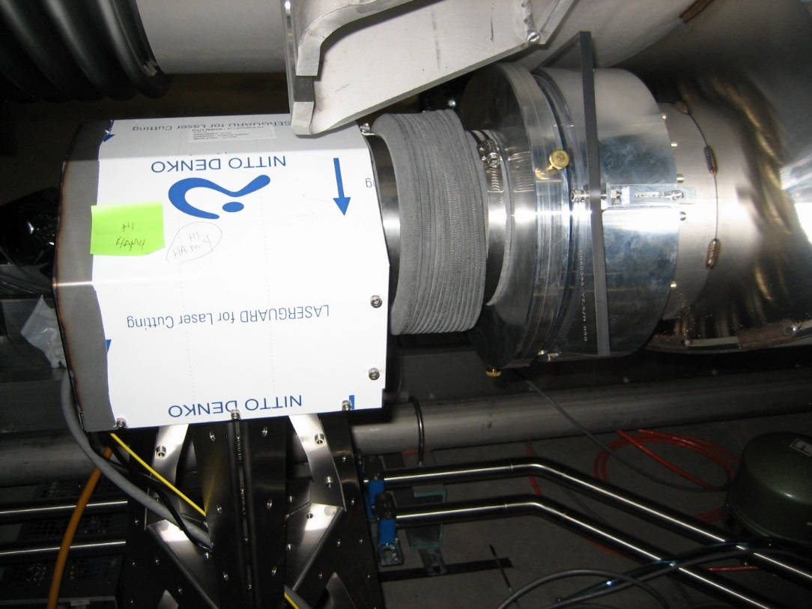

Electronics
- Needs laser mounting rack to get it off floor. Needs to be designed or bought. (This may require more than one configuration as each installation has unique requirements).
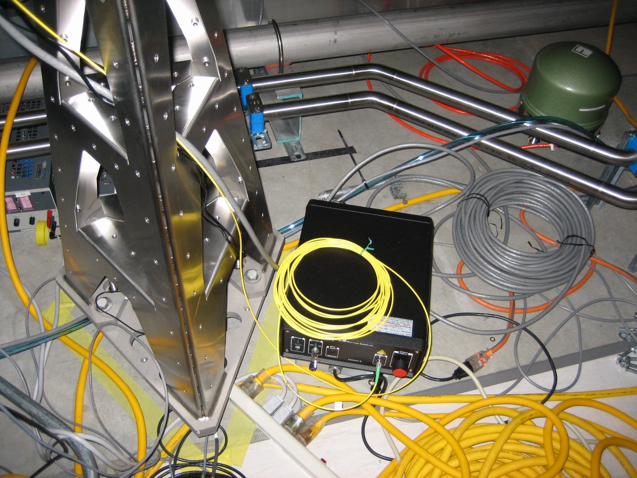
- Laser needs to have the 18vdc to 5vdc daughter card installed outside of laser enclosure (heat issue).
- Note: No ice chest enclosure (not aLIGO req).
- Write ECR - Reduced RPM on laser enclosure fan (add diodes) – Yes X, No ? ___
- Bench setting of mode hop free range – Yes ___, No X
- Binary output modulator installed, no gains set.
- Add “quick” connects to translation stage power and signal cables to save on wear and tear by having to hard wire each time a connection is needed.

Optics
- The fiber must be rolled into a larger loop and secured to protect it.

Pier Location and Mechanical
- Remove extraneous equipment and trash from piers. Add labels to piers indicating 'No Step' and 'No Touch'.
- Grout, add grommet
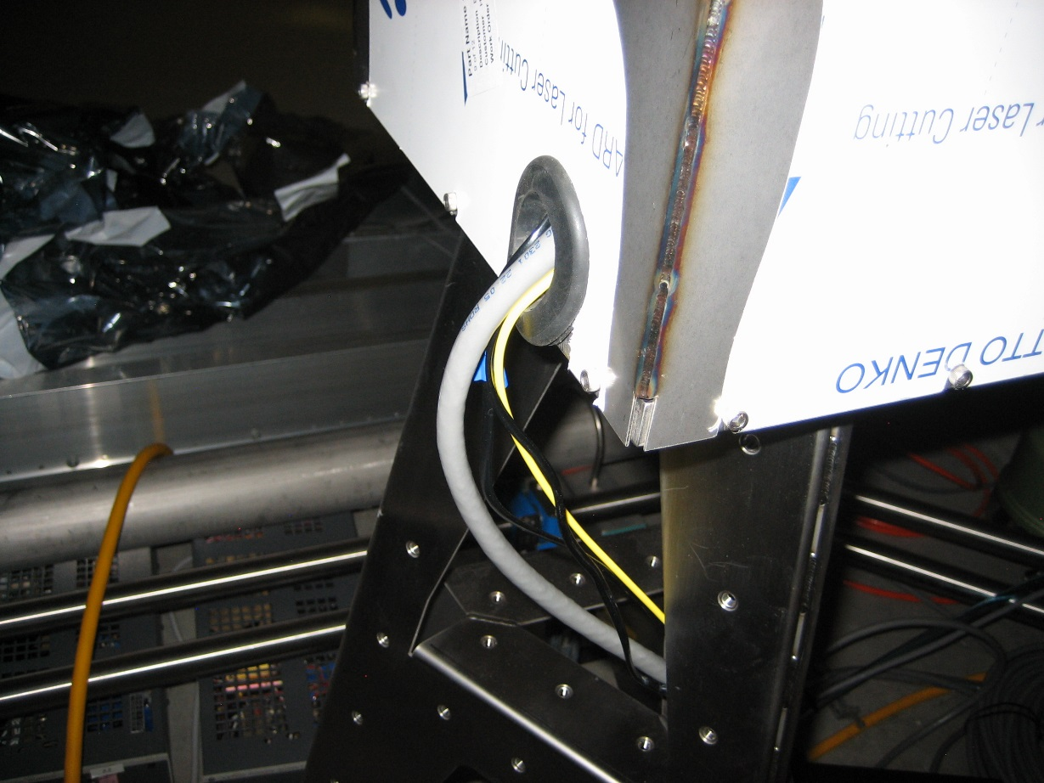

Testing
- Calibration (after installation).
- Beam not profiled or power measured.
- Check the matrix to get pitch and yaw DOF recording to the proper channels, right hand rule configuration, no scaling for units yet.

11. HAM5 - Partially Installed, waiting for gate valve closures and Laser Safe Condition and beam hunting when the chamber is reopened for other tasks.

Transmitter/Receiver (Transceiver):

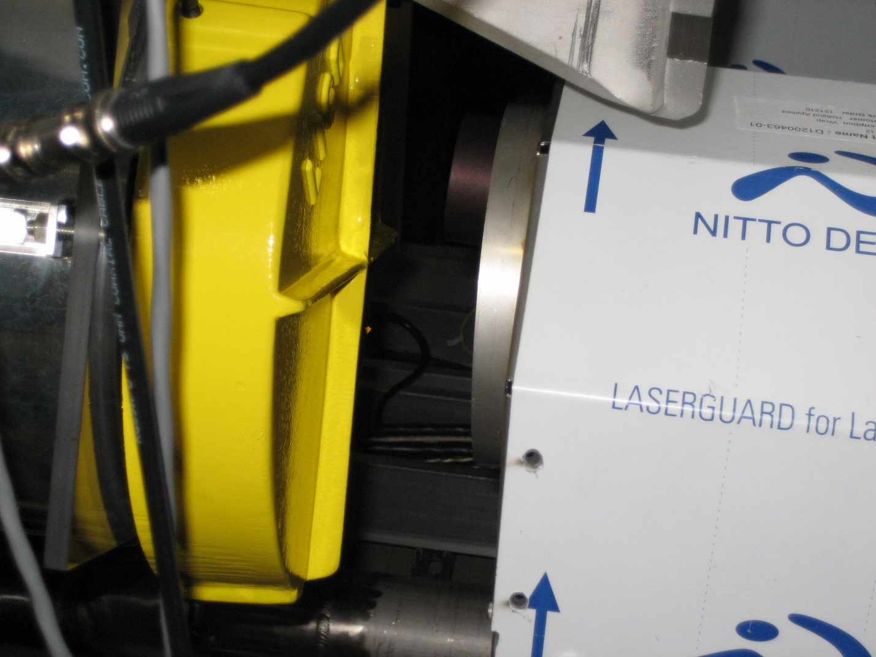

Electronics
- Needs laser mounting rack to get it off of the cable tray. Needs to be designed or bought. (This may require more than one configuration as each installation has unique requirements).
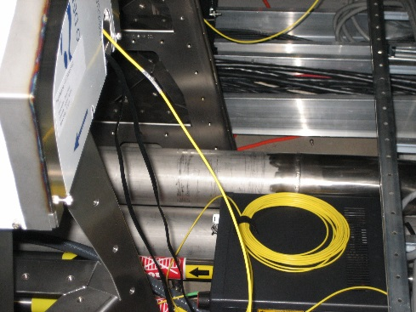
- Laser needs to have the 18vdc to 5vdc daughter card installed outside of laser enclosure (heat issue).
- Note: No ice chest enclosure (not aLIGO req).
- Write ECR - Reduced RPM on laser enclosure fan (add diodes) – Yes X, No, ? ___
- Bench setting of mode hop free range – Yes ___, No X .

Optics
- The fiber must be rolled into a larger loop and secured to protect it.

Pier Location and Mechanical
- Remove extraneous equipment and trash from piers. Add labels to piers indicating 'No Step' and 'No Touch'.
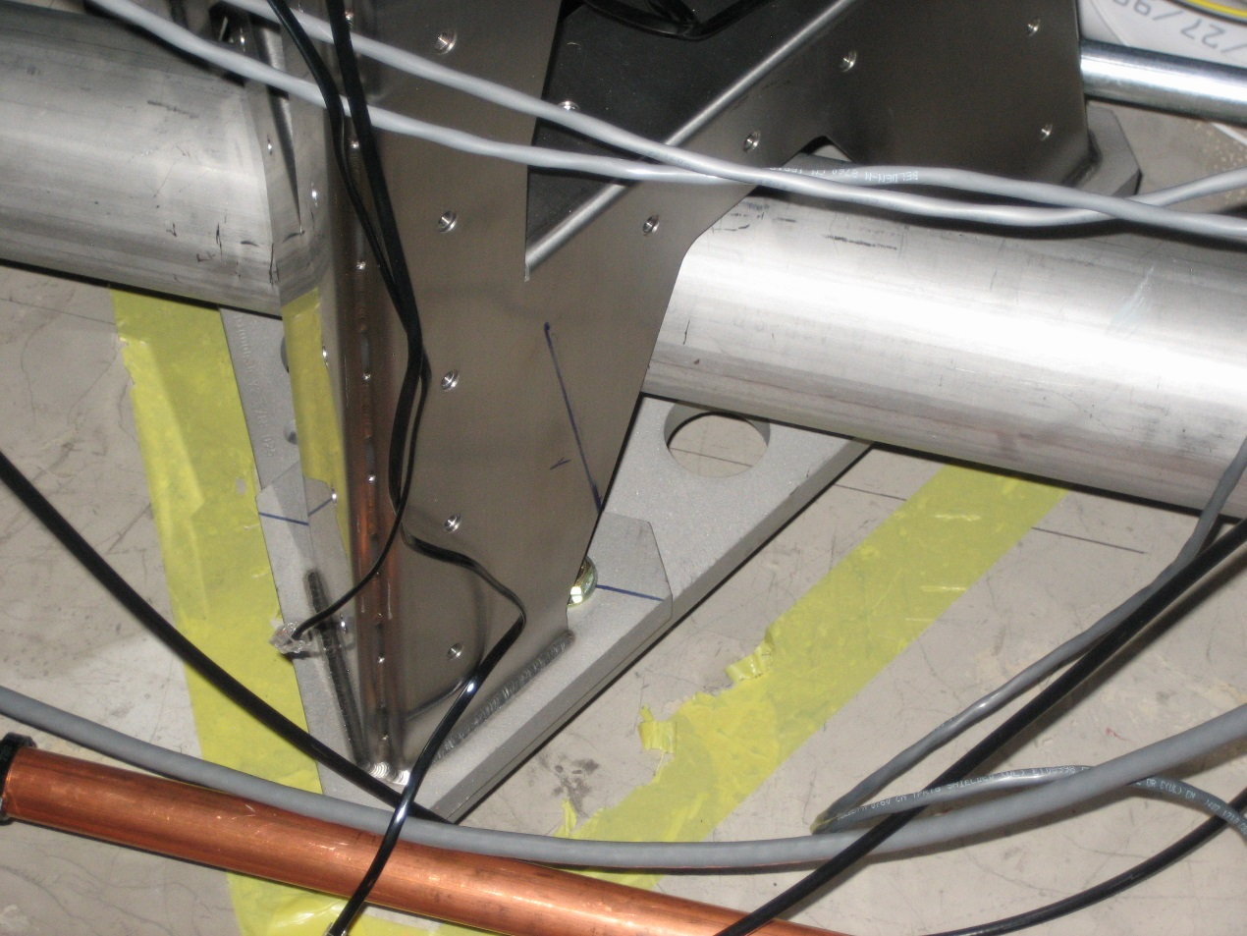

Electronics
- Binary output modulator installed, no gains set.

Pier Location and Mechanical
- Remove extraneous equipment and trash from piers. Add labels to piers indicating 'No Step' and 'No Touch'.
- Grout, add grommet
- Needs bellows.
- BK Hammer measurements

Testing
- Calibration (after installation).
- Beam not profiled or power measured.
- Check the matrix to get pitch and yaw DOF recording to the proper channels, right hand rule configuration, no scaling for units yet.

