LASER INTERFEROMETER GRAVITATIONAL WAVE OBSERVATORY

CALIFORNIA INSTITUTE OF TECHNOLOGY
MASACHUSETTS INSTITUTE OF TECHNOLOGY
Laser SOP LIGO-MXXXXXXX-VX [Date]
[Site] [Power] [Subsystem] SOP
Submitted By:
[Author list]

LIGO Hanford Observatory LIGO Livingston Observatory
P.O. Box 159 19100 LIGO Lane
Richland, WA 99352 Livingston, LA 70754
Phone (509) 372-8106 Phone (225) 686-3100
Fax (509) 372-8137 Fax (225) 686-7189
E-mail: info@ligo.caltech.edu E-mail: info@ligo.caltech.edu

California Institute of Technology Massachusetts Institute of Technology
LIGO Project – MS 100-36 LIGO Project – NW22-295
Pasadena, CA 91125 185 Albany St. Cambridge, MA 01239
Phone (626) 395-2129 Phone (617) 253-4824
Fax (626) 304-9834 Fax (617) 253-7014
E-mail: info@ligo.caltech.edu E-mail: info@ligo.mit.edu

Table of Contents
APPROVAL SIGNATURES 2
CHANGE LOG 3
PREFACE 4
1. INTRODUCTION 4
2. HAZARDS 11
2.1 Nominal Hazard Zone 11
3. CONTROLS 12
3.1 Access and Administrative Controls 12
3.2 Physical Controls: Exposure Control 12
3.3 Physical Controls: Electrical Controls 15
3.4 Eye Protection 16
4. OPERATING PROCEDURES 17
4.1 Responsible Laser Operator 17
4.2 Start-up Procedures 17
4.3 Shutdown Procedures 17
5. TRAINING 18
6. RESPONSIBILITIES 19
7. References 20

APPROVAL SIGNATURES

Subsystem Coordinator Name, Laser Subsystem Coordinator Date

Site LSO Name, [Site] Laser Safety Officer Date

Site Safety Coordinator Name, [Site] Site Safety Coordinator Date

Site Head Name, [Site] Head Date

LIGO LSO Name, LIGO Laser Safety Officer Date

LIGO Safety Coordinator Name, LIGO Safety Coordinator Date

CHANGE LOG

Version | Author | Date | Summary of Changes
V1 | Original Author(s) | DD MMM YYYY | Original

PREFACE
Table of Documentation Hierarchy

Tier 1 = M950046 (LIGO Laboratory System Safety Plan)
Tier 2 = M960001 (LIGO Laser Safety Program)
Tier 3 = M1000228 (LLO Laser Safety Plan) (Site-specific)
Tier 4 = Site-specific, laser-specific SOPs, FMEAs, and special procedures
Tier 5 = Operating, user, or other technical manuals from the manufacturer
Tier 6 = Wiki entries instructing operators "how-to".

This document is for individuals who require basic knowledge about this laser equipment. It is not a substitute for operating manuals or for one-on-one training. Standard operating procedures (SOPs) are site-specific and equipment-specific documents that fall under the jurisdiction of the site laser safety officer. Candidate laser operators must read and understand all site-specific laser safety plans as well as laser-specific SOPs. Candidate laser operators must understand that reading this documentation is necessary, but does not automatically qualify personnel to work on this laser equipment. Neither does it clear anyone to operate identical hardware at any other LIGO location.

1. INTRODUCTION

To the Laser Sponsors,
This is a template with instructions. It is found in LIGO-M1400242. Standard operating procedures are manuscripts that briefly inform the world about various aspects of the laser system installed at our observatory. This SOP is not meant to be a manufacturer’s user’s manual (a tier 5 document). Instead it briefly describes the laser, its components, its location(s) with illustrations and images of experiment hall floor plans, hazards, safety features or controls, laser light parameters, and safe operating practices around the laser table. This manuscript is required to be detailed enough to inform staff how to activate and to disable lasers as well as train staff to become liaisons to laser working groups.
It is your responsibility to generate and maintain this SOP. No one knows the lasers to be installed better than you. Questions may be directed to the site LSOs at any time.
Thanks - the LIGO Laser Safety Officers.
The following minimal outline is recommended to be followed. There are seven sections required.
1) INTRODUCTION
2) HAZARDS
3) CONTROLS
4) OPERATING PROCEDURES
5) TRAINING
6) RESPONSIBILITIES
7) REFERENCES

Additional sub-sections may be added if necessary. All sections highlighted in yellow ought to be changed appropriately. Sections left non-highlighted may not be altered. Laser sponsors are required to understand the non-highlighted sections.
The INTRODUCTION should contain:
- General information about the laser: power, wavelength, manufacturer, location on site (include NHZ floor plans)
- Component names and locations: power supplies, cooling systems, pump lasers
- Cognizant laser team (i.e. the school and team responsible for this laser)
- An illustration of the laser system and its appropriate NHZs are shown.
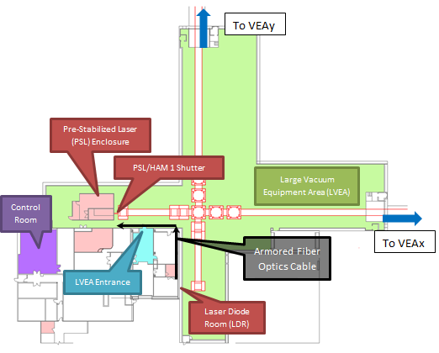
Figure 1: Modify this image to show the location of an SOP’s laser in its respective experiment hall, with its NHZ.

- Magnified views of NHZs may necessary to clearly show component locations. Make sure that pictures are labeled and the appropriate NHZs are shown.

NHZ

PSL Enclosure
NHZ
MOPA
PSL Table
PSL Acoustic Enclosure
PSL Anteroom
Fibers from LDR

PSL Electronics Racks
Figure 2: Modify your images as needed to clearly show the relationship of the laser to the NHZ.

P

NHZ

Not NHZ
PSL Chiller
Pump Laser Diodes (PLD)
Clean Suits and Goggles
Laser Status Panel
Equipment Doors
Laser Hazard Status Sign
Emergency Shutdown Buttons
Figure 3: Descriptive captions go here that clarify safety components of the NHZ.
- Orientation images of the laser, position on an optical table, and accompanying descriptions.
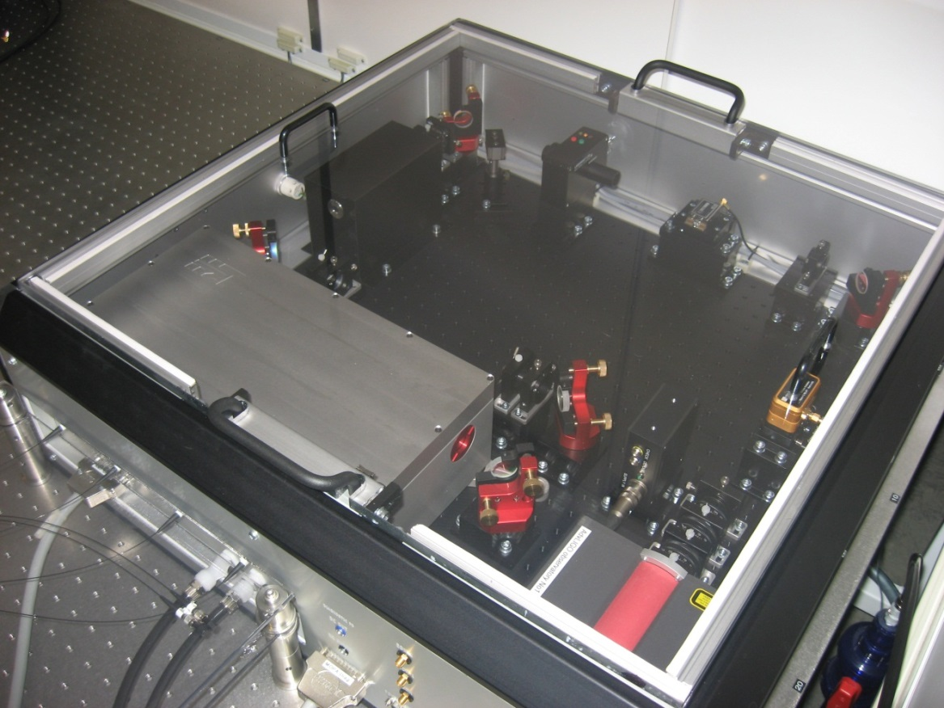
Mephisto 2 W NPRO
Electro-mechanical Shutter
Manual shutter (on front exterior)
Fiber optics from LDR
Power Amplifier
Mephisto Manual Shutter
Figure 4: The table layout is important.

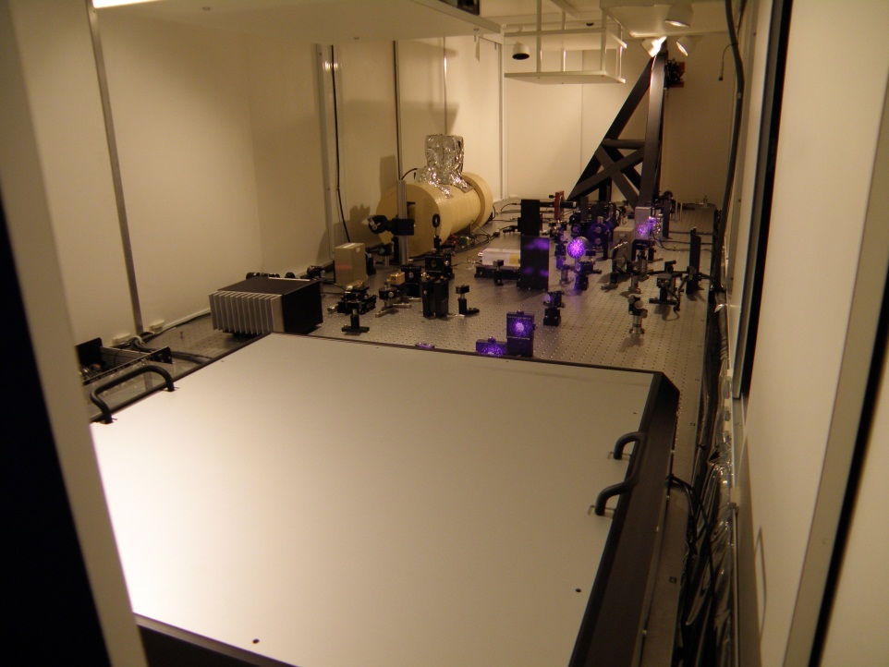
PSL Table Sliding Doors
Optics
Reference Cavity
PSL periscope
PSL MOPA
Figure 5: More than one photograph may be needed to clarify the table layout.
- Provide power supply location photos and brief descriptions.
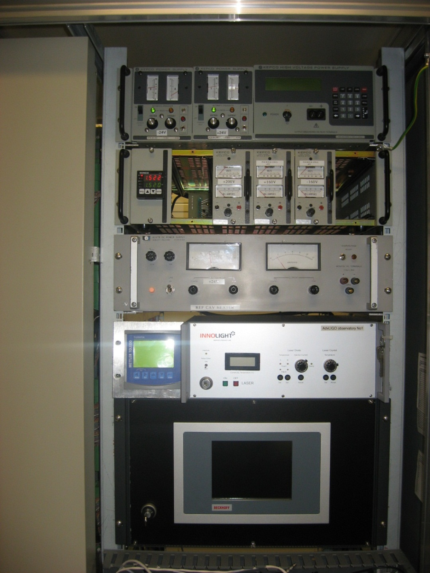
Beckhofff Automation Control Box
Activation Key
Activation Key
Mephisto Power Supply
Figure 6: A photograph showing the front panels of the installed power supply.

- Continue descriptions of special and essential components.
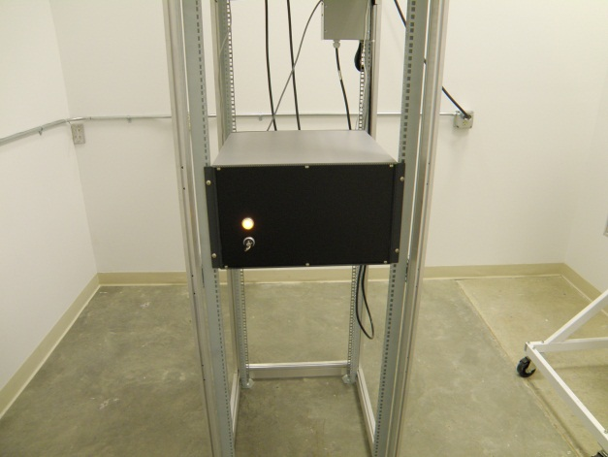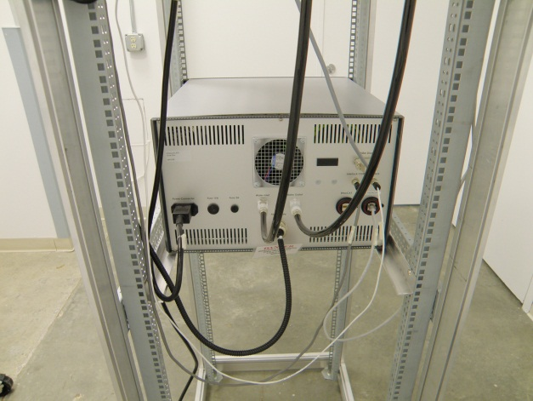
Activation Key
Figure 7: The important special contents that are essential to the understanding of the laser system should be shown.

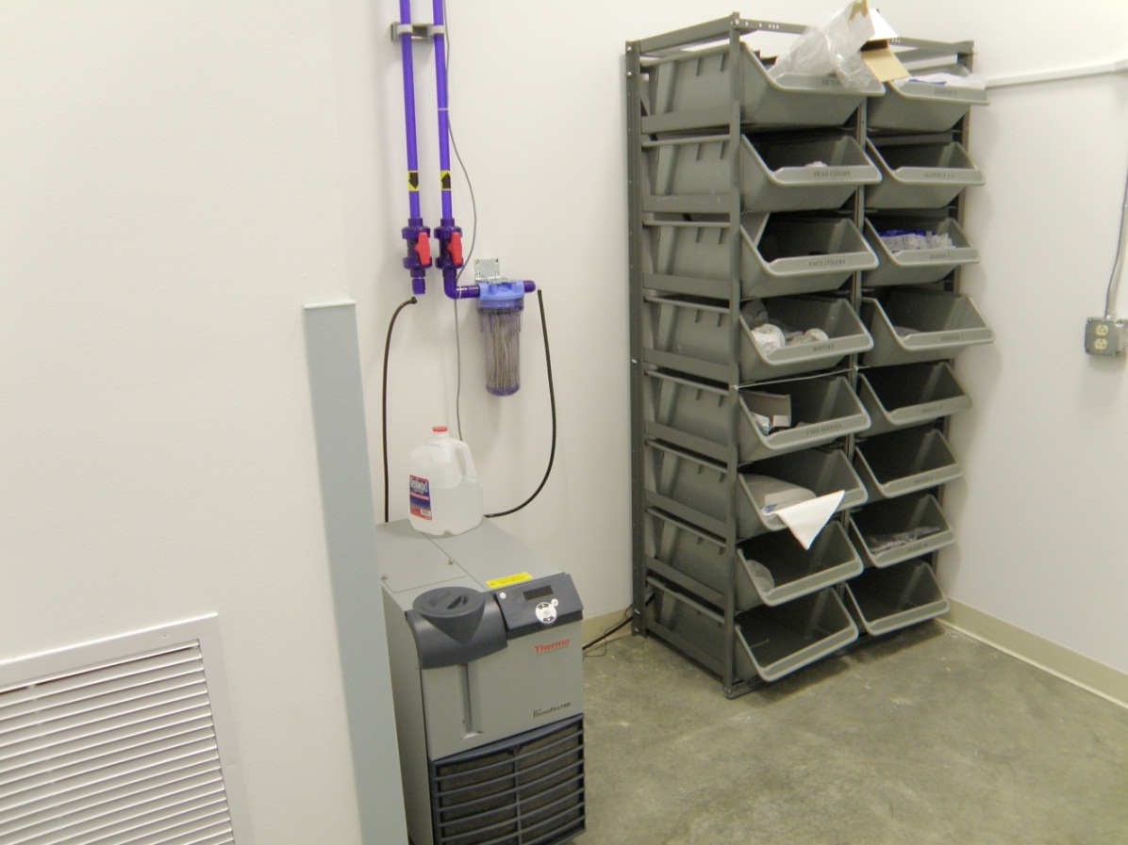
LDR NHZ Room
LDR Clean Suits
PSL Chiller
Particulate Filter
Cutoff Valves
Figure 8: The location of special components should be shown as well.

- Required: The parameters for the primary output of the (laser) are listed in table 1.
Table 1: Laser parameters.
Description | Value/Designation
Laser Type | MOPA, excimer, diode, gas CO₂?
Class | X
Emission center wavelength | Nm
Emission repetition rate | Continuous Wave
Emission waist (minimum radius) | Mm
Waist location | With respect to aperture
Beam divergence | Mrads
Output polarization | s-pol or p-pol? Vertical or Horizontal
Maximum power output | Watts
Interlocked | Will this be monitored?
Authorized locations | NHZ names

2. HAZARDS
- What hazards does this laser present? (fire, burns, eyesight)
- What type of beam dumps may be used?
- Are there electrical hazards? What voltage and currents can one expect?
- Is coolant water used? Could it leak into electrical circuits and pose a risk?

2.1 Nominal Hazard Zone
The nominal hazard zone (NHZ) for the LIGO (laser name) is considered to be the following:
List the associated floor plan.

NHZ

NHZ
EX with VEAx NHZ in red
EY with VEAy NHZ in red
Gowning Room
Main Entrance
Figure 9: The associated floor plans are illustrated.

3. CONTROLS

3.1 Access and Administrative Controls
- Is access to the laser controlled?
- How is it controlled administratively?
- Where are lighted laser status signs found?
Lighted warning signs are found at access points of each associated NHZ and indicate either a “Laser Hazard” or “Laser Safe” condition. These locations are as follows:
- List or diagram the locations of pertinent signs.

3.2 Physical Controls: Exposure Control
- How is access to laser light controlled physically? Explain? (shutters, beam tubes)
- Are there redundancies and fail-safes?
- Can the physical controls terminate full beam power indefinitely?
- Are shutters on the laser source interlocked? Do they stop emissions or lasing?
Note: Insertion and extraction of beam dumps for the primary beam requires care due to the scale of momentarily scattered light. Beam dumps placed in high power beams for long periods of time must be either water cooled or high power plate-style beam dumps.
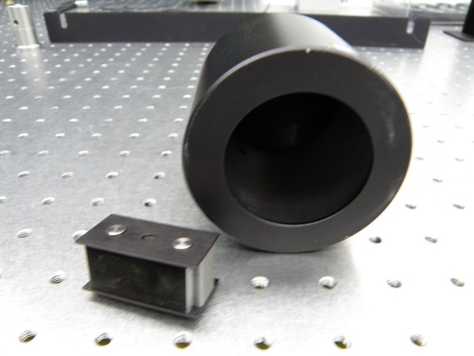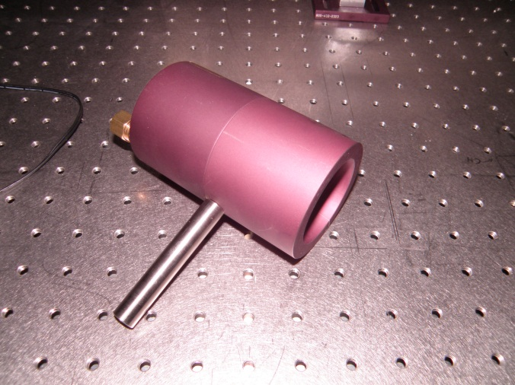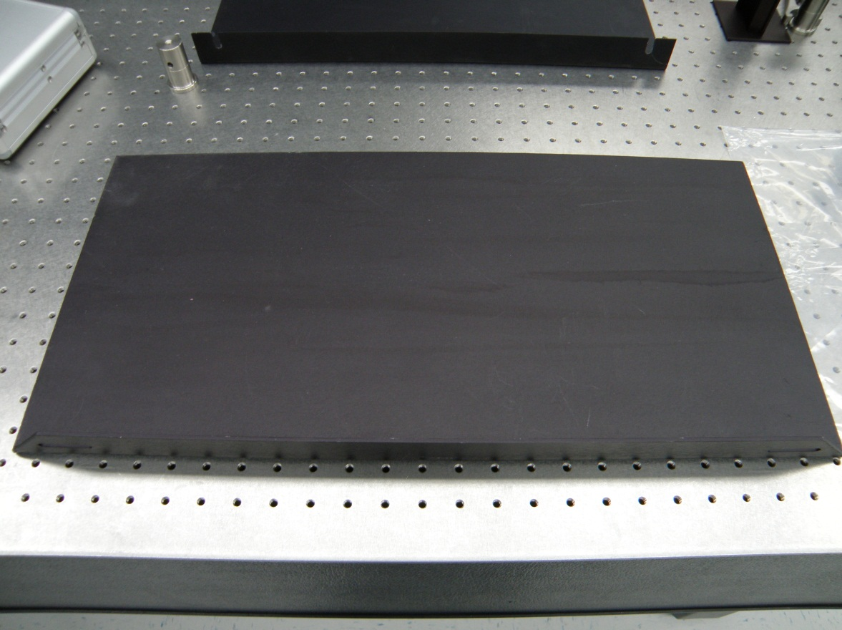
Figure 10: Engineering controls should be illustrated.
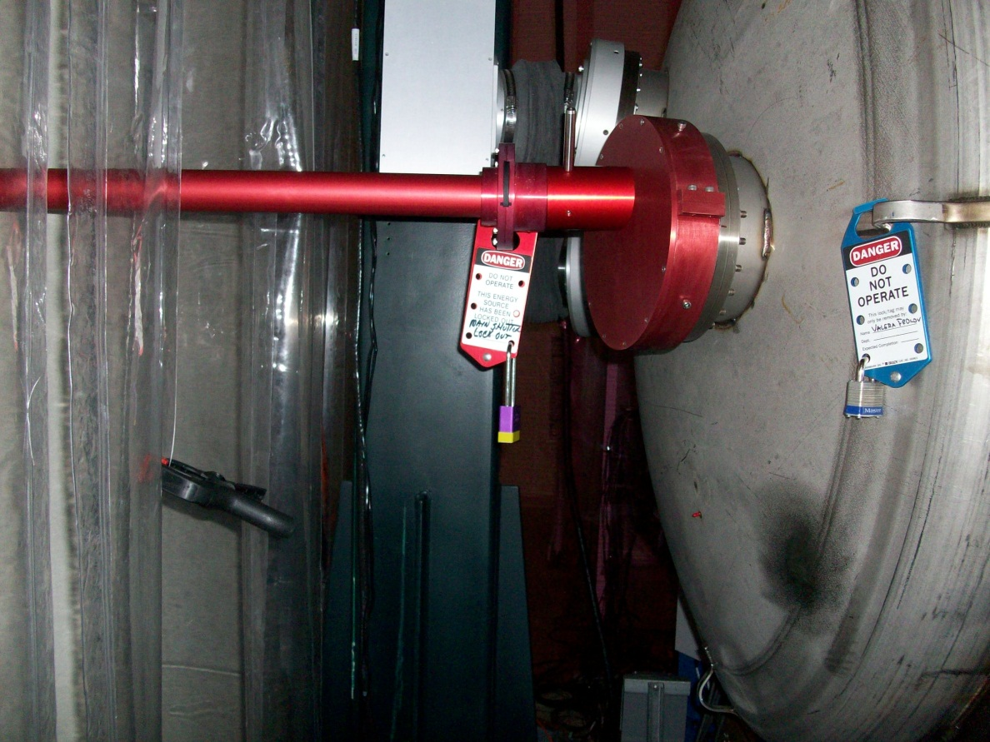
Sliding Shutter Seen Edge On
Pad Lock with Tag
Beam Tube
Figure 11: Other engineering controls are also illustrated.

3.3 Physical Controls: Electrical Controls
- Describe the electrical control safety systems.
  - Are there keyed activation switches?
  - Can the hardware keys override software commands?

- Where are the emergency laser shutdown buttons?
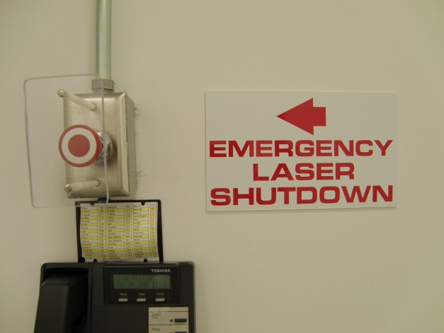
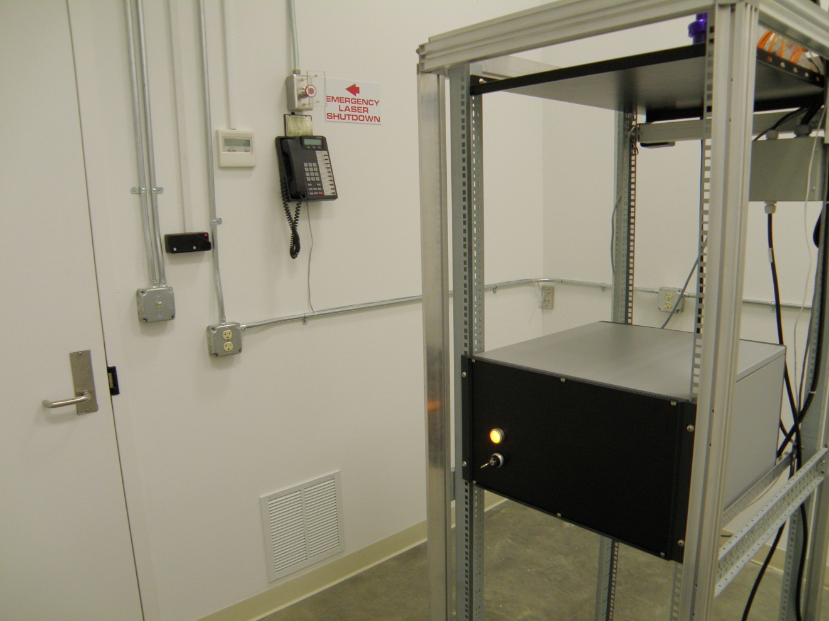
Access key card for exit
Main Door
Figure 13: Location of the “Emergency Laser Shutdown” button and other interlocks are illustrated.

3.4 Eye Protection
All personnel working in the (NHZ) while the laser is capable of being or is energized must wear protective laser safety eyewear whose optical density is specified in Table 2.
Table 2: Laser safety eyewear minimum optical density (OD) for the PSL with fibers removed and LDR
Wavelength (nm) | Minimum O.D. | Beam parameters (est)
λ1 | minOD | Max Power; waist
λ2 | minOD | Max. Power; waist

4. OPERATING PROCEDURES

4.1 Responsible Laser Operator
The Responsible Laser Operator (RLO) coordinates tasks in the (NHZs) with the control room operator on duty. If a work permit is required, one must be filed before any work begins.
- Are there special rules for the RLO? If not modify the following paragraphs appropriately. Else, briefly describe the special responsibilities.

4.2 Start-up Procedures
- Describe the standard operating procedures for starting the laser.
NOTE: If a laser beam with power in excess of 2 mW is found (reported by any observer), leaving the optics table, the laser will be shut down by the LSO and will remain “OFF” until start-up authorization is received.
NOTE: It is the responsibility of each person working within the Laser Nominal Hazard Zone (NHZ) to ensure that LIGO standards for safe laser operation are being followed at all times

4.3 Shutdown Procedures
- Describe the shutdown procedures for the laser

5. TRAINING
LIGO basic laser safety training must be completed before any individual can work around any class 3b and/or class 4 laser emission.
Access to the PSL enclosure and the LDR is only on an “as needed” basis for qualified laser operators. To become a qualified laser operator, an individual must complete the following requirements.
- Received LIGO basic laser safety training
- Have a full understanding of this SOP and its associated FMEA
- Understand emergency and safety procedures
- Received authorization from the LIGO Livingston laser safety officer
NOTE: Training on any specific laser system does not automatically qualify individuals for other lasers at the LIGO facilities and associated university labs.

6. RESPONSIBILITIES
- Each person working within the LIGO NHZ Name is responsible for ensuring that safe laser practices are being followed at all times.
- The responsible laser operator is responsible for conducting tasks on a specific laser system in accordance with the prescribed control measures and in compliance with this SOP.
- The responsible laser operator is responsible for informing any and all assisting personnel regarding the control measures and SOP for the specific laser system.
- The responsible laser operator is responsible for any communications with other site personnel regarding changes in the operational status of the specific laser system.
- In case of safety incidents, contact the personnel in the immediate vicinity and (if necessary) emergency medical services as soon as possible.
- Any identified flaws in procedures or potential improvements that could enhance safety should be brought to the attention of the LLO Laser Safety Officer or cognizant laser personnel.

7. References
- American National Standard for Safe Use of Lasers, ANSI Z136.1-2007
Laser Institute of America, ISBN 0-912035-65-X
- LIGO-M950046 (LIGO Laboratory System Safety Plan)
- LIGO-M960001 (LIGO Laser Safety Program)
- LIGO-M080368 (LLO NHZ Transition Procedures)
- LIGO-M0900241 (Laser Safety Training for Certification and Recertification of LIGO Personnel)
- LIGO-M1000228 (LLO Laser Safety Plan)
- LIGO-G0901007 (LIGO Basic Laser Safety Training Presentation)
- LIGO-G1000017 (LLO Addendum to Basic Laser Safety Training)

