Title | Fast Shutter Driver Test Procedure
Author | R. Abbott, Caltech
Date | 11 November 2014
Hardware Version | PCB D1300780-v5 in Chassis D1400078

Overview
This procedure along with test code found under E1400390 is used to verify proper operation of the D1400078 Ultra-fast Shutter Driver Chassis. This chassis operates at voltages up to 500VDC and portions of this procedure assume that the person performing the test be familiar with high voltage circuit testing, The Test Technician or Engineer MUST be a LIGO approved Qualified Electrical Worker specifically authorized to work on energized equipment. This procedure also assumes a considerable familiarity with Cypress PSoC programming and the fast shutter in general.

Table 1
Chassis Serial Number
Date
Tested By
Overall Test Result | PASS | FAIL
 | ☐ | ☐

DC Measurements Section

Quiescent current draw
External to the chassis under test insert a Fluke Multi-meter in series with each power form and measure the power supply current. Record the results in the following table. Mark each measurement as Pass or Fail. The USB programming cable must not be actively plugged into the front panel of the chassis as this alters the current draw on the +18V supply. Remove meter and turn off HV after completion of the quiescent current measurements.

Table 2 Quiescent Current Draw
Quiescent Current Draw (mA) | Specified Value | Measured Value | Pass | Fail
+18V Supply | 160mA +/- 20mA |  | ☐ | ☐
-18V Supply | 30mA +/- 20mA |  | ☐ | ☐
+450V +/-5V on rear panel HV input with front panel HV switch ON | 1.4mA+/-0.5mA |  | ☐ | ☐

Test Procedure Using Test Code
Ensure the main drive cable is not attached to a fast shutter. Attach the20 ohm test load to main drive output. The test load has an integral short circuit between the coil integrity pins to bypass the Open Load interlock. Attach test board, D1400208, to front panel 9 pin D-sub and then turn on the LV supplies. Load the test code into the USB jack on the front panel using the PSoC programming software.

Table 3
Test | Specified Result | Measured Value | Pass | Fail
Using the HV Enable switch on the front panel verify the LED is functional by enabling and disabling | - | - | ☐ | ☐
HV Enable OFF, then apply +450V +/-5V on rear panel HV input | LCD Capacitor Charge Voltage = 0 VDC |  | ☐ | ☐
HV Enable ON, then OFF after measurement. Terminate step by pushing SLOW UP on test board | LCD Capacitor Charge Voltage = 433VDC +/-10VDC |  | ☐ | ☐
Push SLOW DOWN on test board | LCD = OK |  | ☐ | ☐
Push FAST UP on test board | LCD = OK |  | ☐ | ☐
Simulate open coil by removing test load with integral short | Fault LED ON (Red), LCD = OK |  | ☐ | ☐
STATUS LED Test. Terminate with SLOW UP | STATUS LED (Green) flashing |  | ☐ | ☐
FAST UP LED Test. Terminate with SLOW UP | FAST UP LED (Green) flashing |  | ☐ | ☐
HV READY LED Test. Terminate with SLOW UP | HV READY LED (Green) flashing |  | ☐ | ☐
SLOW UP LED Test. Terminate with SLOW UP | SLOW UP LED (Green) flashing |  | ☐ | ☐
SLOW DOWN LED Test. Terminate with SLOW UP | SLOW DOWN LED (Green) flashing |  | ☐ | ☐

Test Procedure Using Normal Operational Code
During this portion of the test, the normal operating code is loaded into the shutter and a series of tests verifies the normal operation of the shutter circuitry when delivering high current, high voltage pulses to a 20 ohm resistive dummy load. The HV is initially de-energized in this test until specified under the test instructions. The test board D1400208 should still be attached to the front panel test port.

Table 4
Test | Specified Result | Measured Value | Pass | Fail
Load the regular Pulser code (not test code) under E1400390 then unplug the programming USB cable | - | - | ☐ | ☐
Momentarily unplug the test board from the front panel and observe the FAULT LED is lit after ~5 seconds | Fault LED ON |  | ☐ | ☐
Push SLOW UP on test board | Verify SLOW UP LED lit and +18V supply current increases by ~160mA |  | ☐ | ☐
Push SLOW DOWN on test board | Verify a brief flash on SLOW DOWN LED |  | ☐ | ☐
Attach Tektronix TCP202 clamp-on current probe around positive wire leading to 20 ohm resistive load. See Figure 2 | - | - | - | -
Put HV ENABLE switch to DISABLE and apply 450VDC +/- 5VDC to HV power input on rear panel. HV ENABLE switch to ENABLE | Verify HV READY LED on after ~10 seconds and that the LCD reads 433VDC +/-10VDC |  | ☐ | ☐
Set O-scope for single shot trigger off the rising edge of current pulse. Initiate a pulse by pushing FAST UP and compare the result to Figure 1 | Verify the rising edge of the current pulse is 21.5A +/-1A and that the SLOW UP LED is on |  | ☐ | ☐
Push SLOW UP | Verify the SLOW UP LED is not on |  | ☐ | ☐
Put HV ENABLE switch to DISABLE | Verify the capacitor charge voltage on the LCD display decays to less than 50VDC in less than 10 seconds |  | ☐ | ☐
Turn off HV and LV supplies | - | -

Figure 1 shows a typical 21.5A leading edge current pulse corresponding to a capacitor voltage of 433VDC when fired into a 20 ohm resistive dummy load.
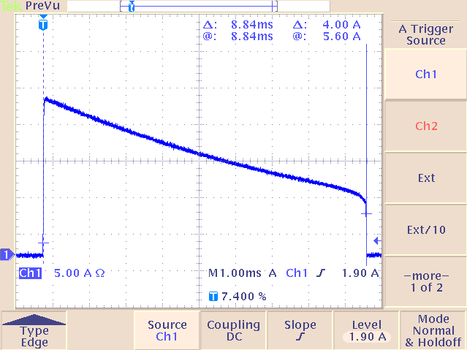

Figure 2 shows the dummy load with integral short, clamp-on current probe, and test board
