[SECTION]

Feature

[HEAD]

From Theory to Experiment

[SUBHEAD]

A view of the types of physics research from the Laser Interferometry Gravitational-wave Observatory

[AUTHOR(S)]

by Jess McIver
Graduate Student, at University of Massachusetts Amherst

Getting involved in research is one of the most beneficial aspects of a physics education for any future career aspiration, and it’s never too early to get involved. Physics research can usually be classified as theory, experiment, computation, or somewhere in between. Each type of research has its own challenges and rewards.

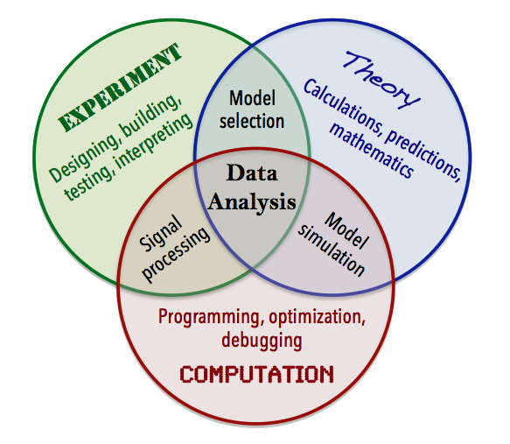
Caption: Not all physics research will fit neatly into this diagram, but it gives an idea of how different aspects of research fit together and what you might expect at the most general level.

Theory

Theorists use mathematics and models to explain current phenomena, predict new ones, and describe the laws of the Universe. Often these researchers tackle specific problems limited in scope, such as modeling nuanced particle interactions or predicting the amplitude of gravitational waves echoing from shortly after the Big Bang.

Experiment

Experimentalists test theoretical predictions investigate observable interactions and physical behavior. This generally involves constructing and operating instrumentation used for measurement or observation, on a scale from the rather small (equipment that fits easily inside a small room) to the very large (e.g., the LHC, which has a 27km circumference). Experimental physics often leads theory, as when a new unpredicted particle is discovered.

Computation

Computational physics is increasingly becoming a field unto itself. These researchers apply numerical analysis and other computational techniques to physics problems, including large scale weather simulations, investigations of the properties of semiconductors, or simulating protein folding. Computation has deep connections to both theory and experiment.

< Insert cartoon of physicists working on theory, experiment, computation collaborating together.>

Introducing LIGO

The Laser Interferometer Gravitational-wave Observatory (LIGO) experiment is a great example of a
project that spans many different types of research, including theory, experiment, computation, and
everything in between. LIGO consists of two state-of-the-art interferometers, one in Hanford, Washington, and the other in Livingston, Louisiana. Both are designed to measure gravitational waves, tiny perturbations on the fabric of spacetime emitted by astrophysical events great distances away.

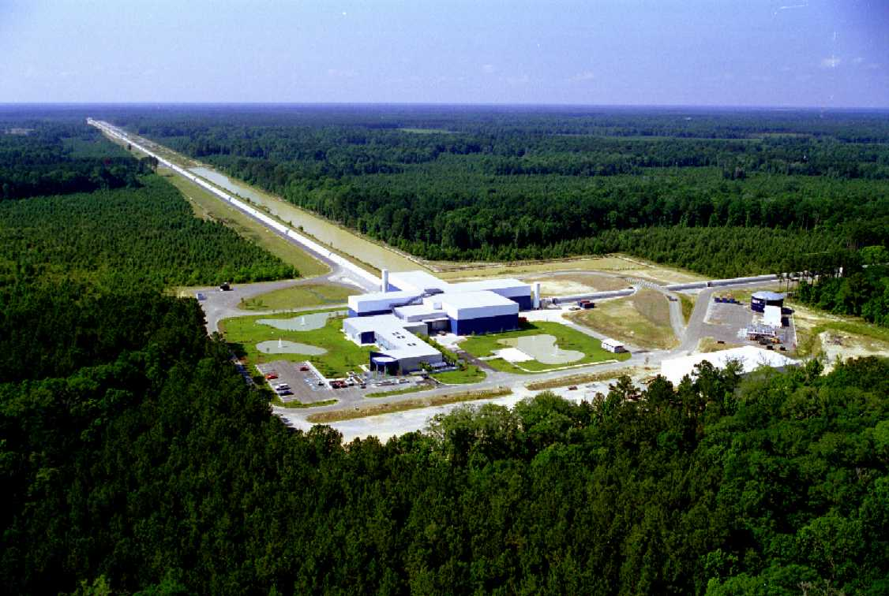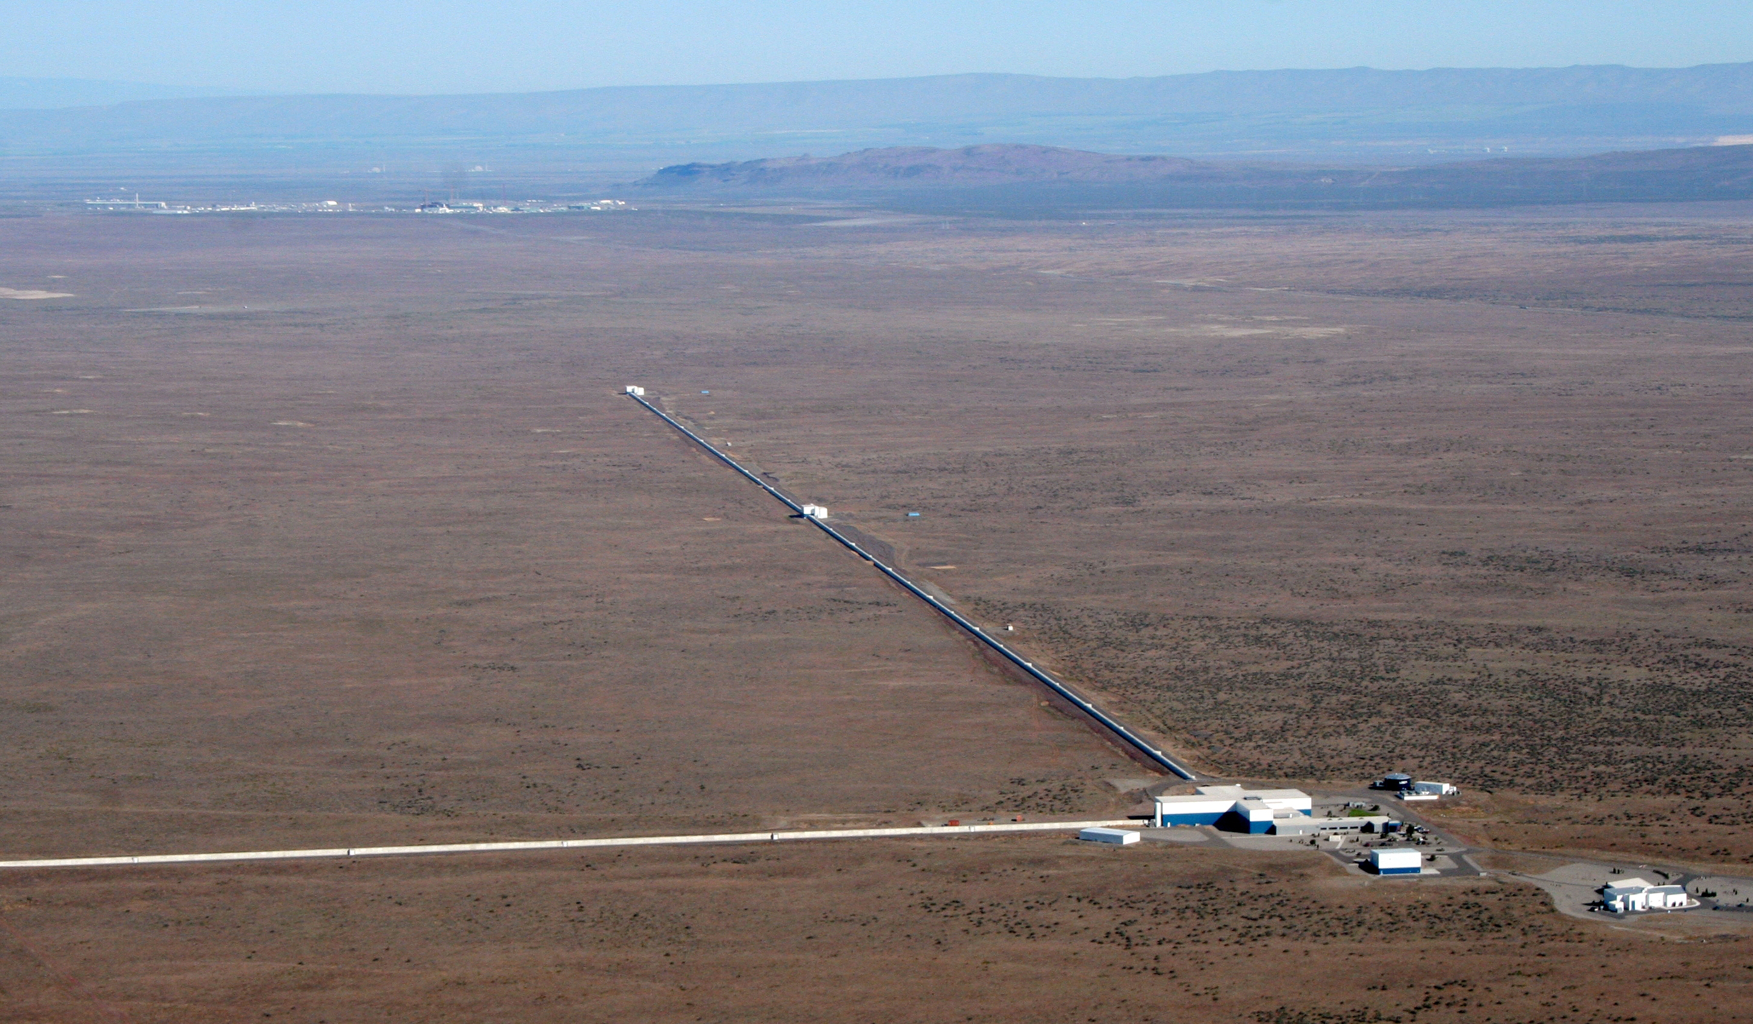
LIGO Livingston LIGO Hanford

Using strain measured by LIGO’s giant Michelson interferometers, we can reconstruct the signal of a passing gravitational wave created by a distant binary black hole, a neutron star merger, a galactic supernovae, a pulsar, or perhaps even an echo of spacetime tiny fractions of a second after the birth of the Universe. Gravitational waves are especially interesting for probing astrophysical objects and events that are difficult to observe via telescopes.

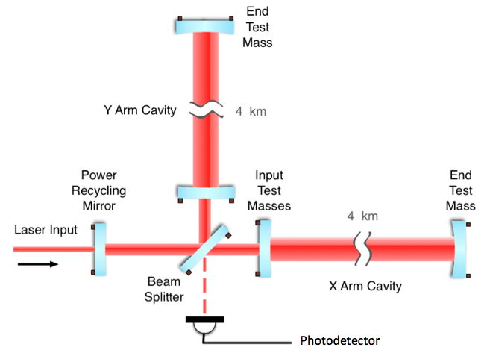

Caption: LIGO and other ground-based gravitational wave interferometers around the world (such as GEO600 in Germany, Virgo in Italy, or KAGRA in Japan) use Michelson interferometry to make very precise measurements of any differences in length between the two arm cavities. In this simplified schematic, a beam of coherent laser light is split to sample two perpendicular spatial degrees of freedom, and any difference in length between the arms is observed as a change in phase of the light, seen as an interference pattern at the photodetector. This signal is translated to gravitational wave strain, or the induced change in length over length.

LIGO is a great example of a project that draws on many different types of physics. Experimental physicists and engineers from around the world have collaborated to design, test, and install the cutting-edge technology for Advanced LIGO’s precision interferometery, from optic cavities and coatings to systems that isolate the optics from constantly moving ground. Reading out the data that LIGO produces, calibrating it correctly, transmitting it for immediate analysis, and storing it all for future use requires an enormous amount of computing power. To search for very small signals in noisy LIGO data, data analysts blend theory, experiment, and computation techniques to build algorithms that search for different types of gravitational wave signals. An especially powerful method compares the data with gravitational wave signal templates generated with known astrophysical models, supplied by theorists and computational theorists called numerical relativists. It’s an enormously complicated project with many different specialties.

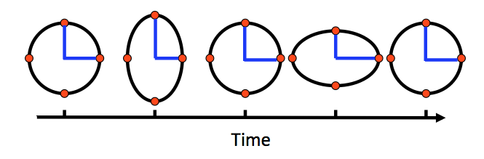
Caption: A gravitational wave incident on the plane of this paper would stretch and squeeze spacetime as shown (for ‘plus’ polarized waves). But this is not to scale! For example, for gravitational waves produced the inspiral of two binary neutron stars, a source Advanced LIGO is expected to be sensitive to, at 50 million light years away would produce a change in length 1000 times smaller than the width of a proton (or equivalently, a strain of 10^-22).

The scientists of the LIGO Scientific Collaboration are a diverse group at different stages of their careers, based at institutions big and small, focusing on many types of physics research that are all integral to the goal of observing new astrophysics from gravitational waves.

<TRACY - For layout, I’m picturing each person having their own “baseball card.” With a photo of the person. Two per page.>

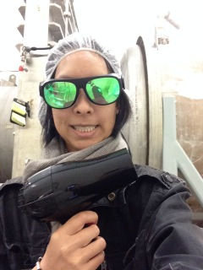
UNDERGRADUATE EXPERIMENTALIST
Nutsinee Kijbunchoo
Class of 2015, Louisiana State University

I worked at the LIGO Livingston site characterizing the instruments in preparation for Advanced LIGO’s first observing run. Being in the control room meant I was never working solely on my project, which was sometimes frustrating, but meant I got the chance to help with different projects. This way I really learned more about the interferometer and was able to see what’s going on with LIGO as a whole.

Key skills. I acquired quite a few useful skills after one year working at LIGO. The two most important skills were Python coding and data analysis. Coding is king at LIGO, and data analysis skills are crucial for both theorists and experimentalists.

Future plans. I have recently accepted a position at LIGO Hanford and will be joining the team as an operation specialist. The LIGO interferometers are very complicated instruments, and my goal is to learn as much as I can while being an operator there. After that I plan to go to grad school to pursue LIGO-related research.

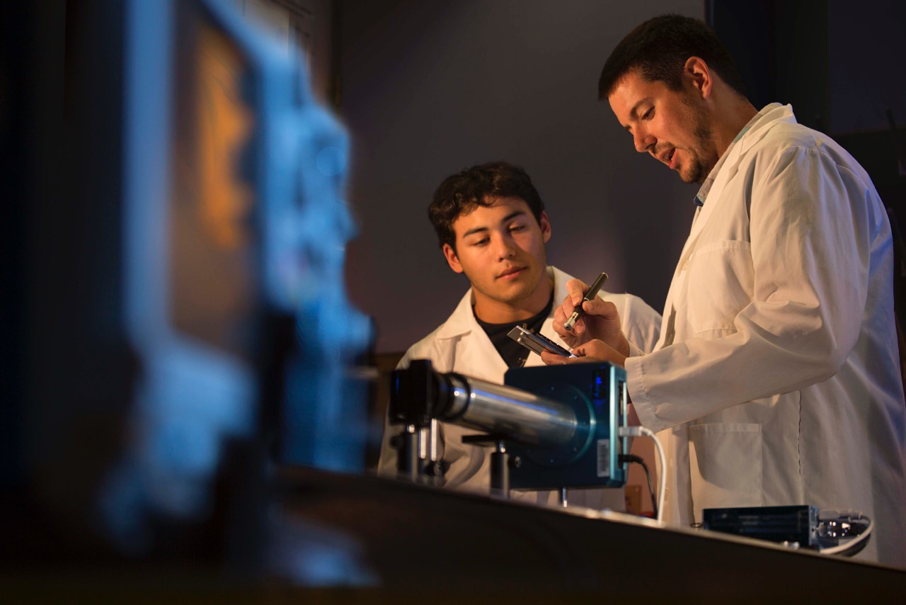
EXPERIMENTALIST
Josh Smith
Assistant Professor of Physics
California State University Fullerton

In our lab undergraduates and master’s students characterize the laser-light scattering properties of optics for gravitational-wave detectors.

Key skills. For the experimental design and analysis, we use the undergraduate-level optics in Optics by Eugene Hecht for many experiments. In addition, we use scattering theory from books like Optical Scattering by John Stover. For analysis of the data, we use MATLAB programming, including image analysis of FITs files.

Daily challenges. We want to measure the intrinsic scatter of samples. If the optics are not pristinely clean, we measure the scatter of dust or residue instead. So we spend a lot of time in a clean room wearing clean room apparel and cleaning the optics using ultra pure methanol and dust free optic wipes.

Advice. Speak with other students involved in research you want to do, and see if they like it.

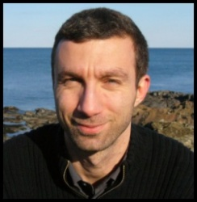
THEORIST
Lorenzo Sorbo
Associate Professor of Physics
University of Massachusetts, Amherst

I am particularly interested in primordial inflation, a period of very fast expansion during a tiny fraction of a second after the Big Bang, when, among other things, a large amount of gravitational waves might have been produced.

Daily challenges. Carrying on long paper-and-pencil calculations in the context of General Relativity and quantum mechanics. Then stopping from time to time to make sure that the equations we get agree with what physical intuition would tell. When this does not happen, the fun part begins: is the calculation wrong, or was our intuition wrong?

Motivation. At the undergrad level, an interest in theory often starts with a fascination for “the most beautiful theory in Physics”. Sometimes you get to theory through cosmology. At a later stage, interest in the purely mathematical aspects of theory can also come up.

Advice. Accept the fact that progress in research is slow, and that most of the time the work you do is not very glamorous. Make sure that you enjoy the process more than its outcome.

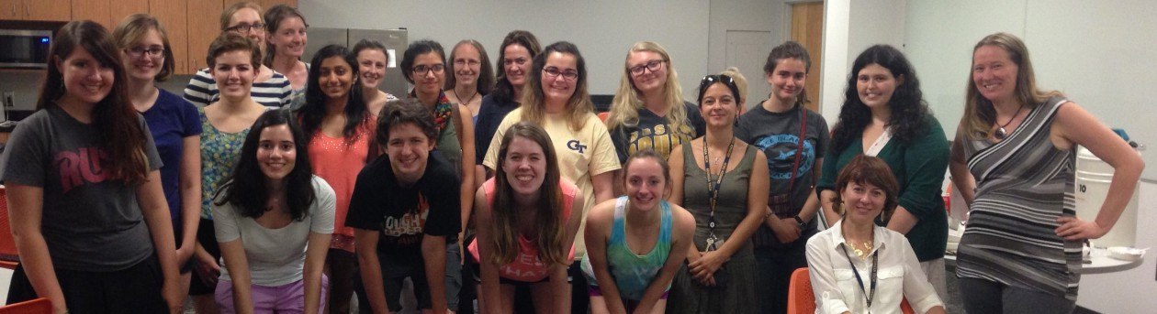NUMERICAL RELATIVIST
Deirdre Shoemaker, Numerical Theory
Associate Professor
Georgia Institute of Technology

I collide black holes for a living! Basically, I do the theoretical (computational) predictions of what gravitational waves will be emitted when two black holes collide in the universe.

Key skills. Programming, statistics, gravitational waves, relativity, partial differential equations, General Relativity knowledge, writing, speaking, time management.

Daily challenges. The really important research goals do not have a fixed deadline, while the less important tasks often do. The problem then becomes getting the important research done without dropping the ball on the little tasks or ignoring the research for the tasks.

Advice. Be persistant! I have about 5 to 10 students a year request to work with me. I cannot handle that amount; however, the students that stop by frequently to chat about research are the ones most likely to get into my group. Seek out faculty, find out what they do and what interests you, and then engage the faculty.

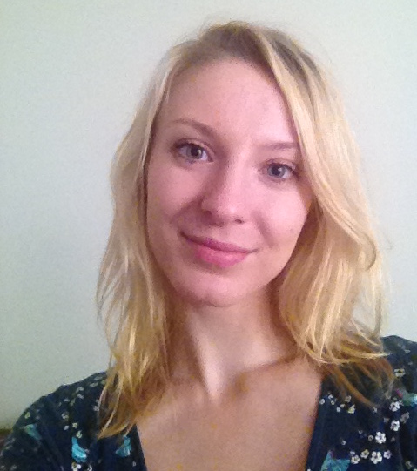
THEORETICAL COMPUTATIONALIST
Sarah Gossan
Graduate student
California Institute of Technology

I work on trying to infer the core-collapse supernova explosion mechanism, using state-of-the-art simulations of core-collapse supernovae. All electromagnetic signals from core-collapse supernovae originate from the outer layers of the progenitor star, and so to look at what is going on in the central engine, one must observe emission in gravitational waves and neutrino messengers.

Key skills. Bayesian statistics! I develop statistical techniques and software to infer information on the physical parameters describing the supernova progenitor star, so great programming skills and thorough knowledge of supernova physics are essential for me.

Daily challenges. Without a doubt, signal processing. To extract information from gravitational waveforms, lots of processing must be carried out, and so extensive knowledge of signal processing methods is invaluable to me on a day-to-day basis.

Advice. For students interested in teaching, I would definitely recommend looking into TA opportunities in your department. Teaching is not easy, and getting as much experience as possible is a great idea.

DATA ANALYST
Nelson Christensen
Professor of Physics
Carleton College

I am searching for stochastic gravitational waves produced in the Big Bang. I also spend a lot of time investigating noise in LIGO.

Key skills. My PhD advisor said you need to know everything about everything. It's true. With LIGO and gravitational wave detection I use programming, statistics, data analysis, optics, general relativity, cosmology, seismology, geophysics, electronics ... the list of skills never seems to end.

Advice. Just do it! See what your professors are doing and find the topic you are most interested in. Then bang on their door and ask for a research project. Don't take no for an answer either, get started on a project with the prof, no matter how small, and build on that. Undergraduate research experience is important. So are internships. It is important to put the books down and get your hands dirty in a field that interests you.

