Build and Use a Simple Spectroscope

Subject Area: Physical Sciences

Grade Level: 9 – 12

Overview

In this activity students will build a spectroscope to analyze the composition of light. Our scope is inexpensive, but if assembled with care it can yield excellent qualitative results. Rather that cut a slit in a box by using a razor blade, we tape a pair of plastic strips over a larger hole to make a very narrow and very uniform entrance for the light.

Spectroscopes can help students build a deeper understanding of light and of wave behavior in general. The activity presumes that students have been introduced to general wave behavior and have developed basic concepts for wavelength, period, frequency, refraction, diffraction and constructive/destructive interference.

Objectives

Students will recognize that visible light is a collection of waves of different wavelengths, and that we perceive different wavelengths as different colors.

Students will use a spectroscope to separate light into its various individual wavelengths.
- Students will define the term ‘diffraction’, and will describe the role of the diffraction grating in the spectroscope.
- Students will recognize that different types of light sources will produce different spectral patterns, and that the spectroscope can be used as a tool to identify unknown light-producing materials (such as chemical elements in stars).

Connections to Standards

- Science: Wave properties and behavior, the nature of light, evidence and explanations, scientific investigations

Safety Awareness

- All materials and tools should be handled with care
- Don’t look at the sun or at laser light through the spectroscope

Materials for each spectroscope

- A small cardboard box (roughly 20 cm on each edge would be fine)
- Two flat smooth ~1” square pieces plastic with very clean and straight edges. We used the plastic stripping that’s on hand at LIGO to band up packing crates for shipment. If the edges are textured at all, the diffraction pattern will suffer.
- Clear tape
- A utility knife for cutting holes in the cardboard box
- A diffraction grating. We used a 13,500-lines per inch grating from Rainbow Symphony, Inc. See http://www.rainbowsymphony.com Click the “Science and Education” button then the “13,500 lines per inch Diffraction Gratings” link. You can purchase 50 gratings for about $18 plus shipping, or you can buy 100 gratings for $30 plus shipping. There are many other sources of gratings on the Web.
- A variety of types of light sources, both white and colored. You may also wish to supply some sheets of thin transparent colored plastic to use as filters in front of white sources.
- A relatively nice day. Some clouds are acceptable, but light from the sky will look better in the spectroscope if the sun is out.

Procedure for making the spectroscope

- Cut square holes in the center of two opposite faces of the box. The holes should be roughly 2 cm on a side.
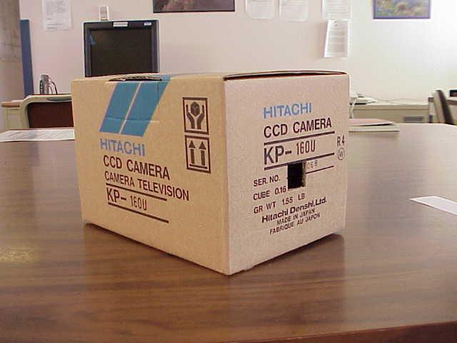
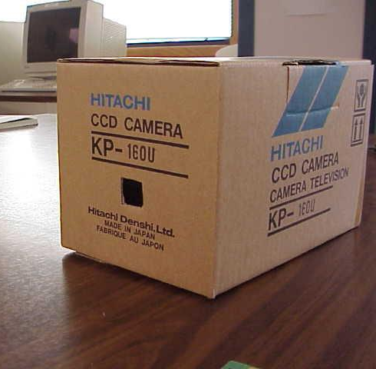

- Position the two plastic strips flat on one face. The two pieces should completely cover the hole you have cut.
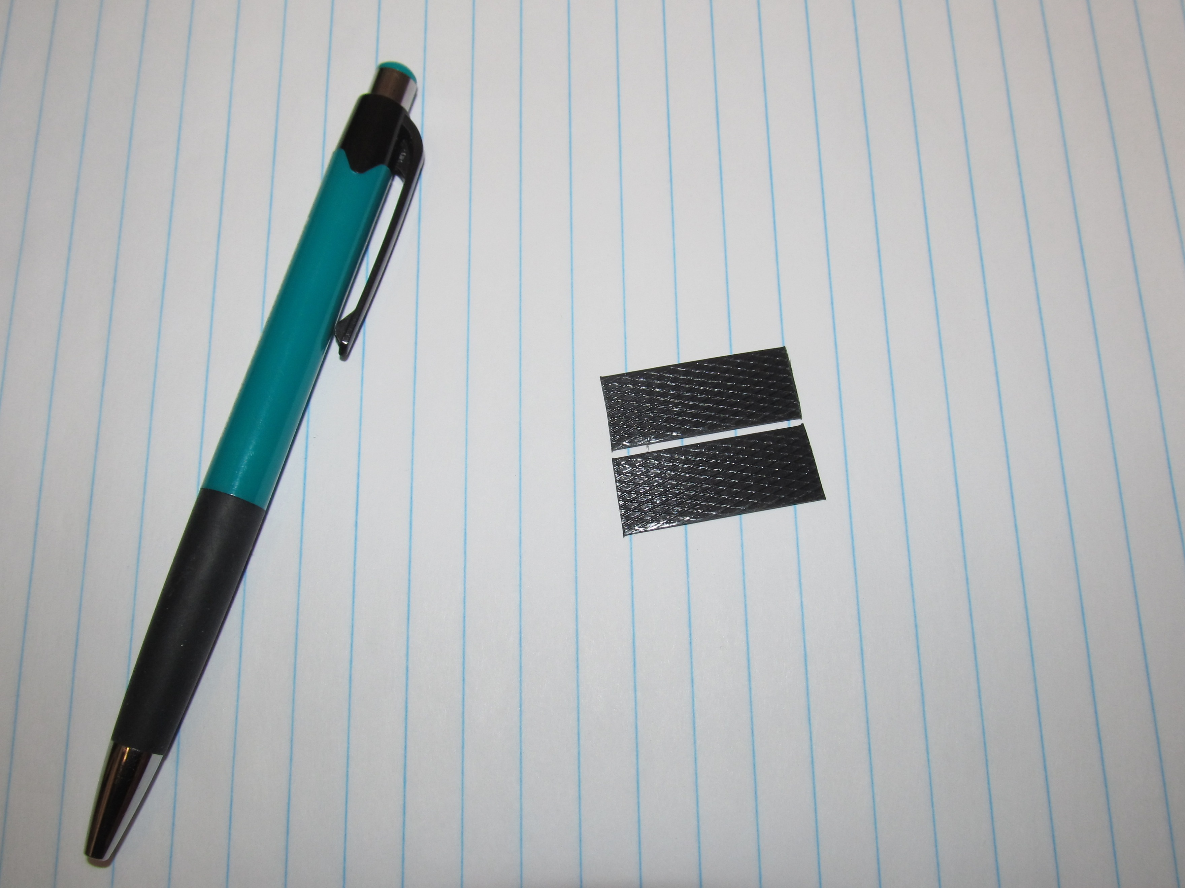

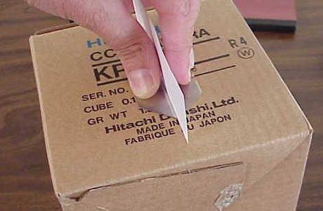
- This is the tricky part. Slide a piece of paper between the plastic pieces that now face each other. The idea is to have the pieces separated only by the thickness of a single sheet of paper. One person should hold the paper upright once you are sure that the paper is completely between the plastic pieces.

- With the thickness of the paper continuing to provide the only separation between the plastic pieces, tape the pieces down to the surface of the box. Don’t move the pieces while doing so.
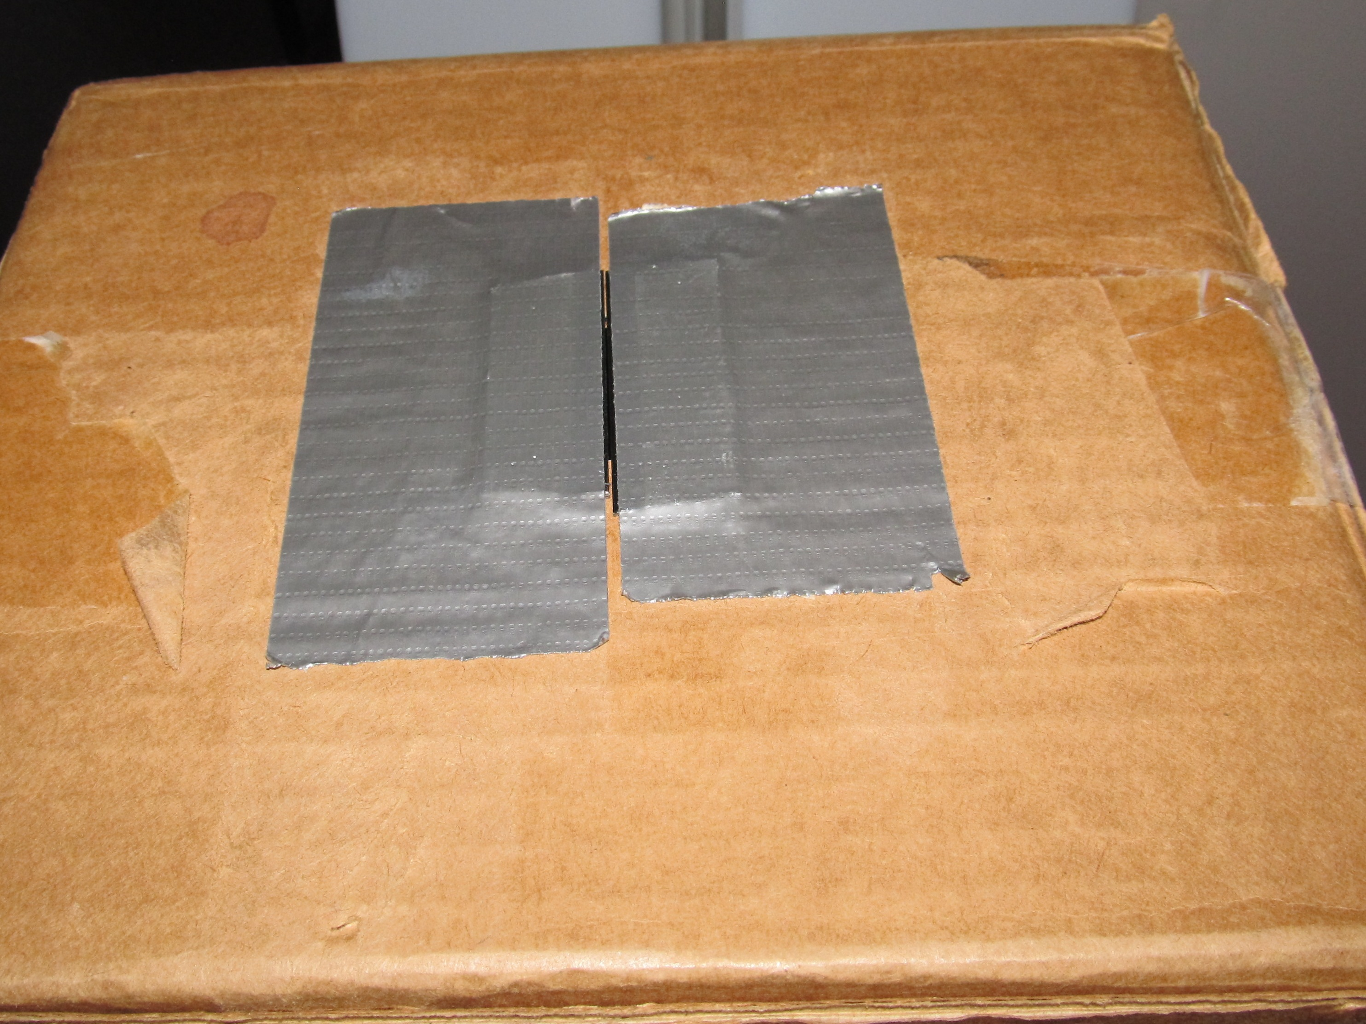

- Now pull the paper out from between the pieces. The plastic edges should be parallel to each other over the hole in the box, and the edges should be separated from each other by the paper’s thickness. If you now look into the box through the other hole (the viewing hole) with the opposite side toward a light source, such as a fluorescent tube fixture in your classroom, you should see a thin vertical strip of light coming through the slit between the plastic edges.

- Now tape the diffraction grating over the hole on the opposite side of the box. Before you tape it, hold the grating by hand over the hole and look in the box. You want to see stripes of color in the diffraction pattern that are vertical and parallel to the slit (see photograph below.

- To use the spectroscope, either tape or hold the diffraction grating slide over the viewing hole in the box. Point the slit towards a light source and peer through the grating into the darkness of the box. You will need to position your eye close to the grating.

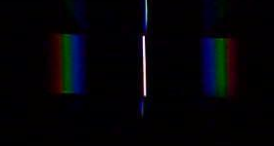

A Handout for Students

The Spectroscope

Now that you have made your spectroscope, use it to make as many observations of light behavior as you can. Try to find different sources of light. Fluorescent lights, incandescent bulbs in lamps, colored bulbs in lamps, candle flames, Bunsen burner flames, neon signs and the sky are all good potential sources. You can also try placing colored glass or colored plastic in front of a white source. Do not look at the sun through your spectroscope, and do not look at laser light through your spectroscope. Even though your viewing slit is narrow, both of these sources can still do permanent damage to your eye. When you observe a light source through the spectroscope, make a written observation of what you see, including a sketch.

Questions
- Using your science textbook or other reference material to help you, define the term ‘wavelength’. Based on the results of this experiment, do you think it is true that sunlight is made of all wavelengths of visible light? Explain your thinking.
- The stripes of colored light that you see in the spectroscope are often called ‘bands’. Are the bands from a blue sky skinny or wide? How about the bands from a white fluorescent light? Propose an explanation for this difference. Can you think of a way to test your explanation?
- If you used your spectroscope to look at a red light, like a stoplight, what do you think would be the appearance of the pattern in the scope? What could you say about the spectral pattern of a green light?
- If all that you saw was a spectral pattern inside your scope – if you couldn’t see the light from the source at all – could you say anything about the nature of the source? If, for example, you saw a spectral pattern of lines, could you say that the source was probably red, or probably green?
- Astronomers use spectroscopy to help identify the chemical elements that make up distant stars. Using what you have learned in this experiment, describe how such identifications are possible.
- Do some quick research (perhaps on the Internet) and see if you can discover some ways that spectrometers are used in the ‘real’ world.

Background

Nature displays considerable variety in the types of waves that we can observe (waves can also be called oscillations or periodic behaviors).
- Tidal cycles are oscillations that occur over hours; ocean waves occur in seconds; sound waves vibrate dozens, hundreds or thousands of times per second; light waves vibrate trillions of times per second.
- Waves vary according to the materials (the ‘media’) through which they can pass (light waves won’t pass through steel, but sound waves will).
- We sense waves by a number of methods. Our eyes, ears and hands all detect different wave behaviors, and we have invented a huge number of devices for sensing waves – everything from seismometers to satellite dishes to X-ray film.
All types of waves, however, can be characterized by certain measurements. Wavelength is a measure of the length of a wave (crest to crest). Period is the amount of time that is needed for a single oscillation of the wave. Frequency is the number of oscillations that occur in a certain time (period and frequency are reciprocals of each other). The speed (or velocity) of a wave is how quickly the wave moves from one location to another. An important mathematical relationship that unites several of these quantities is
Wave speed = (wavelength) * (frequency)
Let’s consider light waves specifically. What we call light is actually one portion of the electromagnetic spectrum, which includes radio waves, microwaves, infrared light, visible light, ultraviolet light, X-rays and gamma rays (in order of increasing frequency). All electromagnetic waves move at the ‘speed of light’ – roughly 300,000,000 meters per second (3.0 * 10⁸ m/s). Since all of these light waves move at the same speed, then those with higher frequencies must have shorter wavelengths, and vice versa.
Light from the sun is composed of all colors of the spectrum. We know this because when we pass sunlight through a prism, we see the colors of the rainbow. The prism refracts sunlight. Refraction occurs when the path of a wave is bent as the wave crosses a boundary into a new medium. Apparently, the different colors (waves) in the visible spectrum are refracted at different angles as they interact with the prism. We say that light undergoes dispersion in the prism (the prism disperses, or separates, the component waves).

An incoming ray of white light undergoes refraction in a prism

Another way to separate the components of light is through the process of diffraction. Diffraction is the bending of a wave path that occurs as the wave passes through a narrow opening.

These waves are moving towards a single slit in a barrier
The slit causes the waves to undergo diffraction.
These waves encounter a barrier with many slits (such as a diffraction grating in the path of a light beam)
The diffracted wave patterns interfere with each other as they move out from the slits. Most of this interference results in cancellation of all wave intensity. The more slits, the more the cancellation. Along the lines formed by the points of intersection of the crests (only two are shown), interference produces amplified wave intensity.

The diagram above shows the diffraction of a set of a wave through a single slit. If the light encounters not just one slit but many, many slits, such as on a diffraction grating, the waves will be diffracted by the slits. The diffracted waves undergo constructive and destructive interference with each other. The interference process will separate the waves according to their color, similar to the refraction process described above. You will use this fact to analyze different types of light when you use your spectrometer.

