Theoretical Mirror Response in Thermo-Optic Experiment with Penetrating Heating Laser
LIGO-T1500038 v1
Gregory Holdman, Greg Ogin
Whitman College
An understanding of the thermo-optic properties of the mirrors used in the Laser Interferometer Gravitational-Wave Observatory (LIGO) detectors is important to characterizing the thermo-optic noise, which has the potential to dominate signals from gravitational wave sources. While there is a large amount of documentation on the properties of fused silica glass in bulk, which makes up the substrate of the mirrors, there is little information on the properties of the dielectric stack mirror coating. In this paper, we present the theory and subsequent expectations of an experiment that measures the effective change of reflected phase with temperature ($dφ/dT$) of a mirror coating in an experiment of the type performed by Greg Ogin at Caltech in 2012, only with the additional component of a heating beam that simultaneously heats both the coating and part of the substrate.

1. Theoretical Response without Surface Absorption
1.1 Temperature Profile
To start, we will derive the temperature profile $u(z,t)$ of the substrate assuming the density of energy deposited is proportional to an exponentially decaying pump laser intensity. For a sufficiently large heating spot and relatively slow changes, we can assume a constant temperature profile in the transverse directions and we can begin with the 1-dimensional heat equation with a forcing function F,
 | $$\frac{∂u}{∂t}=a\frac{∂^{2}u}{∂z^{2}}+F\left(z,t\right)$$ | (1.1)
where$u$ is the temperature, $z$ is the distance into the substrate, and $F(z,t)$ describes the temperature forcing produced by the absorption of the laser in the substrate, in units $K∙s^{-1}$. The constant$a$ is given by,
 | $$a≡\frac{κ}{ρ C_{p}}$$ | (1.2)
with$κ$ being thermal conductivity, $ρ$ being the density, and $C_{p}$ the specific heat of the substrate.
Since the pump beam will be amplitude modulated at a frequency $ω$ and the heat equation is linear, we can expect all responses will be sinusoidal at the same frequency as the driving term. Therefore, the temperature profile will have the same time dependence and can be written as$u\left(z,t\right)=u\left(z\right)e^{iωt}$. We will switch to phasor notation and treat all equations as if they were multiplied by a factor $e^{iωt}$ for the remainder of the paper. Any term multiplying this factor will be complex, with its amplitude describing the size of the resulting oscillations and its complex phase representing the phase delay relative to the driving pump oscillations.
For the forcing function, we will assume that the power absorbed, and thus temperature forcing, will follow the exponential decay of the pump laser beam in the substrate. The forcing function is then,
 | $$F\left(z\right)=\frac{P_{0} a}{κ A z_{0}}e^{-\frac{z}{z_{0}}}$$ | (1.3)
where $P_{0}$ is the total power deposited, $z_{0}$ is the decay distance into the substrate, and$A$ is the area of the pump beam. The constants are determined from calculating the temperature rise from deposited power and normalizing so that the total power deposited is $P_{0}$.
The heat equation then becomes,
 | $$iωu=a\frac{∂^{2}u}{∂z^{2}}+\frac{P_{0} a}{κ A z_{0}}e^{-\frac{z}{z_{0}}}$$ | (1.4)
Since this is a second order differential equation in $z$, there will be a homogeneous solution (with two coefficients to be determined by boundary conditions) and a particular solution. It is straight-forward to show that the homogeneous solution can be written,
 | $$u\left(z\right)=Be^{-ikz}+Ce^{ikz}$$ | (1.5)
where,
 | $$k=e^{-i45°} \sqrt{\frac{ω}{a}}$$ | (1.6)
This variable$k$ behaves as a wave vector. Since it is complex, it will describe either exponentially growing or decaying waves. The constant $C$ in equation 1.5 must be zero since exponentially increasing temperature variations at large z are unphysical.
For a particular solution, we will try the form$u_{p}\left(z\right)=De^{-\frac{z}{z_{0}}}$. Plugging this into equation 1.4 gives,
 | $$D=\frac{-P_{0} a}{κ A z_{0} (\frac{a}{{z_{0}}^{2}}-iω) }$$ | (1.7)
The full solution to the heat equation is then,
 | $$u\left(z\right)=Be^{-ikz}-\frac{P_{0} a}{κ A z_{0} (\frac{a}{{z_{0}}^{2}}-iω) }e^{-\frac{z}{z_{0}}}$$ | (1.8)
In order to determine B we need another boundary condition. Here we may use the power flux continuity condition at the surface,
 | ${\left.-κ \frac{∂u}{∂z}\right|}_{z=0}=\frac{P_{0}}{A}$ | (1.9)
The mirror is in a vacuum, so we may assume that no heat is absorbed through the surface. Thus, there is no power at the surface implying that the right side of equation 1.9 is zero. This, in turn, implies a boundary condition of $u'\left(0\right)=0.$ Applying this boundary condition allows us to determine B,
 | $$B=\frac{P_{0}a^{3/2}}{κ A {z_{0}}^{2} (\frac{a}{{z_{0}}^{2}}-iω)} \frac{e^{-i45°}}{\sqrt{ω} }$$ | (1.10)
Our full temperature profile through the substrate is then,
 | $$u\left(z\right)=\frac{P_{0}a^{3/2}}{κ A {z_{0}}^{2} (\frac{a}{{z_{0}}^{2}}-iω)} \frac{e^{-i45°}}{\sqrt{ω} }e^{-ikz}-\frac{P_{0} a}{κ A z_{0} (\frac{a}{{z_{0}}^{2}}-iω) }e^{-\frac{z}{z_{0}}}$$ | (1.11)
The left-hand term we can recognize as a thermal wave that decays as we move into the substrate. The second term is in phase with the laser and is proportional in decay. Notice here that we have what looks to be a low-pass filter factor ${(\frac{a}{{z_{0}}^{2}}-iω)}^{-1}$ on each term. This factor is not present when the pump is absorbed promptly at the surface, and thus will be important in understanding the experiment when the pump penetrates into the substrate.

1.2 Thermo-Elastic Response of Substrate
To find the thermo-elastic response, we simply integrate equation 1.11 over the substrate multiplying by the coefficient of thermal expansion and multiplying by -1 to account for the fact that an increase in substrate thickness will be seen as a decrease in length of the interferometer arm,
$${δl}_{TE}=-α_{S}\int_{0}^{∞}{u\left(z\right)dz}$$
 | $$=\frac{α_{S} P_{0} a}{κ A} \frac{e^{i90°}}{ω}$$ | (1.12)
The second line comes from integrating over the temperature profile in equation 1.11 and performing many steps of algebraic simplification. Notice that this term has a phase of $90°$ in advance of the pump beam modulations, falls off as$ω^{-1}$, and does not depend on$z_{0}$. This last point might seem surprising, but one can imagine that spreading out the power will heat the substrate less so more material will expand a small amount, while concentrating the power towards the surface will heat that region more causing greater expansion in the small part that gets heated.

1.3 Thermo-Refractive Response of Coating
To find the thermo-refractive response, we multiply the surface temperature by the coefficient $β_{eff}$ with a factor of$-\frac{λ}{4π}$ to convert from optical phase to apparent arm length change,
$${δl}_{TR}=-\frac{λ}{4π}β_{eff} u(0)$$
 | $$=\frac{λ β_{eff} P_{0}a^{3/2}}{4π κ A {z_{0}}^{2} (\frac{a}{{z_{0}}^{2}}-iω)} \frac{e^{i135°}}{\sqrt{ω} }+\frac{λ β_{eff} P_{0} a}{4π κ A z_{0} (\frac{a}{{z_{0}}^{2}}-iω) }$$ | (1.13)
Here, we assume that the coating is thin enough that it is all at the same temperature as the surface of the substrate. This part of the response includes the low-pass filter term, an effect we should see in the data. Notice also that it includes a phase of$135°$ahead of the pump beam modulations. We ought to see this in the phase response as well. We also find that unlike the substrate response, this term depends on$z_{0}$. The sum of equation 1.12 and equation 1.13 gives the full response.

2. Theoretical Response with Surface Absorption
2.1 Temperature Profile
In this experiment, we suspect there is the possibility of excess absorption in the coating. This is mainly due to the fact that the coating is made of layers of different materials that will absorb the pump radiation differently than the substrate. In this section, we derive the solution for when a fraction f of the power is absorbed at the surface. The thickness of the coating will be much smaller than other dimensions in the problem such as $z_{0}$ and the thermal wavelength, or,
 | $t_{coating}≪z_{0}$ and $t_{coating}≪λ_{thermal}$ | (2.1)
Therefore, we will account for this extra surface absorption by introducing a heat flow boundary condition at the surface. Since we haven’t introduced any new heat sources in the bulk, the heat equation throughout the substrate is the same as equation 1.4, with the only difference that the total power is$(1-f)P_{0}$ rather than${ P}_{0}$. The particular solution is thus,
 | $$u_{p}\left(z\right)=\frac{-(1-f)P_{0} a}{κ A z_{0} (\frac{a}{{z_{0}}^{2}}-iω) }e^{-\frac{z}{z_{0}}}$$ | (2.2)
We will still use the decaying homogeneous solution since we still expect the temperature to decay as $z$ approaches infinity, but this time we must apply a boundary condition which will allow for the absorption of the rest of the power${fP}_{0}$ through thermal heat flow at the surface. This condition is the power flux continuity condition of equation 1.9, with ${fP}_{0}$ rather than$P_{0}$, which leads to,
 | $$B= \frac{f P_{0} \sqrt{a}}{κ A}\frac{e^{-i45°}}{\sqrt{ω}}+\frac{ \left(1-f\right) P_{0}a^{\frac{3}{2}}}{κ A {z_{0}}^{2} (\frac{a}{{z_{0}}^{2}}-iω)}\frac{e^{-i45°}}{\sqrt{ω}}$$ | (2.3)
Note that the second term on the right hand side is exactly the same as$B$ from equation 1.10, only with ${\left(1-f\right)P}_{0}$ instead of$P_{0}$. As we said before, this term along with the exponential $e^{-ikz}$ describes the thermal wave produced from the heat of the penetrating laser. Also note that the left term is exactly the coefficient when assuming a surface source, found on page 32 of Professor Ogin’s thesis, only with ${fP}_{0}$ rather than$P_{0}$. This term along with the wave exponential describes the flow of heat absorbed at the surface. Now our temperature profile is,
 | $$u\left(z\right)=\left(\frac{P_{0} f \sqrt{a}}{κ A}\frac{e^{-i45°}}{\sqrt{ω}}+\frac{P_{0} \left(1-f\right)a^{\frac{3}{2}}}{κ A {z_{0}}^{2} \left(\frac{a}{{z_{0}}^{2}}-iω\right)}\frac{e^{-i45°}}{\sqrt{ω}}\right) e^{-ikz}-\frac{(1-f)P_{0} a}{κ A z_{0} (\frac{a}{{z_{0}}^{2}}-iω) }e^{-\frac{z}{z_{0}}}$$ | (2.4)
If we let $f$ approach zero, as was our assumption in section 1.1, then this reduces to equation 1.11, the first temperature profile found in that section. If we let$f$ approach 1, we find the temperature profile for assuming a surface source, as seen in equation 3.7 of Professor Ogin’s thesis.

2.2 Thermo-Elastic Response of Substrate
Integrating and multiplying by the coefficient of thermal expansion as we did before gives the thermo-elastic response,
 | $${δl}_{TE}=\frac{α_{S} P_{0} a}{κ A} \frac{e^{i90°}}{ω}$$ | (2.5)
Notice that this is the same as equation 1.12. This is surprising, but makes physical sense as it should not matter where the power is absorbed since we have a linear coefficient of thermal expansion.

2.3 Thermo-Refractive Response of Coating
The thermo-refractive response changes. We see the effect of the extra term from equation 2.3,
 | $${δl}_{TR}= \frac{λ β_{eff} P_{0} \sqrt{a} f}{4π κ A }\frac{e^{i135°}}{\sqrt{ω}} +\frac{λ β_{eff} P_{0} a^{3/2} (1-f) }{4π κ A {z_{0}}^{2} \left(\frac{a}{{z_{0}}^{2}}-iω\right)} \frac{e^{i135°}}{\sqrt{ω}} + \frac{λ β_{eff} P_{0} a \left(1-f\right)}{4π κ A z_{0} \left(\frac{a}{{z_{0}}^{2}}-iω\right)}$$ | (2.6)
The first term was not seen in equation 1.13 while the other two are the same as 1.13 with a factor of $(1-f)$. The response behaves as expected. As $f$ approaches zero, it reduces to equation 1.13, the thermo-refractive response from section 1.2. Also, as $f$ approaches 1 we find that this reduces to equation 3.8 from Professor Ogin’s thesis, with the exception of 180 degrees of phase which can be attributed to the minus sign we included in the thermo-refractive response of this document. Note that we have the low-pass filter factors in two terms and a phase of 135 degrees in two terms.

2.4 Full Response
The sum of equations 2.5 and 2.6 is the full response,
 | $$δl=\frac{α_{S} P_{0} a}{κ A} \frac{e^{i90°}}{ω}+ \frac{λ β_{eff} P_{0} \sqrt{a} f}{4π κ A }\frac{e^{i135°}}{\sqrt{ω}} +\frac{λ β_{eff} P_{0} a^{3/2} (1-f) }{4π κ A {z_{0}}^{2} \left(\frac{a}{{z_{0}}^{2}}-iω\right)} \frac{e^{i135°}}{\sqrt{ω}} + \frac{λ β_{eff} P_{0} a \left(1-f\right)}{4π κ A z_{0} \left(\frac{a}{{z_{0}}^{2}}-iω\right)}$$ | (2.7)
This is the function which we will investigate and to which we will fit our data.

3. Fitting to Data
3.1 Overview
This section is concerned with fitting the data to the response. A measurement in this experiment will constitute a sinusoidal change in brightness from the interferometer. The magnitude of this change will correspond to the length change of the arm due to the mirror. We will also compare the phase with that of the pump beam. Thus, the data will be a set of frequencies, each associated with a complex value as the response at that frequency.
We have four potentially unknown parameters in this response:$z_{0}$, $β_{eff}$, $f$, and $P_{0}$. The one we wish to measure with greatest accuracy is $β_{eff}$ as that carries the information about the coating. Regarding equation 2.7, it appears we will be able to achieve this. The first term allows us to determine$P_{0}$. Since that term describes the low frequency behavior, it will be easy to measure. We can now use the value of $P_{0}$ in the rest of the terms. Now the only unknowns are$z_{0}$,$β_{eff}$, and$f$. All three appear in the third and fourth terms, but only$β_{eff}$ and$f$ appear in the second term. It appears that if we have a good fit to$f$, then the second term allows for a good fit to $β_{eff}$. This is promising, but it turns out that, aside from the thermo-elastic term, the third term is dominant throughout the range of frequencies we will consider. Since this term contains a factor of $z_{0}$, we will still need to hope for a good fit to that parameter. It seems that all parameters will be important in this fit.

3.1 Using Plots to Determine Effectiveness of Fit
As we vary the parameters in the substrate responses, we hope they will cause unique changes to the response. In particular, we hope to find that the response clearly distinguishes values of $β_{eff}$ as this is the parameter we are hoping to measure with greatest accuracy. We will now investigate this by looking at plots of both the length response and the phase response for a substrate of fused silica and varying the parameters about an expected value. In each of the plots, I use the following expected values for the parameters: $P_{0}=1$ W; $β_{eff}=1.39 ×{10}^{-4} K^{-1}$ from equation 3.41 on page 95 of Greg Ogin’s thesis; $z_{0}=32 μm$ (he found this in an article by McLachlan and Meyer, Applied Optics, Vol 26, No. 9, 1987); $f=17\%$ as a somewhat naïve initial guess. We will not vary $P_{0}$ as it only serves to multiply the entire response by a constant, and we are sure none of the other parameters have this effect.
Figures 1 through 3 show the length response of the mirror as we vary the parameters. A common thread is that the parameters have a greater effect at high frequencies. This makes sense, as the thermo-elastic response is dominant at low frequencies and none of the parameters are present in that term. The parameter $f$ only has an effect above about 1000 Hz. The parameters $z_{0}$ and $β_{eff}$ appear to have an effect over a much larger range of frequencies, from 100 Hz and above. Though they have effects over the same range, they have inverse effects. A low $z_{0}$ means a greater magnitude at high frequencies while a low $β_{eff}$ means a lower magnitude at high frequencies. In general, the parameters all seem to behave uniquely and we can expect to fit with accuracy.

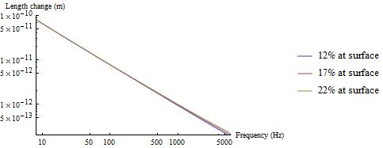
Figure 1: Plot showing how variation of$f$ changes the length response.

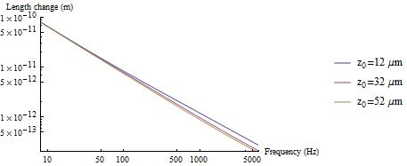
Figure 2: Plot showing how variation of$z_{0}$ changes the length response.

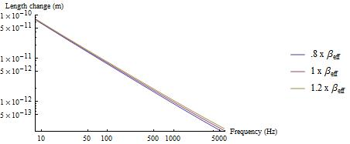
Figure 3: Plot showing how variation of $β_{eff}$ changes the length response.

Figures 4 through 6 show the phase responses. Each parameter changes the phase response in a unique way. This is encouraging for the fit since we will be fitting to the full complex response. It seems that$f$ and$z_{0}$ show the greatest variation. The effect of $β_{eff}$ is smaller, but still distinguishable. If the other parameters are known to a strong accuracy, this fit should still be able to discern$β_{eff}$.

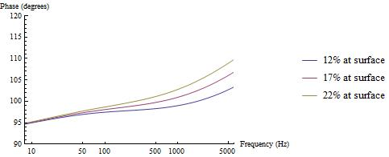
Figure 4: Plot showing how variation of$f$ changes the phase response.

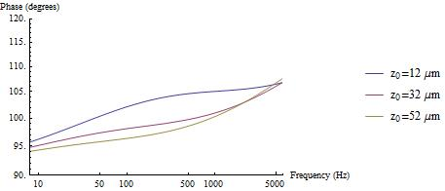
Figure 5: Plot showing how variation of$z_{0}$ changes the phase response.

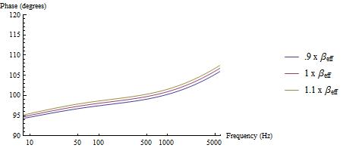
Figure 6: Plot showing how variation of$β_{eff}$ changes the phase response.

In conclusion, we find that each parameter has a unique and discernable effect on the response of the mirror. We can expect to find a reasonable fit to each parameter. We will demonstrate this more directly in the next section.

3.2 Applying a Fit
The function we are trying to fit is a complex valued function of a real parameter$ω$. The standard fitting routines in software we have available, namely Mathematica and Matlab, are not written to handle complex values. Fortunately, Mathematica does have minimization functions that will serve the same purpose assuming you ask them to minimize an appropriate error function. We wrote an error function $Error$ that quantifies how well a response function $δl$ fits to a set of $n$ data points$\{x_{i},y_{i}\}$ where$x_{i}$ is the frequency and $y_{i}$ is the complex response,
 | $$Error\left(z_{0},f,β_{eff},P_{0}\right)=\sum_{i=1}^{n}{\frac{{|δl\left(x_{i}, z_{0}, f, β_{eff},P_{0}\right)-y_{i}|}^{2}}{{|y_{i}|}^{2}}}$$ | (3.1)
The factor ${|y_{i}|}^{-2}$ is there so that the fit will be penalized by the same amount for the same fractional error. This is important in cases like ours where the data is likely to span many orders of magnitude. A standard least squares fit could conceivably ignore a large error (e.g. 200%) in a small magnitude data point, while giving significant weight to low error (e.g. 5%) in a large magnitude data point. We then use Mathematica’s FindMinimum function with a maximum of 400 iterations to determine the parameters which minimize the total square fractional error.
To check the fits obtained in this way, we tested the process on fake data. To simulate data, we chose 100 logarithmically spaced frequencies between 10 Hz and 5000 Hz, a frequency range shown to be reasonable in Professor Ogin’s previous work. For a specific frequency $x_{i}$ we calculated the complex response $δl(x_{i})$ using the expected values for the parameters we used in section 3.1. To this result, we then added a random complex number$δl\left(x_{i}\right)R e^{i φ_{R}}$, where$R$ is a random real number chosen from a Gaussian distribution centered on zero with a standard deviation of $σ=.035$ and $φ_{R}$ is a random real number between $–π$ and $π$. In other words, we add a roughly 3.5% error to each point with random phase. An example of this generated data is shown in Figure 7. Notice that the noise is of comparable order to that of the data in Figure 3.30 of Professor Ogin’s thesis.
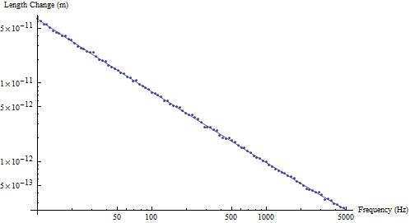
Figure 7: An example of the length response of our fake data. The solid line is the true response from which the data was generated.

Due to the random nature of the data, we needed many tests to check that our algorithm was working properly. We would produce a set of fake data, then use that fake data to minimize equation 3.1. Once this was accomplished and we had our fitted parameters, we would calculate the percent error off of the expected values we had first used to generate the data. This percent error was added to a running total for each parameter. After $n$ data sets had been generated, fit to 3.1, and their percent errors added to the total, we divided by $n$ to obtain the average percent error for each parameter.
Using our algorithm, we were able to find fits to good percent error: ~10% for$z_{0}$, ~10% for$β_{eff}$, ~5% for$f$, and ~1% for$P_{0}$ averaged over 1000 different generated data sets. We investigated whether the algorithm systematically over- or underestimated the fit. Little to no bias occurred either way. We found that there was never more than a 10% difference in over- versus underestimates.
It turns out that $z_{0}$ is the only parameter that appears in a nonlinear way. We found that knowing the value of $z_{0}$ has strong benefits for the fit. We were able to achieve much better fits on the other parameters when $z_{0}$ was known, with all parameters then having percent errors under 5%.
Since we are fitting a complicated function of four parameters, the error landscape is non-trivial, and good initial values for the parameters are important. Using our algorithm, Mathematica did report from time to time that the function may not have converged to a minimum. Upon further investigation, we found that all fits were reasonably close to the value we expected, thus the message was not a cause for alarm. In our experience, the initial value needed to be more than a factor of about 5 off of the true value to cause a failure to converge to reasonable values. Importantly, these bad fits were easily distinguishable by eye. See for example Figure 8 and Figure 9. It is evident that the fit is wrong, especially in the phase response. Such a failure would prompt us to re-try with slightly different starting values (possibly determined by the “chi-by-eye” process of hand-altering the parameters until the function appears by eye to match the data). Thus, even though we do not expect to see these poor fits, we know that they are identifiable should they occur.
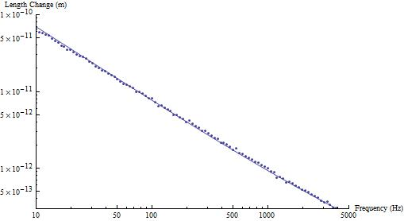
Figure 8: An example of the length response of a poor fit. The solid line is the fit to the data points.

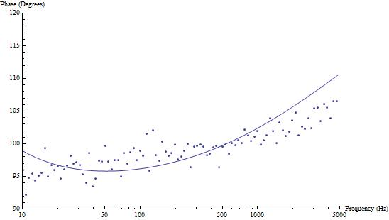
Figure 9: An example of the phase response of a poor fit. The solid line is the fit to the data points.

4. Conclusion
In conclusion, we believe we will be able to measure the parameter $β_{eff}$ to roughly 10%. We found that each unknown parameter has an effect on the response that is different from the others. All are important for a proper fit to$β_{eff}$. We also showed that we are able to determine each of the four unknown parameters to a reasonable accuracy. Fortunately, even if the data is not sufficiently nice for a proper fit, we know that bad fits are easily identifiable and may be ignored. An important point to note is that the results are even more accurate if$z_{0}$ is a known quantity. Overall, we expect to be able to measure our parameter $β_{eff}$ in order to characterize the thermo-optic properties of the LIGO mirror’s coating.

Acknowledgements
I would like to acknowledge the Louis B. Perry Award for funding this work and Professor Gregory Ogin for advising me.

