LIGO Laboratory / LIGO Scientific Collaboration

LIGO-T1500315-v1 Advanced LIGO June 22, 2015

PI Band Pass Filter Board Test Procedure

Carl Adams, R. Abbott

Distribution of this document:
LIGO Scientific Collaboration

This is an internal working note
of the LIGO Laboratory.

California Institute of Technology  LIGO Project – MS 18-34  1200 E. California Blvd.  Pasadena, CA 91125  Phone (626) 395-2129  Fax (626) 304-9834  E-mail: info@ligo.caltech.edu | Massachusetts Institute of Technology  LIGO Project – NW22-295  185 Albany St  Cambridge, MA 02139  Phone (617) 253-4824  Fax (617) 253-7014  E-mail: info@ligo.mit.edu
LIGO Hanford Observatory  P.O. Box 1970  Richland WA 99352  Phone 509-372-8106  Fax 509-372-8137 | LIGO Livingston Observatory  P.O. Box 940  Livingston, LA 70754  Phone 225-686-3100  Fax 225-686-7189

http://www.ligo.caltech.edu/

Overview
This test procedure applies to Parametric Instability Band Pass Filter circuit board LIGO-D1500172-v1. This is a 10 KHz to 80 KHz Band Pass Filter designed for use with parametric instability active damping electronics. The board consists of a differential receiver with -6dB gain, a high pass 2nd order Sallen-Key filter cascaded with a low pass 2nd order Sallen-Key filter with a pass band gain of -0.5dB, and ending with a differential driver with 6dB gain.

Testing
Each filter board assembly must be functionally tested and the results recorded in Section 4. It is assumed that the person using this procedure is familiar with Dynamic Signal Analyzers, and rudimentary test equipment including oscilloscopes and multimeters.

DB9 Pinouts
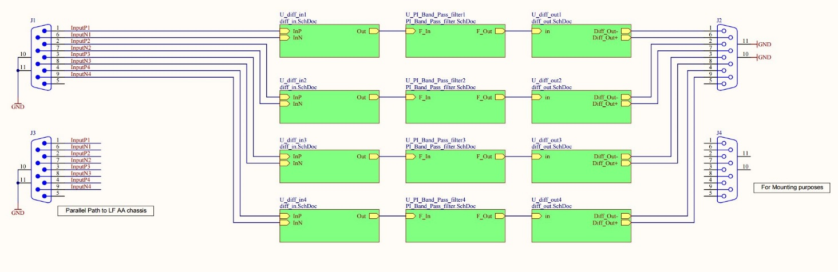

Test Data Tables

General Information
Table 1
Tested By | Board Serial Number | Date

DC Power Supply Data
Note that these boards are intended to be used within a chassis with a Chassis Power Regulator PCB D1000217-v1, and are not regulated. Use caution in believing the digital readouts of laboratory triple output power supplies. Their meters are not highly accurate. When in doubt, use a multimeter on the appropriate scale in series with the supply to be measured.

Apply +/- 15, +/-200 mV Volts DC to the board under test and record LED operation and the total positive and negative power supply current in Table 2.

Table 2, Record of DC Test Data
Parameter | Typical Value | Allowable Range | Measured Value  mA
Front +/- 15VDC Power LEDs | Both Lit | N/A
Rear +/- 15VDC Power LEDs | Both Lit | N/A
+15VDC, +/-0.2VDC TOTAL supply current | 180 mA | +/- 50mA
-15VDC, +/-0.2VDC TOTAL supply current | 170 mA | +/- 50mA

DC Offsets on Each Differential Output
As a general measure of the health, the DC offset must be measured at the differential outputs for each channel. The input connector is to be left open.
Measure the DC offset differentially at the output D-sub for each channel and Record the results as measured by a multimeter in Table 3.

Table 3, Differential Output DC Offset
Differential DC Measurement Point | Typical DC Offset  mV | Allowable Range | Actual DC Offset  mV
Channel 1 | 14 | +/- 5mV
Channel 2 | 14 | +/- 5mV
Channel 3 | 14 | +/- 5mV
Channel 4 | 14 | +/- 5mV

Frequency Response
The transfer function of each channel of the filter should be measured using the dynamic signal analyzer SR785. The input drive level is 5V for all swept sine measurements. A differential input will be required.
Measure the magnitude and the phase differentially at the output D-sub for each channel as required. Record the results the following tables.

Table 4, Frequency Response Channel 1
Measurement  Frequency | Magnitude (dB) | Allowable Range | Phase (deg) | Allowable Range | Measured Magnitude | Measured Phase | Pass/Fail
1KHz | -41 | +/- 1dB | 169.6 | +/- 5 deg
10.461KHz | -3.5 | +/- 1dB | 78.8 | +/- 5 deg
29KHz | -0.5 | +/- 1dB | 0.5 | +/- 5 deg
83.145KHz | -3.5 | +/- 1dB | -81.4 | +/- 5 deg
100KHz | -5.3 | +/- 1dB | -98.5 | +/- 5 deg

Table 5, Frequency Response Channel 2
Measurement  Frequency | Magnitude (dB) | Allowable Range | Phase (deg) | Allowable Range | Measured Magnitude | Measured Phase | Pass/Fail
1KHz | -41 | +/- 1dB | 169.6 | +/- 5 deg
10KHz | -3.5 | +/- 1dB | 78.8 | +/- 5 deg
30KHz | -0.5 | +/- 1dB | 0.5 | +/- 5 deg
80KHz | -3.5 | +/- 1dB | -81.4 | +/- 5 deg
100KHz | -5.3 | +/- 1dB | -98.5 | +/- 5 deg

Table 6, Frequency Response Channel 3
Measurement  Frequency | Magnitude (dB) | Allowable Range | Phase (deg) | Allowable Range | Measured Magnitude | Measured Phase | Pass/Fail
1KHz | -41 | +/- 1dB | 169.6 | +/- 5 deg
10KHz | -3.5 | +/- 1dB | 78.8 | +/- 5 deg
30KHz | -0.5 | +/- 1dB | 0.5 | +/- 5 deg
80KHz | -3.5 | +/- 1dB | -81.4 | +/- 5 deg
100KHz | -5.3 | +/- 1dB | -98.5 | +/- 5 deg

Table 7, Frequency Response Channel 4
Measurement  Frequency | Magnitude (dB) | Allowable Range | Phase (deg) | Allowable Range | Measured Magnitude | Measured Phase | Pass/Fail
1KHz | -41 | +/- 1dB | 169.6 | +/- 5 deg
10KHz | -3.5 | +/- 1dB | 78.8 | +/- 5 deg
30KHz | -0.5 | +/- 1dB | 0.5 | +/- 5 deg
80KHz | -3.5 | +/- 1dB | -81.4 | +/- 5 deg
100KHz | -5.3 | +/- 1dB | -98.5 | +/- 5 deg

Output Noise Spectra
The output noise voltage of each channel of the filter board should be measured using the dynamic signal analyzer SR785. This measurement should be made while the input is open, and the frequency range is set from 1Hz to 100 kHz, differentially into a SR560 with 1000 gain.
Measure the output referred noise differentially at the rear panel D-sub output for each channel as required. Record the results in Table 8.
Table 8, Channel Noise
Channel | Measurement Frequency | Typical Amplitude dBVrms/√Hz | Measured Amplitude dBVrms/√Hz | Pass/Fail
1 | 30KHz | < -129
2 | 30KHz | < -129
3 | 30KHz | < -129
4 | 30KHz | < -129

