LIGO Laboratory / LIGO Scientific Collaboration

LIGO- T1500406 LIGO August 12th, 2015

SEI WD Saturation Counter Update
Version 3

Hugo Paris, Brian Lantz

Distribution of this document:)
Advanced LIGO Project

This is an internal working note
of the LIGO Laboratory

California Institute of Technology  LIGO Project – MS 18-34  1200 E. California Blvd.  Pasadena, CA 91125  Phone (626) 395-2129  Fax (626) 304-9834  E-mail: info@ligo.caltech.edu | Massachusetts Institute of Technology  LIGO Project – NW22-295  185 Albany St  Cambridge, MA 02139  Phone (617) 253-4824  Fax (617) 253-7014  E-mail: info@ligo.mit.edu
LIGO Hanford Observatory  P.O. Box 1970  Mail Stop S9-02  Richland WA 99352  Phone 509-372-8106  Fax 509-372-8137 | LIGO Livingston Observatory  P.O. Box 940  Livingston, LA 70754  Phone 225-686-3100  Fax 225-686-7189

Table of Contents
I) Clear Saturations Button 4
a) Description 4
b) Tests Performed 6
II) Saturation Counters 11
a) Description 11
b) c-code (as of Aug 12th 2015) 12
c) Model implementation 15
d) Tests Performed 16

Update Summary

Changes listed below apply to the HAM-ISI, BSC-ISI and HEPI master models as well as the related MEDM Watchdog screens. Two changes are suggested:

1) Add a "clear saturations" button which is separate from the "reset Watchdog" button. The "Reset Watchdog" button will be unchanged, and the new "clear saturation" button will just clear the saturation counters.

2) The watchdog is setup so that if the total saturations in the history are greater than the allowed number of saturations then the watchdog will trip. Currently, the history is kept until the watchdog trips or the history is reset. We propose changing the saturation history buffering so that saturations more than 1 hour old (value defined in the simulink model) are automatically cleared. The history will be stored in 60 bins, each 1 minute long. Bins more that 1 hour old are cleared.

Reason for Change(s):
Change #1 is so that we can separate the “reset watchdog” from the “clear old saturations” function. Change #2 is so we only trip on recent troubles, not a slow accumulation of old trouble. JimW

08/11 Bug fix (SEI alog #813)
The bug:
the Saturations_total = current_buffer + sum_of_history

The current_buffer is updated in real-time and contains the total number of saturations since the current 60 second block started.

history_array is 60 element array which contains the history. At the end of each 60 sec block, the current_buffer is put into 1 element of the history_array. It overwrites the "oldest" element of that array, which is how we drop old saturations.
- AND -
The history array is summed to find the new sum_of_history.
i.e. the sum_of_history is only updated 1 time every 60 seconds.

THE BUG -
When you hit reset, it set each element of the history_array = 0 and the current_buffer = 0. BUT NOT the sum_of_history.
THE FIX -
is to also set sum_of_history = 0.

this bug is annoying but not really dangerous. after 60 seconds, the sum_of_history gets recalculated, so the new sum_of_history will be 0 + whatever new saturations arrived between pressing the CLEAR and the end of the 60 second block.

I) Clear Saturations Button

a) Description
A “clear saturations” button was added the the WD screen. This button allows clearing the number of saturations registered on all our devices (CPS, GS13, ACT etc...) without having to reset the WD themselves. Model and MEDM changes are shown below, along with their description.

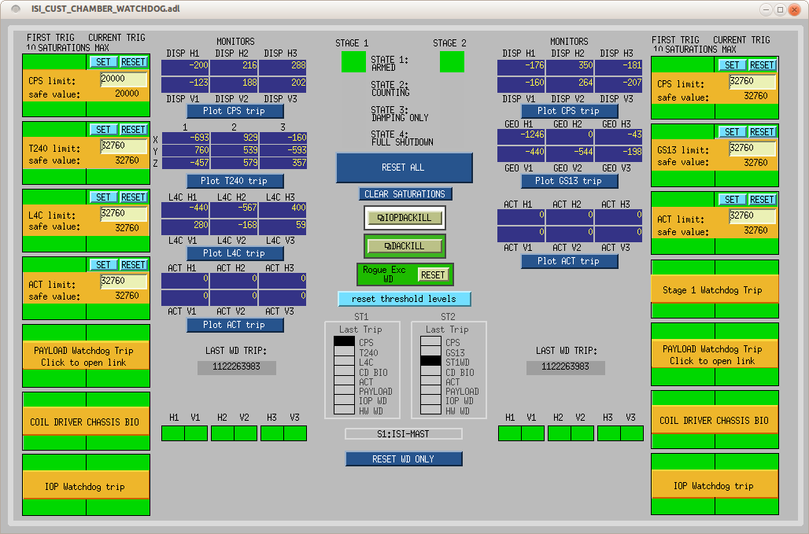
Fig.1. BSC-ISI WD screen after update

Fig.1 shows the BSC-ISI WD screen after the update. The “Clear Saturations” button can be found in the center of that screen, right under the “Reset All” button (regular WD reset).

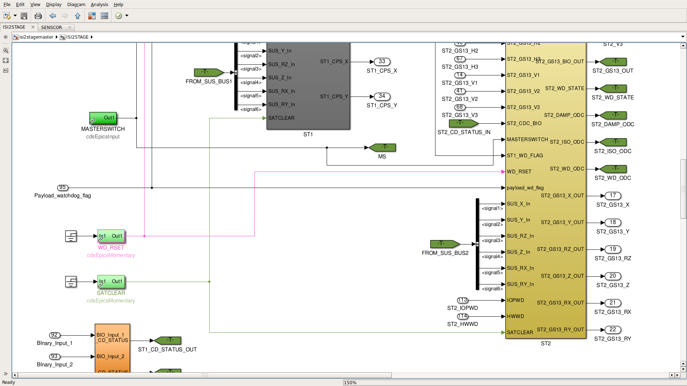
Fig. 2. SATCLEAR in top layer of model
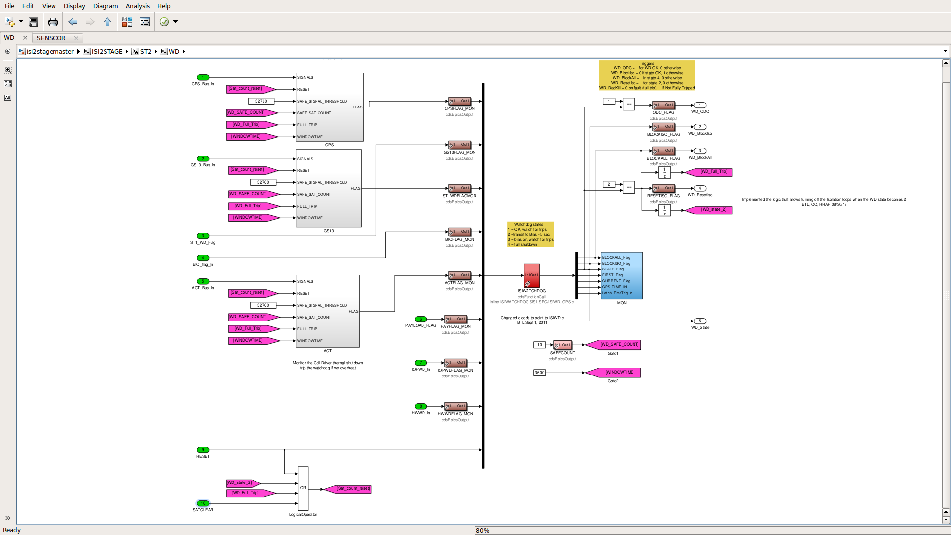
Fig. 3. SATCLEAR signal in the WD block
Fig.2-3 show the model changes necessary for the “ Clear Saturations” button to work. Fig.2. Shows the top layer of the BSC-ISI model to which a SATCLEAR EPICS momentary was added. This momentary is the one triggered by the “Clear Saturations” button of the WD screen. Its signal is then sent all the way down the model to the WD block where is is linked to the RESET input of the new WD saturation counter c-code (fig.3).

b) Tests Performed
The tests performed to ensure the “Clear Saturations” feature was properly working are listed below with the test result. The tests performed are illustrated in the figures below.
- Apply a number of saturation lower than the saturation counter limit (which was temporarily raised to 3000cts to facilitate the test).
- Make sure the number of saturations rises properly by monitoring them on DV and make sure that this information is properly displayed on the WD screen. (fig. 4-5)
- Use the “Clear Saturations” button to clear those saturations
- Confirm that the saturation counters got cleared by looking at both the WD MEDM screen and a DV session. (fig 6-7)
Test Result: Passed.

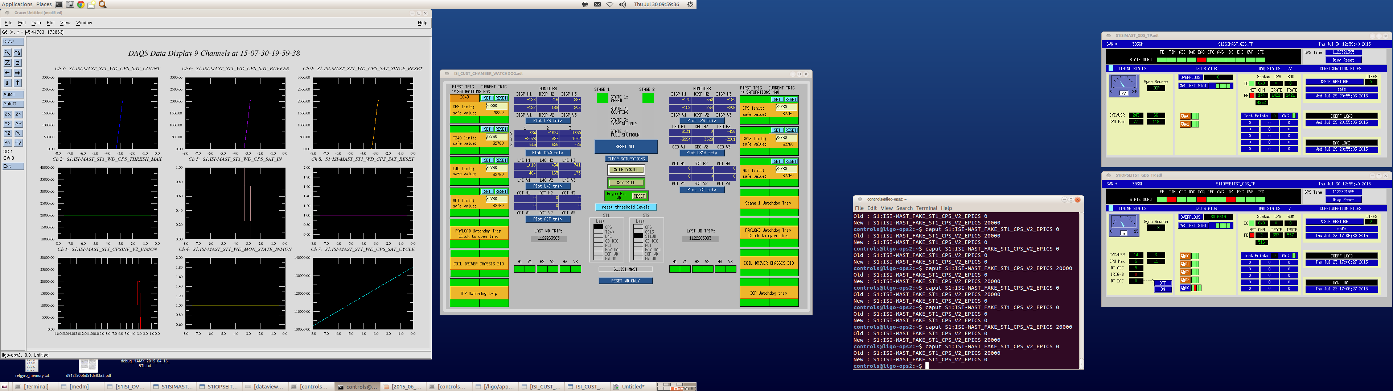
Fig.4. “Saturation Clear” test sequence part 1
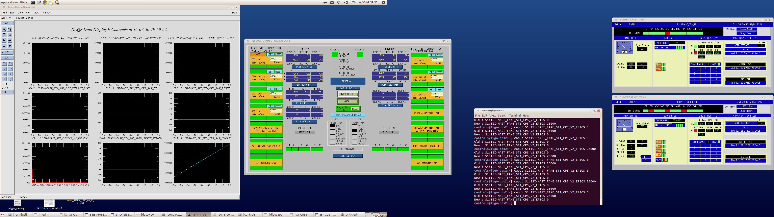

Fig.5. “Saturation Clear” test sequence part 2
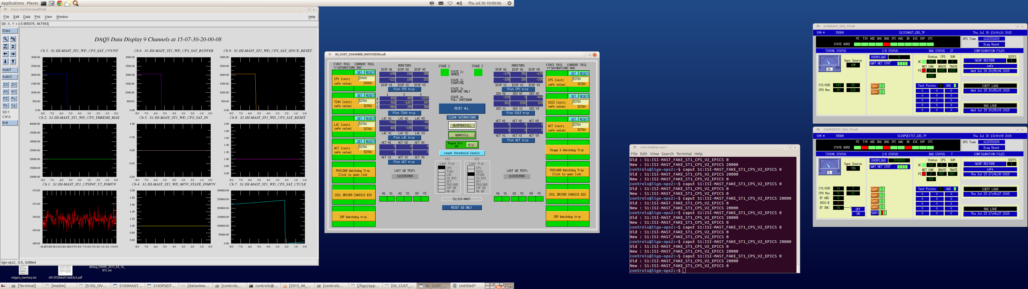
Fig.6. “Saturation Clear” test sequence part 3

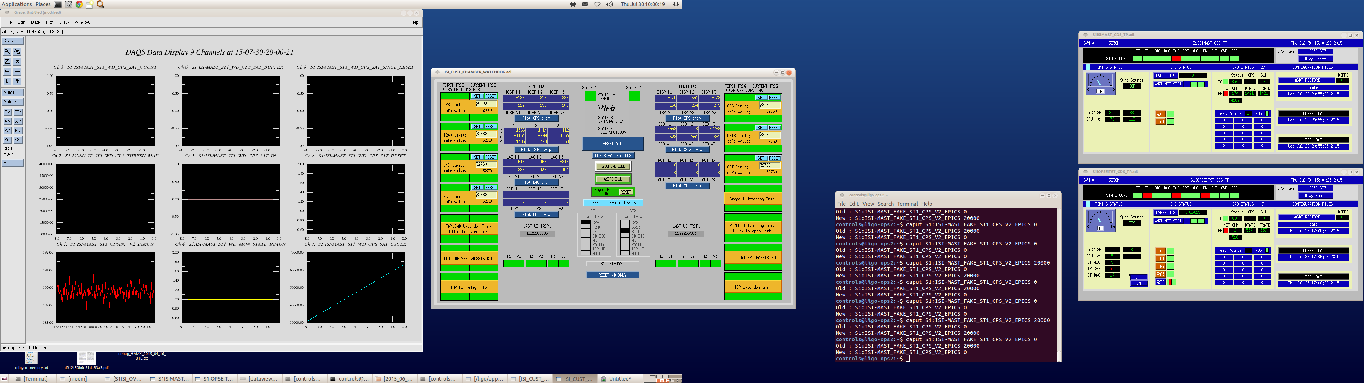
Fig.7. “Saturation Clear” test sequence part 4

II) Saturation Counters

a) Description
The watchdog is setup so that if the total saturations in the history are greater than the allowed number of saturations then the watchdog will trip. Currently, the history is kept until the watchdog trips or the history is reset. We propose changing the saturation history buffering so that saturations more than 1 hour old (value defined in the simulink model) are automatically cleared. The history will be stored in 60 bins, each 1 minute long. Bins more that 1 hour old are cleared.
The saturation counters are now handled by a new piece of c-code called WD_SATCOUNT.c. This code presented in II) b) c-code, can be found under $userapps/isi/common/src/.
The design of WD_SATCOUNT.c is inspired by circular buffers, also called ring buffers. The idea of such a system is that a circular window is used to store buffered data, The data is stored in subdivisions of the main window called bins, which get replaced, once the main window is full, starting from the oldest.
In the illustration below (Fig.8), the main window is the full circle, its subdivisions are the bins and the purple content is pasted from the buffer into the bins, oldest bins getting replaced first, as the main window fills up.

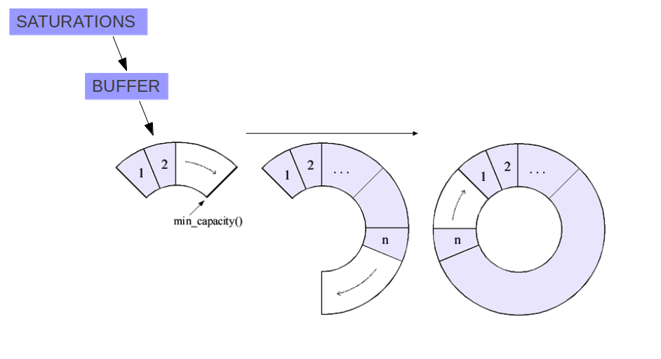
Fig.8 Circular buffer illustration

b) c-code (as of Aug 12th 2015)
/* WD_SATCOUNT.c Function: WD_SATCOUNT.c
*
* SATCOUNT is a WD saturation counter that only accounts for saturations
* that occured during a given time window. The way saturations are
* stored in this time window is inspired by ring buffers. Saturations
* are stored in the limited number of bins the main time window is made of.
* Bins get replaced, oldest first, when the main time window is full.
*
* Inputs:
*--------
* (1) int SATURATIONS: wd saturations signal
* 0: no saturation
* 1+: Number of saturations registered during the current FE cycle
* (2) int WINDOWTIME: total time observed by the main time window (in seconds)
* (3) int RESET: reset signal
* 0: Clear the saturation counter
* 1: Leave the saturation counter
*
* Outputs:
* -------
* (1) int SATURATIONS_TOTAL: total number of saturations to be compared
* against the SAFE_SAT_COUNT
* (2) int BUFFER: current number of saturations in the buffer - FOR TESTING
* (3) int CYCLE: current FE cycle number, modulo the number of cycles in a bin. - FOR TESTING
* (4) int RESET: reset request received. - FOR TESTING
* (5) int SAT_SINCE_RESET total number of saturations since last reset - FOR LONG TERM MONITORING
*
* Authors: HRAP, BTL
* July 2015
*
* See ECR E1500325 / integration issue 1086
*
* Aug 15, 2015 BTL removed test cases from end and fixed the CLEAR_BUG
* BTL fix RESET behavior so that history clear works.
* bug was that the precomputed history sum (BIN_SAT_TOTAL) was not being set to 0
*/

#define MODEL_RATE FE_RATE // makes a constant out of the model rate
#define BINS 60 //number of bins within time window

void ISISATCOUNT(double *argin, int nargin, double *argout, int nargout){
int SATURATION_IN = argin[0];
int WINDOWTIME = argin[1];
int RESET = argin[2];

// ---------------------Initialisations------------------------------------

// Note: as of now there is no regulation to insure that the TIMEWINDOW / BINS doesn't have a remainer
int WINDOW_CYCLES, NUM_BINCYCLES;
WINDOW_CYCLES = WINDOWTIME * MODEL_RATE; // window duration in FE cycles
NUM_BINCYCLES = WINDOW_CYCLES / BINS; // number of cycles per bin

// CYCLE keeps track of the FE cycles
// using "Static int" allows keeping value between FE cycles
static int CYCLE = 0;

// Initialize WINDOW with empty bins
// "static int WINDOW[BINS]={0};" Oly works if BIN is a constant (define).
// It wouldn't work otherwise because
// when the compilers sees your variable declaration
// interpreter returns: "variable-sized object may not be initialized"
static int WINDOW[BINS]={0};

// Total number of saturations since last reset
static int SAT_SINCE_RESET = 0;

// Initialize:
// - BUFFER: Buffer whithin which saturations are summed into bins
// - AVAILABLE_BIN: Available bin (oldest one) in the WINDOW array
// - BIN_SAT_TOTAL: sum of the bin history
// - SATURATIONS_TOTAL: bin history + number of sat. in current BUFFER - main output
static int BUFFER = 0;
static int AVAILABLE_BIN = 0;
static int BIN_SAT_TOTAL = 0;
int SATURATIONS_TOTAL = 0;
int i = 0; // simple counter

// ---------------------Computation----------------------------------

// Apply RESET:
if (RESET == 0)
{
BUFFER = 0; // clear buffer
SAT_SINCE_RESET = 0; // clear the number of saturations since last reset.
SATURATIONS_TOTAL = 0;
BIN_SAT_TOTAL = 0; // this fixes the initial 'not clearing consistantly' bug.
for(i = 0; i < BINS; i++)
{
WINDOW[i] = 0 ; // clear window
}
}

// Store the number of saturations in the buffer, and the number of saturations
// since last reset, at every sample
BUFFER = BUFFER + SATURATION_IN ;
SAT_SINCE_RESET = SAT_SINCE_RESET + SATURATION_IN ;

// Update the cycle number
CYCLE++;

// If new bin ready
if (CYCLE >= NUM_BINCYCLES)
{
// Store buffer in next available bin in the window
WINDOW[AVAILABLE_BIN] = BUFFER;

// Update AVAILABLE_BIN location in WINDOW
AVAILABLE_BIN++;

// Limit AVAILABLE_BIN to the number of bins avaialble in WINDOW
if (AVAILABLE_BIN >= BINS)
{
AVAILABLE_BIN = 0 ;
}

// Clear BUFFER
BUFFER = 0;

// start counting CYCLES over
CYCLE = 0;

// SUM the saturations in the whole window
BIN_SAT_TOTAL = 0; // initialize sum
for(i = 0; i < BINS; i++)
{
BIN_SAT_TOTAL = BIN_SAT_TOTAL + WINDOW[i] ; // sum of the saturations in the whole window
}

}

// SUM the current amount of saturations
// (SATURATIONS_TOTAL is the output of the c-code block)
SATURATIONS_TOTAL = BIN_SAT_TOTAL + BUFFER;

// output the total number of saturations
argout[0] = SATURATIONS_TOTAL;
argout[1] = BUFFER;
argout[2] = CYCLE;
argout[3] = RESET;
argout[4] = SAT_SINCE_RESET;

return;

}

c) Model implementation
A WINDOWTIME flag (bottom right) goes into the CPS block (Fig.9). CPS block details are shown in Fig.10. Note the WINDOWTIME and RESET inputs to the c-code and the c-code's outputs (Fig. 10). The SAFECOUNT is recorded in an epics output for each device (CPS, GS13, ACT, etc...).
Fig. 9 BSC-ISI ST2 WD block.
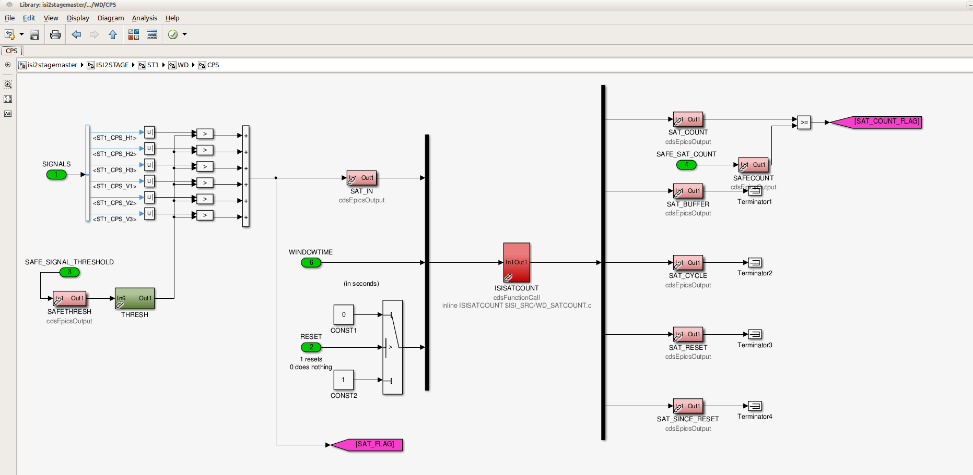
Fig. 10 BSC-ISI ST2 CPS WD block

d) Tests Performed
- Preliminary: saturation counter limit is temporarily set at 3000cts for this test
- Make sure model compiles and starts properly
- Saturate the CPS and make sure the WD trip when CPS saturation counters go over the saturation counter limit
- Clear WD and saturate the CPS again, but this time keep the number of saturations below the saturation counter limit .
- Make sure the number of saturations is properly displayed on WD MEDM screen
- Make sure that the “Saturation Clear” button works
- Make sure that uncleared saturations get automatically cleared once the main window gets renewed (3600s on final design)
- Switched the main window time to a short non-integer (20.1s). The cycle counter looks a bit strange. It doesn't always go to 0, or to its max value before/after being reset. However:
- The WD trip properly when there is too many saturations
- The saturations get accounted for properly
- The WD_RESET and SATCLEAR buttons work properly
- the WINDOWTIME is hardcoded in the mastermodel and should never be changed from 3600s without SEI approval
Note: the CPU max went up by about 10 after the model update.
- Make sure that the SAFECOUNT values can be monitored:
controls@ligo-ops2:~$ chndump | grep SAFECOUNT
S1:HPI-HAMX_WD_SAFECOUNT 1 0 0 4 16 0
S1:ISI-HAMX_WD_ACT_SAFECOUNT 1 0 0 4 16 0
S1:ISI-HAMX_WD_CPS_SAFECOUNT 1 0 0 4 16 0
S1:ISI-HAMX_WD_GS13_SAFECOUNT 1 0 0 4 16 0
S1:ISI-HAMX_WD_L4C_SAFECOUNT 1 0 0 4 16 0
S1:ISI-HAMX_WD_SAFECOUNT 1 0 0 4 16 0
S1:ISI-ITMX_ST1_WD_SAFECOUNT 1 0 0 4 16 0
S1:ISI-ITMX_ST2_WD_SAFECOUNT 1 0 0 4 16 0
S1:ISI-MAST_ST1_WD_ACT_SAFECOUNT 1 0 0 4 16 0
S1:ISI-MAST_ST1_WD_CPS_SAFECOUNT 1 0 0 4 16 0
S1:ISI-MAST_ST1_WD_L4C_SAFECOUNT 1 0 0 4 16 0
S1:ISI-MAST_ST1_WD_SAFECOUNT 1 0 0 4 16 0
S1:ISI-MAST_ST1_WD_T240_SAFECOUNT 1 0 0 4 16 0
S1:ISI-MAST_ST2_WD_ACT_SAFECOUNT 1 0 0 4 16 0
S1:ISI-MAST_ST2_WD_CPS_SAFECOUNT 1 0 0 4 16 0
S1:ISI-MAST_ST2_WD_GS13_SAFECOUNT 1 0 0 4 16 0
S1:ISI-MAST_ST2_WD_SAFECOUNT 1 0 0 4 16 0

Test Result: Passed.

