Title | Changes to Hardware Watchdog
Author | R. Abbott, B. Abbott, Caltech
Date | 7 August 2015

Overview
An analysis of the existing Hardware Watchdog System (HWWD) was conducted and reported in T1500405. The following note details the prescribed changes in a checklist format such that the existing HWWD chassis (D1300642-v1 containing D1201549-v3 PCB programmed with E1500315-v1, 2014 HWWD Code) can be upgraded to a version suitable for initial deployment. The required changes are summarized as follows:
- Load E1500315-v2 HWWD code
- Ensure PSoC power supply jumpers are in the 5V position
- Install Logic Inverter Board, D1500215-v1

Loading New Code
Software to interface to the HWWD internal PSoC can be downloaded from the Cypress Semiconductor Inc. website (http://www.cypress.com/products/psoc-3) that allows the HWWD code to be loaded into the HWWD chassis via a rear panel USB connection, or by plugging directly into J1 on the internal PSoC board contained within the HWWD chassis.
The software can be run on a typical Windows based laptop PC. Once the physical connection is made between the PC and the HWWD chassis, the PSoC will power up over the USB link, so there is no need to have the HWWD chassis energized by external power during the code update. After loading the new code, be sure to unplug the USB connection such that a fresh boot will be obtained on normal chassis power up.
After powering up the HWWD chassis via the normal +/-18VDC feed on the rear panel, the signature observation indicating a successful code update is that the front panel LEDs annunciating the “LED” and “PD” states will initially simultaneously flash to indicate the loaded code revision.

Figure 1 Front Panel of D1300642 showing PD and LED annunciations
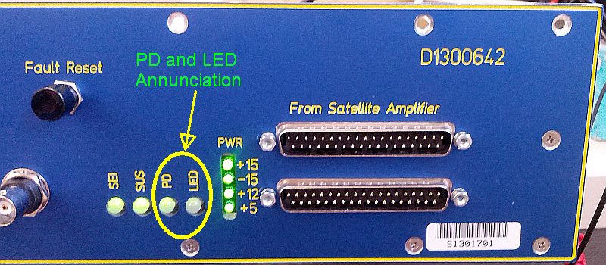

For example, for code revision-2, both LEDs will simultaneously flash two times before beginning the normal operation of the HWWD function. This process is invoked each time the HWWD chassis is powered up.

PSoC Jumpers in Correct Position
As seen in the image below, there are two jumpers (J10 and J11) on the PSoC board. Be sure the jumpers are as seen and in the 5.0V mode.

Figure 2
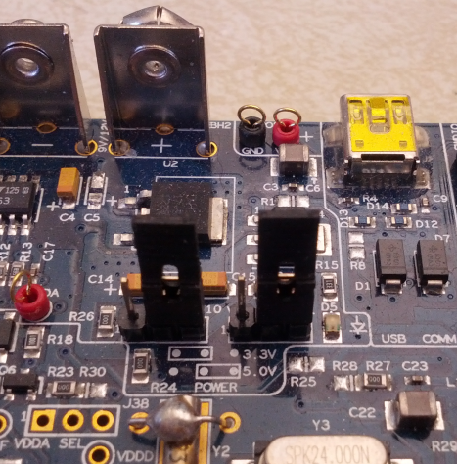

Install Logic Inverter Board
The D1500215-v1 Logic Inverter Board is shown installed into the HWWD chassis below. Note the use of pan head 4-40 screws to ensure a solid physical connection for the small Logic Inverter. Also of note is the Logic Inverter power connection that derives +15VDC from a spare connector on the internal +/-15VDC power board.

Figure 3 Logic Board Overview
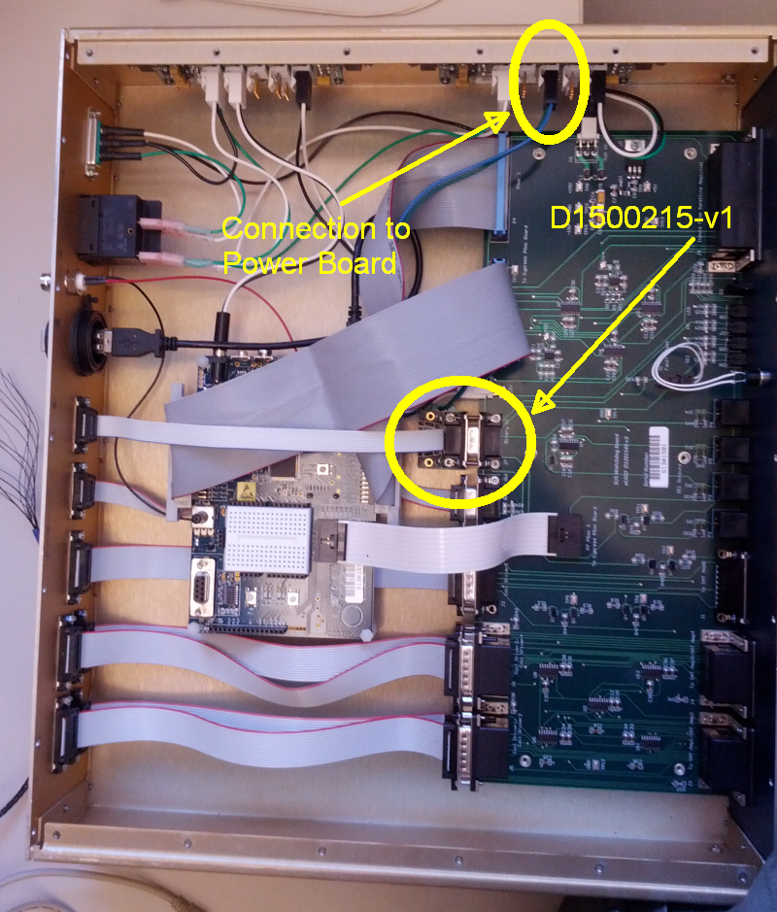

Figure 4 Logic Board Detail (view rotated 90 degrees CW from overview image)
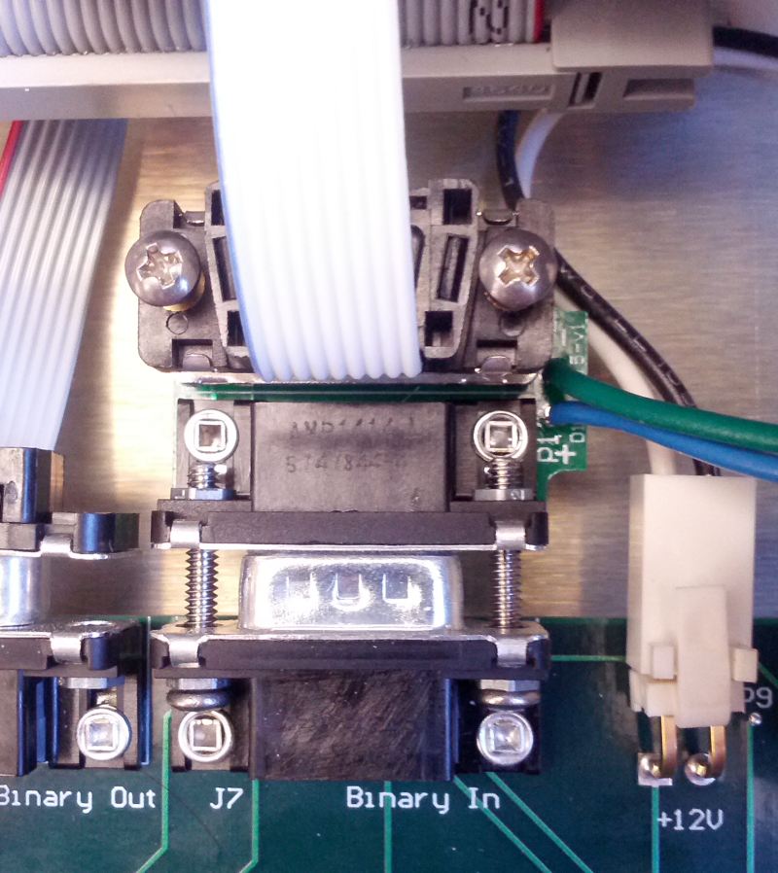

Miscellaneous Items

During evaluation of this chassis, it was noted that there are many internal connections that do not have very good strain relief. It is preferable that each D-sub connector be secured with at least one screw. The unit evaluated at Caltech was retrofitted to have the requisite screws were possible.
The ground connection to establish a common-mode level between the satellite modules and the HWWD is tenuous at best. There is no explicit connection made by the interconnecting cabling other than the possibility that the cable shield is connected at both ends. There is a tortuous path through the DC distribution system. This weakness may lead to electronics failures in the event of large electromagnetic events (lightning, nuclear attack, etc.).

