Required Modifications (Oct 13, 2015 Koji Arai, Oct 29, 2015 Daniel Sigg)

1. Metal washers on the thermal tabs of the power transistors need to be replaced with insulation shoulder washers (Digikey PN: HS418-ND). The metal washers are causing an electrical short circuit between the tab and the back panel.
- Circuit schematic D0900848-B: Q3, Q4, Q5, Q6, Q7
- Circuit schematic D0900848-B: Q8 needs to be resoldered, since it doesn’t match up.
2. The W2 jumper needs to be connected with a solder ball.
Circuit schematic D0900848-B: W2
3.The coarse rotary switch doesn’t have a pin installed to prevent turning from min to max directly.
The knobs (Digikey PN: 226-3010-ND) for the rotary switches were not installed.
4. The internal RF connections are incorrect. They should be corrected as shown in the following photo.
5. R69 on board D0900847-B needs to be 66.5 (rather 200).

Before (Incorrect) | After (Correct)
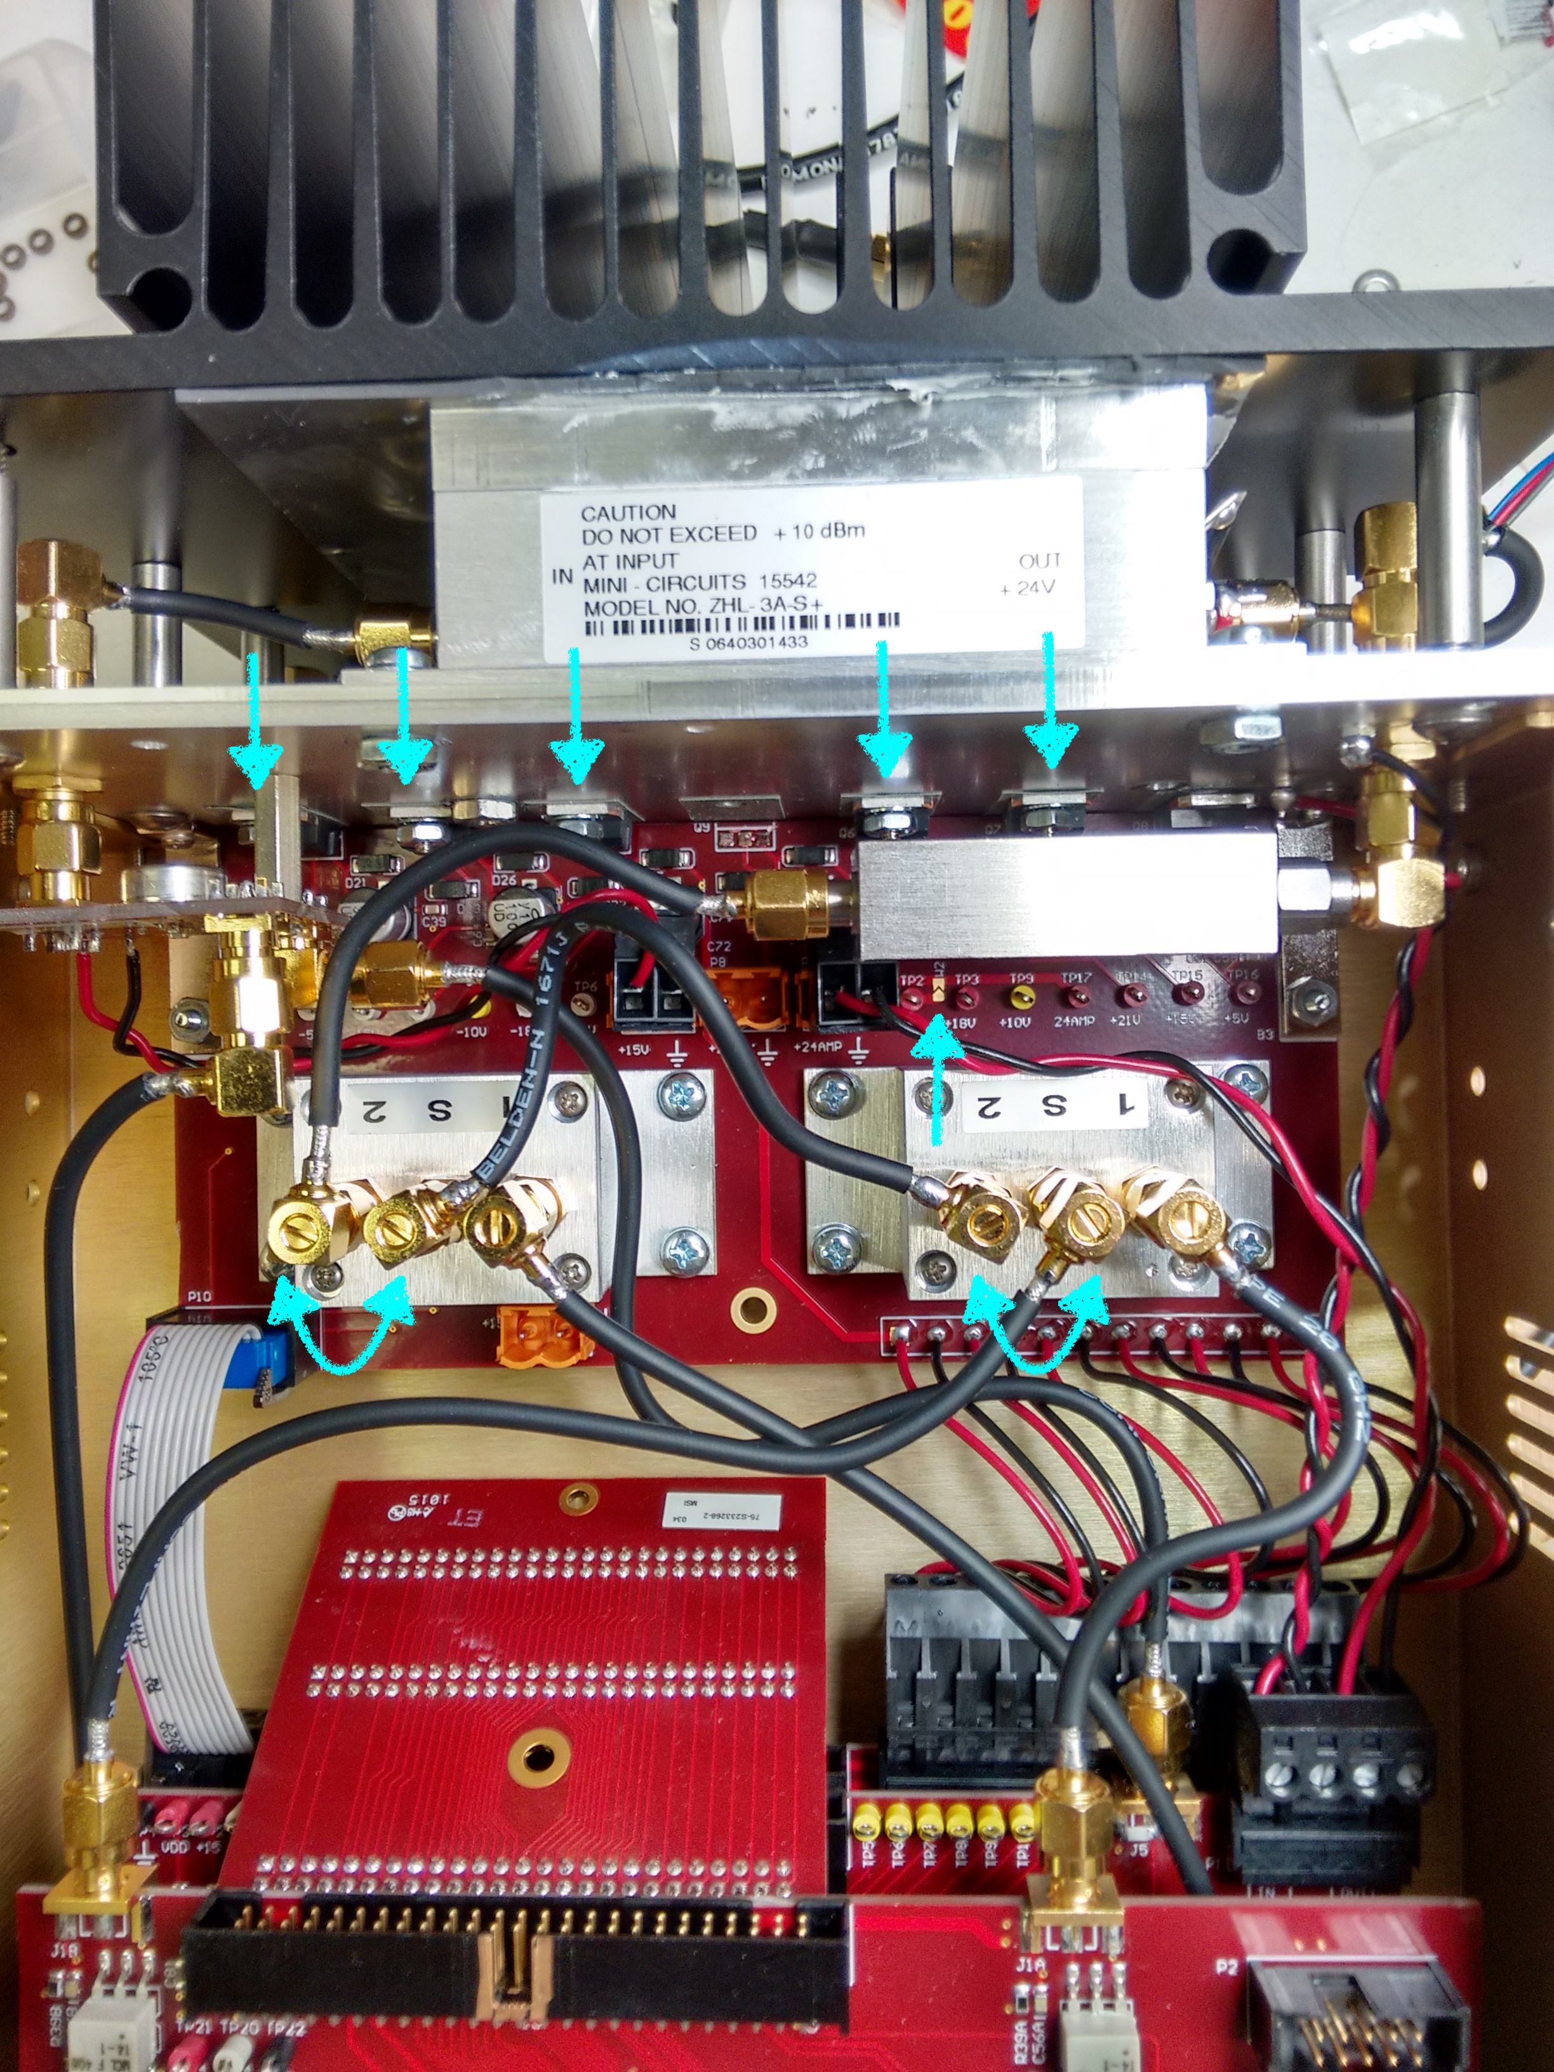 | 