LASER INTERFEROMETER GRAVITATIONAL WAVE OBSERVATORY

-LIGO-

CALIFORNIA INSTITUTE OF TECHNOLOGY

MASSACHUSETTS INSTITUTE OF TECHNOLOGY

Document Type  Test Procedure | DCC Number  T1500564-v1 | November 10, 2015
SUS Hardware Watchdog Chassis Test Procedure

B. Abbott, R. Abbott

Distribution of this draft:
This is an internal working note of the LIGO Laboratory

California Institute of Technology Massachusetts Institute of Technology
LIGO Project – MS 18-33 LIGO Project – MS 20B-145
Pasadena, CA 91125 Cambridge, MA 01239
Phone (626) 395-2129 Phone (617) 253-4824
Fax (626) 304-9834 Fax (617) 253-7014
E-mail: info@ligo.caltech.edu E-mail: info@ligo.mit.edu

http://www.ligo.caltech.edu/

Overview:
The Hardware Watchdog Chassis (D1300642-v1) is used to stop seismic and suspension drive signals in the event of a potentially harmful failure. This test procedure is designed to test proper functionality of the chassis, and is performed using a custom wiring harness that makes the testing quicker and easier. The use of this harness and the functional tests that should be performed are outlined in the following sections.

Setup:
Plug in all the cables and connectors to their respective chassis connectors. The front should look like this:
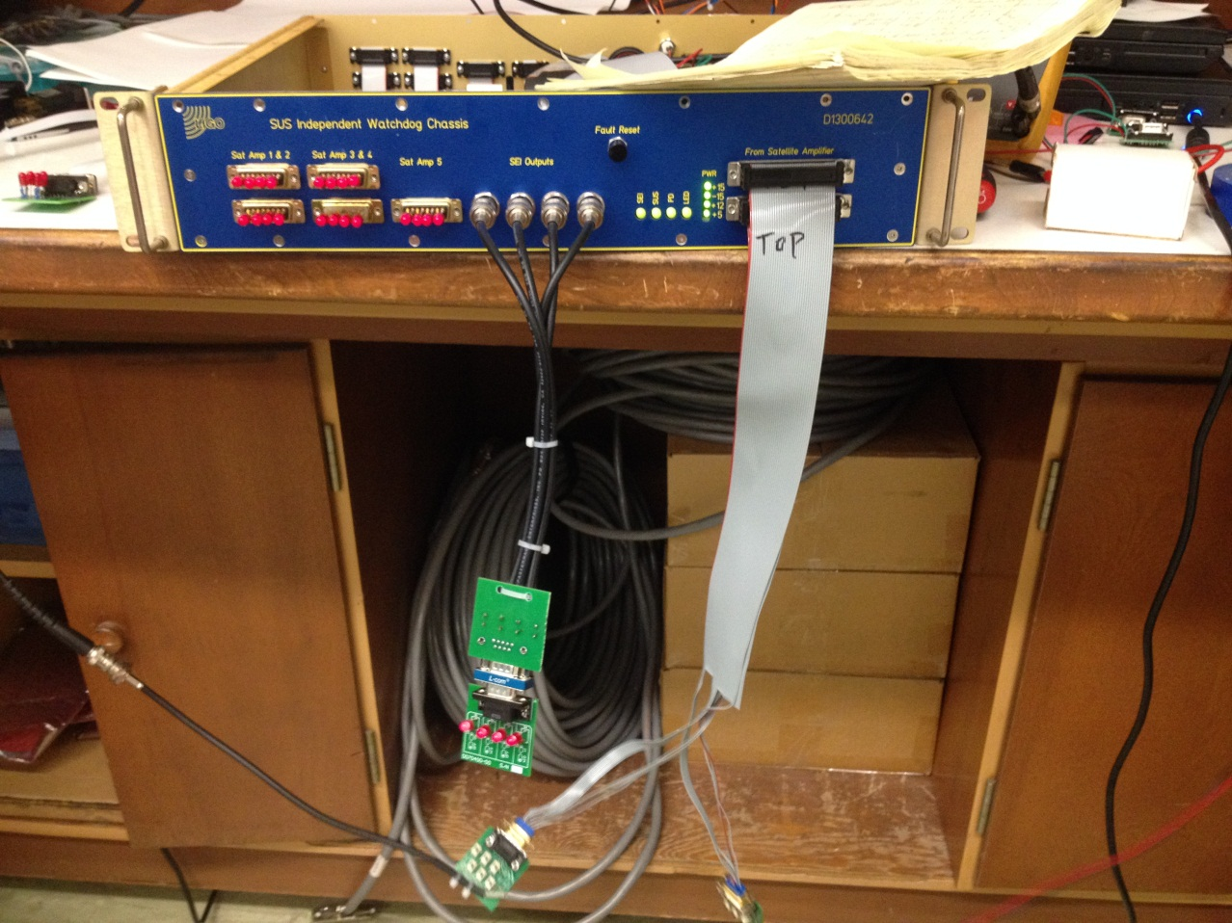
SUS Throughput LEDs, SEI Output LEDs
Front Panel Reset

PD RMS Input Switches LED Input Switches

And the back should look like this:
DMM, +/-18V, Binary Outputs from Chassis, Binary Input Reset Switch,
+5V
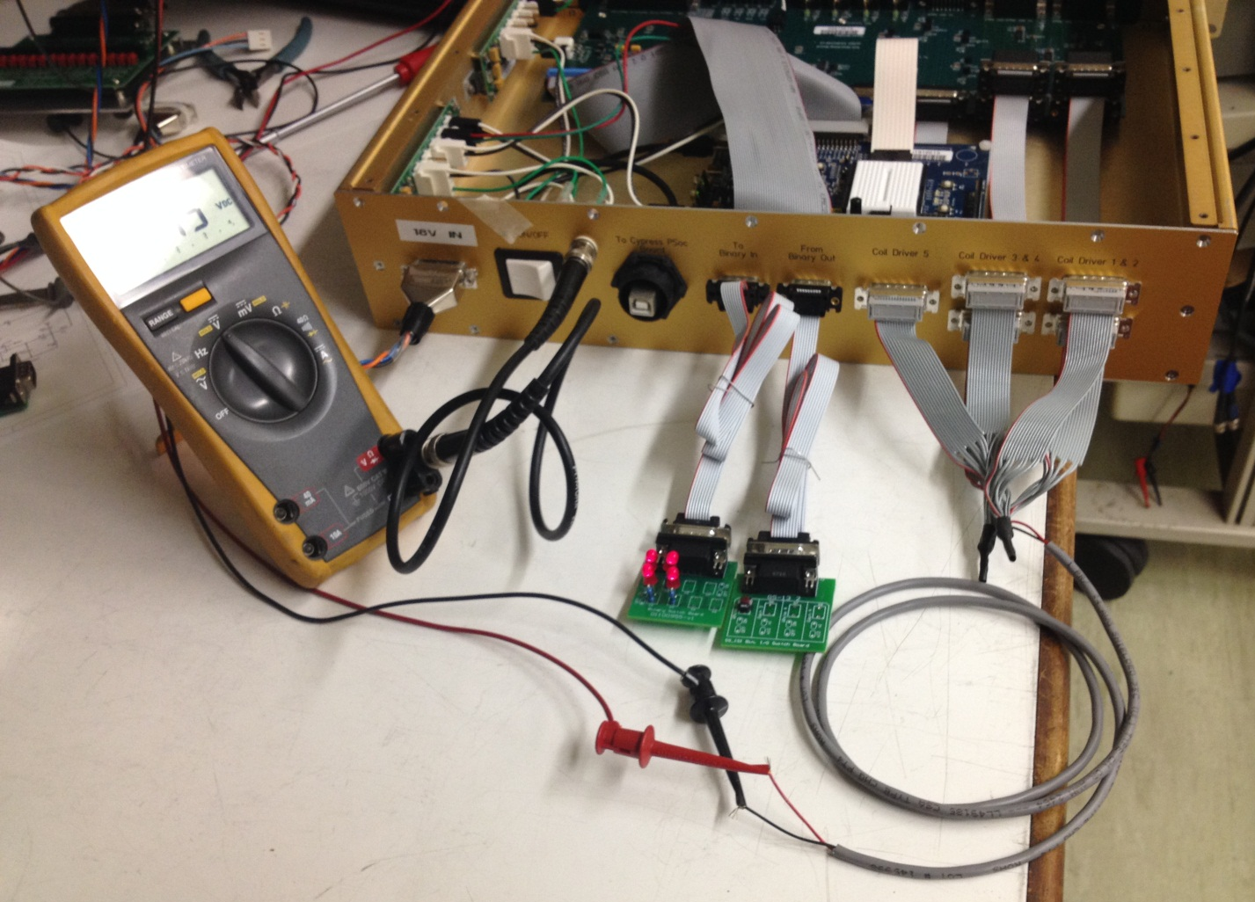

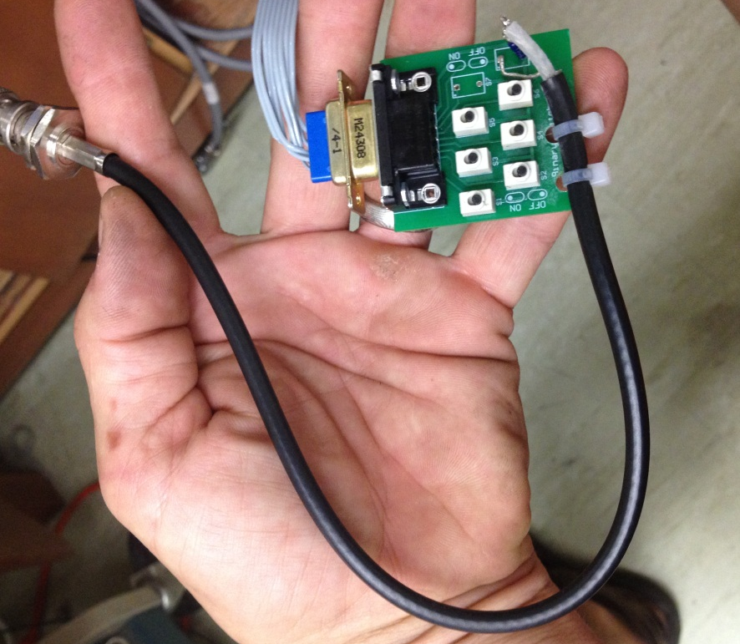
Put a 1Hz, 1.5Vrms sine wave into the BNC cable attached to the PD Input Board, and make sure that all of the switches are “off”, as in the picture (black switch is to the right):

Next, put a 1.4V DC level into the LED Input Board. Positive goes to the resistor, and GND goes to the black wire. Make sure that all of the switches on this board are “On”, as in the picture below:
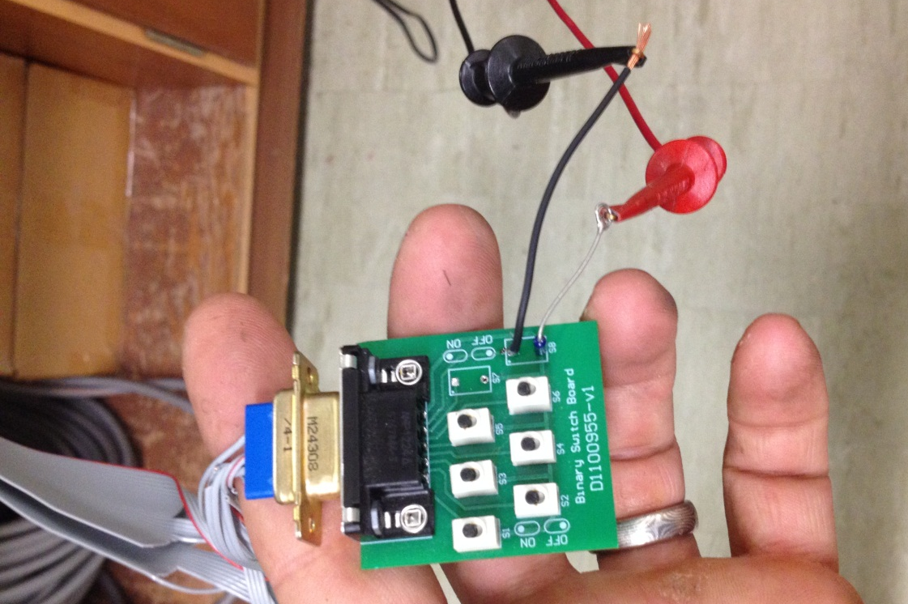

Tests:
With the 1.5Vrms signal still going into the PD Input Board, switch on the top left switch (SW1), and wait.
In ~5 seconds, the front panel “PD” LED should turn from green to red, and the Binary Output back panel “S2” light should turn off.
Correctly Functioning? (Yes/No)_____________
In ~15 more seconds, the SEI light should turn from green to red, the back “S1” LED should turn off, and the four SEI Output LEDs (shown in the picture below) should turn off.

Correctly Functioning? (Yes/No)_____________
In about 5 more seconds, the front panel “SUS” LED should turn from green to red, the back “S3” LED should turn off, and the 5 connectors of Sat Amp output LEDs should turn off. These LEDs are shown below:

Correctly Functioning? (Yes/No)_____________
At this point, look at a DMM reading DC voltage that is connected to the back panel BNC. It should read a signal 110mV, +/- 10mV.
BNC Reading: _____________mV
Turn the PD Input Board S1 back off. The “PD” LED should return to green and the S2 LED should come back on. At this point, push and hold the front panel reset switch for about 3 seconds, and release. The SUS and SEI LEDs should become green, and the S3 and S1 LEDs should come back on.
Correctly Functioning? (Yes/No)_____________
Now, cycle through the other 5 PD switches and leave them off just long enough to see the front panel “PD” LED, and back panel “S2” lights do the same changes as above, then switch them back off.
Correctly Functioning? (Yes/No)_____________

Next, switch off S1 on the LED Input Board, and wait.
In ~5 seconds, the front panel “LED” LED should turn from green to red, and the Binary Output back panel “S4” light should turn off.
In ~15 more seconds, the SEI light should turn from green to red, the back “S1” LED should turn off, and the four SEI Output LEDs should turn off.
In about 5 more seconds, the front panel “SUS” LED should turn from green to red, the back “S3” LED should turn off, and the 5 connectors of Sat Amp output LEDs should turn off.
Correctly Functioning? (Yes/No)_____________
Turn the LED Input Board S1 back off. The “LED” LED should return to green and the S4 LED should come back on. At this point, push and hold the rear panel reset switch (Shown Below) for about 3 seconds, and release.

Reset Switch

The SUS and SEI LEDs should become green, and the S3 and S1 LEDs should come back on. Now, cycle through the other 5 LED switches and leave them off just long enough to see the front panel “LED” LED, and back panel “S2” lights do the same changes as above, then switch them back off.
Correctly Functioning? (Yes/No)_____________
If all answers to the above questions were “Yes” and the voltage was in spec, the chassis passed this test procedure.

