**AN OVERVIEW OF THE CONTROL LAYERS IN LIGO 4KM INTERFEROMETERS**

# INTRODUCTION

The two LIGO detectors located in Hanford (WA) and Livingston (LA) house 4 km long interferometers designed to measure gravitational waves. In the past five years, the new generation of instruments called Advanced LIGO was constructed and installed in the vacuum envelope of the two observatories [1]. The picture on the left of FIGURE 1 shows an aerial view of the Livingston observatory and its 4km long vacuum envelope. On the 14th of September 2015, the two LIGO interferometers recorded the first detection of gravitational wave emitted by the merger of a binary black holes system [2], the strain waveform of which being shown on the right of FIGURE 1. The relative motion measured between the test masses of the 4 km long interferometer is on the order of ${10}^{-18} m$. To perform such sensitive measurements twenty active platforms and several tens of passive suspensions are used on each site to isolate the optical components from ground motion. The article describes how the vibration isolation sub-systems have been engineered not only to provide tremendous isolation performance, but also to meet all the project requirements of the construction phase (schedule, budget, integration) and operation phase (stability, robustness, operability).

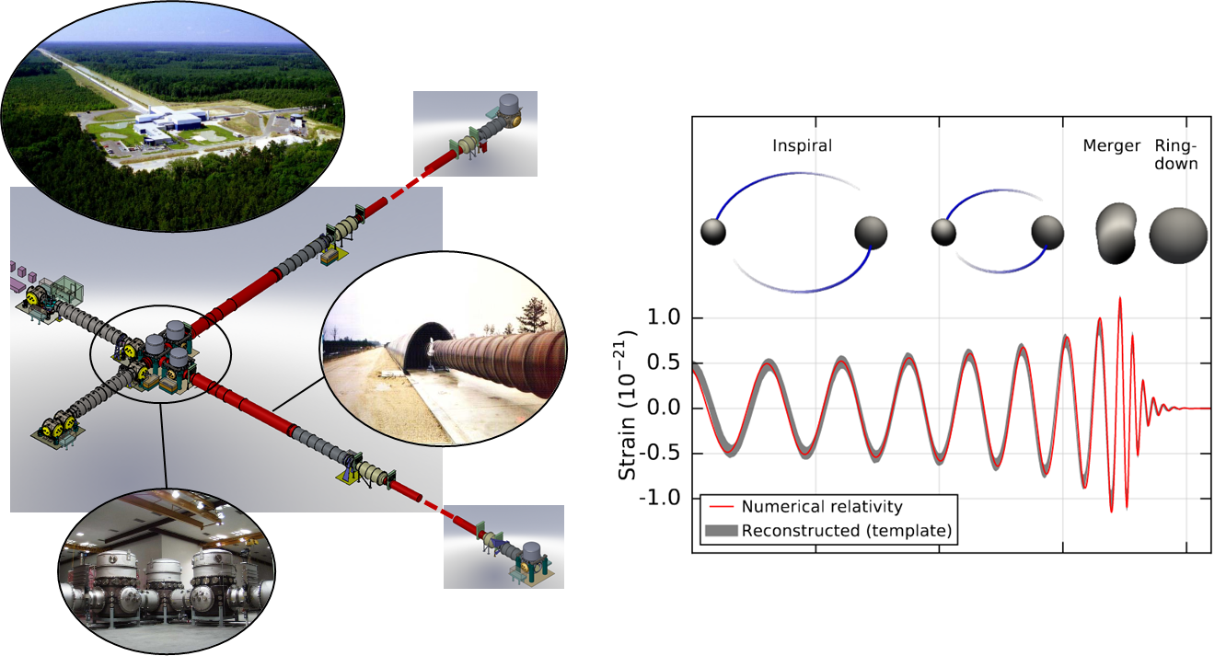

FIGURE 1: The picture on the left shows one of two LIGO detectors (aerial view of the Livingston site and pictures of the vacuum system housing the 4km interferometer). The picture on the right shows the gravitational signal emitted by the binary black hole merger detected by the LIGO detectors on September 14, 2015 [2].

# SYSTEM OVERVIEW

A gravitational wave is a transverse wave which compresses one direction of space orthogonal to the direction of propagation while it elongates the other orthogonal direction, and vice-versa as the wave goes by. Interferometric detectors are based on a Michelson configuration to measure the differential change of length between the two directions orthogonal to the wave propagation. The amplitude of the strain wave produced by astrophysical events is gigantic at the source but it is very faint by the time it reaches earth. Therefore, the interferometers must be extremely sensitive in order to detect the wave.

A simplified schematic of the Advanced LIGO optical layout is shown in FIGURE 2. To reach the required level of sensitivity, the detectors use: a 4 km Michelson baseline; two test masses in each arm to form Fabry-Perot cavities; mode cleaners and recycling cavities on the input and output sides of the interferometer.

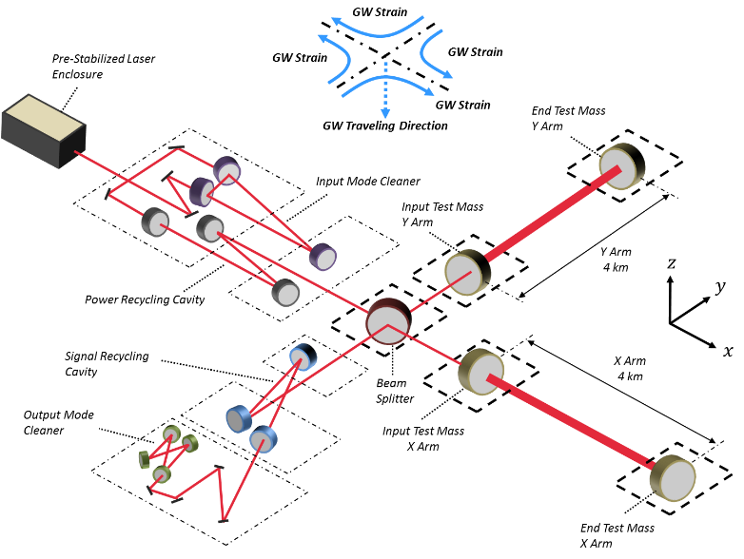

*FIGURE 2: Advanced LIGO simplified optical layout*

A very high level of vibration isolation is needed to lock the interferometers and cavities on their operating point, and to lower the test masses motion below the amplitude of the gravitational waves. About three orders of magnitude of isolation is required at 1 Hz to lock the interferometers, and more than ten 10 orders of magnitude around 100 Hz to detect the signals. Like most high performance isolation systems, the strategy requires the use of multiple layers of filtering, and a subtle combination of passive and active components to obtain adequate seismic noise attenuation over a large bandwidth. The design of such distributed isolation systems is a complicated problem. Trade-offs must be made between cutoff frequencies and number of layers of isolation, while accounting for cost, schedule constraints, and robustness of operation. The next section gives an overview of the strategy used in Advanced LIGO.

# THE VIBRATION ISOLATION STRATEGY

Advanced LIGO detectors are very complex systems which use hundreds of optical components and servo-control loops. The system requires not only very high vibration isolation, but also high robustness and duty cycle. To achieve the objectives, the isolation strategy is based on the use of active isolation platforms instrumented with very low noise inertial sensors, and featuring the large optical tables on which are mounted the passive suspensions holding the optics.

The active platforms provide the very low-frequency isolation, from about 100 mHz to 10 Hz. They combine relative sensors for the quasi DC positioning, and inertial sensors for the vibration isolation. The inertial active approach avoid the need for soft springs to provide low frequency isolation. Relatively rigid spring are used to suspend the platforms. The rigid-body modes are in the range of 1Hz to 10 Hz. By comparison with soft platforms, this approach significantly ease the construction, balancing and tuning process.

Passive suspensions are used to hold the optics and provide the high frequency isolation. Between one and four layers of passive isolation are used depending on the requirements for each optics. Compact actuator-sensor pairs are used to actively damp the rigid-body modes of the suspended stages. As the sensors measure the differential motion between the frame and the stage (unlike the inertial sensors of the active platforms), the damping must be carefully tuned to not compromise the passive isolation with sensor noise and/or recoupling of the stage with the frame. Since the suspensions are mounted on very quiet inertial active platforms, only light damping is required to reduce the amplitude of motion at the suspension resonance which preserves the passive isolation, and relaxes the noise requirements for the sensors used to provide active damping.

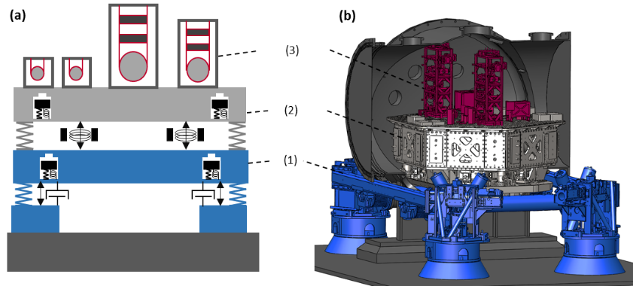

FIGURE 3: Conceptual picture (a) and CAD picture (b) of the layers of isolation used for the auxiliary optics of Advanced LIGO.

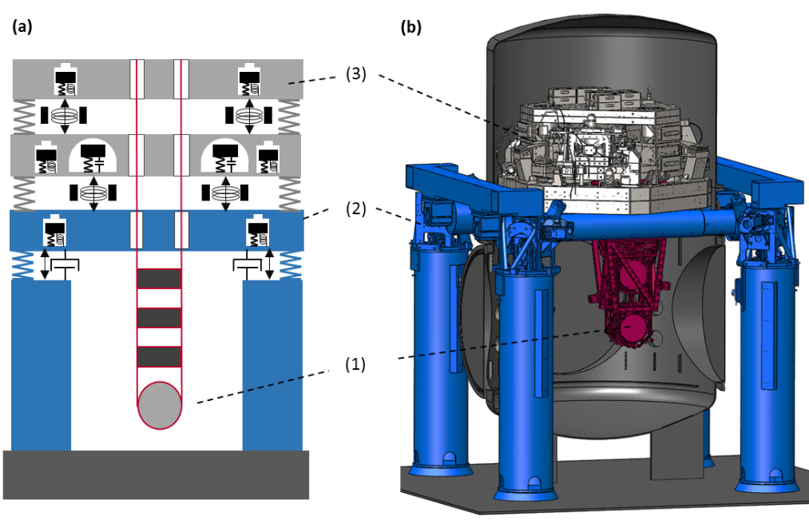

FIGURE 4: Conceptual picture (top) and CAD picture (bottom) of the layers of isolation used for the core optics of Advanced LIGO.

The schematics in FIGURE 3 and FIGURE 4 illustrate the combination of active and passive systems used for the auxiliary optics and core optics respectively. Though they provide a different amount of isolation, they rely on the same strategy:

(1) An active stage located outside the vacuum system provides pre-isolation from approximately 0.1 Hz to 10 Hz. This hydraulic system provides a very robust base for the sub-sequent layers of isolation. The same system is used for the auxiliary and core chambers.

(2) An active platform features an optical table about 2 meter wide on which are mounted the components of the interferometers. This system is instrumented with the large and heavy low noise inertial sensors. A single stage active isolator is used for the auxiliary optics, while a two-stage system is used for the core optics.

(3) The optics are suspended passively using multiple pendulums. Up to three layers of passive isolation are used for the auxiliary optics, while four layers are necessary for the core optics.

The next section gives a presentation of the active isolation platforms.

# ACTIVE INERTIAL CONTROL

## Isolation and control overview

The passive-active concept used in Advanced LIGO isolation platforms can be summarized by the schematic in Fig. 4. The motion disturbance transmitted by the support structure (or the previous isolation stage) is shown in grey (0). The isolation platform (1) is supported by suspension springs (2). Above the resonance frequency, the platform is inertially decoupled from the input stage and provides passive isolation. Relative sensors (3) are used to servo-position the platform with respect to the support structure at very-low frequencies. Inertial sensors (4) are used to provide active inertial isolation through feedback control from about 0.1 Hz to 30 Hz. The signals from all the sensors are combined in a sensor fusion to drive the control forces (5). Additional performance is obtained using feedforward inertial sensors (6). The platforms are designed to be rigid and to minimize the cross couplings between the degrees of freedom (DOF) in the control bandwidth. Each of the six DOF can be controlled using independent single input single output control loops.

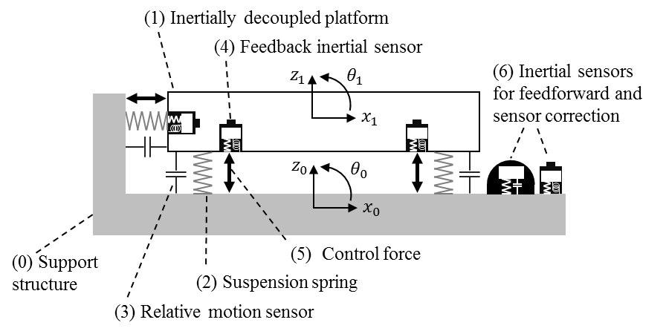

Fig. 4: Schematic representation of a passive-active inertial isolation system

Each platform (or stage of a platform) is equipped with a set of relative position sensors, a set of inertial sensors (geophones and/or seismometers), and a set of actuators. A minimum of six instruments for each set of sensors (or each set of actuators) is necessary to sense (or drive) of all the rigid body motions. More sensors can be used and combined in a sensor blend/fusion to reduce the sensor noise, or to sense deformation modes. The local measurements (or actuations) performed by each individual sensor (or actuator) are symbolically represented with vectors in Fig. 5 (a). In this example, there are three horizontal instruments (sensors or actuators) mounted tangentially, and three vertical instruments.

The local relative sensor signals are combined in real time to measure the platform’s relative displacement along the Cartesian basis (axis of the interferometer), as illustrated on the right of Fig. 5 (b). A matrix based on the geometry (instruments location and orientation) is used to perform the change of basis. Details of the matrix calculations can be found in [[26](#_ENREF_26)]. A similar construction is used to sense the absolute motion of the platform in the Cartesian basis using the set of inertial sensors. The local actuators are combined to drive the platform with forces and torques in the Cartesian basis. All the controls are done in the Cartesian basis. The rigid body translations and rotations (called X, Y, Z, RX, RY, RZ) are controlled independently of each other. The next section describes the topology used to control each of the independent DOF.

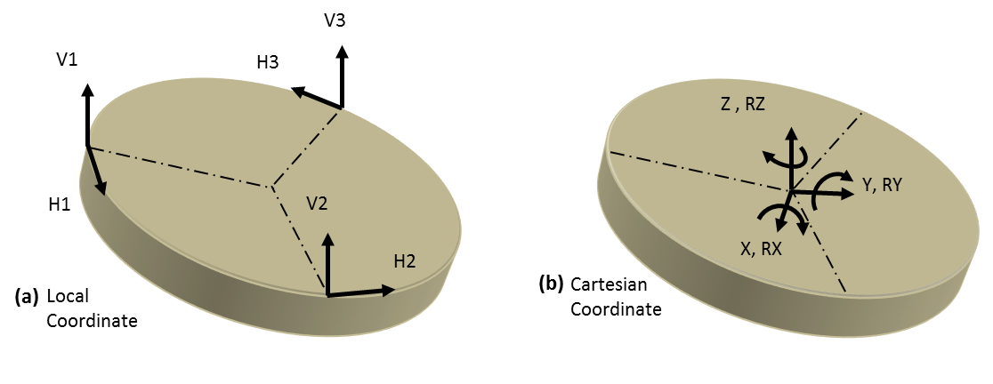

Fig. 5: Sensing and driving change of basis

## Control scheme

The block diagram in Fig. 6 shows the generic topology used to control one degree of freedom ($X$, in this example). The seismic path (transmissibility) is denoted $P_{s}$, and the actuator path (force or torque transfer function) is denoted $P_{F}$. The control force $F$ is used to reduce the platform motion denoted $X_{1}$ induced by the input motion disturbance denoted $X_{0}$. The control scheme includes three main components: a feedback block, a sensor correction block and a feedforward block.

The platform motion ${ X}_{1}$ is the sum of the input disturbance and the control force contributions as shown in equation (1). The feedback block is the central part of the control scheme. The measurement of the platform’s absolute motion made with the inertial sensors is called ${ U}_{a}$. The sensor noise of the inertial instruments is ${ N}_{a}$. Only inertial sensors (accelerometers, geophones, seismometers) can be used to provide seismic isolation, but such instruments are inherently AC coupled and they cannot be used at very low frequencies (noise limited). For that reason, relative sensors are used at low frequencies to measure the differential motion between the output and the input stages (${X_{1}-X}_{0}$). This sensor cannot be used to provide seismic isolation, but it allows low frequency positioning with respect to the input stage. The relative sensor signal is denoted ${ U}_{r}$. The noise of this sensor is denoted ${ N}_{r}$.

The relative motion signal ${ U}_{r}$ is low passed with the filter $L$, and the absolute motion signal ${ U}_{a}$ is high passed with the filter $H$. The filters $H$ and $L$ are tuned to obtain a suitable compromise between active seismic isolation at “high” frequencies (typically above 100 mHz), and motion amplification induced by sensor noise at low frequencies (below 100 mHz) [[27](#_ENREF_27)]. The design of $H$ and $L$ is based on complementary filters ( $L+H=1$ for all frequencies). The frequency at which the inertial sensor and relative sensor have equal participation is called the blend frequency. The signal resulting from this blend (sensor fusion) is called the super sensor. It feeds the feedback controller called ${ C}_{FB}$.

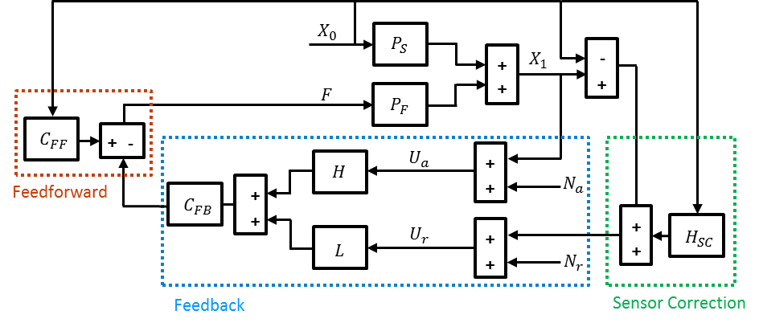

Fig. 6: Simplified block diagram of the active control scheme

Equation (2) gives the feedback control force as a function of the blended signal when the feedforward and sensor correction are not engaged. Using complementary filters as written in Eq.(3), the closed loop transmissibility simplifies to the expression given in Eq. (4). The denominator shows the loop gain attenuation. The numerator shows that the transmissibility is increased by the term $(L {C_{FB } P}_{F })$ induced by the relative sensor control. The limit given in Eq. (5) shows that in the control bandwidth (where the loop gain is high), the transmissibility tends to the low pass filter applied to the relative sensor.

The time average of the noise contributions is expressed in Eq. (6). This equation gives the output stage power spectral density assuming the input motion, inertial sensor noise and relative sensor noise are uncorrelated. Eq. (7) gives the limit of the amplitude spectral density for high loop gain. This expression shows the influence of the low pass filter $L$ on the transmissibility and on the relative sensor noise injection. It shows the influence of the high pass filter $H$ on the inertial sensor noise injection. The low pass filter (and its complementary high pass), are tuned to obtain a suitable compromise between isolation above the blend frequency and noise injection below the blend frequency.

|  |  |  |
| --- | --- | --- |
| $$X_{1}= P_{s }{ X}_{0}+P_{F }F$$ | | (1) |
| $$F={-C}_{FB }(H{ X}_{1}+L \left(X_{1}-X_{0}\right))$$ | | (2) |
| $$H+L=1$$ | | (3) |
| $$\frac{X_{1}}{X_{0}}= \frac{ P_{s }+L {C_{FB } P}_{F } }{1+C_{FB } P_{F }}$$ | | (4) |
| $$\lim_{{(C}_{FB} P_{F})→∞}{( \frac{X_{1}}{X_{0}} ) }= L$$ | | (5) |
|  | (6) | | |
|  | (7) | | |

An example of complementary filters is given in Fig. 7 (a). In this example, the blend (cross-over between $N$) frequency is 200 mHz. The super sensor signal is dominated by the relative sensor signal below 200 mHz and by the inertial sensor signal above that frequency. The high-pass filter is designed at low frequency to sufficiently filter the inertial sensor noise ${ N}_{a}$. In the control bandwidth (up to 25 Hz), the low pass filter is designed to provide adequate isolation. Notches have been added to reduce the transmissibility at frequencies of particular interest (1 Hz and 1.5 Hz, which correspond to the resonances of the suspensions mounted on the platform). At higher frequency, the low pass filter is designed so that the relative sensor noise does not compromise the isolation. In the control bandwidth, the transmissibility follows the low pass. Additional isolation can be obtained using higher order filtering in the low pass filter. This would however result in higher motion amplification near the blend frequency.

For practical implementation, both signals are calibrated in the same units in order to be combined with the complementary filters. The inertial sensor signal is integrated (“stretched”) before entering the high pass filter. Calibration and complementary filters are usually combined for practical implementation in the digital real time system.

The second block of the control scheme is called sensor correction. It is shown in the block diagram in Fig. 6. It uses an inertial instrument sensing the ground motion. This signal is filtered and added to the relative sensor signal as shown in Eq. (8). The inertial sensor provides the information needed to reduce the transmissibility that is limited by the relative sensor part of the super sensor, as written in Eq. (9).

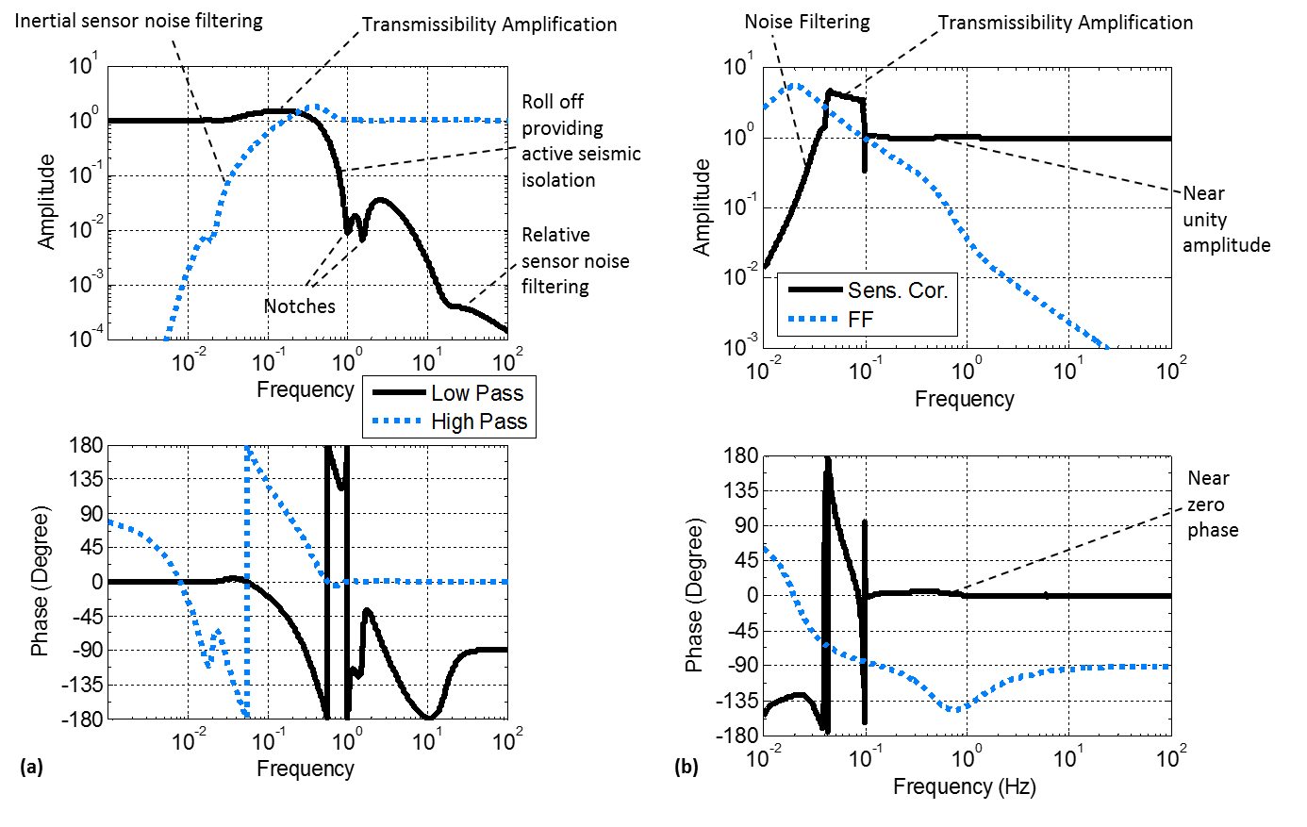

Fig. 7: (a) example of complementary filters and (b) FIR filter and feedforward filters [[27](#_ENREF_27)]

The isolation that can be obtained through sensor correction depends on the coherence between the witness sensor (ground instrument) and the platform motion ($X_{1})$. One benefit of the sensor correction technique is that a single low noise instrument can be used for the sensor correction of multiple platforms. Another benefit is that the sensor noise injected is common to all the platforms fed by the same ground instrument. Therefore, the low frequency motion amplification possibly caused by sensor noise injection is common to all the platforms, to the limit of the calibration mismatch between the position sensors of the various platforms. This is a key feature for interferometric cavities sensing the differential motion between optics mounted on different platforms.

The limit in Eq. (10) shows the transmissibility for high loop gain, assuming perfect coherence between the ground instrument and the platform motion. A sensor correction filter $H_{sc}$ equal to unity at all frequencies would cancel the transmissibility. Another way to phrase this is that the inertial instrument sensing $X_{0}$, added to the relative sensor ($X_{1}-X_{0})$, provides an ideal measurement of the absolute motion $X_{1}$. The ground inertial instrument is nevertheless noise limited at low frequency. Therefore it must be adequately filtered by $H_{sc}$. Fig. 7 (b) shows an example of a sensor correction filter. It is a Finite Impulse Response (FIR) filter designed by Hua [[27](#_ENREF_27)]. It provides near perfect amplitude and phase matching above 100 mHz where most isolation is needed. At those frequencies, this filter minimizes the residual motion given in Eq. (10). The filter provides high pass filtering at very low frequency to not inject sensor noise, at the cost of motion amplification between 50 mHz and 100 mHz. This filter provides a compromise accounting for ground motion spectra (peaking at the micro-seismic motion above 100 mHZ), and the inertial sensor noise dominating the signal at low frequencies.

|  |  |
| --- | --- |
| $$U_{r}=\left(X_{1}-X_{0}\right)+H_{SC } X_{0}$$ | (8) |
| $$\frac{X_{1}}{X_{0}}= \frac{ P_{s }+L {C_{FB } P}_{F }(1-H_{SC }) }{1+C_{FB } P_{F }}$$ | (9) |
| $$\lim_{{(C}_{FB} P_{F})→∞}{( \frac{X_{1}}{X_{0}} ) }= L(1-H_{SC })$$ | (10) |

The sensor correction operates only where the loop gain is sufficiently high as shown in Eqs. (9) and (10). If residual coherence exists between a witness instrument and the platform motion, a standard feedforward control can be implemented to reduce further the transmissibility as shown in the feedforward block diagram in Fig. 6. Equation (11) gives the definition of the ideal feedforward controller accounting for the sensor correction already implemented. The filter is typically band-passed so as not to deteriorate the transmissibility at frequencies where the coherence is low. An example of such a feedforward filter is shown in Fig. 7 (b).

|  |  |
| --- | --- |
| $$C_{FF }=-\frac{ { P}_{s } }{{ P}_{f }}-L C_{FB } (1-H_{SC })$$ | (11) |

# SUSPENSIONS CONTROL

The quadruple pendulum is used to suspend the ETM and ITM optics, the most sensitive in the instrument. Fig. 1 provides an illustration of the pendulum and Fig. 2 a photograph of a prototype. It is a stable pendulum consisting of two hanging vertical chains of four stages each. The stages in each chain are numbered top down 1 through 4, where the fourth stage in the main chain is a highly reflective interferometer mirror. In each chain stages 1 and 2 are approximately 22 kg and stages 3 and 4 are a combined 80 kg. The main and reaction chains are about 2 m from top to bottom. At stage 4 they hang 5 mm apart for the ETMs and 20 mm for the ITMs. Each stage of the pendulum is modeled as a rigid body connected elastically by very lightly damped springs to the neighboring stages. Consequently, a second order differential equation is associated with each stage providing *f*^-2 isolation above the pendulum's resonant frequencies, where *f* represents frequency. Thus, by using four stages a performance of *f*^-8 is achieved. In this way the pendulum realizes six to seven orders of magnitude of seismic isolation in the single decade between its mechanical resonances and the low frequency end (10 Hz) of LIGO's sensitivity requirement. The reaction chain is used to provide a quiet actuation platform to filter any disturbance or noise that might couple through the actuators.

Macintosh HD:Users:brettshapiro:Documents:Massachusetts Institute of Technology:Mech E:PhD:Papers and Conferences:Quad Modeling Journal Paper:Quad_Schematic_with_coord2.pdf

Figure 1. Illustration of the quadruple pendulum. It consists of two chains, a main chain, and a reaction chain. Stage 4 of the main chain is the interferometer optic. Three stages of blade (cantilever) springs provide vertical isolation. Sensor actuator devices (OSEMs) provide active damping and control in conjunction with an electrostatic drive (ESD). The reaction chain is used as a seismically isolated actuation surface.

There are six collocated sensor/actuator devices called OSEMs (Optical Sensor Electro-Magnet) placed around each stage 1 and referenced to the ground. These are used to damp the mechanical resonances of the pendulum and provide low frequency mirror positioning control. Fig. 3 includes an illustration of this device. The mechanical resonances, generally between 0.5 Hz$ and 5 Hz, are purposely designed with very high quality factors to optimize the thermal noise spectrum of the mirror. Damping control is permitted only at stage 1 since the OSEM sensor noise is non-negligible compared to the high sensitivity required. As a result, the pendulum mechanically attenuates the sensor noise through the pendulum chain below. 22 out of 24 modes of vibration for each chain are designed to couple to stage 1 to ensure controllability for the damping loops. The remaining two modes, at 9 Hz and 13 Hz, couple weakly to both the ground and the interferometer length signal and are consequently left undamped [23].

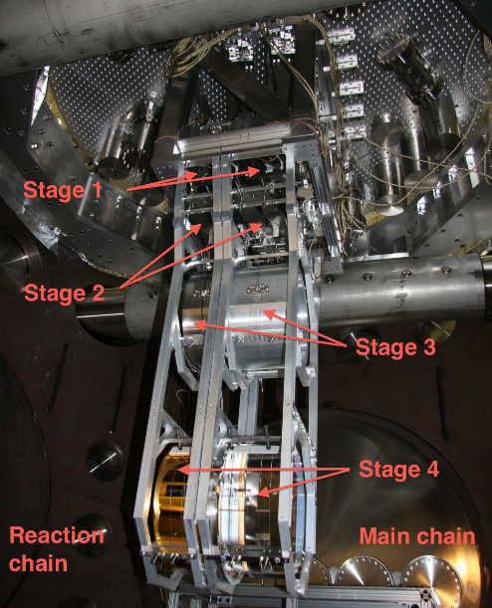

Figure 2. Photograph of a mature prototype quadruple pendulum at the Massachusetts Institute of Technology hanging from a seismic isolation system inside a vacuum chamber. Much of the surrounding cage is not in place, allowing greater visibility of the suspended components. The reaction chain is visible on the left, the main chain on the right. Stage 1 is largely obstructed by the surrounding cage. Stage 4 on both chains is constructed of fused silica. In the production pendulums, stage 4 of the main chain is connected to a fused silica stage 3 with 400 μm diameter fused silica fibers. Here the main chain’s stage 4 hangs from an aluminum stage 3 with steel wires.

The position and angular control of the mirror, in addition to low frequency control with the stage 1 actuators, is done with actuators placed between the main and reaction chains at the second, third, and fourth stages. The pendulum is designed to split the mirror control between the various stages so that larger and noisier low frequency control forces are applied to the higher stages where there is better mechanical attenuation to the mirror. The second and third stages have four OSEMs each, and at stage 4 there are four electrostatic actuators known as the Electrostatic Drive (ESD). The error signal sent to each of these stages is the position of only the main chain's stage 4 measured from interferometric signals. The OSEM sensors here are used only for the assembly of the pendulum.

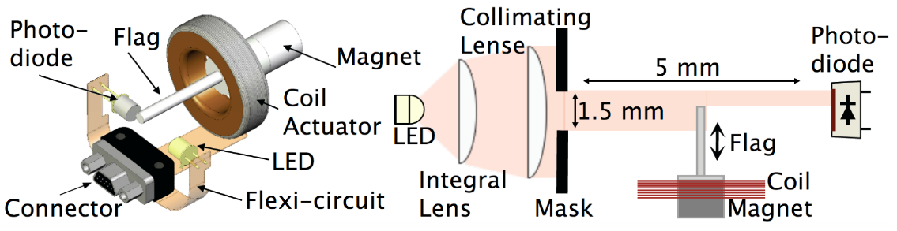

Figure 3. Drawing of the working parts of an optical sensor electromagnet (OSEM). The basic OSEM components consist of an LED, photodiode, and coil of wire. A flag mounted to a stage on the quadruple pendulum blocks part of the LED light and produces a position dependent signal from the photodiode. When a current is run through the coil, an actuation force is produced on a permanent magnet mounted under the flag. Adapted from [24].

# OPTICAL CAVITIES LOCKING

# PERFORMANCE

FIGURE 9 (a) shows an example of isolation results obtained with the two-stage active platforms. The black curve shows the ground motion. The red and blue curves show the motion of two of the active platforms, which provide very similar isolation. The motion is near or below requirements at all frequencies above 0.5 Hz.

In FIGURE 9 (b) the measurements of the six degrees of freedom of the active platform are combined to estimate the longitudinal motion at the input point of the suspension. In the red curve, this motion is combined with a model of the isolation provided by the suspension. As shown in this example, only light damping of the resonance is needed. The combined active and passive isolation permits bringing the optic motion under ${10}^{-19} m/√Hz$ at 10 Hz.

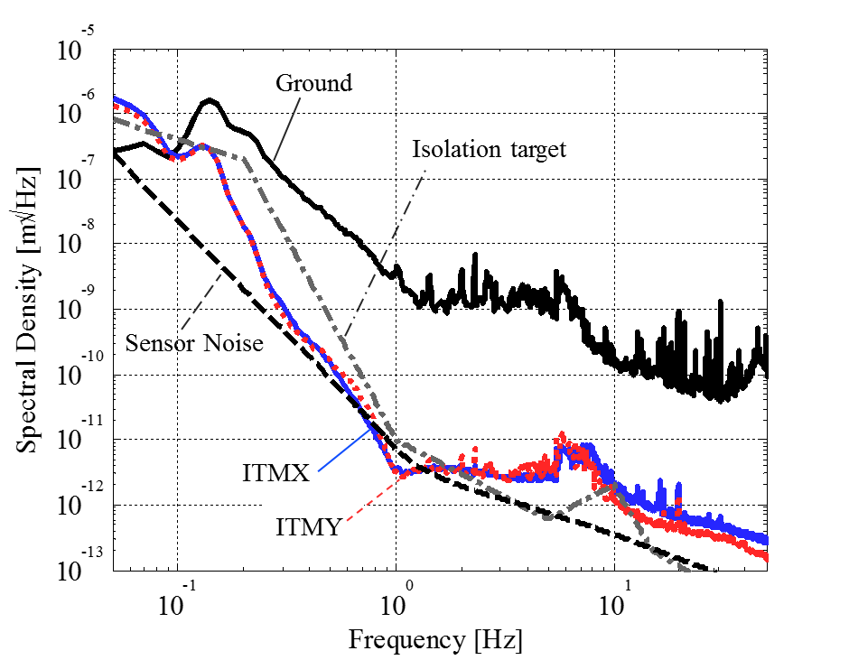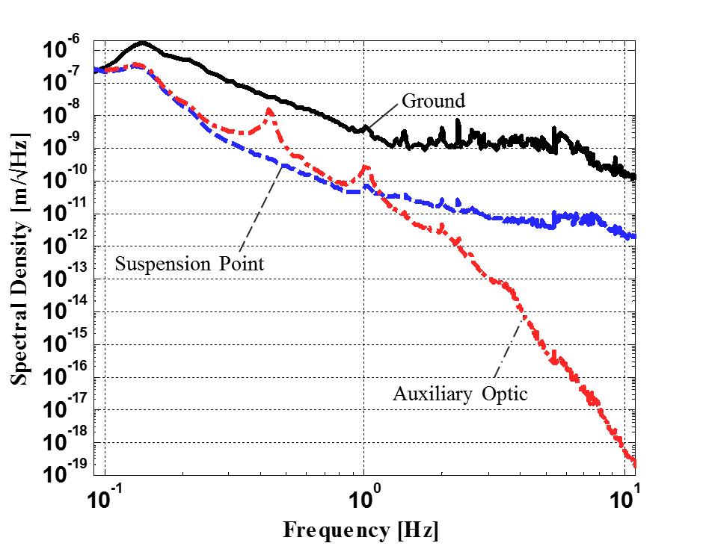

*FIGURE 9: Performance of the active isolation platform (right), and combined active-passive isolation (right)*

# ADVANCED CONTROLS

# CONTROLS INFRA-STRUCTURE

## Electronics

Fig. 8 (a) gives a schematic overview of the electronics diagram of a seismic isolation platform. Actual electronics are shown in Fig. 8 (b). Custom low noise electronics boards and chassis have been designed to condition the instruments signal and to distribute them to the Analog to Digital Converter (ADC), to receive the drive signals from the Digital to Analog Converter (DAC), and then to condition and distribute them to the actuators.

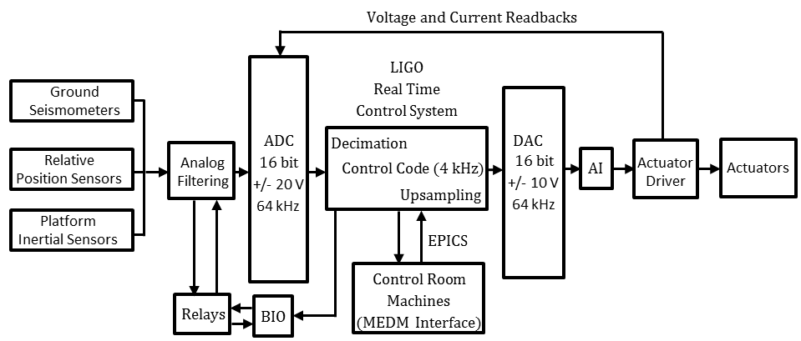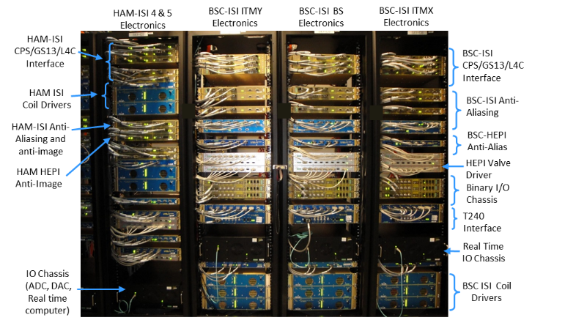

Fig. 8: Diagram (a) and actual picture (b) of the isolation systems electronics.

The detailed design is described in [[28](#_ENREF_28)]. It includes low noise pre-amplification boards designed for the passive geophones [[29](#_ENREF_29)]. Their design is based on noise budget estimates of the platform motions as described in [[30](#_ENREF_30)]. Amplification and whitening filter stages are used to maintain the signals above the ADC noise. These stages of amplification can be switched remotely as a function of operating conditions via binary IO cards and relays. The electronics provide read back signals to monitor the state of the switchable filters. The output electronics include anti-image and actuator drivers (valve drivers of hydraulic actuators and coil drivers of electromagnetic actuators). These filtering stages are designed to reduce the DAC noise transmitted to the drivers. Coil drivers voltage and current read backs are sent to the ADC for monitoring.

## Real time system

The signals are digitized at 64 kHz using 16 bits +/- 20V ADC cards. A third order Chebyshev at 10 kHz with a notch at 216 Hz is used for the anti-aliasing filter. The signals are decimated to the real time controller sampling frequency (at 2kHz for HEPI platforms, 4 kHz for HAM-ISI and BSC-ISI). The controller output is up-sampled to the DAC cards frequency at 64 kHz. The digital controller is based on the LIGO CDS real time code [[31](#_ENREF_31)]. An Epics database [[32](#_ENREF_32)] is used for communication with the control room machines. The operator interface is built in MEDM code [[33](#_ENREF_33)]. A software system was developed to coordinate and automate the hierarchical and sequential turn on and turn off process of Advanced LIGO subs-systems (just for the seismic isolation system, each detector uses 21 active platforms, which include up to 12 DOF per platform, several hundreds of parallel feedback and feedforward loops, and thousands of digital channels) [[34](#_ENREF_34)].

## Top level Control Supervision

A custom hierarchical state machine, known as Guardian, manages the global state of the interferometers. Written in Python, Guardian consists of a distributed set of automaton nodes, each handling automation for a distinct sub-domain of the instrument. Each node is loaded with a directed state graph that describes the dynamics of its sub-domain. A master manager node at the top of the hierarchy communicates with multiple sub-manager nodes; these in turn communicate with device level nodes at the bottom of the hierarchy, which directly control the instrument through EPICS. Guardian provides automation of interferometer lock acquisition, as well as the subsequent transitioning to low-noise operation.

# ACKNOWLEDGEMENTS

LIGO was constructed by the California Institute of Technology and Massachusetts Institute of Technology with funding from the National Science Foundation, and operates under cooperative agreement PHY-0757058. Advanced LIGO was built under award PHY-0823459. The material presented in this paper is the fruit of the outstanding work of the LIGO Suspension and Seismic isolation teams. This paper carries LIGO Document Number P1600103. The left side of Figure1, Figure [3-7] and the data in Figure 9 was published in [3] and is re-used with permission from the Institute of Physics. The right side of Figure1 was published in [2] and is re-used with permission from the American Physical Society.

# REFERENCES