Hipot testing procedure for Withstand testing of HV coax cabling using the Vitrek 955i Electrical Safety Analyzer:

- Safety warnings:
  - Follow the “Hazard Analysis HIPOT Testing for Beam Tube Ion Pump Power Supply Cable” document E1500305-v1 and all other related documents listed.
  - WARNING - THE 955i IS INTENDED TO BE POWERED FROM A POWER CORD HAVING A PROTECTIVE GROUND WIRE WHICH MUST BE INSERTED INTO A POWER OUTLET HAVING A PROTECTIVE GROUND TERMINAL. IF THE 955i IS NOT POWERED FROM A SUITABLE POWER SOURCE THEN THE CHASSIS GROUND TERMINAL LOCATED NEAR THE POWER ENTRY CONNECTOR ON THE REAR PANEL MUST BE PROTECTIVE GROUNDED.
  - WARNING - THE 955i PRODUCES VOLTAGES AND CURRENTS WHICH MAY BE LETHAL, ENSURE NO VOLTAGE OR CURRENT IS PRESENT WHEN CONNECTING TO OR DISCONNECTING FROM THE TERMINALS OR DUT. The HIGH VOLTAGE OR HIGH CURRENT PRESENT warning symbol on the front panel of the 955i is illuminated whenever an unsafe voltage is present on the HV terminal or a high current is present between the SOURCE terminals.
  - The insulation of the wiring to the HV terminal of the 955i must be rated for at least the highest voltage expected during the test sequence.
  - The user should ensure that all personnel remain at a safe distance from the HV wiring during testing. When using high voltages, even if there is sufficient insulation, there may be significant capacitive coupling which can cause an unsafe current to flow to nearby objects and corona can occur even outside of the insulation. This is made worse by sharp corners on objects or the wiring.
  - The user may depress the STOP button on the 955i front panel at any time while a test sequence is being run to remove the voltage or current as quickly as possible and abort the test sequence.
- Setup:
  - If the cable was pulled through conduit, test first before installing the connectors to ensure that the cable was not damaged due to being pulled through the conduit, then test again after the connectors are installed.
  - ensure the work area is clean and uncluttered
  - If cable is run through conduit, make sure no personnel or equipment are within 2 feet of the conduit.
  - Ensure both ends of cable to be tested are stripped in a way that there is sufficient gap (~3 inches) between center conductor and shield.
    - Also wipe the inner conductor and dielectric down with some isopropyl alcohol and place on a clean, non-conducting surface to prevent surface arcing (concrete may not be sufficient).
- Operation:
  - Use a 3 prong AC cord connected to an outlet with verified ground to power the HIPOT tester.
  - Self Test:
    - with leads removed press the TEST button to load self test
    - press START when prompted
  - The 955i requires that the DUT (at least that portion which is being measured) is isolated from ground
  - The DUT should be wired between the HV and RETURN terminals of the 955i. The 955i provides a safety ground for the DUT during the test via its’ RETURN terminal.
  - Push the SELECT button and then the down EDIT button to select the #1 “11000” DCW sequence.
  - Press the ENTER button, this will load the pre programmed DCW Hipot test.
  - When everyone is all clear (ask out loud) and all connections are safe and secure, press the START button.
- Test Completion or Test Failure
  - After a test sequence has completed successfully or was aborted due to failure, discharge of the DUT should be verified - even though the tester has a discharge function. This should be done at both ends, if the center conductor is easily accessible with a HV Probe (Fluke 80K-40 for example).
  - If some voltage is found after testing, the cable can be discharged by connecting a wire from the tip of the HV probe to a suitable ground (the rear of the Hipot tester for example).

Cable Terminating Tips

- Use soldering tweezers on the center pin:

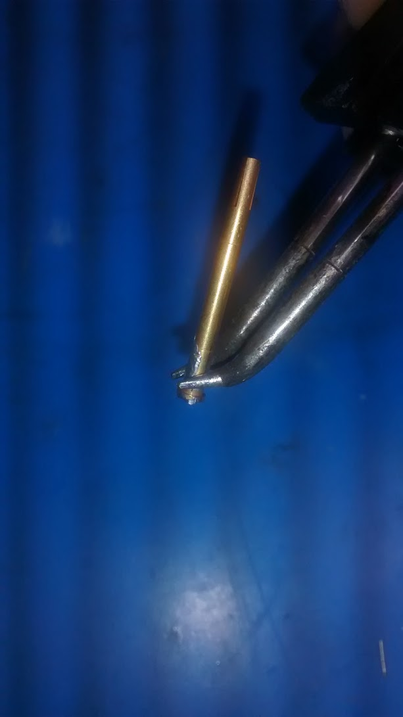

- Cool down the solder joint ASAP to stop the dielectric bulging and preventing the connector from sliding over. Canned Air / Duster worked.
- After the soldering is done, zip tie and heat shrink the the safety connector (SMB) at a length where it disengages before the SHV-10 connector.
- Vernier calipers work for checking center pin depth if a depth gauge is not available (~0.56”).

