Title | OMC DCPD Preamplifier Test Procedure
Author | R. Abbott, Caltech
Date | 18 July 2016
Hardware Version | D060572-v1

Overview
The following brief procedure documents the test results of an OMC DCPD Preamplifier.

Table 1
Preamplifier Serial Number
Date
Tested By
Overall Test Result | PASS | FAIL
 | ☐ | ☐

DC Measurements Section

Quiescent current draw
Using an adapter cable to D-Sub 9 pin, apply +/-15VDC to the preamplifier with two Fluke DVMs in series to measure current. Record the results in the following table. Mark each measurement as Pass or Fail.

Table 2, D-Sub Pin Map for Rack Interface
Pin (+,-) | Function
1 | Out +
6 | Out -
7, 8 | GND
2 | +15VDC
3 | -15VDC
4 | Bias (+V)
9 | Transimpedance Select

Table 3 Quiescent Current Draw
Quiescent Current Draw (mA) | Specified Value | Measured Value | Pass | Fail
+15V Supply | 23mA +/- 5mA |  | ☐ | ☐
-15V Supply | 23mA +/- 5mA |  | ☐ | ☐

Output DC Offsets
Using a Fluke DVM, measure the DC offset voltages between pins 1 and 6 of the output Rack Interface D-Sub connector. Record the results in the following table.

Table 4 Output DC Offsets
D-Sub Pin | Specified Value | Measured Value | Pass | Fail
Pin 1 | 0mV +/- 2mV |  | ☐ | ☐
Pin 6 | 0mV +/- 2mV |  | ☐ | ☐

Oscillation Check
Using an oscilloscope, verify that there are no oscillations at each pin of the differential output. Mark the measurement as Pass or Fail in the following table.

Table 5 Oscillation Check
D-Sub Pin to Observe With Scope | Pass | Fail
Pin 1 | ☐ | ☐
Pin 6 | ☐ | ☐

Transfer Function
Use an SR785 to measure the transfer function between the preamplifier input and the differential output. An additional D-Sub breakout cable/fixture is needed go between the preamplifier input and a D-Sub breakout board. Mark the results and indicate Pass or Fail in in the following data table.

Table 6, D-Sub Pin Map Preamplifier Input
Pin (+,-) | Function
1 | Bias (V+)
2 | Preamplifier Input
3 | GND

Table 7, Main Path Transfer Function
Frequency(Hz) | Gain (dB) | Phase (Deg.) | Measured  Gain (dB) | Measured  Phase (Deg.) | Pass | Fail
10 | 15.2dB +/- 1dB | 93.9 +/- 3 deg. |  |  | ☐ | ☐
100 | 43.5dB +/- 1dB | 68.0 +/- 3 deg. |  |  | ☐ | ☐
1kHz | 47.6dB +/- 1dB | 1.8 +/- 3 deg. |  |  | ☐ | ☐
10kHz | 44.8dB +/- 1dB | -56.9 +/- 3 deg. |  |  | ☐ | ☐
100kHz | 18.0dB +/- 2dB | -102.7 +/- 6 deg. |  |  | ☐ | ☐

Figure 1, Predicted Transfer Function
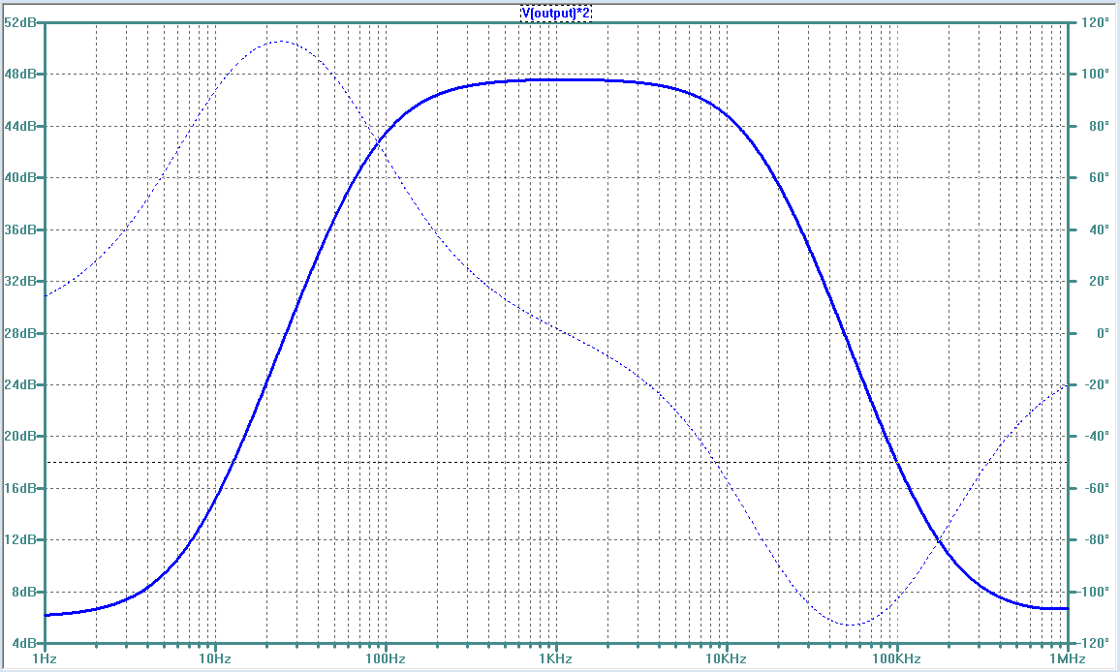

Output Noise Measurement
The figure below shows the output voltage noise measured differentially at pins 1&6 of the Rack Interface output with the preamplifier input open circuited (Z=100Ω).

Figure 2, Differential Output Voltage Noise

Table 8
Frequency | Predicted Noise (nVrms/√Hz) | Measured Noise  (nVrms/√Hz) | Pass | Fail
20Hz | 67n +/-5  nV/√Hz |  | ☐ | ☐
1kHz | 477n +/-10 nV/√Hz |  | ☐ | ☐
10kHz | 345n +/-10 nV/√Hz |  | ☐ | ☐

Transimpedance Relay Functionality
Using a Fluke DVM, measure the resistance between the preamplifier input (Pin 2 of the input D-Sub) to ground. By applying +5V on the Rack Interface D-Sub between pins 9 and ground (Transimpedance Switch or Z-switch), the transimpedance can be switched between 100Ω and 400Ω. Verify this functionality and record the results in the table below.

Table 9 Transimpedance Select Relay
Voltage applied to Z-switch | Specified Value | Measured Value | Pass | Fail
0VDC | 100Ω +/- 2 Ω |  | ☐ | ☐
5VDC | 400 Ω +/-5 Ω |  | ☐ | ☐

Bias Path Protection Path Voltage Knee
A transient voltage suppressor (TVS) diode is included from the bias path to ground. The voltage rating of the correct component is 18VDC. Voltages above this will begin to cause conduction in the diode. The following test requires a power supply to be attached to TP9 though a 1kΩ resistor. The current flowing through the TVS can be obtained by measuring the voltage across the series 1kΩ resistor. In the following table, record the applied voltage that causes 1mA to flow (1 volt drop across the 1kΩ resistor).

Table 10 TVS Voltage Knee
 | Specified Value | Measured Value | Pass | Fail
Voltage applied to TP9 corresponding to 1mA current flow | 21.2 VDC +/- 1 VDC |  | ☐ | ☐

