Progress Report
1

Udochu, Ogbonnaya

SURF- LLO
The first week of the program I went through the safety, laser and contamination control trainings, both the online and walk through. Upon starting the SURF fellowship, I was introduced to the vacuum team at LLO (LIGO, Livingston, LA). I will be working with the whole team and a graduate student for the duration of the fellowship. So far, I have done and been assigned numerous tasks. My focus are the residual gas analyzers (RGA), I have been engaged in other activities that also aid in the vacuum system functionality.
After all the trainings and contamination control I began going to the LVEA, X-end and Y-end to help out and learn about the vacuum system. I have a daily job of taking pressure reading of specific parts of the system that had previous work done on them (the HAM doors were put back on, ion pumps and turbo pumps replaced and gates were closed/open). These reading are taken in order to monitor the vacuum conditions and ensure proper functionality after changes. The readings being recorded are the cold cathode pressure, the ion pump pressures.

A Residual Gas Analyzer (RGA) allows the user to measure the gases present in low-pressure environments. It is an essential tool to measure performance of the ultra high vacuum (UHV) systems. It allows one to know the chemical species involved in gas phase reactions and can help one to determine which reactions are most important. The principle of operation is the same for all RGA instruments: A small fraction of the gas molecules are ionized (positive) and the resulting ions are separated, detected and measured according to their molecular masses. I have begun my personal research into RGAs; how to calibrate and general knowledge of its function. As of the time of this report, I have (with the aid of the vacuum personnel) begun on the installation of another RGA on the vacuum system.

To begin setting up the RGA we first took all the parts being used to a clean room. This is to prevent contamination of the sensitive parts. Parts such as the ‘O’ rings are to be clean and absent of dust particles hence, the use of a clean room. Below is a picture of the filament and calibrated leak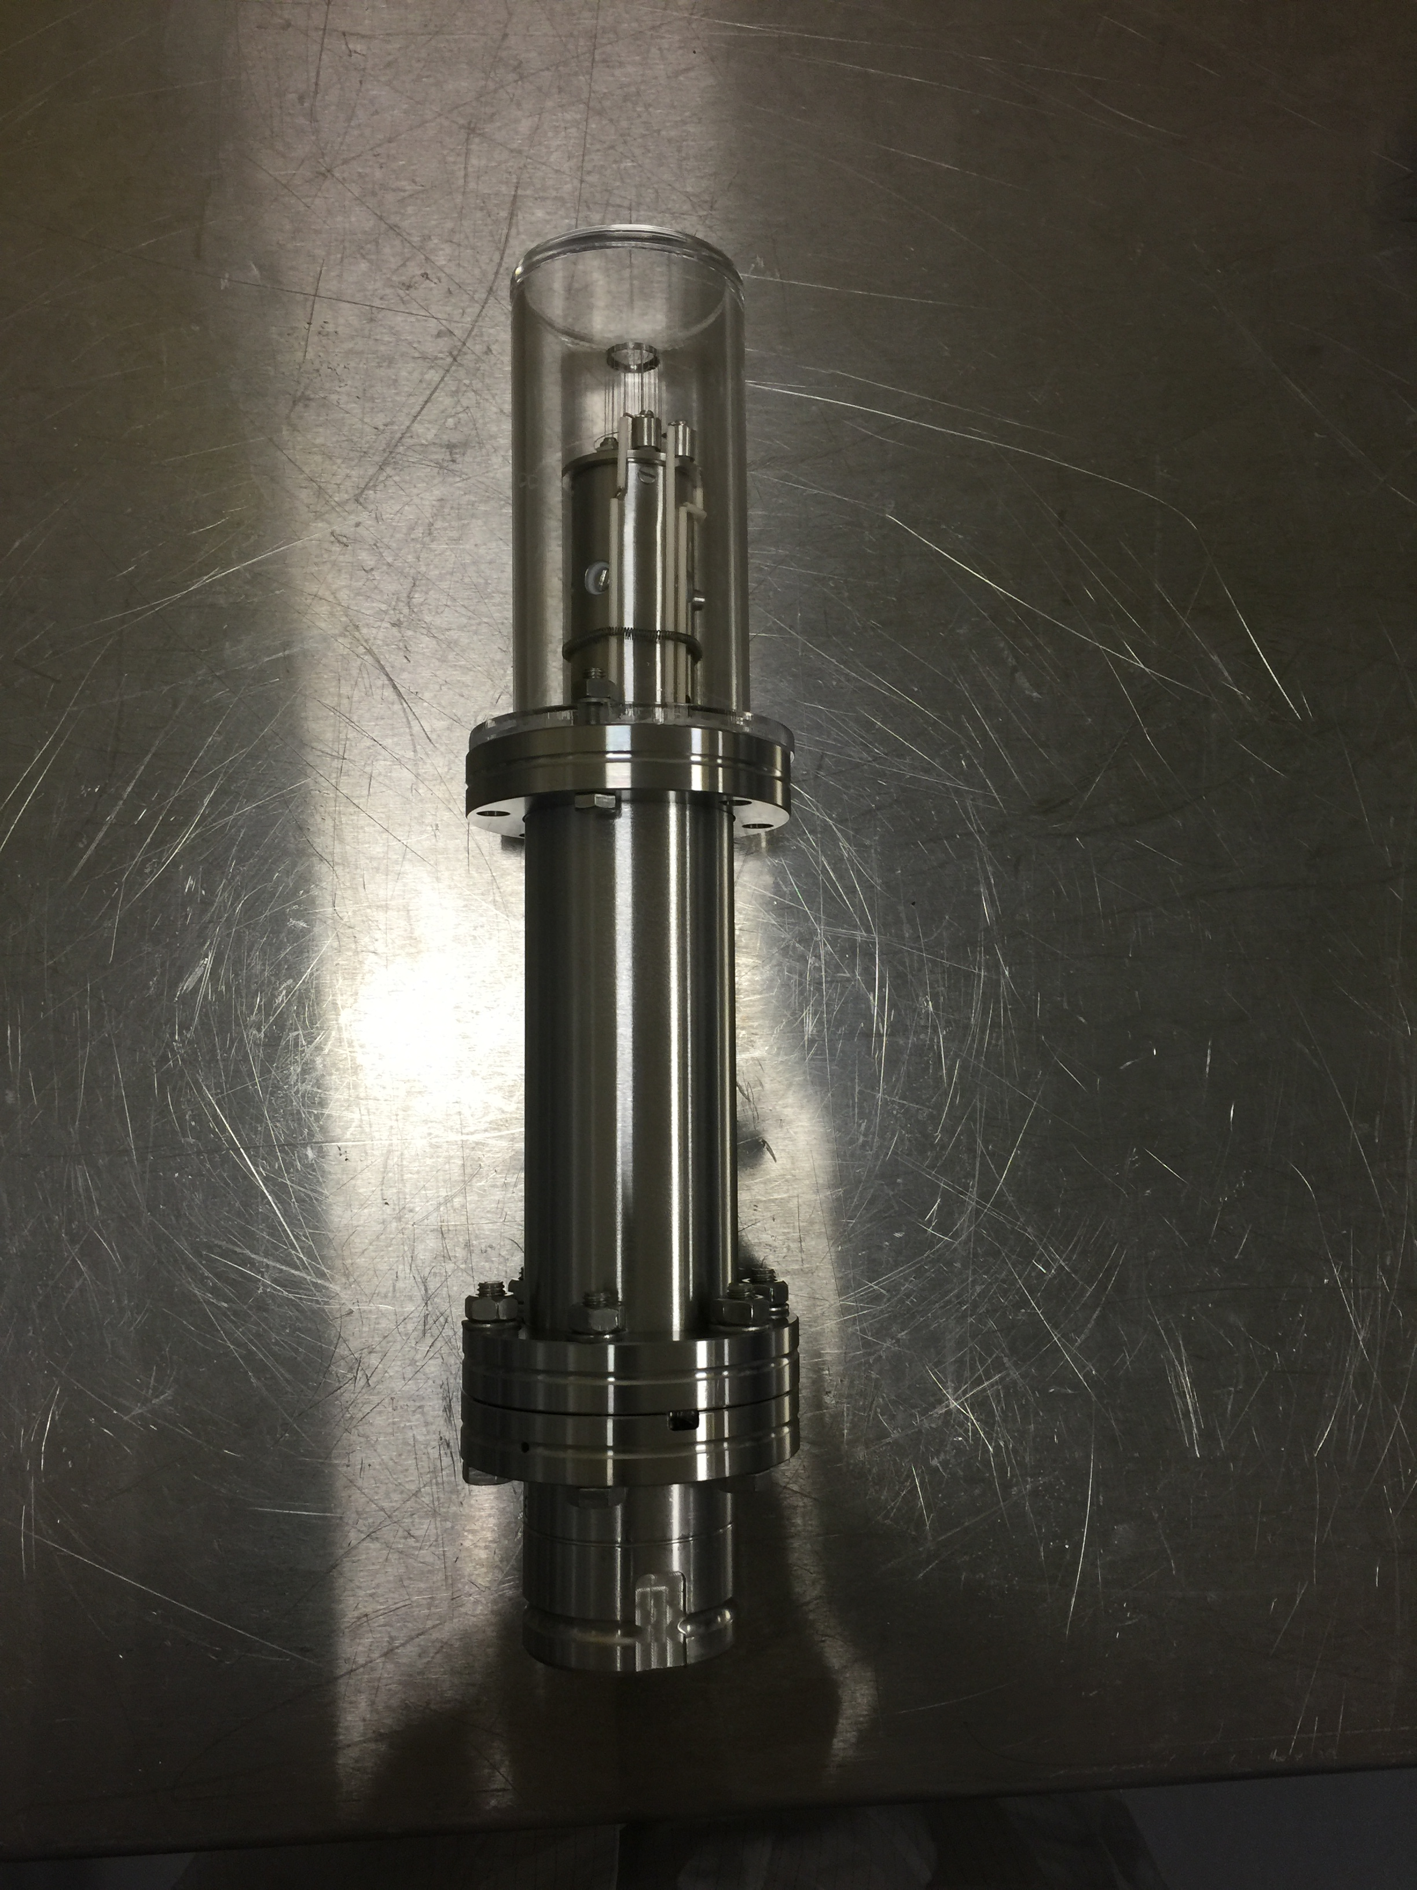Fig 1: Filament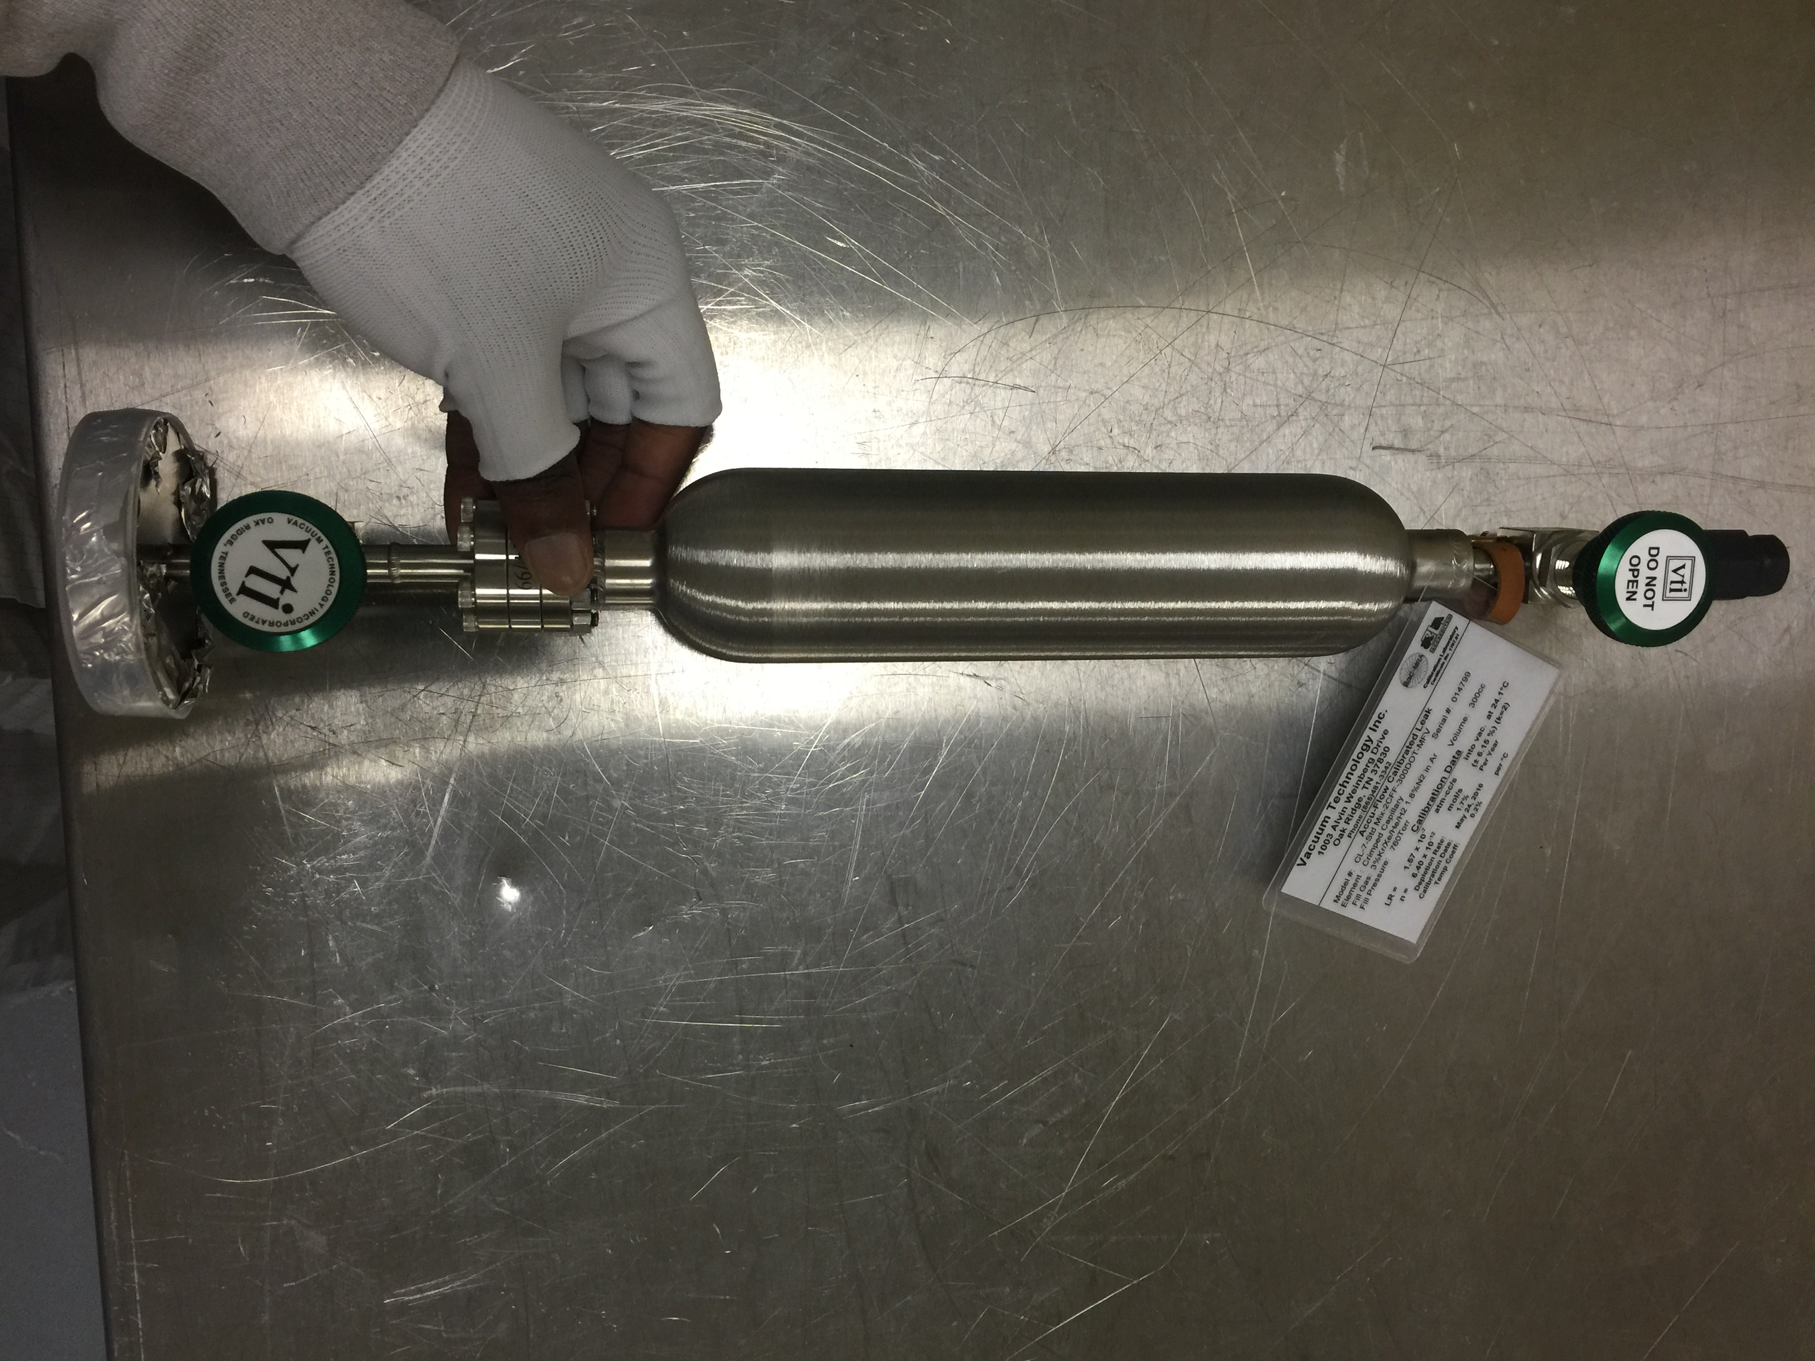Fig 2: Calibrated Leak

Below is a picture if the coupled calibrated leak and the filament. It should be noted that the filament has not yet been baked.
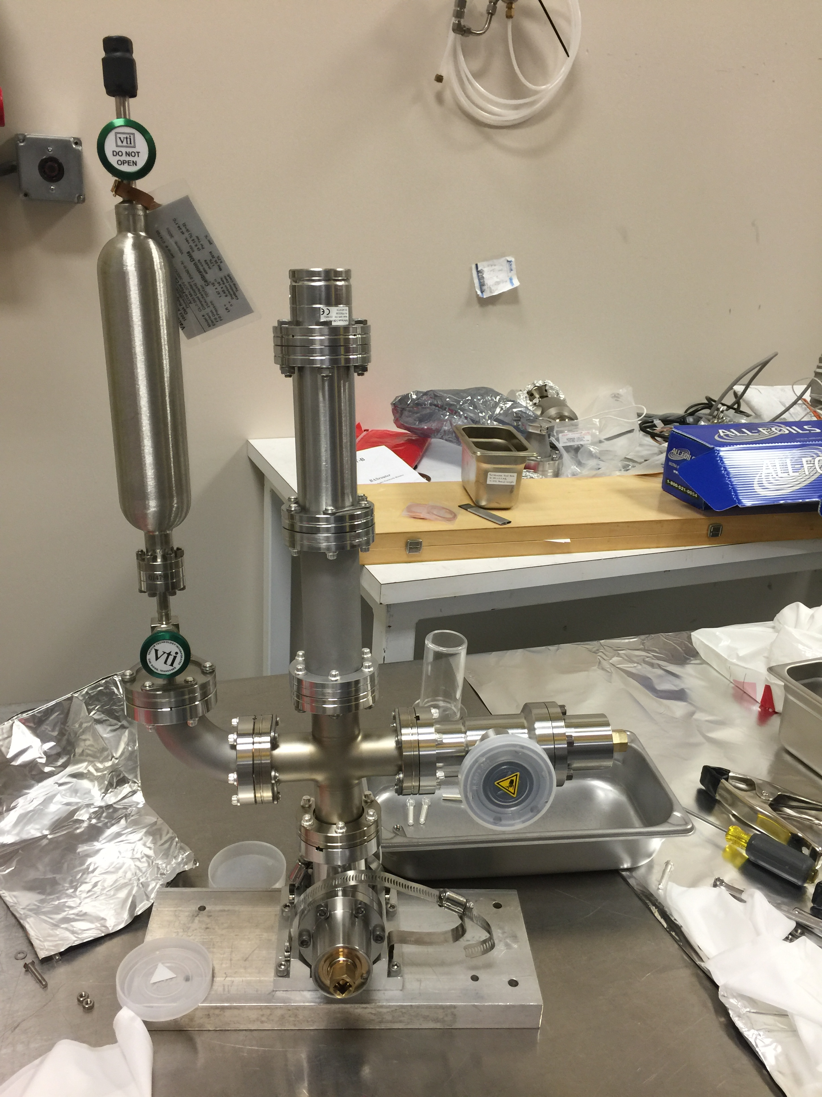

Fig 3: Calibrated Leak and Filament Coupled Together

Below shows the leak checking of all the components coupled together. There were no leaks and the over all part will be ready to be added onto the main volume.

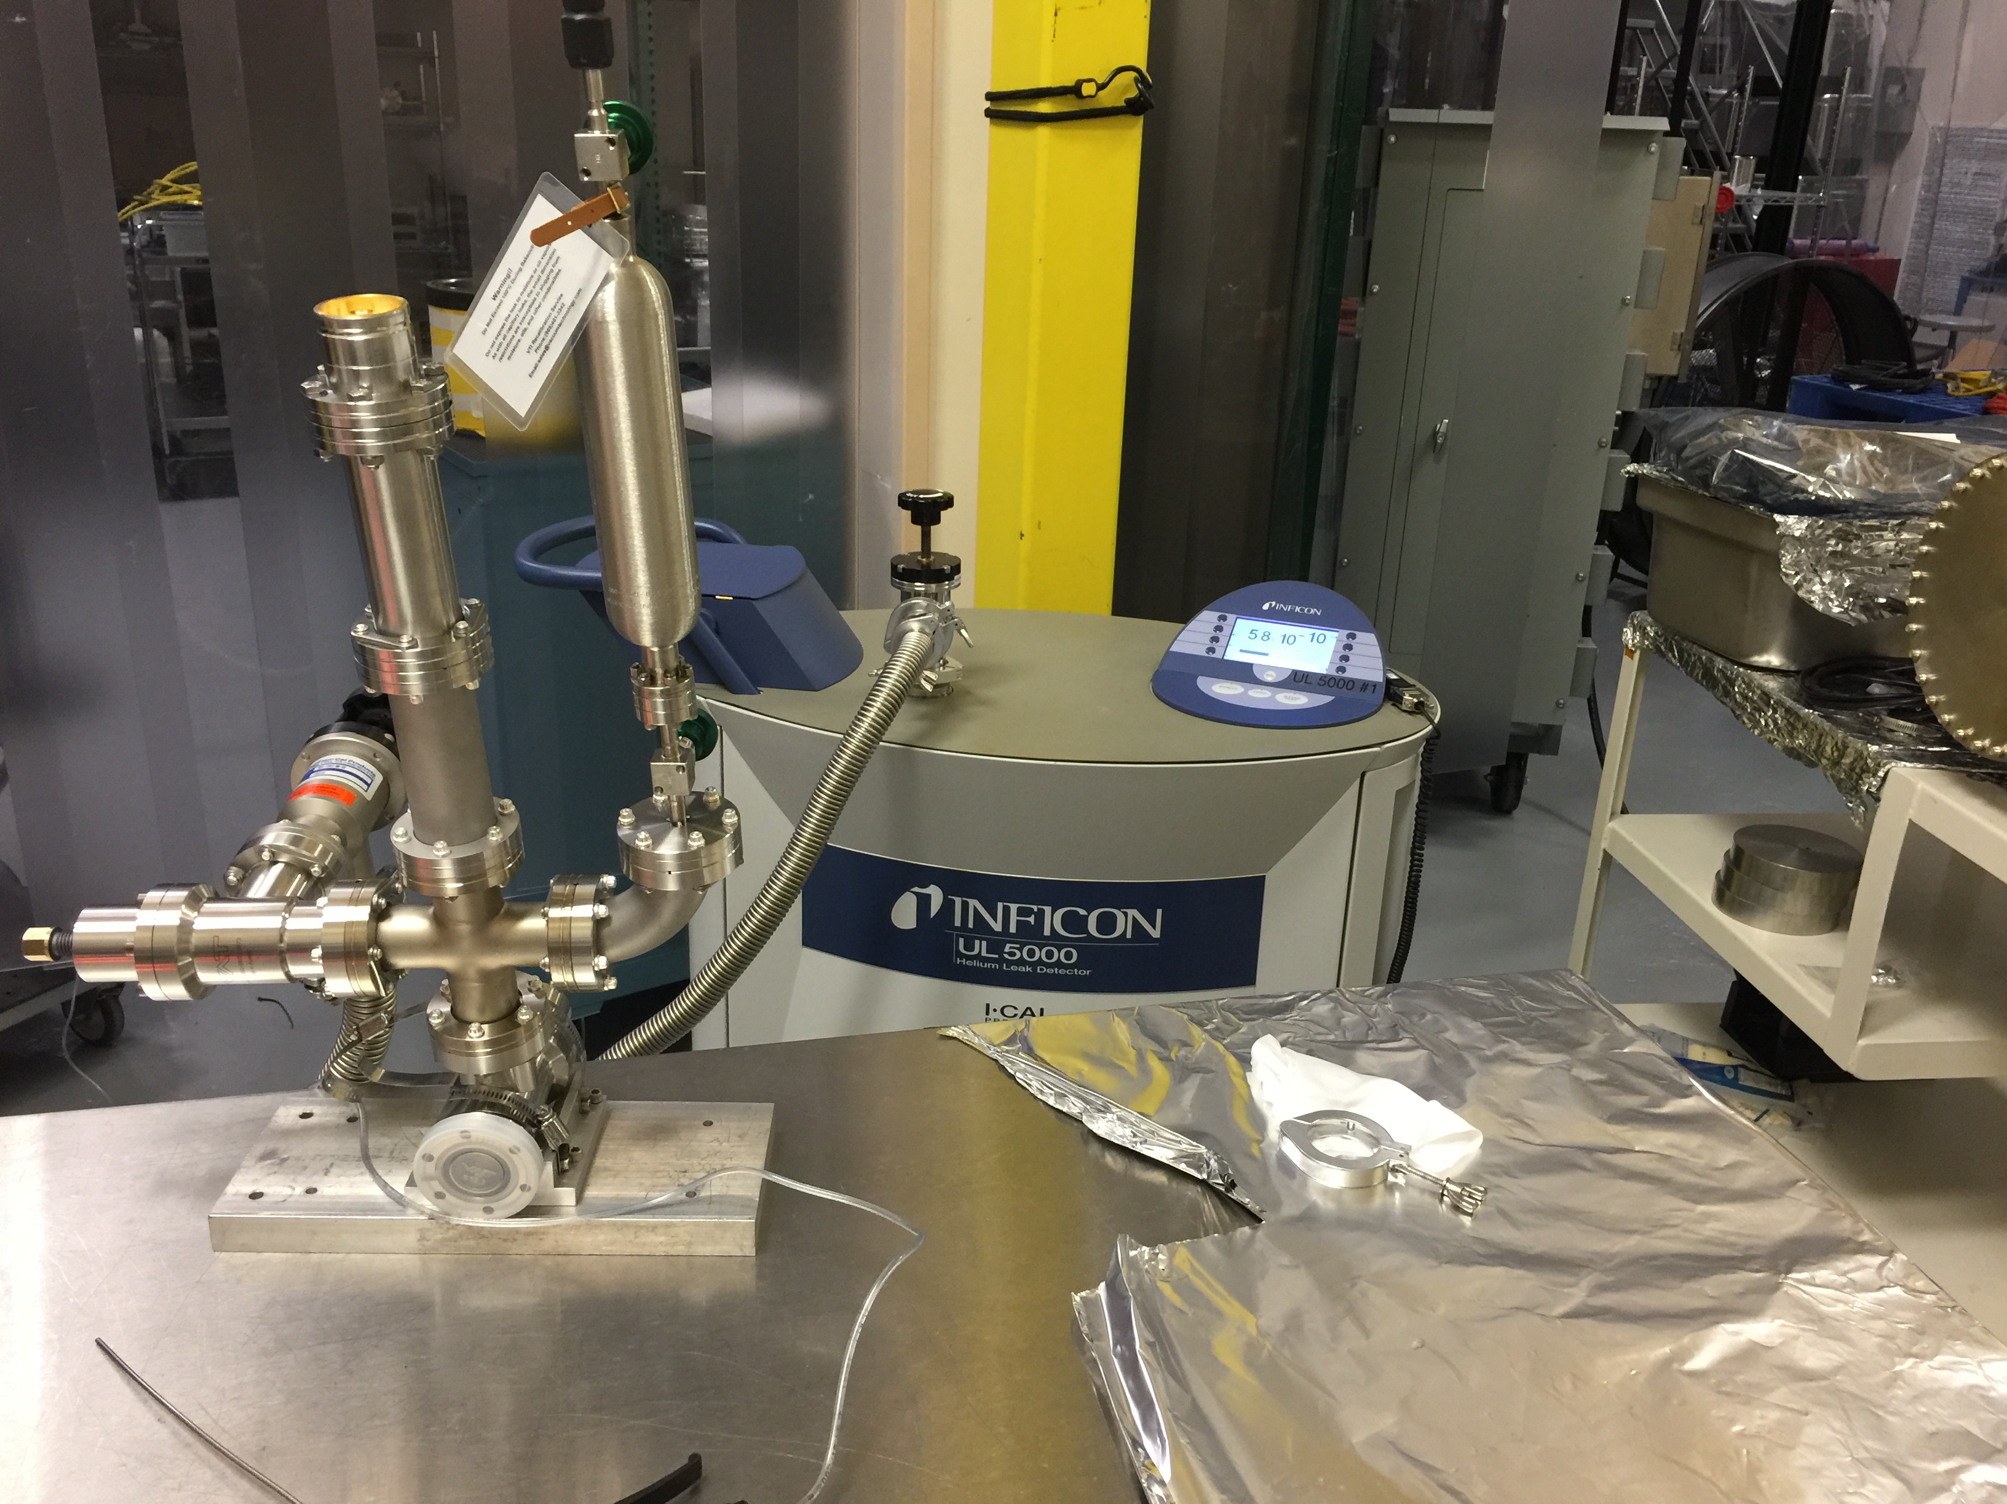

Fig 4: Leak Checking Coupled parts with Helium.

The coupled part above will be added to the main volume after it has been pumped down and the filament will then be baked.
So far the past three weeks have been very interesting and I am looking forward to learning even more about vacuum systems.

