LLO's Lock Losses and STS Response to Wind in O1

It's been estimated that 6% of downtime at Livingston is due to high winds (from the operating mode of the IFO set by the operators, under the summary pages). To explore lock losses caused by wind, Arnaud Pele and I did a short study on wind during O1. This study focused on characterizing three main things:
- lock losses due to wind during O1
- wind speed and direction during O1
- the STS response to wind during O1

O1 Lock Losses

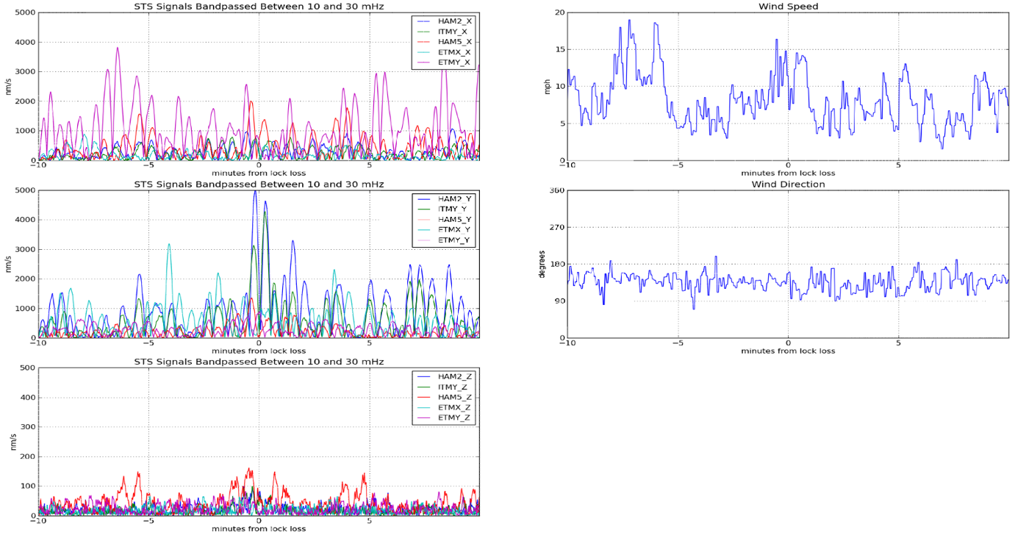
To explore O1 lock losses, I went through the aLog and wrote down the GPS time for every lock loss that was explicitly attributed to wind. For each of these times, I recorded the wind speed and wind direction at the time of lock loss. For example, alog 23088 records a lock loss on Nov 27 at 18:23 UTC. The corresponding plot for this lock loss (Figure 1) shows that the wind right before the lock loss was 13 mph, and the low-frequency BLRMS was 5 μm/s in the y-direction at HAM2 and ITMY. High sustained winds are often correlated with high microseism, which may sometimes be the true cause of lock loss. There also seems to be some weak evidence that gusts can also cause some small peaks in the anthropogenic BLRMS windows, but using the summary pages is a pretty rough way of doing this analysis.
Figure 1: example of wind speed and ground motion during lockloss

All of the data recorded from the summary pages and lock losses can be found in the WindQuakeLockLosses.ods, as well as some information about whether or not there was an elevation in the anthropogenic and earthquake bands at the time of lock loss.
Using the wind-related lock loss times I recorded from the aLog, I got the wind direction and wind speed during lock losses using the corner station anemometer, which is 50 meters away from the building corner, and 10m off the ground. I also obtained the wind direction and wind speed for all O1 (Described more in the next section). A plot containing the distributions of wind speed and direction from all O1 data and O1 lock losses were plotted using the PlotLockLoss function in WindGroundFunctions.py. It's important to note that the wind directions and wind speeds were averaged over 10 minute windows for the lock losses, so the effect of gusts will be underestimated. Figure 2 contains the distributions of wind speed and direction.

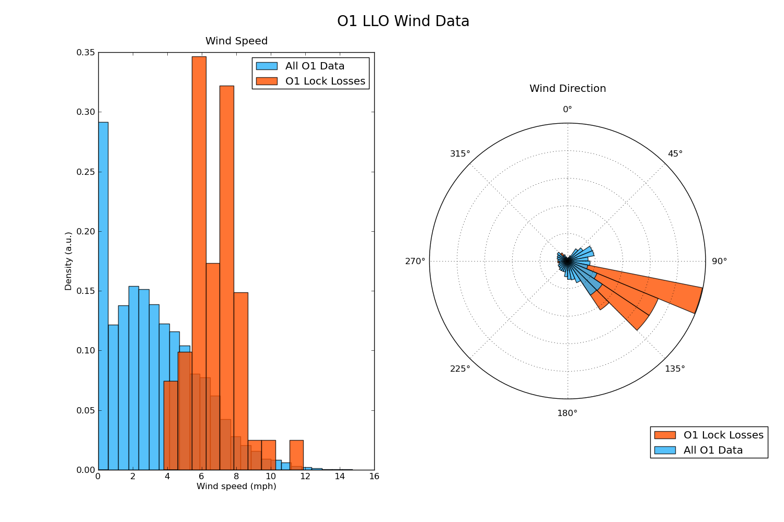
Lock losses begin occurring for wind speeds of 4 mph. The highest number of lock losses happen at 6 and 8mph and the distribution dies off pretty rapidly after that, suggesting that wind-related lock losses predominantly happen for sustained winds below 10mph. Also, while the total distribution of wind directions (blue) shows peaks at 135 degrees, lock losses are predominantly from wind coming from this direction. 4/50 lock losses occur when the wind is blowing from the North, another 4/50 when the wind sensor is spinning rapidly, and the remaining 42/50 occur when the wind is blowing from the Southeast.
Figure 2: histograms of wind speed / direction vs locklosses
The average wind speed shown in Figure 2 is probably underestimating the speed of wind gusts around the lock loss. For example, Figure 1 shows some typical behavior of the seismic channels and wind sensors in a 20 minute window around a lock loss. While the average wind speed is only about 10 mph, there is a gust of 15mph just before the lock loss. This gust causes significant tilt seen by HAM2_Y and ITMY_Y.

O1 Wind Speed and Direction

To better characterize the wind direction and speed over O1, I created a code to get the data from NDS2 in 15 minute increments. For the wind, this data is averaged over the 15 minute increment. Because the end station weather stations were unreliable, I could only use data recorded by the corner station during O1. To get some extra information, I also retrieved wind direction and speed data from the Hammond airport weather station, via wUnderground, and a Baton Rouge weather station maintained by LSU's College of Agriculture. Figure 3 compares distributions of the wind speed and direction from the three stations.
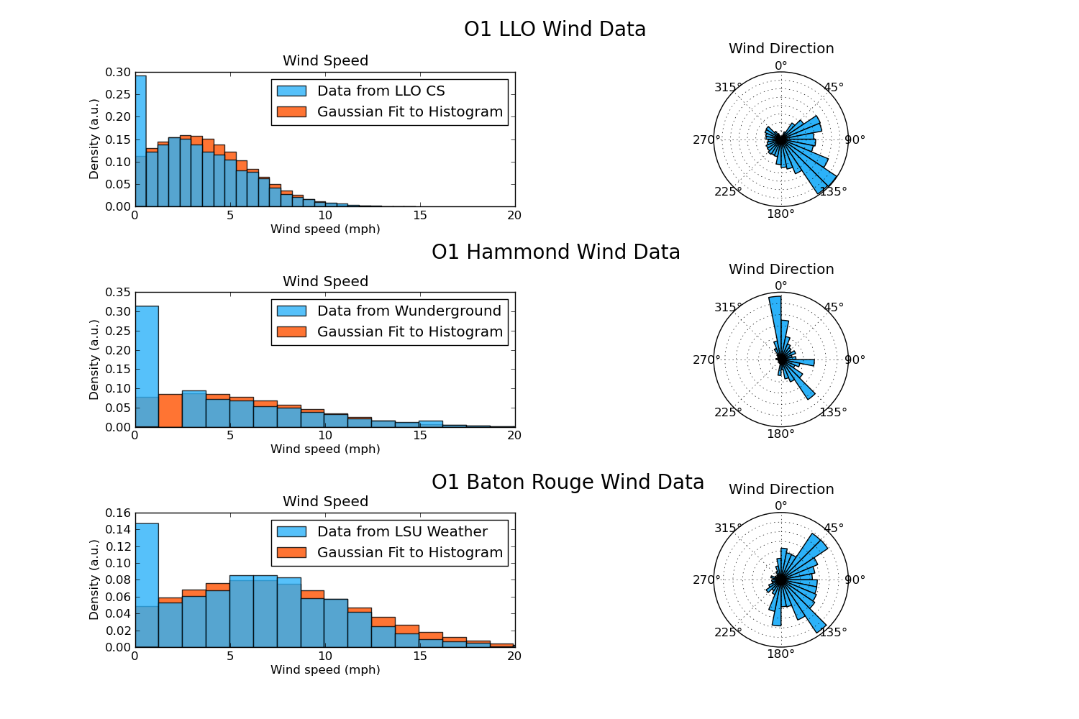
Figure 3: Wind speed and direction histograms from different weather stations in Louisiana
From these plots, we can see that the Baton Rouge (BR) and Hammond stations see much stronger wind, which may suggest that there is some kind of isolation for the L1 weather station. The isolation may be due to trees, or due to the building although the station is 50 m away from the building corner, as measured by google maps and we are using the sensor with 10m height. The directions also vary significantly between the three weather stations. Jeremy Birch (L1 operator) has some experience with weather stations, and said that the LSU/BR station should be fairly reliable. The Hammond station disagrees significantly with both the BR and L1 measurements, showing the highest amount of wind from the North which doesn't match up with expected weather patterns. Both the BR and L1 stations show a high probability of winds coming from the Southeast and from the Northeast, although BR sees more from the Northeast than L1 does. The weather station is Southwest of the corner station, so this supports the idea that the building has some kind of effect on the wind seen at the corner station.
O1 STS Response
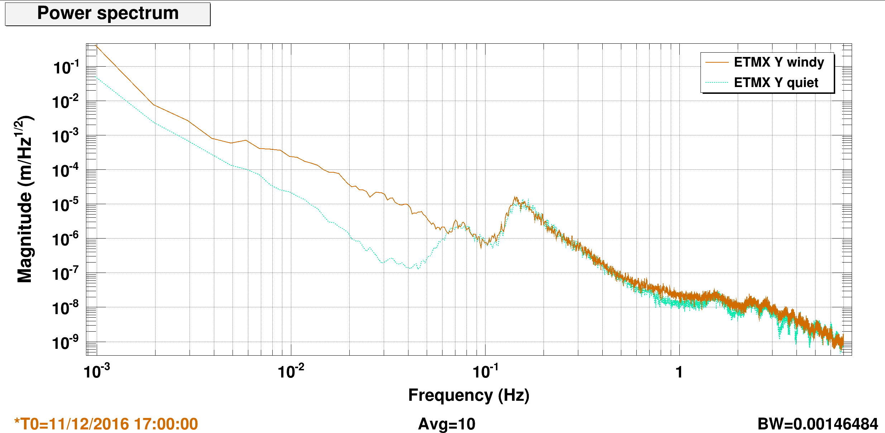
To see how the wind affected the seismometers at L1, I also collected O1 10-30mHz 15 minute BLRMS for each of the 5 seismometers on site. The three corner station seismometers are referenced as HAM2-ITMY and HAM5, from their proximity to those chambers. HAM2 seismometer is located on the south side of the beam tube between HAM2 and HAM3 chambers, HAM5 seismometer is on the west side of the beam tube between HAM4 and HAM5 chambers, and ITMY seismometer is in the ‘corner’ between the arms, on the south-west side of the VEA. The data was band passed between 10 to 30mHz, as a high primary microseism will dominate the signal over wind above 60 mHz (see Figure 4). The z-components of the seismometer output usually an order of magnitude below the x- and y-components, confirming that this frequency window is primarily sensitive to wind.
Figure 4: Difference in spectra of a seismometer signal between quiet and windy time, during high primary (80mHz) microseism

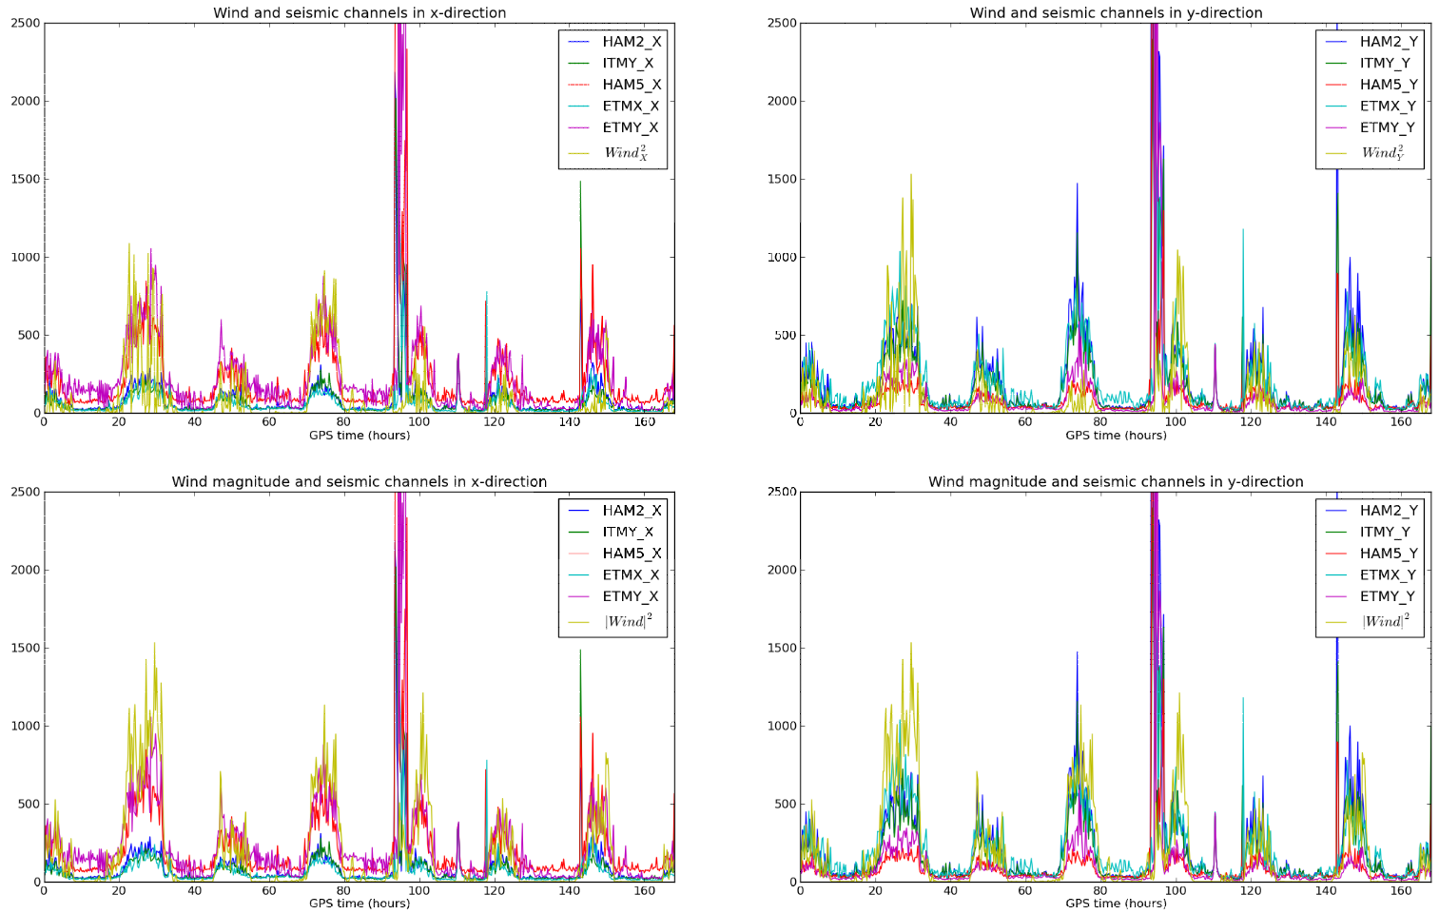
First, to confirm whether the response measured by the seismometers was proportional to the wind speed squared, as suggested by Brian Lantz (G1501371), I plotted the seismic BLRM's in each direction and the wind speed squared in each direction (Figure 5). They have a very similar trend, and I was able to fit a coefficient of wind squared with lower mean squared error from the average of STS channels than with a coefficient of the wind alone, which confirms the relationship between wind speed squared and the BLRM's. The magnitude of the wind speed better fits the motion measured by the seismometers than the wind speed projected onto L1 directions, which is somewhat strange. This is mostly because the wind speed in the x-direction matches the seismometer motion in the x-direction very badly, as the wind speed in the y-direction matches STS motion well.
Figure 5: wind speed squared vs seismometer 10-30mHz blrms
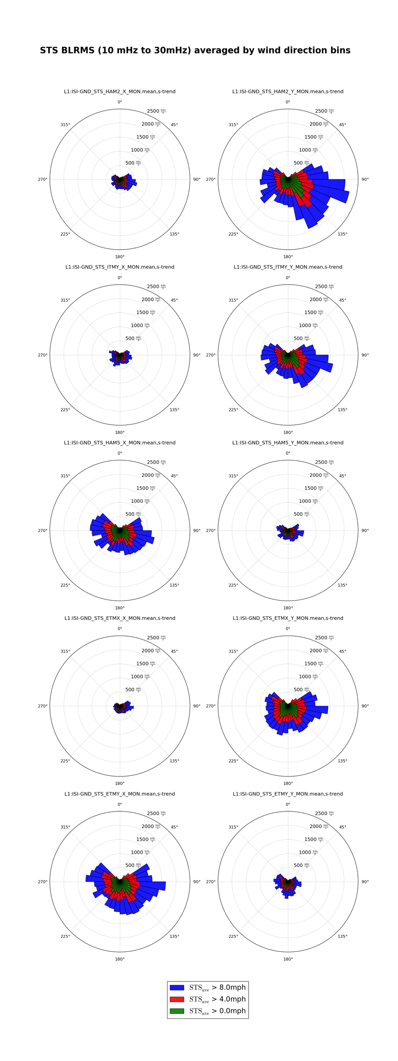
Lock losses show an obvious directionality, so we wanted to better understand the response of the seismometers to wind direction. To do this, I plotted wind roses for the x- and y- directions BLRM's of each seismometer (Figure 6). 32 angular bins are created, and an average STS velocity is calculated by using the data points with wind direction within the angular bin. This process is also repeated for subsets of data points with wind above some threshold. Because of the small number of data points with wind coming from the North, these plots are not useful for determining the seismic response to wind between 315 and 45 degrees. However, qualitative comparisons between seismometers and their sensitivity in other directions should be reliable. From the wind roses, we can see that the seismometers in the end stations measure the largest motion in the direction perpendicular to the beam tube. In the corner station, a similar relationship is present – HAM2 and HAM5 are more sensitive to wind blowing across the building, where the LVEA is narrowest. The seismometer in the vertex (ITMY) is very similar to HAM2 and shows a larger response in the y-direction. These relationships hold no matter which direction that the wind is blowing. For example, the motion measured in the x-direction at HAM2 is never as large as the motion measured in the y-direction. Also, every sensor measures the largest motion when the wind is blowing from the East, and is also very sensitive to wind blowing from the West.
Figure 6: STS tilt response roses

A more recent example of the difference between the LLO STS tilt response is plotted on the spectra in Figure 7. The 1mHz resolution data set was measured during O2, on December 2 2016, while the corner station anemometer was measuring a 10-15mph South-East wind The same conclusion can be drawn from this figure, where in the corner station, HAM2 X, ITMY X and HAM5 Y axis are less sensitive to wind tilt than their respective perpendicular axis. At the end station, it is the transverse degree of freedom that is consistently the noisiest.

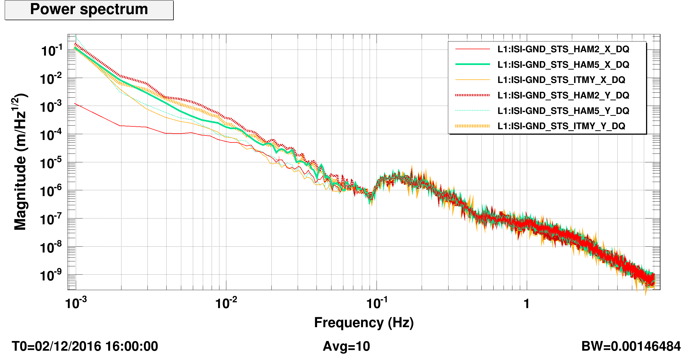
Figure 7: Comparison of corner station STS response during high wind (10-15mph)

Conclusion

LLO is very sensitive to wind, as lock losses occur with sustained wind as low as 4 mph. While the wind is most likely to come from the southeastern direction, lock losses are much more common from that direction than would be expected simply from the natural distribution of wind direction. The weather station at the corner station appears to be fairly reliable when compared to the weather station in Baton Rouge, but the lack of wind coming from the Northern direction may be due to some effect of the building. Smaller wind speeds are observed by the L1 weather station than by the weather stations in Hammond or Baton Rouge, which suggests that the building or trees isolate the L1 weather station from the wind in some way.
The wind speed squared matches the BLRM's of the seismic channels between 10 and 30 mHz, confirming that they are primarily sensitive to the wind tilt. STS responses are larger in the directions perpendicular to the beam tube for HAM2, HAM5, and the end stations. The seismometer in the vertex has behavior very similar to seismometer at HAM2. All seismometers measure the largest velocity when the wind is blowing East or West. Because HAM2_X and HAM5_Y are much more two to three times more resistant to wind, using a combination of the two seismometers may offer a reduction in the feed-forward of tilt at L1.
Technical Details

All of the python codes and results can be found in . The O1 data was generated using the python code GetData.py, which allows a user to collect data using cdsutils over a user-specified range in a user-specified interval. There is an option that performs the BLRMS in the 10-30 mHz window for each interval. Otherwise, it is averaged. There is support for saving the data in a scratch directory as it is collected, which is important when a large period of time is accessed.
All of the plots were done using a combination of plotGround.py and WindGroundFunctions.py. The former is a much simper code that shows how to plot the main results included in this document. WindGroundFunctions contains all of the functions used to generate and save the plots. There's quite a lot in it, and it's not well organized, but I think that the documentation is good enough that someone could repeat the plots for a different dataset.

