CHARACTERIZATION OF ADVANCED LIGO CORE OPTICS

GariLynn Billingsley, Hiroaki Yamamoto, and Liyuan Zhang
LIGO Laboratory
California Institute of Technology

Pasadena, California, USA.

INTRODUCTION
Precision optical measurement is a core technology contributing to the success of the Advanced LIGO detectors [1]. The round trip cavity loss requirement for each 4 kilometer LIGO arm is < 75 parts per million. The loss budget based on mirror requirements is estimated at 64 ppm. The fabrication of these low loss cavity mirrors relies on accurate characterization of the optics. The metrology at the heart of this process delivered coated optics with an average surface figure error of 0.4 nm rms over a diameter of 160 mm and an estimated Fabry-Perot cavity loss of 45 ppm. The power spectral density curves for different spatial frequency ranges are presented; these provide insight into sources of measurement error.

THE LIGO INTERFEROMETERS
The Advanced LIGO gravitational wave detectors are second generation instruments designed and built for the two LIGO observatories in Hanford, WA and Livingston, LA. The two instruments are identical in design, and are specialized versions of a Michelson interferometer with 4 km long arms as shown in Figure 1. As in initial LIGO, Fabry-Perot cavities are used in the arms to increase the interaction time with a gravitational wave, and power recycling is used to increase the effective laser power. Signal recycling has been added in Advanced LIGO to improve the frequency response. The primary operating parameters are summarized in Table 1.

REQUIREMENTS
The LIGO optics must have few defects and very small surface aberration in order to store high power, large beams in the 4 kilometer long interferometer cavities. In addition, the substrates and coatings must have low absorption to minimize thermo-elastic distortions. Defects and small spatial scale surface aberration, of order 1 cm or less, contribute to power loss in the cavity. Larger scale surface aberrations are tolerated as long as they are symmetric and do not destroy the near-perfect contrast required as the beams re-combine at the dark port of the interferometer. Excess absorption in the coatings and substrates can lead to thermal lensing and surface deformation, which can also destroy the contrast at the dark port.

While the term Core Optics applies to all of the large optics in LIGO resonant cavities, we limit this discussion to the test masses that form the Fabry-Perot cavities, since these have the most stringent requirements. The design basis for these optics is that total losses are low enough to meet the 75 part per million round trip cavity loss budget for the LIGO Fabry-Perot cavities while minimizing the effects of Brownian thermal noise [2][3].

Using the largest spot size possible minimizes Brownian thermal noise. We set this size at 6.2 cm radius on the ETM, setting the diffraction loss at 1 ppm. This large beam size exacerbates the problems of excess loss due to phase distortion from figure error.

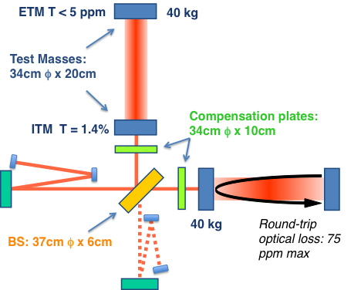

FIGURE 1. The LIGO detectors are specialized Michelson interferometers. Each 4 km arm contains a Fabry-Perot cavity formed by the Input Test Mass (ITM) and End Test Mass (ETM).
Requirements for the Advanced LIGO optics are calculated using a custom built code called “Stationary Interferometer Simulation” (SIS). [4] This is a numerical simulation package for an interferometric optical system, which is comprised of optical resonators and telescopes. The field in the interferometer is calculated using a fast Fourier transform. Realistic details of the optical components can be included in the simulation. These details include: size, measured or modeled mirror surface and lens transmission maps. Optical resonators are set close to the actual operating conditions, and the power loss caused by mirror surface aberrations and field distortions are calculated. The simulation results are used to quantitatively set the optics requirements.

TABLE 1. Main parameters of the Advanced LIGO interferometers.
Parameter | Value
Arm cavity length | 3994.5 m
Arm cavity finesse | 450
Laser type and wavelength | Nd:YAG, λ = 1064 nm
Input power, at PRM | up to 125 W
Beam polarization | linear, horizontal
Test mass material | Fused silica
Test mass size & mass | 34cm ϕ x 20cm, 40 kg
Beam radius (1/e²), ITM / ETM | 5.3 cm / 6.2 cm
Radius of curvature, ITM / ETM | 1934 m / 2245 m

Cavity Loss Budget – the test mass surface
The round trip cavity loss is required to be less than 75 ppm. The LIGO design uses known, repeatable, state of the art optical performance characteristics in combination with the SIS model to allocate losses and estimate the performance of the optics as designed.

Defects
The primary contribution to cavity loss is scatter due to point defects, scratches, sleeks and contamination. The requirements on these defects are partitioned among the various sources according to experience and are generally budgeted as geometric occlusion. The total budget for loss due to defects and contamination is 13 ppm per mirror.

Figure Error
The second largest contribution to cavity loss comes from the figure error of the test masses. This is budgeted at 24 ppm for the combined error in the Input Test Mass (ITM) and End Test Mass (ETM) mirrors. The corresponding requirement is that each test mass surface must have a root mean square figure error of less than 0.3 nm over the central diameter of 160 mm, after subtraction of power. The model for this budget assumes that the surface error is similar to the iLIGO optics in amplitude and spatial distribution.

Absorption
A corollary to the figure error requirement is the loss due to absorption in the test mass coatings. Though the loss is budgeted at 0.5 ppm per mirror the 750 kW of circulating power creates a heat load of up to 0.4 Watts in each test mass. The thermo elastic deformation of the mirror surfaces is symmetric in the cavity, an error which scales differently than the random figure error described above. However, this 0.4 Watts is absorbed into the bulk of the ITM, causing a significant thermal lens in the resonant cavities of the near Michelson arms of the interferometer. The LIGO design includes a thermal compensation subsystem to manage this dynamic lensing [5].

Microroughness
There is prompt loss in the arm cavities due to high spatial frequency roughness of the test masses. This is scatter that promptly exits the cavity, not hitting the opposite mirror even once. The spatial scale for this is greater than 1/mm. The requirement in this region is that the amplitude be less than 0.16 nm rms in the center 120 mm diameter of the optic. Using the classic phase grating analysis [6] gives us a budget of 7 ppm for the total cavity loss.

End Mirror Transmission
Coating transmission for the ETM is specified at less than 5 ppm. This is based on the best-known performance of Ion Beam Sputtered (IBS) coatings.

Substrates
Fused silica is the substrate used for all of the LIGO Core Optics. The material has low mechanical loss [7], which is critical in test mass optics. Fused silica is also available in grades with very low bulk absorption and scatter [8].

FABRICATION
The Advanced LIGO test masses are made from Suprasil 3001 and 312 for the ITM and ETM respectively. The test masses were polished by Coastline Optics in Camarillo, CA, and ASML Optics in Richmond, CA, under subcontract to L3 Communications Integrated Optical Systems-Tinsley. ASML is now known as Zygo Extreme Precision Optics. The polishing process, proposed by ASML was a two part process involving a super-polish followed by Ion Beam Figuring (IBF.) The test masses were coated using IBS by Laboratoire Des Materiaux Avances (LMA) in Lyon, France.

Substrates
Suprasil 3001 is used for the ITMs where low absorption and good homogeneity are critical. Suprasil 312 is used for the ETM where the transmitted beam is used for control and diagnostics. There are total of 20 Suprasil test masses, 12 at time are needed for instrument operation, the remaining 8 are in process spares.

Polishing
A summary of some of the key polishing characteristics are compared to the results reported by ASML, as shown in Table 2. Due to a need for symmetry, the LIGO radius of curvature requirements are broken into two components; ‘absolute accuracy’ and ‘precision.’ The absolute accuracy describes the error budget for assuring the absolute radius of curvature. This budget is fairly large, -5, +15 meters. This is 1% of the final radii shown in Table 1. The precision requirement pertains to the grouping of as-built optics, they must measure the same (within their class) to within ± 3 meters [9].

TABLE 2. As-built attributes of the polished aLIGO test masses reported by ASML, now Zygo Extreme Precision Optics, are well within the aLIGO requirements.

Test Mass Attribute | Spec. | Average of 20
Radius of Curvature precision | ± 3 m | ± 1.1 m
RMS (160 mm ϕ) λ_{s} > 1/mm | < 0.3 nm | 0.13 nm

ASML uses IBF in order to sculpt the back side of the ITM to compensate for inhomogeneity in the bulk material. This provides for a near perfect wave front as the beam enters the arm cavity through the bulk of the ITM. This same process is used on the compensation plates, which are suspended next to the ITMs. The combined optical path length of the compensation plate and ITM is 435 mm, so this correction of the bulk homogeneity is critical.

Coating
Test masses are coated by Ion beam sputtering. The masses are coated two at a time in order to achieve the best possible match in transmission for the two arm cavities. This symmetry is critical in order to minimize contrast defect at the dark port of the interferometer. A double planetary system is used by LMA in order to achieve required uniformity for two masses coated at once [10]. During the development of the planetary system LIGO provided large area surface figure metrology. The phase map of the uncoated surface is subtracted from the phase map of the coated surface, providing a high-resolution map of coating uniformity. An example of the earliest ETM uniformity attempts in the planetary coater is shown in Figure 2.

FIGURE 2. Phase map showing characterization of coating uniformity in the early stages of the large planetary coater at LMA. Peak to Valley is 4.2 nm and rms is 0.7 nm. This plot shows only the center 160 mm of the mirror.

The coating uniformity was subsequently improved to suppress the spiral pattern. The final optics show no sign of this pattern, though a small spherical aberration remains. The power spectral density (PSD) of the uncoated and final coated surfaces are compared in Figure 3. These data are from different instruments.

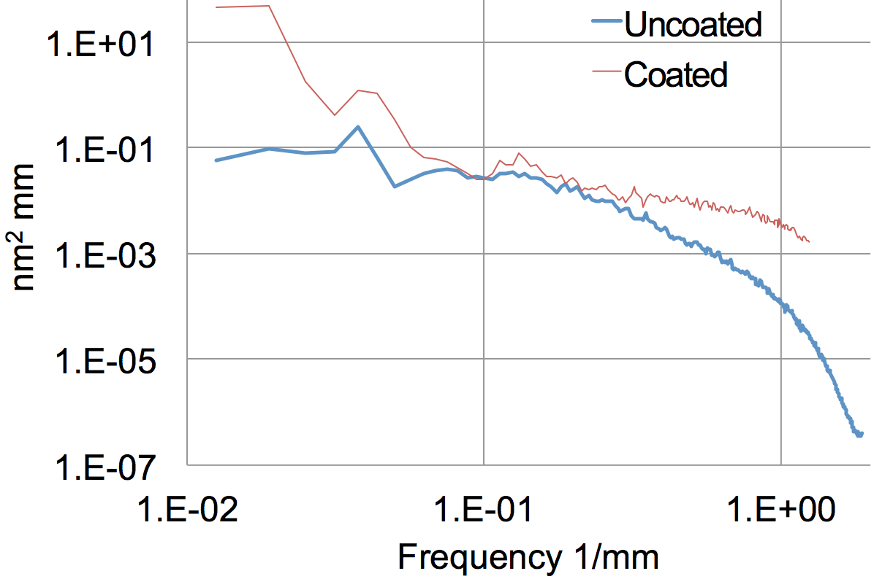

FIGURE 3. The final coating uniformity achieved is demonstrated in a 160 mm aperture PSD of the uncoated and coated ETM15. The uncoated data are provided by ASML. The coated data are from the Caltech measurement.
CHARACTERIZATION
The fabrication of low loss cavity mirrors relies on accurate measurement of the optics. The LIGO lab played the central role in monitoring the quality of optics under development, and confirming the quality of final deliverables. LIGO lab used a custom commercial Fizeau interferometer to measure surface figure throughout the polishing and coating process. A custom scanner was used to characterize absorption, scattering, reflection and transmission over the active aperture of the optics [11].

The goal of the characterization effort was not just to inspect for compliance with the specification requirements. Instead, the goal is to provide the best knowledge of the optical characteristics that could be provided within budgetary constraints. The final use of the characterization data is in the SIS code. This code can use realistic maps and thus predict and help diagnose interferometer performance.

Scatter
The total integrated scatter (TIS) from an HR coating is measured using an integrating sphere. The 1064 nm output of a JDSU NPRO laser is regulated by a half-wave plate and a Faraday isolator. Photo diodes are placed before and after the optical chopper to monitor the power of laser beam going into the integrating sphere. The polar angle collection range of the integrating sphere is defined by the sizes of the top and bottom ports. The current set-up has a collection range from 1.0° to 75°, corresponding to a bandwidth of spatial frequency 17 – 910 mm⁻¹. The collected scatter is measured with a photo diode coupled to the output port of the integrating sphere. Calibration is accomplished by installing a diffuse reflectance standard (Labsphere Spectralon) at the bottom port and normalizing the measured signal to the incident power.

Scatter is measured over two diameters; 50mm and 160 mm. These measurements are performed with a step size of 0.3 mm, and 1 mm respectively. Both scans use a 0.3 mm probe beam diameter. The results of both are quite similar, an example of the small step size scan is shown in Figure 4. The figure contains a histogram of the measured values. The average scatter of all test masses is 9.5 ppm.
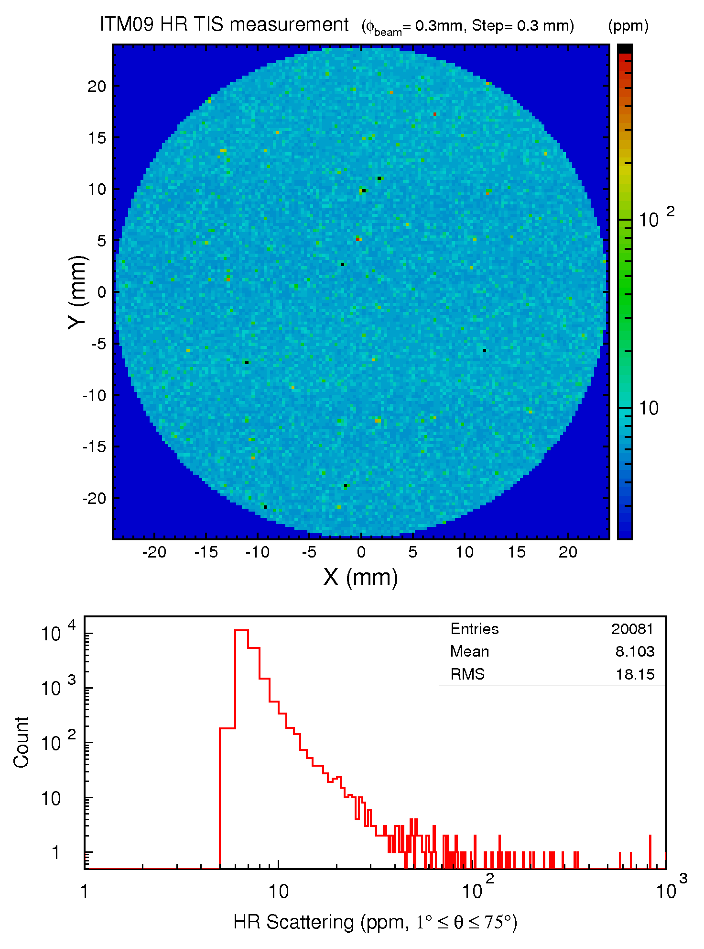

FIGURE 4. Scatter report for the center 50 mm of a LIGO ITM shows a mean scatter of 8 ppm.

Absorption
Absorption at the ppm level in the bulk substrate and coatings is measured using Common-Path Interferometry [12]. Qualitatively, a chopped high power Nd:YAG beam is focused on the sample and the optical path difference (OPD) is probed by a low power CW He-Ne beam with a beam size of a few times larger than that of the chopped Nd:YAG beam. The OPD changes due to the absorption caused by thermal refractive index change (dn/dt) and thermal expansion. At a distance of (~10 mm) from the interaction point, the perturbed center of the He-Ne beam interferes with the non-perturbed part of the beam and converts the absorption induced OPD into an intensity signal. This signal is read through a pinhole with a photodiode and a lock-in amplifier.

The absorption scans are performed on the coating outside 60 mm radius in order to avoid any risk of damage from the high power pump beam to the center of the optic. The pump laser operates at 0.5 MW/cm² during measurement of the lowest coating absorption. Four linear scans of 20 mm in length are carried out along ± X and ± Y outside central 60 mm radius. The calibration is done using a ring-down cavity HR mirror, where the absorption was measured during a ring-down test. The average absorption for all test mass coatings is 0.29 ppm.

Reflection And Transmission
Reflection and Transmission are measured on the same apparatus as scatter and absorption. The measured signals are normalized to the incident beam. In this case the measurement beam is 1 mm and the step size is 1 mm. A transmission scan of ETM10 is shown in Figure 5. The mean transmission in the center 160 mm diameter is 3.9 ppm, with an rms of 1.4 ppm. There are several spots of high transmission, none exceeding 200 ppm. The average transmission for all ETMs is 3.9 ppm.

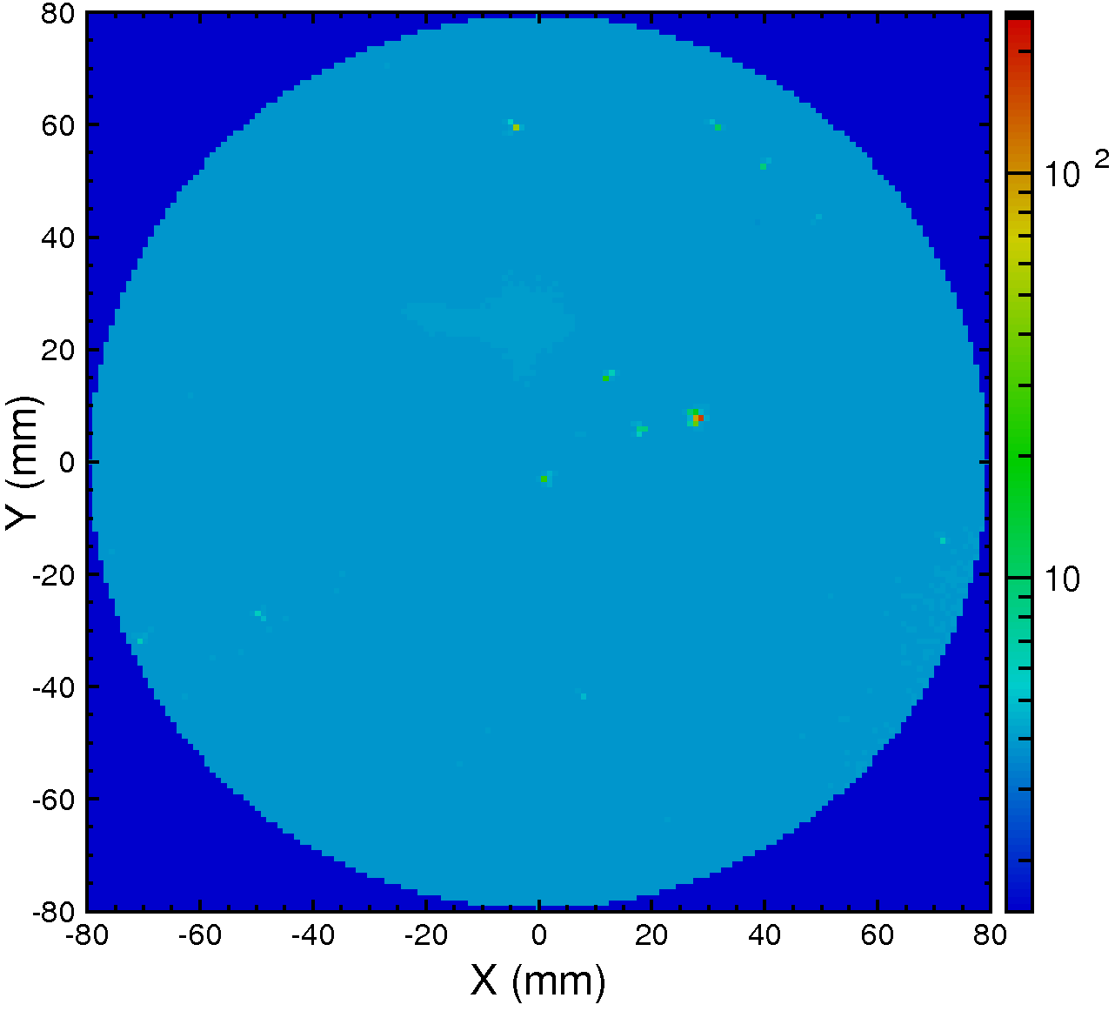
FIGURE 5. Transmission map of ETM10 showing a few spots of < 10 and one exceeding 100 ppm transmission. The color scale is in ppm.

Figure Measurement
Of particular importance in the measurement at the LIGO Lab is understanding surface figure error and PSDs derived from it. The estimation of the systematic error of the data is difficult and several techniques were used to get proper estimation of the error. The transfer function delivered with the Fizeau interferometer showed inefficiency around the 1 mm spatial scale region without magnification, this was also observed in the data of the polished surface. This inefficiency is analyzed by comparing data sets measured with and without magnification.

The Zygo interferometer commissioned by LIGO has four fixed magnifications. There are two collimators; in addition, a turret magnifier can be put into position in front of the camera to magnify each collimator image by a factor of 2. The lowest noise data come from the unmagnified collimators. Figure 6 compares PSD curves taken in the center 30 mm diameter of ETM11. Of particular interest is the difference in the 10X data, obtained by the same method, but using different cavity lengths. Close visual inspection of the datasets suggests that defects in the transmission sphere are in better focus in the shorter cavity (80mm) and are slightly defocused in the longer cavity.

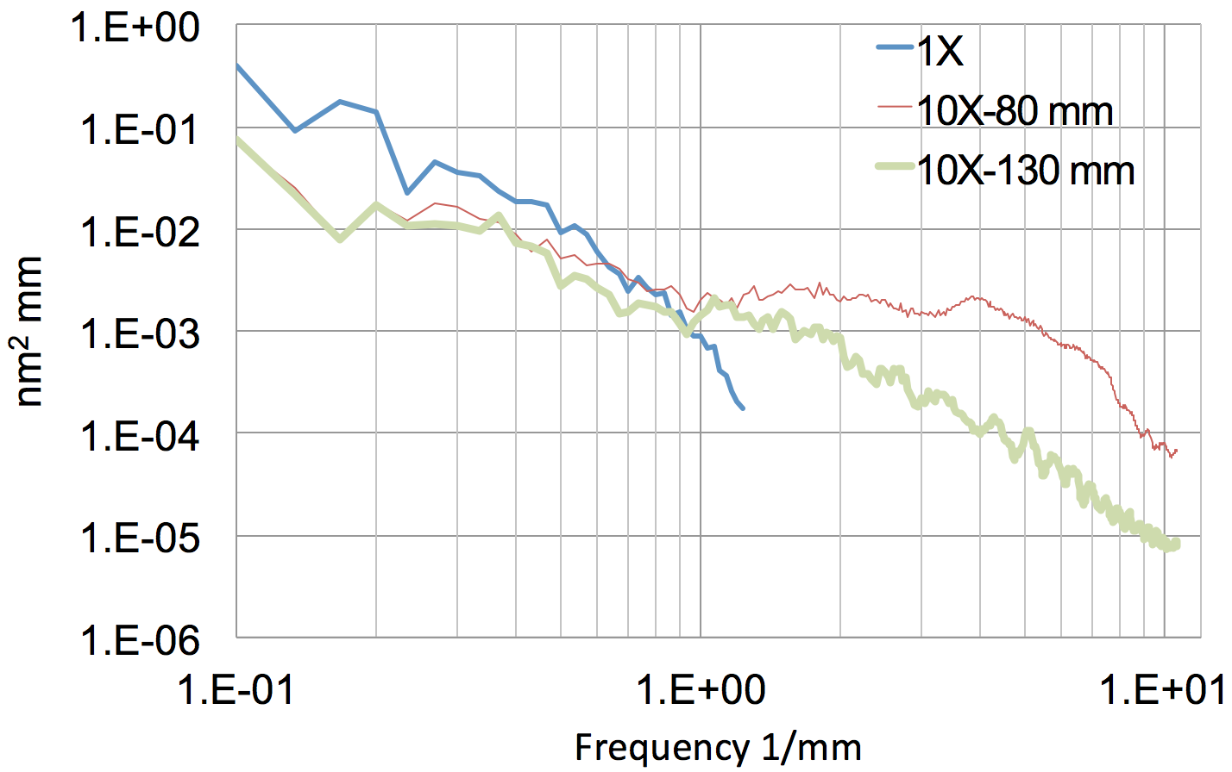
FIGURE 6. Data from the center 30 mm diameter of an ETM optic are compared using two different fixed magnifications and two different cavity lengths. Considerable noise is added when the reference sphere is too close to the test piece.

ACKNOWLEDGEMENTS
LIGO was constructed by the California Institute of Technology and Massachusetts Institute of Technology with funding from the National Science Foundation, and operates under cooperative agreement PHY-0757058. Advanced LIGO was built under award PHY-0823459. This paper carries LIGO Document Number LIGO-P1700029-v5.

REFERENCES
[1] Abbott BP, et al. Observation of Gravitational Waves from a Binary Black Hole Merger. Physical Review Letters. 2016;116,061102
[2] The LIGO Scientific Collaboration. Advanced LIGO. Classical and Quantum Gravity. 2015;32,7,074001
doi: 10.1088/0264-9381/32/7/074001
[3] Harry GM, Bodiya TP, DeSalvo R., editors. Optical Coatings and Thermal Noise in Precision Measurement. Cambridge University Press; 2012.
[4] Yamamoto H, Day RA. SIS15, FOG inside, manual. LIGO Document LIGO-T1300942-v2. https://dcc.ligo.org/LIGO-T1300942/public.
[5] Brooks AF, Hosken D, Munch J, Veitch PJ, Yan Z, Zhao C, Fan Y, Ju L, Blair D, Willems P, Slagmolen B, Degallaix J. Direct Measurement of Absorption-Induced Wavefront Distortion in High Optical Power Systems. Applied Optics. 2009;48,355-364.
[6] Winkler W, Schilling R, Danzmann K, Mizuno J, Rüdiger A, Strain KA. Light scattering described in the mode picture. Applied Optics. 1994;33,7547-7550.
[7] Penn SD, Ageev A, Busby D, Harry GM, Gretarsson AM, Numata K, Willems P. Frequency and surface dependence of the mechanical loss in fused silica. Physics Letters A. 2006;352,3-6.
[8] Chen X, Ju L, Flaminio R, Lück H, Zhao C, Blair DG. Rayleigh scattering in fused silica samples for gravitational wave detectors. Optics Communications. 2011;284,4732-4737.
[9] Flanigan M. ETM Polishing specification. LIGO Document LIGO-E080512-v2. https://dcc.ligo.org/LIGO-E080512/public
[10] Michel C, Morgado N, Pinard L, Sassolas B, Bonnand R, Degallaix J, Forest D, Flaminio R, Billingsley G. Realization of low-loss mirrors with sub-nanometer flatness for future gravitational wave detectors. Proc. Of SPIE, 2012;8550,1-7.
[11] Zhang L, Billingsley G, Phelps M. QA Test Procedure for aLIGO COC Reflection Transmission Scatter and Absorption. LIGO Document LIGO-E1000863-v1. https://dcc.ligo.org/LIGO-E1000863/public.
[12] Markosyan A, Route R, Armandula A, Fejer F. Absorption Loss Measurements on LIGO Optics. LIGO Document LIGO-G080315. https://dcc.ligo.org/LIGO-G080315/public

