LIGO HANFORD OBSERVATORY
PO BOX 159
RICHLAND WA 99352

TEL: 509.372.8106
FAX: 509.372.8137

MEMORANDUM

DATE: January 31, 2018

TO: | SQZ team
FROM: | Daniel Sigg, Marc Pirello
SUBJECT: | Modifications to the TTFSS V4
Refer to: | LIGO-E1700364-v2

This document lists the modifications to the 4th generation TTFSS, based on PCB D1700346-v1 and on schematics D1700077, D1700076 and D1700078.

Board modifications
Change 1:
U2 is missing the +15V rail. Add a jumper wire between the C5 pad towards U1 and the C46 pad towards U1 (Servo board, D1700077, bottom).

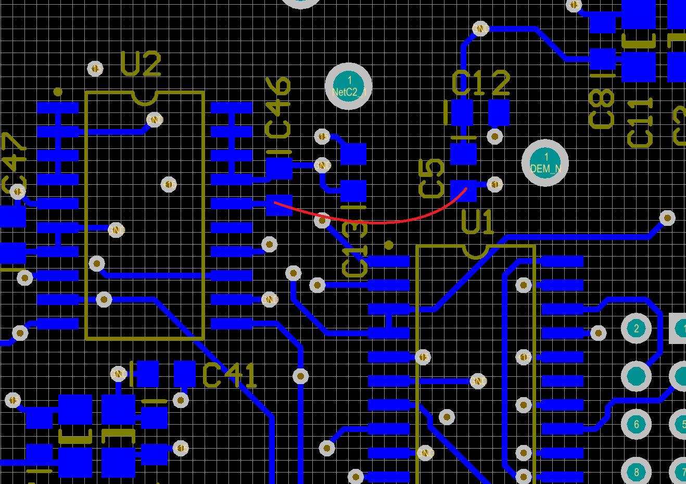

Change 2:
Input to U26 is floating when OPT4 is selected without an option board. Add a 10 kΩ resistor (R174) between pins 8 and 18 of header JP1 (Servo board, D1700077, bottom).

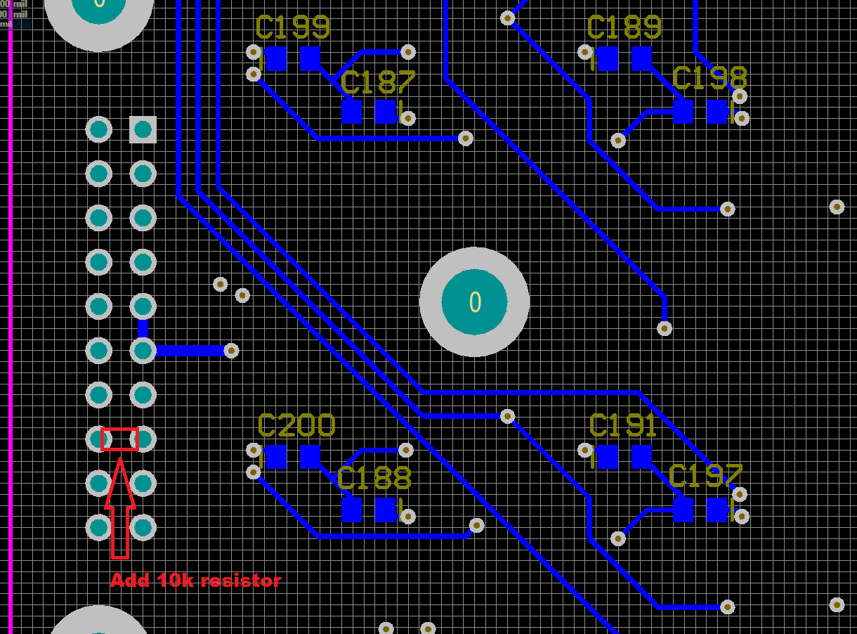

Part modifications:

Change 3:
A couple of AD829 operational amplifiers are missing a small capacitor in the feedback path to make them stable (Servo board, D1700077, top).

C66 → 4.7 pF
C52 → 27 pF
C53 → 27 pF
C101 → 10 pF
C153 → 4.7 pF

Change 4:
The output of the EOM high voltage stage needs a higher output impedance to limit the maximum current drive (HV board, D1700076, top).

R99 → 470 Ω (350V)
C63 → 100 pF (500V)

Change 5:
The common boost filter knee changed to 480 Hz (Servo board, D1700077, top).

R55 → 1 kΩ
R63 → 1 kΩ

Change 6:
The gain in the fast path that is used together with the EOM needs to be increased by 4 (Servo board, D1700077, top).

R65 → 499 Ω
R66 → 499 Ω

Change 7:
The gain in the EOM path is too low and needs to be increased by a factor 10. By increasing R112 we also need to adjust the compensation of OpAmp U33 to stay at a high bandwidth (Servo board, D1700077, top/bottom).

R112 → 10 kΩ
C152 → NL
C165 → NL

Change 8:
A lead compensation is needed in the EOM path to restore a decent phase margin (Servo board, D1700077, top).

R107 → 2 kΩ
C144 → 100 pF (1% or 2%)

Change 9:
Remove pointless EOM path diodes (Servo board, D1700077, top).

D1 → NL
D2 → NL

Change 10:
Add a fourth notch filter in the fast patch to address resonances below 100kHz (Servo board, D1700077, top).

U29 → AD829
R91 → 100 Ω
R95 → NL
R99 → 249 Ω
R103 → 0 Ω
C141 → 10 nF (NP0, 1% or 2%)

BOM (for 6 units, changes 1 through 4):
Qty | Item | Distributor | Description
10 | P10KDACT-ND | Digi-Key | Change 2; 10 kΩ
20 | 478-1300-1-ND | Digi-Key | C66,153; 4.7 pF
10 | 311-1099-1-ND | Digi-Key | C101; 10pF
20 | 311-1104-1-ND | Digi-Key | C52,53; 27pF
10 | 1135-1606-ND | Digi-Key | R99; 470 Ω
10 | 80-C1206C101FBG | Mouser | C63; 100 pF

BOM (for 6 units, changes 5 through 11):
Qty | Item | Distributor | Description
10 | P10KDACT-ND | Digi-Key | R112; 10 kΩ
20 | P1.0KDACT-ND | Digi-Key | R55, R63; 1 kΩ
10 | P2.0KDACT-ND | Digi-Key | R107; 2 kΩ
20 | P499DACT-ND | Digi-Key | R65, R66; 499 Ω
10 | 311-3379-1-ND | Digi-Key | C144; 100pF
10 | P100DACT-ND | Digi-Key | R91; 100 Ω
10 | P249DACT-ND | Digi-Key | R99; 249 Ω
10 | A110380CT-ND | Digi-Key | R103; 0 Ω
10 | 490-8295-1-ND | Digi-Key | C141; 10 nF, 1%
7 | AD829ARZ-ND | Digi-Key | U29; OpAmp

