LIGO Laboratory / LIGO Scientific Collaboration

LIGO- E1800261-v1 LIGO 30 November 2017

Design Documentation for SOW, LHO Wind Fence
Stephen Appert, Hugh Radkins, Dennis Coyne

Distribution of this document:
Public

This is a working note of the LIGO Laboratory intended for public release.

California Institute of Technology  LIGO Project | Massachusetts Institute of Technology  LIGO Project
LIGO Hanford Observatory | LIGO Livingston Observatory
http://www.ligo.caltech.edu/

Contents
1 Introduction 4
2 Site Information 5
2.1 Site Overview and Map 5
2.2 Wind Fence Locations 7
2.3 Site Terrain and Topology 9
2.4 Site Soil Conditions 9
3 Local Wind Conditions 10
3.1 Temporal Distribution of “High” Winds > 10 m/s at End Y, End X, and Corner Station 10
3.2 Wind Rose at Tri Cities Airport, with Site overlays 11
3.3 Wind Speed Histogram 14
4 Local Environmental Conditions 17
4.1 Meteorological Information 17
4.2 Tumbleweed 17
5 Prototype Implementation 18
5.1 Prototype Wind Screen Material 23
5.2 Prototype Dimensions 23
5.3 Prototype Wind Speed Reduction 23
5.4 Modeling for Prototype Development 24

Figures
Figure 1: Civil, Drawing Index, Location & Vicinity Maps D960196-01 5
Figure 2: Civil, Northwest Arm, End-Station, Grading Plan D960216-01 6
Figure 3: Civil, Southwest Arm, End-Station, Grading Plan D960232-01 7
Figure 4: End X Wind Fence Location overlaid onto Google Maps aerial view 8
Figure 5: End Y Wind Fence Location overlaid onto Google Maps aerial view 8
Figure 6: Temporal Distribution of “High” Winds > 10 m/s at End Y, End X, and Corner Station 10
Figure 7: Wind Rose at Tri Cities Airport 11
Figure 8: Wind Rose at Tri Cities Airport, overlaid onto End X 12
Figure 9: Wind Rose at Tri Cities Airport, overlaid onto End Y 13
Figure 10: Wind Speed Histogram 14
Figure 11: Sketch of different Wind Fence coverage cases at End X 15
Figure 12: Sketch of different Wind Fence coverage cases at End Y 16
Figure 13: Prototype Wind Fence Location 18
Figure 14: Landscape View of Prototype Wind Fence (Initial Porous Material) 19
Figure 15: Setting a Post for Prototype Wind Fence 20
Figure 16: Close-up View of Prototype Wind Fence Lathing 21
Figure 17: Prototype Wind Fence (Improved 50% Porosity Material) 22
Figure 18: Example of Wind Monitoring Screen showing 50% Wind Speed Reduction 23
Figure 19: Loading on Building without/with Wind Fence 24
Figure 20: CFD Turbulence on Center Plane, without Wind Fence 25
Figure 21: CFD Turbulence on Center Plane, with Wind Fence 25
Figure 22: Comparison between CFD Model and Prototype Wind Fence (Time Series) 26
Figure 23: Comparison between CFD Model and Prototype Wind Fence, ASD (Frequency) 26

Introduction
This document is intended as a node for referencing and aggregating design information for the LHO Wind Fence SOW C1801957. The information contained herein will be released publicly to vendors as a reference document during the RFP process.

This is a document which expands upon the work done by LIGO to this point in the process. As indicated within the RFP and SOW associated with this procurement, LIGO is not looking to “reinvent the wheel” with any significant R&D effort. The details shared within this document are intended to inform vendors regarding LIGO design decisions. The requirements put forth within the procurement documentation stand as the requirements which govern this procurement.

[remainder of page left intentionally blank]

Site Information

Site Overview and Map
Site engineering drawings for the LIGO Laboratory site are publically available at:
- https://labcit.ligo.caltech.edu/LIGO_web/docs/asbuilts_lho.html
The following drawings have been utilized within visualizations presented in the RFP package:
Civil, Drawing Index, Location & Vicinity Maps
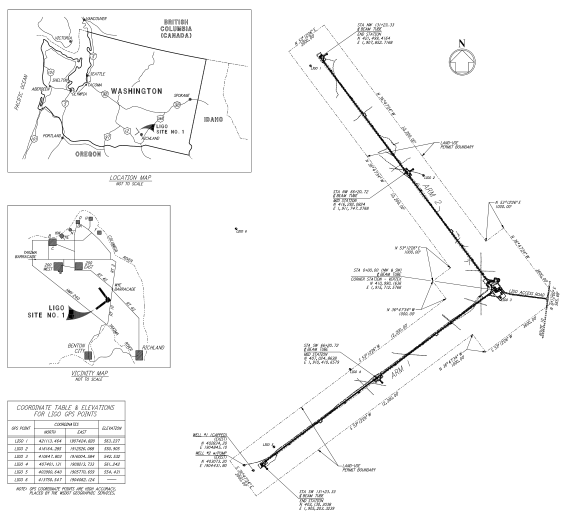
Figure 1: Civil, Drawing Index, Location & Vicinity Maps D960196-01
- Figure 1 Source: https://dcc.ligo.org/LIGO-D960196/public
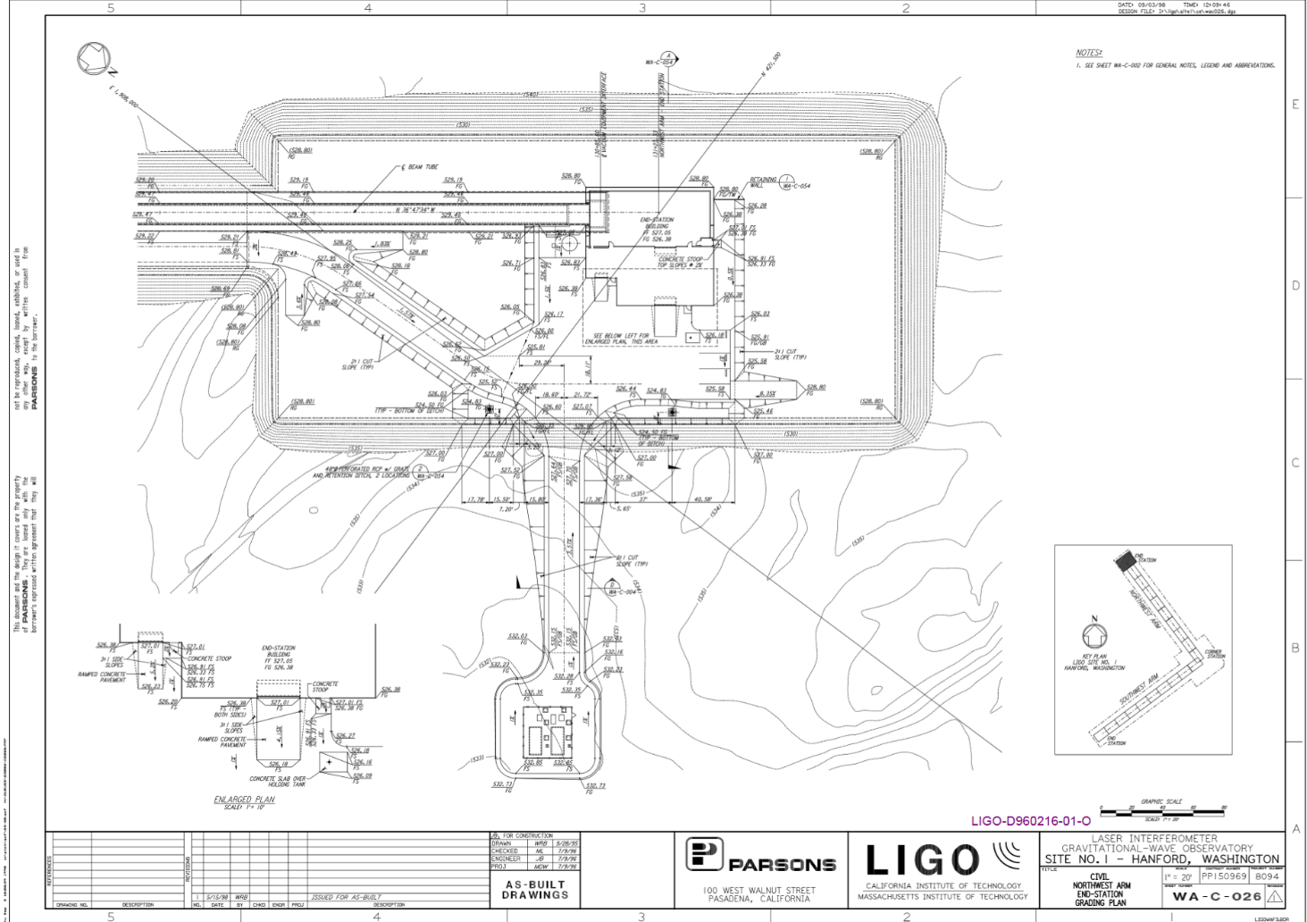
Figure 2: Civil, Northwest Arm, End-Station, Grading Plan D960216-01
- Figure 2 Source: https://dcc.ligo.org/LIGO-D960216/public
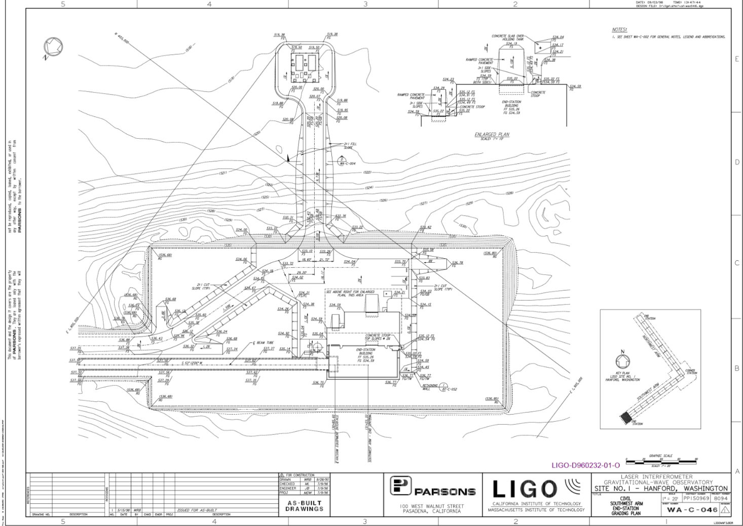
Figure 3: Civil, Southwest Arm, End-Station, Grading Plan D960232-01
- Figure 3 Source: https://dcc.ligo.org/LIGO-D960232/public

Wind Fence Locations
The below Figure 4 and Figure 5 indicate the prescribed zones for the respective base scope and optional scope wind fences at End X and End Y, respectively.
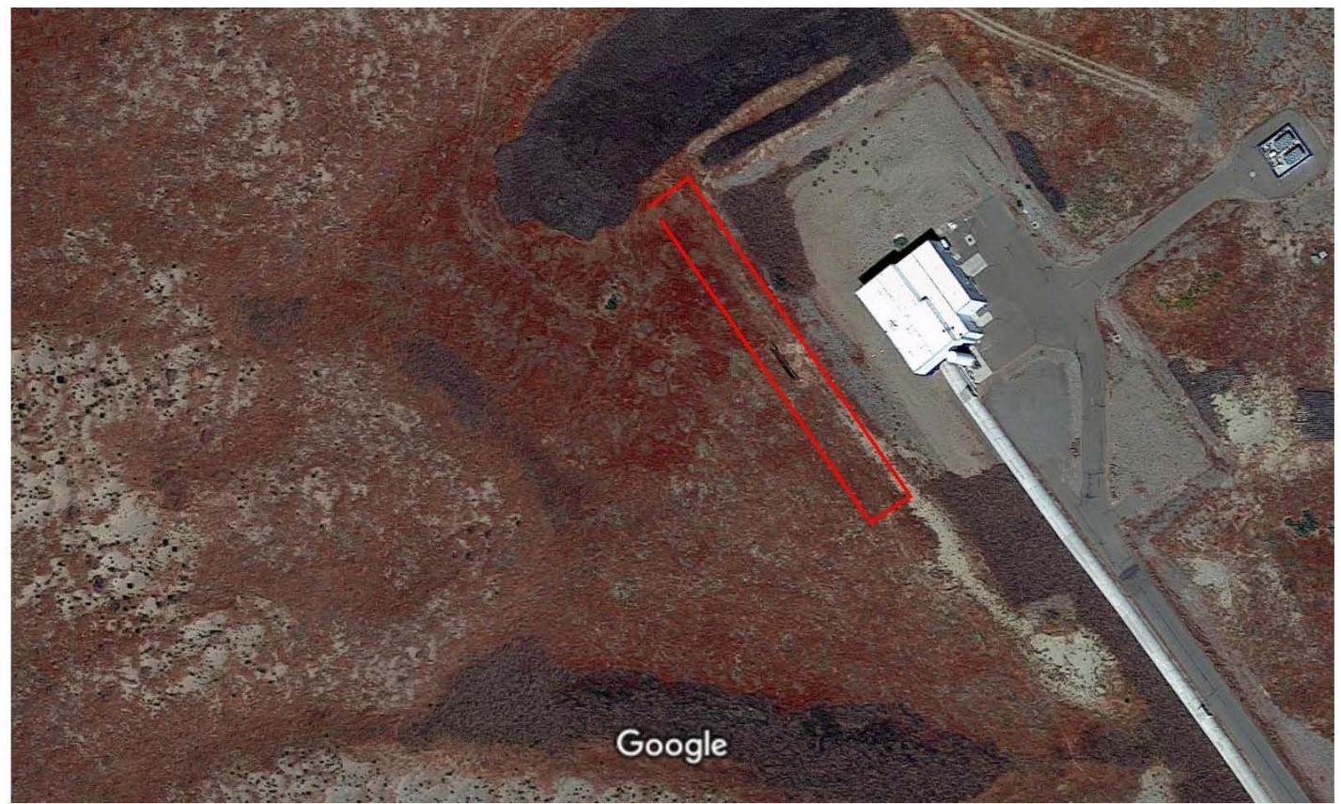
Figure 4: End X Wind Fence Location overlaid onto Google Maps aerial view
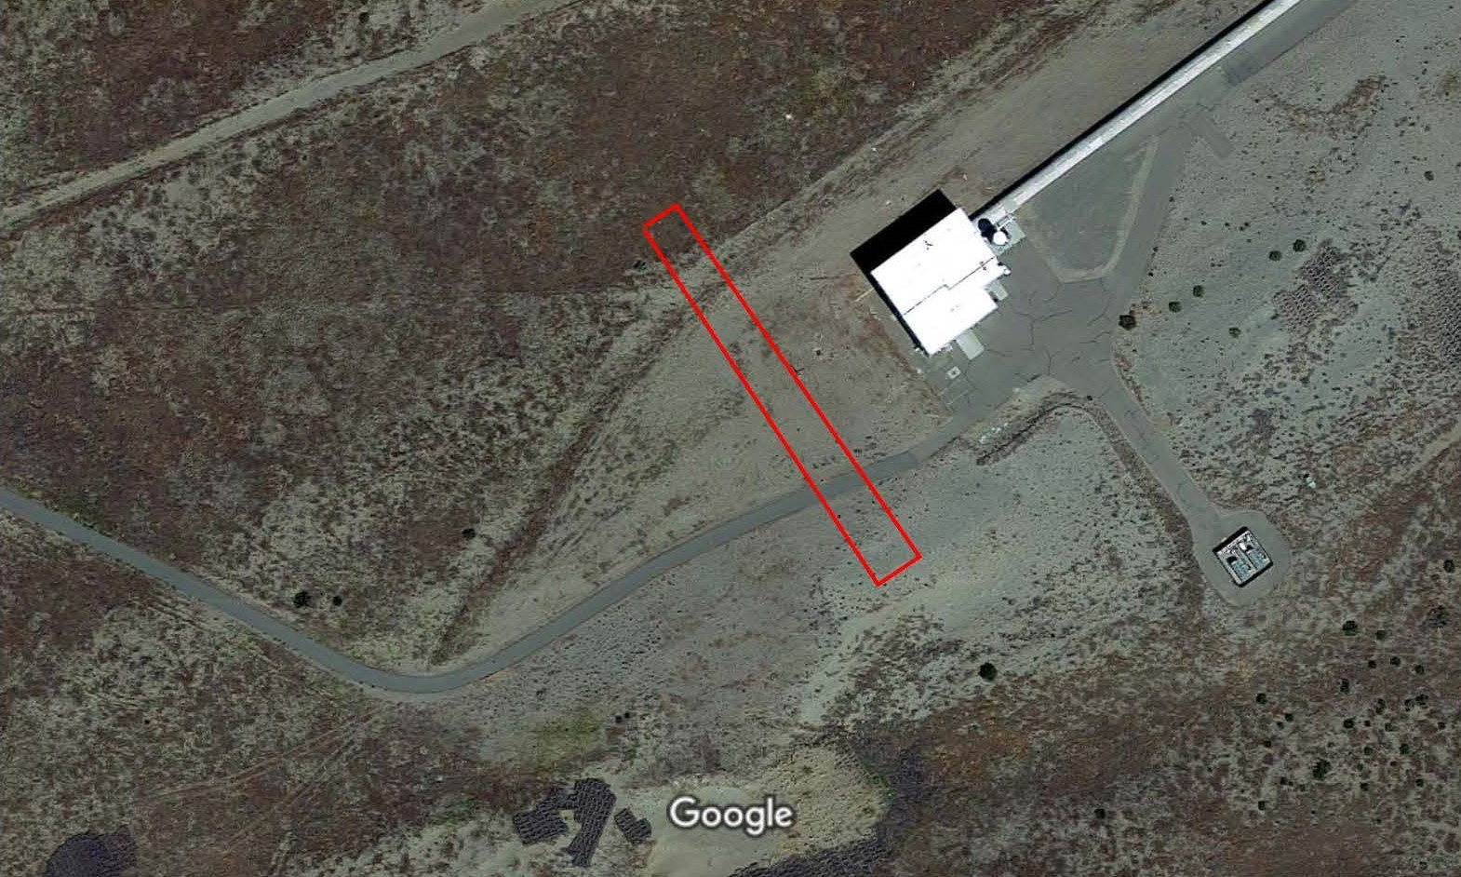
Figure 5: End Y Wind Fence Location overlaid onto Google Maps aerial view
Figure 4 and Figure 5 source: Q&A - LHO Wind Fence Design and Construction

Site Terrain and Topology
The geotechnical report conducted at the site of LIGO Hanford Observatory, prior to construction, is presented in internal document LIGO-C930032, which has been released along with the initial Q&A.
- https://dcc.ligo.org/LIGO-C930032/public
  - Section 4.1 GEOLOGIC SETTING
  - Plates 2 through 6, Site Plan and Cross Sections
  - Other sections may have relevance
As part of this report, the overall site topology is characterized. Topology of the area under the planned locations of the two, 4 km arms was mapped.
The final planned grading is available within the as-built drawing package for the LIGO Laboratory site which are publically available at:
- https://labcit.ligo.caltech.edu/LIGO_web/docs/asbuilts_lho.html
Of particular relevance to the wind fence build is the earthwork that has taken place to bring the site from the initial state to the as built state. In particular, the following two topological complications exist:
End X wind fence is to be built upon a berm of about 12 feet above the End X station terrain. The authors do not know the full extent of the earthwork that was undertaken to create this berm.
End Y wind fence is likely to run along a plateau at the same height as the End Y station terrain, but the span of the End Y wind fence may necessitate that the span extend off of this plateau, at a level of about 6 feet below. The authors do not know the full extent of the earthwork that was undertaken to create this plateau.

Site Soil Conditions
The geotechnical report conducted at the site of LIGO Hanford Observatory, prior to construction, is presented in internal document LIGO-C930032, which has been released along with the initial Q&A.
- https://dcc.ligo.org/LIGO-C930032/public
  - Section 4.2 SITE SPECIFIC SUBSURFACE CONDITIONS
  - Section 4.3 FIELD TESTING
  - Plate 7, Seismic Design Data Typical Soil Profile
  - Appendix A, Field Investigations
  - Other sections may have relevance
The earthwork mentioned in Section 2.3 is of relevance to the actual soil conditions at the sites for the constructed wind fence(s). No geotechnical survey known to the authors have captured the site soil conditions following construction.

Local Wind Conditions

Temporal Distribution of “High” Winds > 10 m/s at End Y, End X, and Corner Station
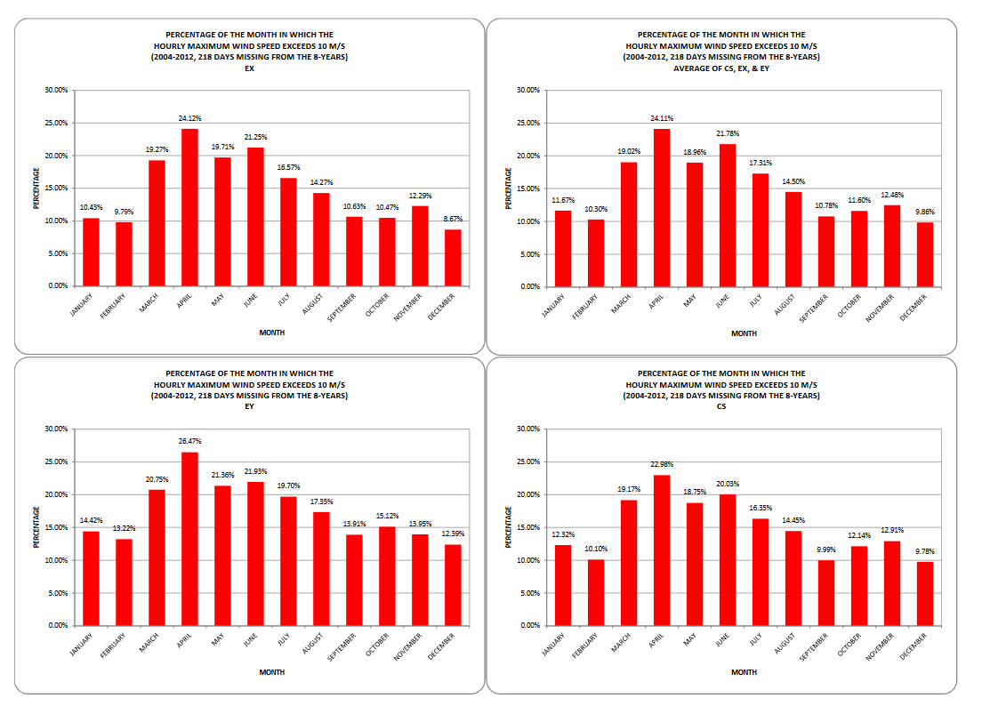
Figure 6: Temporal Distribution of “High” Winds > 10 m/s at End Y, End X, and Corner Station
Figure 6 Source: LHO aLOG 12996

Wind Rose at Tri Cities Airport, with Site overlays
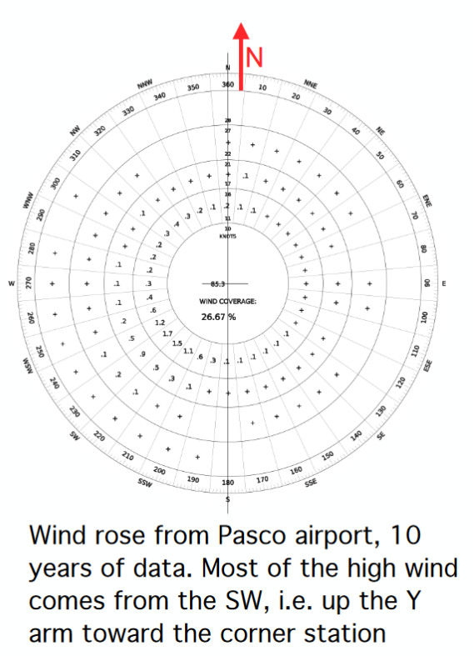
Figure 7: Wind Rose at Tri Cities Airport
Figure 7 Source: G1800148 slide 4
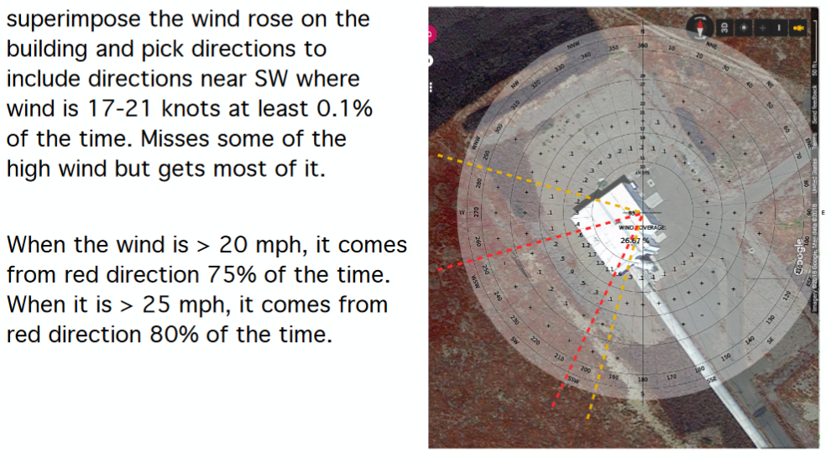
Figure 8: Wind Rose at Tri Cities Airport, overlaid onto End X
Figure 8 Source: G1800148 slide 5

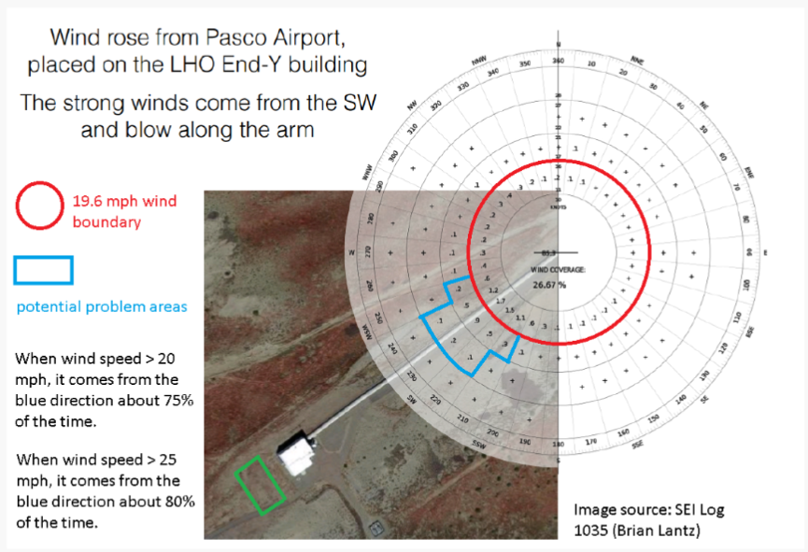
Figure 9: Wind Rose at Tri Cities Airport, overlaid onto End Y
Figure 9 Source: G1800148 slide 8

Wind Speed Histogram
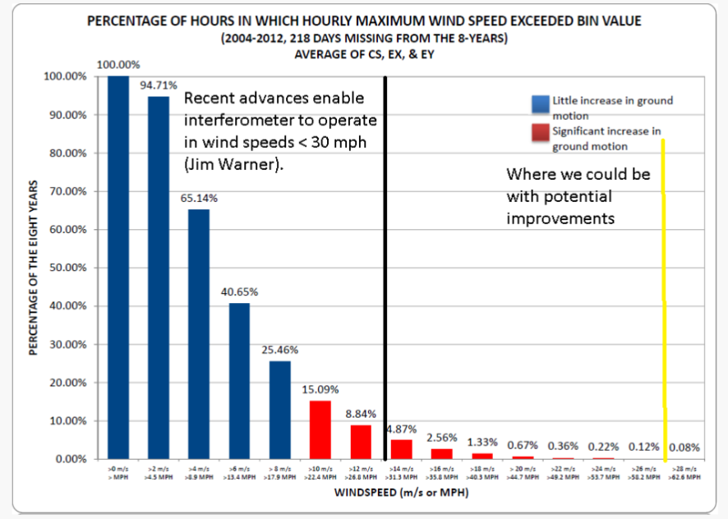
Figure 10: Wind Speed Histogram
Figure 10 Original Source: G1501371-v3 slide 23 / LHO aLOG 12996
Figure 10 Source of Markup: G1800148 slide 9
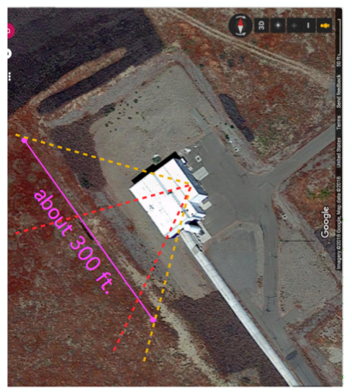
Figure 11: Sketch of different Wind Fence coverage cases at End X
Figure 11 Source: G1800148 slide 6
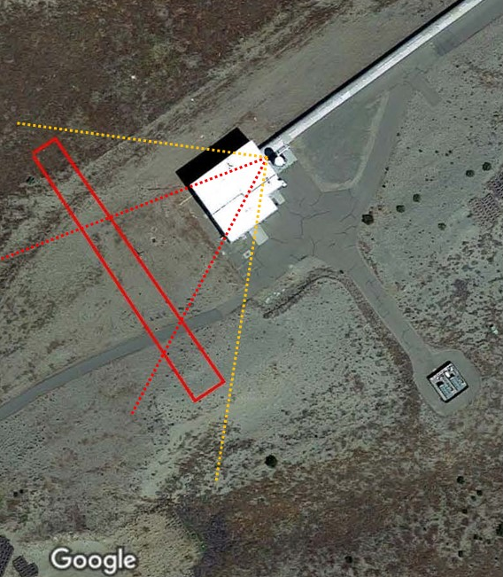
Figure 12: Sketch of different Wind Fence coverage cases at End Y
Figure 12 Source: Q&A - LHO Wind Fence Design and Construction

Local Environmental Conditions

Meteorological Information
Meteorological Data for the DOE Hanford Reservation is available at:
https://www.hanford.gov/page.cfm/HMS
The setting of the LIGO Hanford site is an arid desert with low annual rainfall, typically less than a couple of feet, and one to a few feet of annual snowfall.

Tumbleweed
Particularly during high wind weather conditions, tumbleweed travels across the surrounding terrain and accumulates along site facilities.
The bottom edge of the windscreen material of the Prototype Wind Fence was raised 4’ off the ground, which seemed to provide sufficient clearance to avoid tumbleweed accumulation.

Prototype Implementation
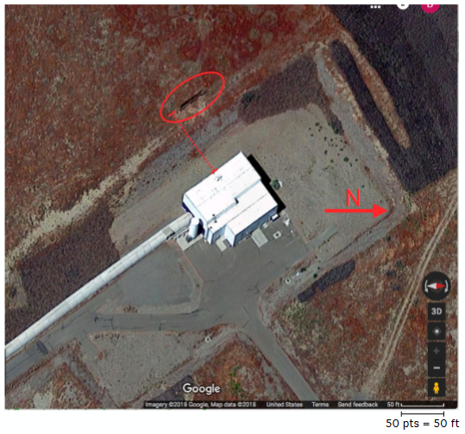
Figure 13: Prototype Wind Fence Location
Figure 13: Source: G1800148 slide 4
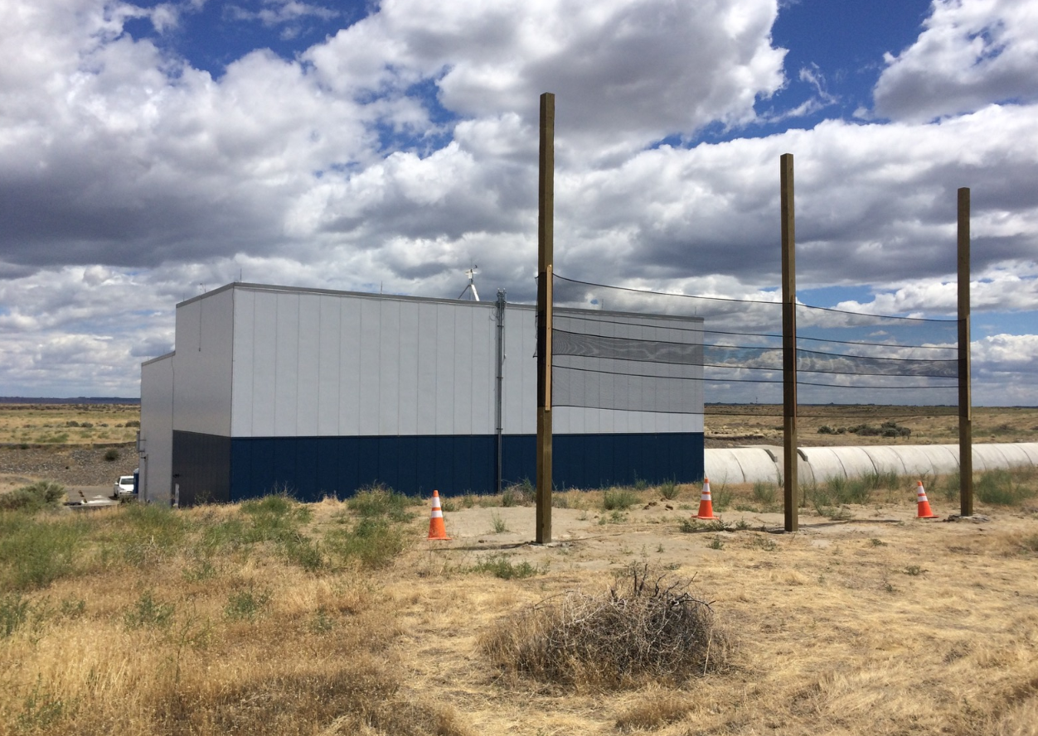
Figure 14: Landscape View of Prototype Wind Fence (Initial Porous Material)
Figure 14 Source: LHO aLOG 27949

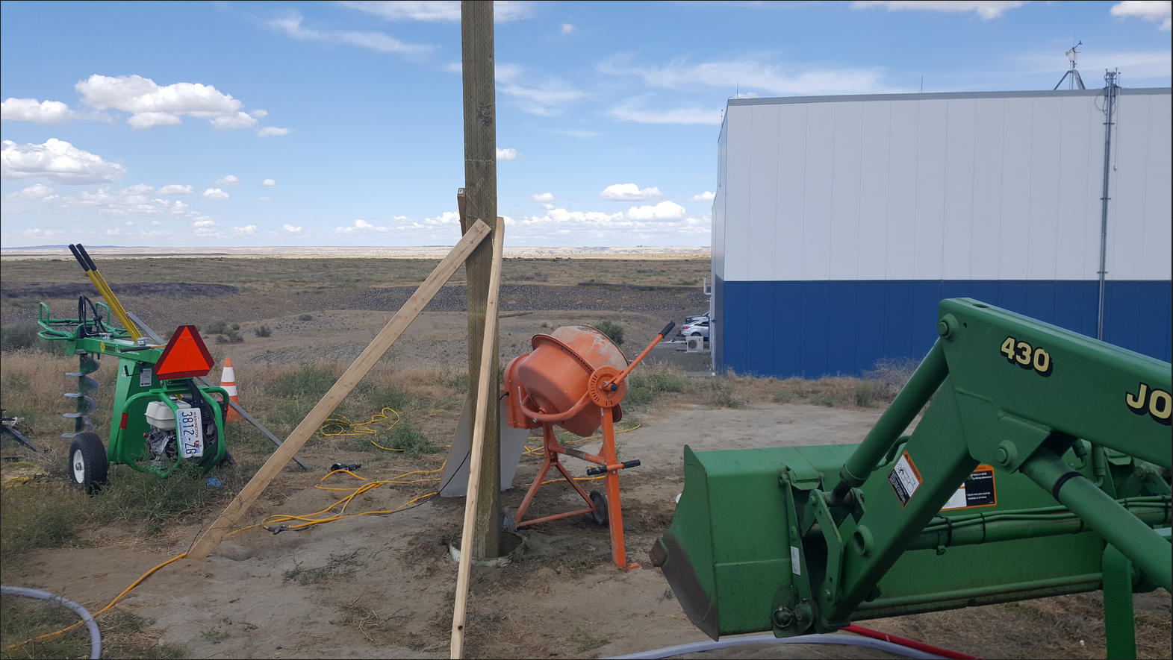
Figure 15: Setting a Post for Prototype Wind Fence
Figure 15 Source: LHO aLOG 27759
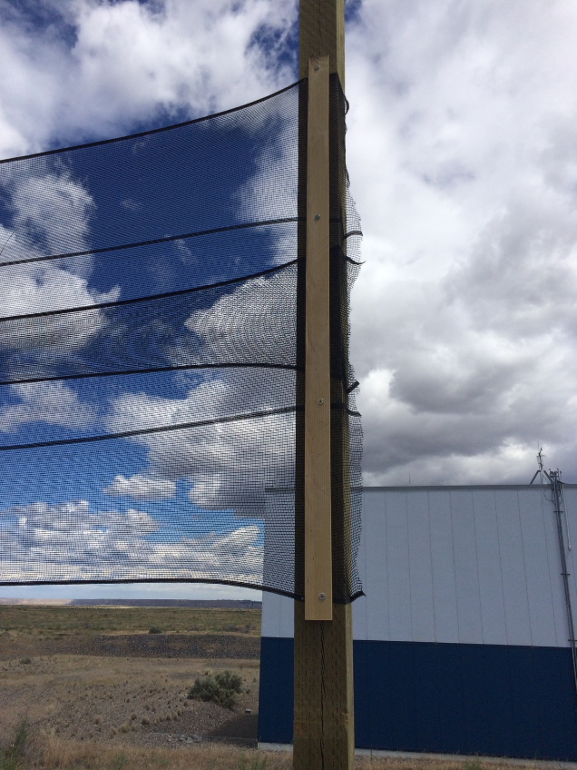
Figure 16: Close-up View of Prototype Wind Fence Lathing
Figure 16 Source: LHO aLOG 27949
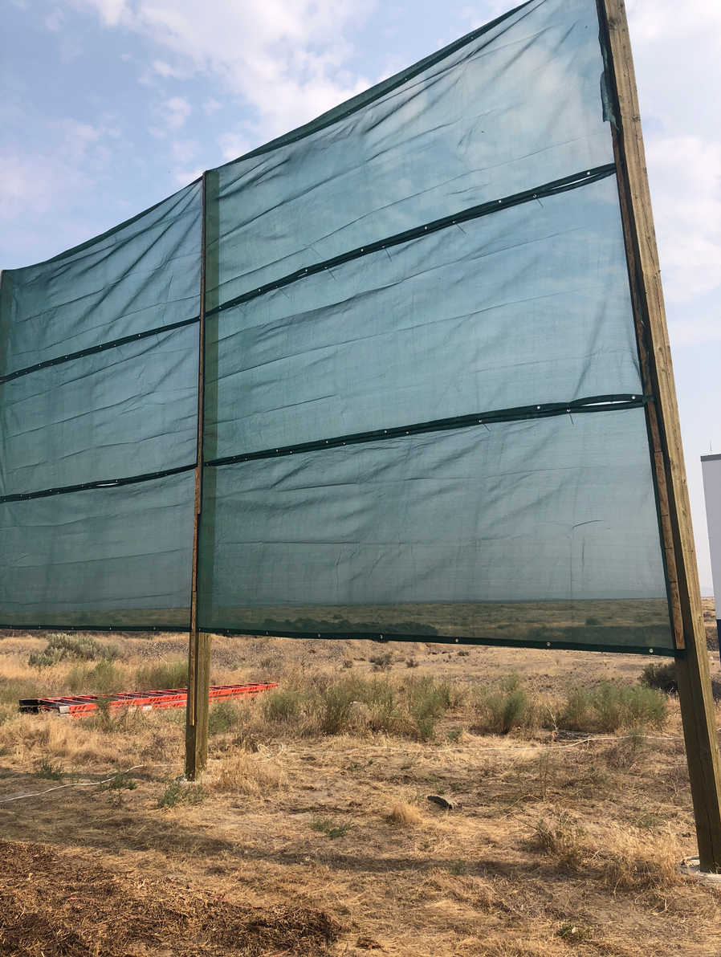
Figure 17: Prototype Wind Fence (Improved 50% Porosity Material)
Figure 17 Source: LHO aLOG 43358

Prototype Wind Screen Material
Tenax 5.6x150ft Green Wind Screen, Home Depot Internet #205358753 (not available as store stock SKU.) This material is available at other suppliers as well.
We utilized a grommeted run of wind screen for ease of use of this fabric, which required 3 segments run horizontally to provide the intended vertical coverage. Just a prototype all in all.
We have evaluated the breaking strength using a few different pull test variations and our analytical calculations suggest that it would survive in the high wind conditions we expect to ride through.
Sources: T1800386, T1800323
We understand that this material is frequently used with a backing material such as chicken wire, but we did not explore any such implementation in any context.
Initially, we used some less porous fabric with less satisfactory results.

Prototype Dimensions
30’ in length. Cladding extends from 4’ to 20’ above ground level. These dimensions were selected because of material availability and construction considerations – analyses clearly show the need for greater extents in all directions.

Prototype Wind Speed Reduction
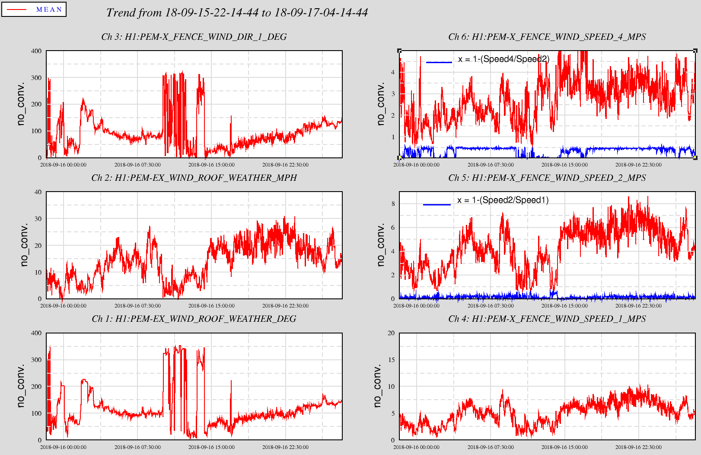
Figure 18: Example of Wind Monitoring Screen showing 50% Wind Speed Reduction
Figure 18 Source: documented in LHO aLOG 44021

Modeling for Prototype Development
In depth and successful modeling efforts were undertaken by collaborators at LIGO group at Stanford University.
The below results of Figure 19, Figure 20, and Figure 21 capture a small subset of the results, indicating Total Force and Total Moment loading reduction of 70%-80%, without compromised turbulence in front of building.
The model was compared with the performance of the prototype Wind Fence within Figure 22 and Figure 23.
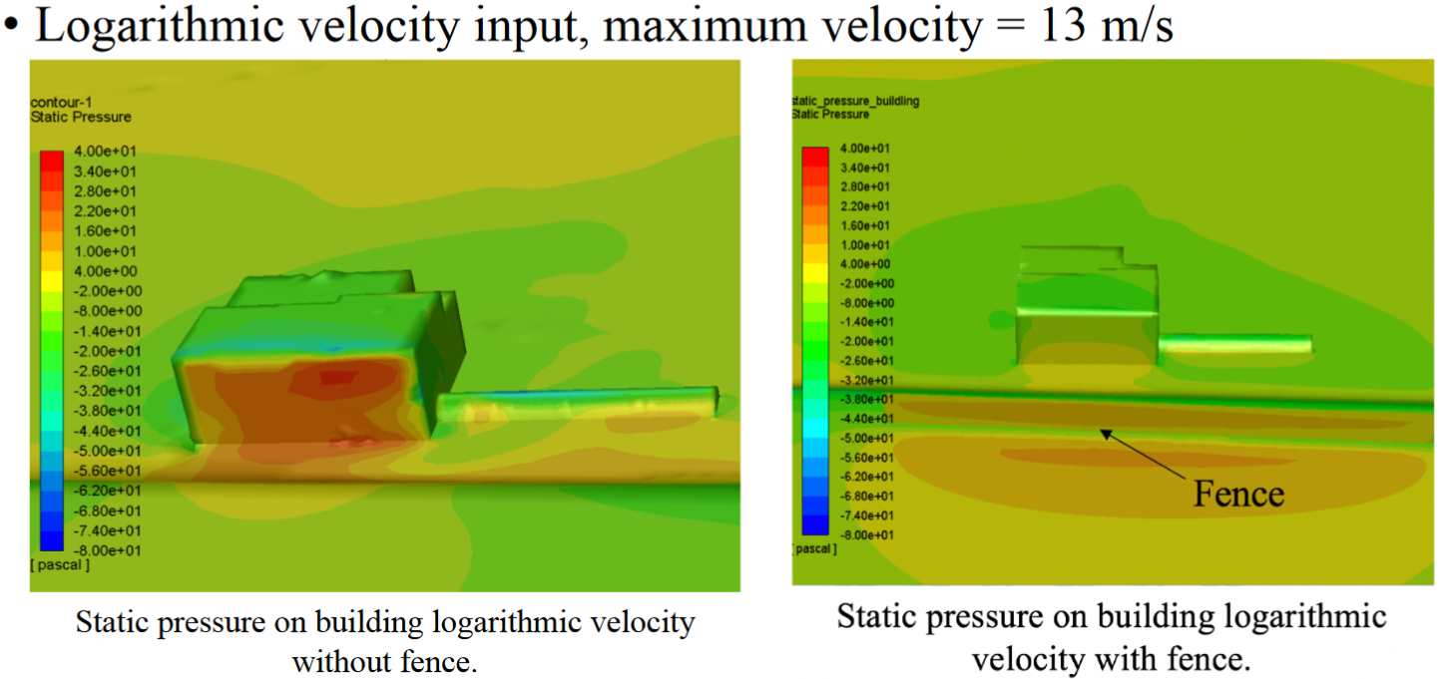
Figure 19: Loading on Building without/with Wind Fence
Figure 19 Source: G1801954

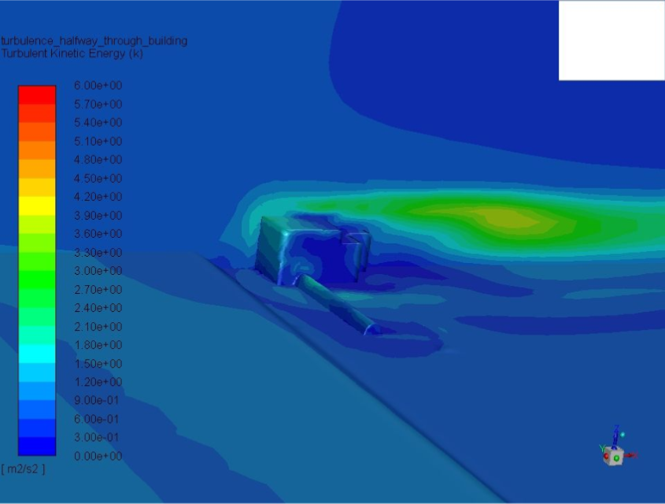
Figure 20: CFD Turbulence on Center Plane, without Wind Fence
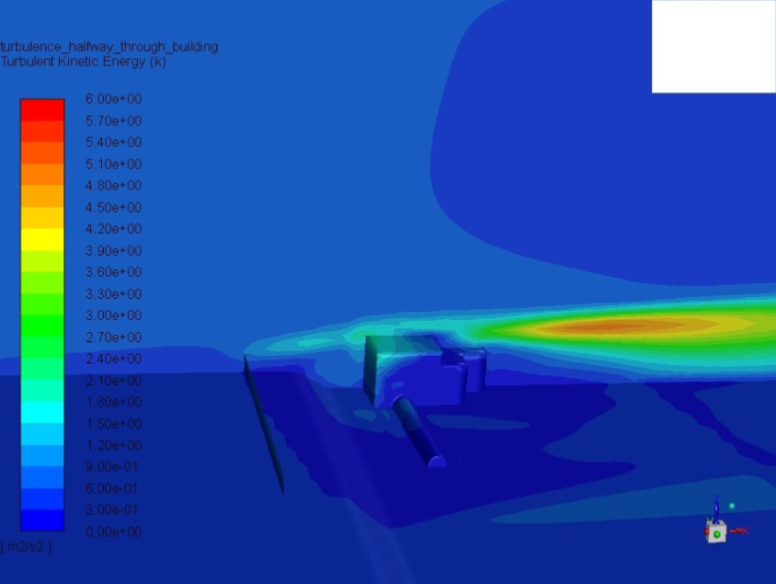
Figure 21: CFD Turbulence on Center Plane, with Wind Fence
Figure 20 and Figure 21 source: T1800360

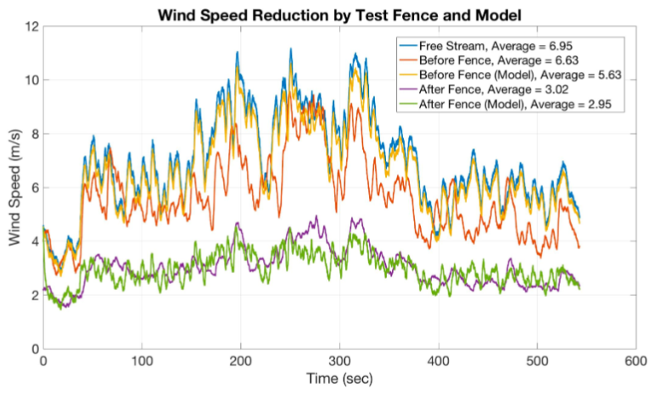
Figure 22: Comparison between CFD Model and Prototype Wind Fence (Time Series)
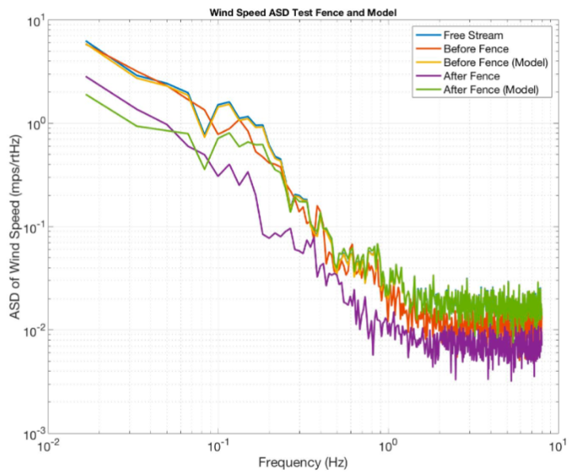
Figure 23: Comparison between CFD Model and Prototype Wind Fence, ASD (Frequency)
Figure 22 and Figure 23 source: G1801954

