LIGO Laboratory / LIGO Scientific Collaboration

LIGO-T1800485-v6 LIGO Date: 1/16/2019

U200 Mount Damping Study
Authors: Craig Worley, Stephen Appert, Norna Robertson, Calum Torrie, Marie Kasprzack, Arnaud Pele, Alexei Garcia, Alena Ananyeva

Distribution of this document:
LIGO Scientific Collaboration

This is an internal working note
of the LIGO Laboratory.

California Institute of Technology  LIGO Project | Massachusetts Institute of Technology  LIGO Project
LIGO Hanford Observatory | LIGO Livingston Observatory
http://www.ligo.caltech.edu/

Contents
2 Abstract 2
3 Experimental Modal Testing of U200 Mount 2
3.1 Experimental Setup 2
3.2 Damping Configurations 2
3.3 Calculating Quality Factor 5
3.4 Test 1: U200 Mount Undamped Frequency Response 6
3.5 Test 2: U200 Mount damped Frequency Response in Configuration 1 6
3.5.1 Comparison of Damped versus Undamped in Configuration 1 7
3.6 Test 3: U200 Mount Undamped Frequency Response 8
3.7 Test 4: U200 Mount damped Frequency Response in Configuration 2 9
3.8 Test 5: U200 Mount Undamped Frequency Response in Configuration 3 9
3.8.1 Comparisons of Undamped, Configuration 2 and Configuration 3 9
4 Mirror Alignment with Viton damping 11
5 Beam Point Drift 11
6 Differences between CIT Tests and LIGO nominal cases 11

Abstract
The purpose of this technical note is to document the frequency response of the U200 mount, and the different responses that is obtained when Viton dampers are installed in various configurations in the mount. Configurations include Viton O-Rings between the two sides of the mirror mount, pressing Viton against the springs of the mount, and pressing Viton against the springs of the mount while putting a Viton pad between the base and mirror mount. The addition of Viton against the springs of the mount reduced the amplitude of the resonance frequencies that were found in the undamped case and fully damped the resonance frequency that created by the springs of the mount at 681Hz. The configuration with both Viton on the springs and a Viton pad between the base and the mirror mount damped all of the resonance frequencies by at least a factor of 10. A concern with the Viton pad is the possibility of long-term beam pointing drift. An experiment over 21 days revealed that the max drift in pitch was .02 degrees.

Experimental Modal Testing of U200 Mount
In order to resolve the IIET Tickets 4639 and 11683, which document issues based on primary aLOG entries LHO 42551 and LLO 30536, SYS is conducting testing of standard Newport U200 mounts. These mounts are primarily used by LIGO in PSL tabletop applications, but they are stylistically similar to a variety of commercial, off-the-shelf mounts used by LIGO in a variety of subsystems, both in and out of vacuum.
In a frequency range of 0-1kHz, a variety of sources of coupling between mechanical vibration and laser noise, or jitter coupling, have been studied through injections on the PSL table at both sites. The issues mentioned in the above IIET tickets create a sense of urgency for improving the frequency response of these mounts in situ by equipping a tool belt of possible improvements.

Experimental Setup
In the CIT Modal Lab, the U200 mount was attached to a typical “University of Florida” style mounting post D1100563. A mirror was mounted using the standard stainless steel set screw which was supplied with the mount. Retroreflective tape was attached to the center of the test mass to increase the signal level witnessed by the transducer, a laser vibrometer. The vibrometer was focused on this retroreflective tape and was used to measure the velocity of the mirror when the structure was excited via hammer strike. The excitation was only supplied in the +x direction on the Z-Y face of the bottom mount, noted in Figure 4. This experiment utilized the Caltech B&K Modal Testing suite to collect data and display Frequency Response spectra in the frequency domain.

Damping Configurations
- Configuration 1: 110 Viton O-Rings are installed between the three contact-points, Figure 1, which act as dampeners within the system
Figure 1: illustrating Configuration 1
- Configuration 2: Placing Viton O-Rings within the mount so they are compressed against the springs

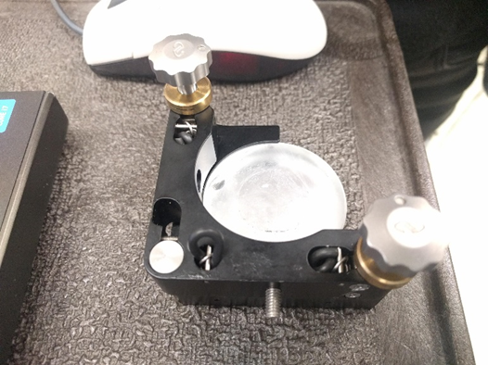
Figure 2: Viton O-Rings being pushed up against the springs in the mirror mount
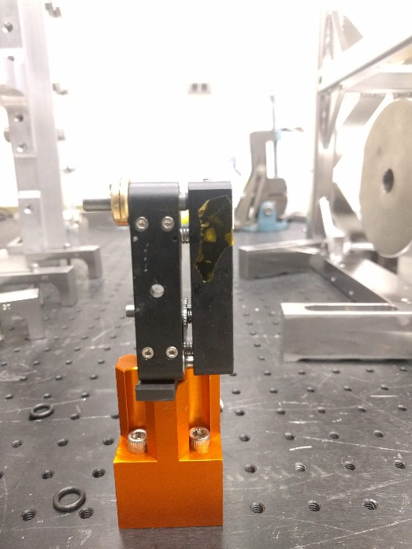
- Configuration 3: Same placement of Viton O-Rings as in Configuration 2, but with the addition of a Viton pad between the mirror mount and the base
Figure 3: Viton pad under mirror mount

Vibrometer focal spot
+y
+x
Hammer strike plane
Figure 4: The experimental test setup, showing the U200 mount, without O-Rings, and the placement of retroreflective tape with coordinate system overlaid. Hammer strike plane and vibrometer focal point are highlighted on the figure. In Test 1 and 2, the vibrometer axis is approximately 20° offset in pitch and 20° offset in yaw from the Hammer strike plane. After Test 2, the rest of the experiments were conducted at approximately 20° in pitch.
Figure 5: Experimental set up, highlighting the vibrometer axis used during testing

Calculating Quality Factor
To compare the different configurations, quality factor (Q) will be calculated for the different peaks returned. The quality factor (Q) of this peak is calculated using Equation 1:
$$Q= {F_{resonance}}/{{ΔF}_{3dB}}$$
Equation 1: Relationship between Quality Factor, Q, Resonance Frequency, F_{resonance}, and bandwidth at $\frac{1}{\sqrt{2}}$ of peak amplitude, or 3dB below peak, ΔF_{3dB}

Test 1: U200 Mount Undamped Frequency Response
The below Figure 6 shows the frequency response measured in the undamped configuration of the U200 Mount.
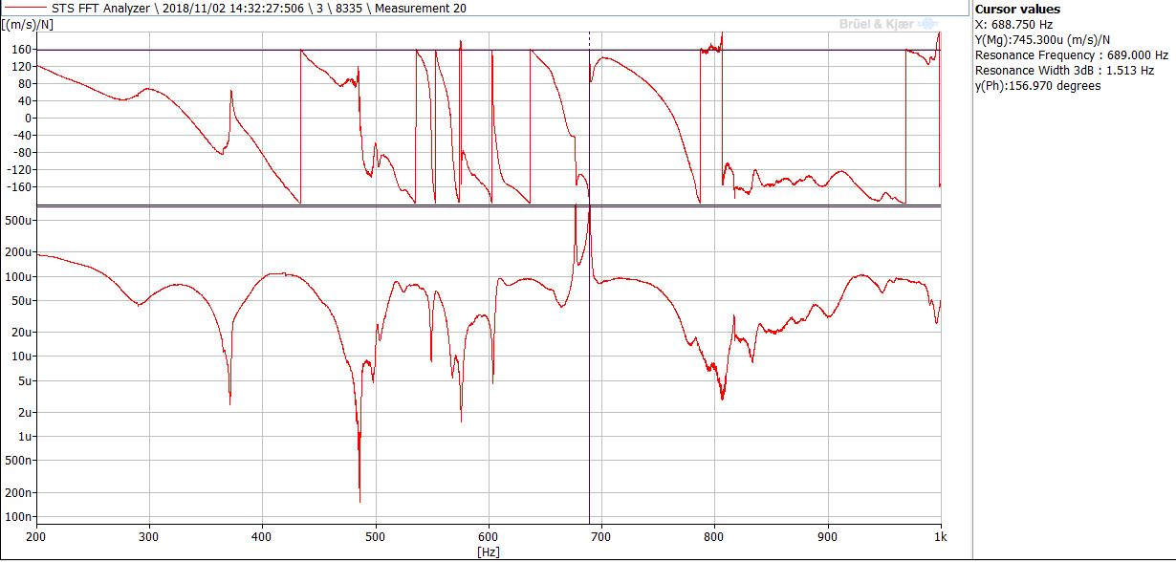
Figure 6: (above) Phase [units: Degrees] and (below) Velocity Frequency Response spectra [units: (m/s)/N] for a non-damped U200 clamp. Note the two peaks around 680 Hz.
This configuration featured no damping between the two halves of the U200 mount. The two prominent peaks around 680 Hz appear to reflect distinct primary modes of the U200 mount. The first peak of interest is at 676.6 Hz and has a Q = 1375. The second peak of interest is at 689.0 Hz and has a Q = 455.

Test 2: U200 Mount damped Frequency Response in Configuration 1
At the three contact points of the U200 mount, size 110 Viton O-Rings were placed between the two plates of the mount. As shown in Figure 6, there are no more high Q peaks resonances over the span of 200-1000 Hz. Using Equation 1, the quality factor for the broad peak of interest at 686.4 Hz is Q = 59.
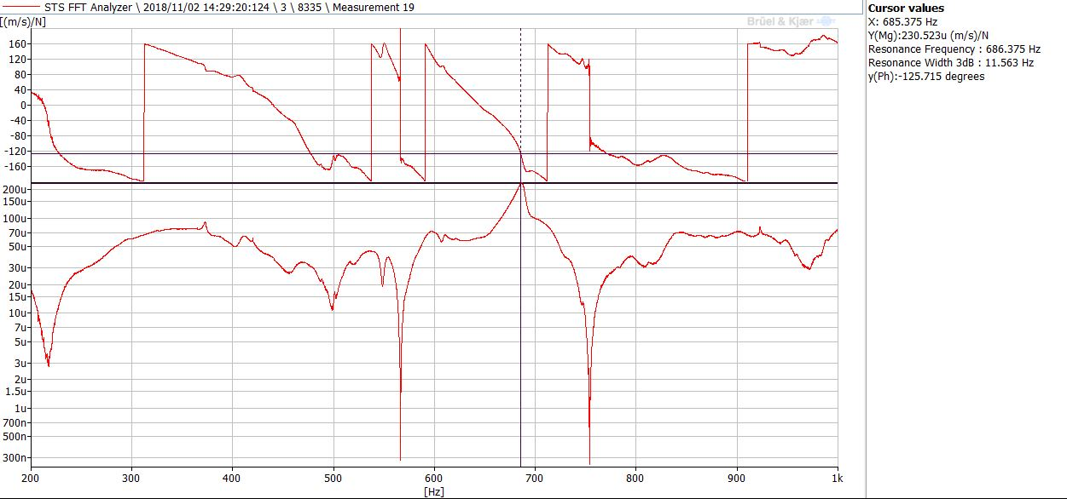
Figure 7: (above) Phase [units: Degrees] and (below) Velocity Frequency Response spectra [units: (m/s)/N] for a Viton O-Ring damped U200 Mount.

Comparison of Damped versus Undamped in Configuration 1
In the below, Figure 6 and Figure 7 are overlaid.
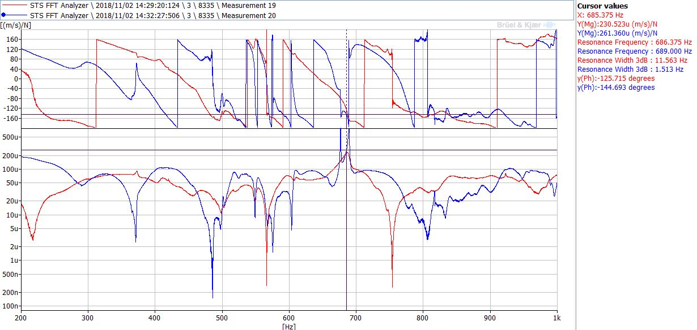
Figure 8: (above) Phase [units: Degrees] and (below) Velocity Frequency Response spectra [units: (m/s)/N], comparing Viton O-Ring damping against standard U200 configuration, both excited in the +X direction
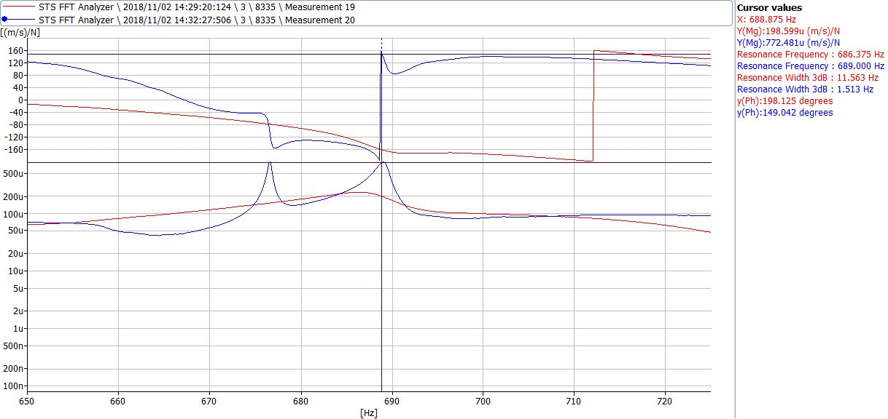
Figure 9: (above) Phase [units: Degrees] and (below) Velocity Frequency Response spectra [units: (m/s)/N], comparing Viton O-Ring damping against standard U200 configuration, both excited in the +X direction, zoomed in on the range 650 Hz-725 Hz
The overlaid comparison of damped in Configuration 1 versus undamped is reported quantitatively in Table 1.
Table 1: Modal Testing Results comparing Damped and Undamped in Configuration 1
Configuration 1 | Frequency (Hz) | 3dB Width (Hz) | Quality Factor
Viton O-Ring Damping | 686.4 | 11.6 | 59
No Damping – Peak 1 | 676.6 | .5 | 1375
No Damping – Peak 2 | 689.0 | 1.5 | 455
By comparing the three resonances measured within the two configurations, the effect of the insertion of Viton O-Rings is observed.

Test 3: U200 Mount Undamped Frequency Response
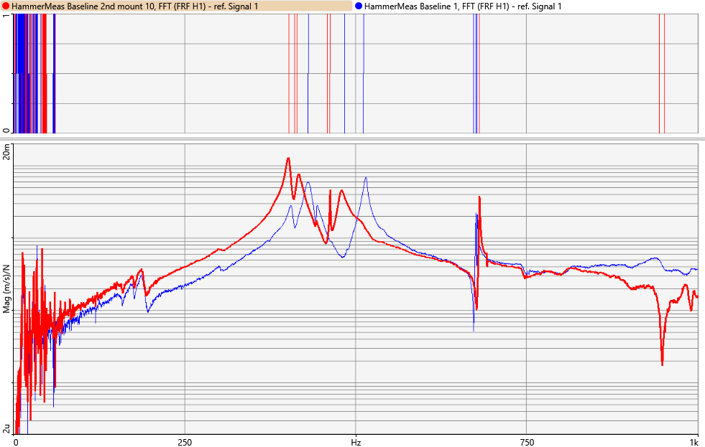
The resonance frequencies of two mirror mounts were compare in this test. The same mirror and base were used, but the black mirror mount was changed, and this resulted in slight differences of the resonance frequencies. The mount that is depicted in red was selected for the rest of the tests and has resonant mode frequencies at: 401.2 Hz, 415.6Hz, 463Hz, 479.4Hz and 681.4Hz. The motivation for conducting this test was to check whether the roughly treated article of U200 mount, used in a wide range of CIT testing, performed similarly to a pristine article. It turned out that there were differences in mount resonances, so the choice was made to utilize the pristine article of U200 mount in Test 4 and Test 5.
Figure 10: (below) Velocity Frequency Response spectra [units: (m/s)/N] comparing two different mirror mounts. The pristine mount was used for the rest of testing, and acts as Baseline 1 due to its nominal set up

Test 4: U200 Mount damped Frequency Response in Configuration 2
By damping the mirror mount via Configuration 2, and comparing the resonance frequency to Test 3, it was determined that the Viton removed the mode at 681.2Hz and 462.8Hz. Also, with this test, it was determined that the mode at 681.2Hz is from the springs located within the mirror mount that compresses the two halves. Referencing Figure 11 below, the graph highlighted in blue shows the comparison to the undamped mirror mount and how those modes are damped out.

Test 5: U200 Mount Undamped Frequency Response in Configuration 3
Along with the introduction of Viton damping at the springs, an additional Viton pad was added in between the contacting surfaces of the mirror mount and the base. There was a reduction of previous frequencies 401.6Hz, 417.2Hz, 479.4Hz, with a general reduction of amplitude by at least a factor of 10. With the addition of the Viton, a new modes appears at 440.4Hz, 625.6Hz and 758.6Hz, however the amplitude of this mode is less than the amplitude of the undamped configuration in Test 3. Referencing Figure 11 below, the green graph shows the effect of the additional Viton pad between the mirror mount and the base.

Comparisons of Undamped, Configuration 2 and Configuration 3
Comparing the three levels of damping, the effect of the Viton damping can be seen in the variation of peak amplitude.

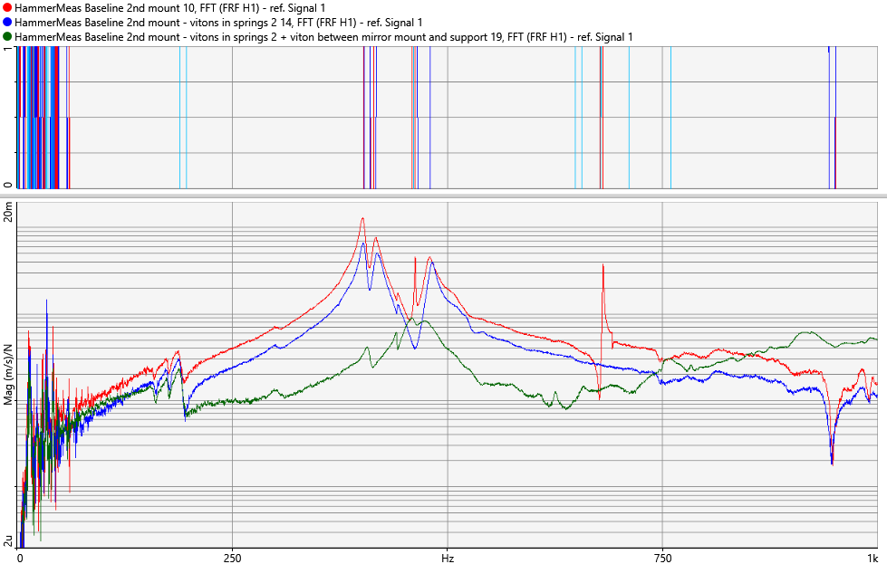
Figure 11: (below) Velocity Frequency Response spectra [units: (m/s)/N] comparing the undamped mirror mount, Configuration 2, and Configuration 3
Configuration-Peak # | Frequency (Hz) | 3dB Width (Hz) | Quality Factor
Undamped-Peak 1 | 401.6 | 6.1 | 65.8
Undamped-Peak 2 | 417.2 | 8.3 | 50.3
Undamped-Peak 3 | 462.8 | 1.0 | 462.8
Undamped-Peak 4 | 479.4 | 10.7 | 44.8
Undamped-Peak 5 | 681.2 | 0.9 | 756.9
Configuration 2-Peak 1 | 402.4 | 6.7 | 60.1
Configuration 2-Peak 2 | 418.4 | 9.4 | 44.5
Configuration 2-Peak 3 | 482.6 | 8.1 | 59.6
Configuration 3-Peak 1 | 407.0 | 12.6 | 32.3
Configuration 3-Peak 2 | 440.4 | 7.7 | 57.2
Configuration 3-Peak 3 | 625.6 | 10.4 | 60.2
Configuration 3-Peak 4 | 758.6 | 34.2 | 22.2

Evaluating Suitability for Mirror Alignment
While Configuration 2 and Configuration 3 have proven to permit full functionality of the U200 mount during these experiments, the same cannot be said of Configuration 1. In Configuration 1, because the Viton O-Rings were to be captured between the two plates of the mirror mount, the actuator thumb screws had to be reconfigured to compress the O-Rings. While it was possible to seat the actuator thumb screws and pinch the O-Rings, this required very precise adjustment. Furthermore, the tension springs joining the two plates of the mirror mount did not supply sufficient force to obtain the typical ~10% squeeze which has been successful in Viton O-Ring damping schemes (see SLiC baffles, for example). Lastly, this required actuator setting made it impossible to alter mirror alignment via the actuator thumb screws on the mount. Configuration 2 and Configuration 3 do not affect the ability to align the mirrors and are preferable.

Evaluating Mount Stability
With the addition of the Viton pad between the mirror mount and the base, concerns of beam point drift over time were raised due to the settling of the mirror on the Viton. To test the effect of beam point drift, a mirror assembly with the Viton pad was left for 21 days with data periodically recorded. The experiment included a beam path of 28.75 inches that concluded with a photodetector capable of differentiating pitch and yaw. Over the length of the experiment, the mean mV response was recorded, allowing for differences in the mirror position to be witnessed. Over the length of the experiment, bi-directional drifting was observed, illustrating that there was a dependency driving the drift. This could have been a result of temperature variations or the Viton settling between the base and the mirror mount. The max drift, which happened in pitch, was a total of .0003 radians (.02 degrees). The calculation and data for this auxiliary effort are captured in “Other Files” of T1800485.

Damping Recommendation
The recommendation of this effort associated with IIET Tickets 4639 and 11683 is to implement the damping approach captured in Configuration 3 on the IO_MB_M3 (90 degree yaw) mount assembly and IO_MB_M5 (90 degree pitch) mount assembly.
- Placing Viton O-Rings within the mount so they are compressed against the springs
- Addition of a Viton pad between the mirror mount and the base
Implementation of this effort would ideally involve the following steps:
- Redesign and fabrication of bases modified to maintain the position of the mirror faces in the degree(s) of freedom affected by the insertion of a Viton pad.
  - To accommodate the slightly squeezed ¼” nominal thickness of the Viton pad, this would involve sinking the mating plane of the relevant mount by the squeezed Viton pad thickness
    - In test, .255” Viton pad was squeezed by .017”. Recommended squeezed Viton pad thickness for redesign is .240” +/-.010.
- Installation would require removal of existing mount and reinstallation of the base and mount upon installation.

Future Work
Site personnel tasked with making jitter coupling measurements, and those tasked with resulting mitigation efforts, would benefit from a well-stocked tool belt to damp optic mount resonances. A highly effective damping technique has been recommended as a result of this effort, but the fact is that there is no one-size-fits-all technique for addressing the jitter coupling issues that rigorous study by site experts have identified as most urgent, much less those which have been identified as less urgent or those which have not yet been identified. In particular, the team intends to continue populating the optic mount damping tool belt by investigating damping techniques which may be affixed or installed without disassembling existing, aligned, mounts.

Differences between CIT Tests and LIGO nominal cases
- The U200 mount and mirror used have been a part of previous experiments and thus are not in pristine condition for Test 1-2. Scratches can be found on the surface of the mount and on the mirror. The effect of those blemishes were displayed in Test 3, and from this point forward, a new mount and mirror were used.
- In Test 1-2, the U200 mount was mounted such that the set screw was at the 9 o’clock position of the mirror instead of the nominal 12 o’clock position. From Test 3 and onward, the U200 mount was re-mounted to be in the nominal location.
- Between Test 1-2 and the rest of the tests in the procedure, the location of the base was relocated in the jitter lab. This removed the need for the 20° offset in yaw from the face of the mirror to the vibrometer focal line. However, there was still a presence of approximately 20° in pitch present in the vibrometer focal line
- Note that the vibrometer axis, which was approximately normal in yaw to the face of the mirror, was not quite parallel to this direction of excitation. However, the motion in the vibrometer axis was anticipated to be dominated by motion in the direction of excitation, so we carried on with this setup.
- It also is worth noting that the front and back halves of the U200 mount are held together with tension springs pulling their respective kinematic contact surfaces into contact. The nominal 3 mm gap (which is generally used in LIGO installations, as per directions supplied with the U200 mount) between the two halves was re-configured to be about 1 mm in the undamped by adjusting the positioning of the pivot point pin and the pitch and yaw micro-adjustment actuators. This provided enough clamping force to compress the Viton O-Rings between the two halves of the mount in Configuration 1.

See “Caltech Setup” at https://dcc.ligo.org/wiki/index.php/Capabilities_Experimental_Modal_Analysis for specific part numbers.

