Title | Overview of High-Reliability Ultra-fast Mechanical Shutter
Author | R. Abbott, P. Fritschel, K. Sreedhar
Date | 13 May 2020

Background

This system offers a novel and robust solution compared to the previously patented electro-magnetic ultra-fast shutter due to the design of a moving payload consisting of magnets and a mirror with no wires attached, compared to the previous design comprised of a moving coil requiring electrical attachment. As a result, this system avoids the failure mode associated with wire fatigue caused by repeated flexure of the coil attachment wires. With a stationary coil, this system uses a permanent magnet for the upward propulsion of the payload. Eddy current damping provided by copper interacting with the payload magnets is included to damp the oscillatory transient response of the payload. This newly designed system achieves the same critical performance specifications as the previously patented ultra-fast mechanical shutter, while being physically smaller, cheaper to build, and vastly more reliable.

Summary

An electro-mechanical device is described, comprising: a solenoidal coil, comprising windings of electrically conducting wire and a payload consisting of a single magnet configured to move linearly along the longitudinal axis of the electro-mechanical device.

The system specifically contains coils that consist of approximately 300 turns of 32 AWG polyimide-insulated copper wire, a rectangular NdFeB grade-52 magnet, and a thin mirror, which can reflect optical beams such as laser light. The mirror is attached to the magnet payload and free to move along the longitudinal axis within the magnetic field of the coil. When a current is applied to the coil, the magnet and attached mirror can move axially relative to the coil, due to the electromagnetic interactions between the current in the coil and the magnet. The movement of the mirror can then allow blocking of an optical beam. In this way, an off/on shutter can be realized. With the addition of a copper damping element, dynamic control of the magnet and the attached mirror can be achieved. The system can be operated in air or in a vacuum environment over a wide range of temperature and cleanliness requirements.

Description

The physical assembly of the system consists of PEEK body upon which are wound approximately 300 turns of 32 AWG polyimide-insulated copper wire as well as a payload comprised of a NdFeB grade 52 magnet and one thin mirror affixed to a magnet (Figure 1).

When voltage is applied to the coil, the current through the coil generates a magnetic field resulting in a net upward force on the magnet. This force activates the system and accelerates the mirror and magnet payload upward to block an optical pulse (Figure 2).

As the magnet travels axially beyond the center point of the coil, the magnet experiences a net deceleration force due its magnetization direction and the direction of the magnetic field in the top part of the coil. This decelerating force provides a non-contact means to arrest the magnet-mirror payload without need of mechanical stops. This feature adds to the overall cleanliness of the system as rubbing and associated particle generation is avoided. The copper damping assembly eliminates excessive overshoot of the payload that could result in any unblocking of the optical pulse due to the oscillatory nature of the undamped magnet.

Figure 1 Coil form assembly
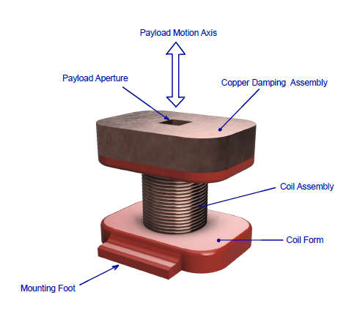

Figure 2 Mirror (blue) and magnet (red) assembly
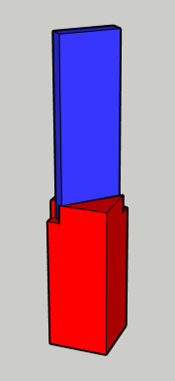

Figure 3 Actual data showing 1.96mSec blocking time
