AUTHOR(S) | DATE | Document Change Notice, Release or Approval
J. Richardson | 3 June 2020 | v2 – switch from lenses to mirrors

Description
25.4 mm (1”) Ø plano-concave/convex mirrors @ 1064 nm

Material
Corning HPFS 7980 (high purity fused silica, UV grade)
Grade 4G or better

Dimensions
Diameter: 25.4 mm +0.0/-0.1 mm
Thickness (edge): 6.35 mm ± 0.2 mm
Wedge: 2.0° ± 0.1°

Radius of Curvature (ROC):
Radius of Curvature (ROC) values are defined over the central 15 mm diameter of the optic.

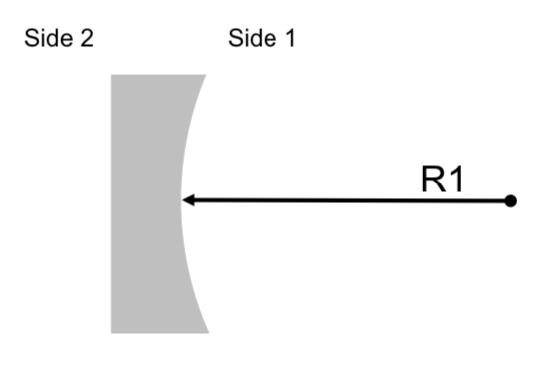
Figure 1: Schematic picture of the plano-concave/convex optics E2000228-v2-X. A concave surface is indicated by a positive radius of curvature and a convex surface by a negative radius of curvature. This picture has the only purpose of identifying the ROC of the optic and the two sides.

- E2000228-v2-A (AS3)
Side 1: ROC R1 = –2.0 m ± 0.02 m
Side 2: Flat

- E2000228-v2-B (LO3)
Side 1: ROC R1 = +0.75 m ± 0.008 m
Side 2: Flat

- E2000228-v2-C (LO4)
Side 1: ROC R1 = –0.45 m ± 0.005 m
Side 2: Flat

Surface Roughness
Side 1:
Super-polished
< 5 Å RMS over central 80% of diameter
10-5 scratch-dig

Side 2:
Commercial polish
< 10 Å RMS over central 80% of diameter

Surface Figure
Side 1:
Deviation from sphere < λ/10 PV at 632.8 nm over central 80% of diameter

Coating
Ion Beam Sputtered (IBS) coatings
Wavelength: 1064 nm
Polarization: p-polarization
Angle of incidence: 0°– 10°

Side 1:
HR coating
T < 100 ppm

Side 2:
AR coating
R < 0.2%

Serial numbers and marks
Each optic shall be laser engraved on the barrel for in-vacuum use—no pencil marks shall be present

Each barrel shall be inscribed as follows:
- Label centered on the thickest location:
E2000228-v2-Y SN0x
    - with “Y” the radius-of-curvature letter designator given above
    - with “x” starting at 1 for each type
- Arrow at the thinnest location pointing towards Side 1

