LIGO Laboratory / LIGO Scientific Collaboration

LIGO-T2000406-v2 Advanced LIGO 23 October 2020

Software Interface to the PCIe Timing Board

Marc Pirello, Daniel Sigg

Distribution of this document:
LIGO Scientific Collaboration

This is an internal working note
of the LIGO Laboratory.

California Institute of Technology  LIGO Project – MS 18-34  1200 E. California Blvd.  Pasadena, CA 91125  Phone (626) 395-2129  Fax (626) 304-9834  E-mail: info@ligo.caltech.edu | Massachusetts Institute of Technology  LIGO Project – NW22-295  185 Albany St  Cambridge, MA 02139  Phone (617) 253-4824  Fax (617) 253-7014  E-mail: info@ligo.mit.edu
LIGO Hanford Observatory  P.O. Box 1970  Richland WA 99352  Phone 509-372-8106  Fax 509-372-8137 | LIGO Livingston Observatory  P.O. Box 940  Livingston, LA 70754  Phone 225-686-3100  Fax 225-686-7189
http://www.ligo.caltech.edu/

Overview
The PCIe timing interface board is a PCI Express board that interfaces the computer software through a memory mapped interface. As part of the PCI bus enumeration the operating system assign the board a unique memory region in the physical address space. This document describes the register assignment within this region.
The board uses an 8 kb address region divided into 2 blocks of 4 kb. The first block is used for the control registers, whereas the second block is used to read the status of the LIGO timing interface.

Address | Description | Size
0x0000 | Control and monitor registers for on-board features, backplane and expansion modules | 4096
0x1000 | Timing Diagnostics Information | 4096
- Memory map of PCIe timing interface.
The PCIe timing board has the following features:
- Part of the Advanced LIGO optical timing distribution system which is based on distributed synchronized 2²⁶ Hz crystal oscillators driven by a master GPS clock.
- Interfaces the IO interface backplane and provides clocking signals for converters.
- Supports an optional master clock expansion module with GPS capabilities
- Supports an optional fanout expansion module with 12 fiber downlinks.

Applicable Documents
The applicable documents can be located through the following dcc pages:
- E2000328: PCIe Timing Interface (DCC top node)
- E2000337: PCIe Timing Interface Software Release
- D2000329: PCIe Timing Interface Board
- D2000297: IO Interface Backplane (LVDS)
- D2000301: Master Clock Expansion Option (GPS)
- D2000302: Fanout Expansion Option
- E0900036: Diagnostics Information for the Advanced LIGO Optical Timing Distribution

Control Registers
Registers are organized in double words (32 bit). It is envisioned that they are read and written as double words through the PCI Express bus. Reading from unassigned memory addresses within the assign memory region results in zeros. Similarly, writing to an empty address or a read-only address is ignored but treated as successful.
This PCI board supports 4 message-signaled interrupts (MSI). Interrupts can be globally enabled and disabled with the interrupt control register. However, individual interrupts must be setup through the interrupt configuration registers located at 0x00C0 to 0x00FC. Typically, the global interrupt register is controlled by the device driver.

Current Time
There are two registers to read the current time. The first register needs to be read first. It contains the fractional seconds of the GPS time and it will latch the second register which contains the GPS seconds.

Address | Description | RW | Size
0x0000 | Fractional second in units of 2⁻³² s  Reading this register will latch the GPS seconds. | R | 4
0x0004 | GPS seconds  Reads the GPS seconds associated with the last reading of the fractional second register. Writing has no effect. | R | 4
- Registers to read the current time.

Status and Interrupt Control
This register is shared between the global status flags and interrupt control. Status flags are read only. The OK flag can be used to check that the timing system is running normally. However, one should also check that the reported GPS seconds are reasonable, i.e., GPS seconds > 1e9.

Address | Description | RW | Size
0x0008 | Bit 31: OK flag (timing system is locked)  Bit 30: This is a root node  Bit 29: Supports fanout ports  Bit 28: Uplink is up and working  Bit 27: Loss-of-signal on uplink  Bit 26: OCXO is locked  Bit 25: GPS is locked  Bit 24: VCXO control voltage out-of-range  Bit 23: UTC time mode enabled  Bit 22: Leap seconds decoded  Bit 21: Subtraction of one leap second pending  Bit 20: Addition of one leap second pending  Bits 19...16: Reserved  Bits 15..8: Leap seconds  Bits 7…4: Reserved for interrupt control  Bit 3…0: Enable for MSI interrupts 3 down to 0 | R  RW | 4
0x000C | Firmware revision of VHDL code | R | 4
- Status and interrupt control register and firmware revision.

Firmware Release
The firmware release version is accessible at address 0x000C.

Converter Backplane Interface
The PCIe timing board interfaces a 10-slot backplane which supports interface cards for the digital converters LIGO is using. Each slot has its own dedicated clock line that can be configured individually. For each clock line the frequency and phase shift can be specified. One can also ask that the clock starts at the next 1 second boundary.
There are 3 options for providing clock signals to the 10 slots:
- Old type TTL ADC/DAC clock (1 per slot)
- Fast LVDS clock (1 per slot)
- Fast LVDS clock and sync lines (shared on neighboring odd/even slots)
Additionally, there a few bits of binary IO that can be controlled for each slot. This is typically used to add the analog DuoTone signal to slot 10, and to route another DuoTone signal from slot 9 to 10. However, these bits are available on all slots, and can be used for other purposes.

Common Functions
The table below shows the common functions for the converter backplane interface. Depending on bit 0 a write to register 0x0018 will either reset the watchdog timer or initialize the SPI devices.

Address | Description | RW | Size
0x0010 | Backplane configuration  Bit 4: Start clock at next transition from idle value (OR with slots)  Bit 3: Start on next second boundary for all slots (OR with slots)  Bit 2: Global enable for all slots (AND with sots)  Bit 1: Reset watchdog timer every time the current time is read  Bit 0: Disable DuoTone output | RW | 4
0x0014 | Watchdog reset or SPI initialization  Bit 0: Init SPI bus when 1, Reset watchdog when 0 | W | 4
0x0018 | Backplane status  Bits 31…10: Reserved  Bit 9: Backplane is present  Bit 8: X5 input  Bit 7: X3 input  Bit 6: X1 input  Bit 5: Temperature alarm  Bits 4…3: Backplane revision  Bit 2: Watchdog monitor  Bit 1: Indicates that all clocks are running  Bit 0: Indicates that all clocks are active | R | 4
0x001C | Reserved |  | 4
- Common registers for the backplane interface.
The analog DuoTone signal is only routed to slots 1 and 2.

Slot Functions
The table below lists the configuration and monitor registers for each slot of the back plane. There are 10 slots, with 2 10 configuration registers and 1 monitor register each. Slot 1 starts at address 0x0020, slot 2 at 0x0030 and so on. All registers are initialized to zero at the beginning and no clock signals are sent to the backplane. Timing diagrams can be found in Section 5.

Address | Description | RW | Size
0x0020 | Slot 1 (odd) configuration  Bits 31…23: Reserved  Bit 22: Bit 2 output high  Bit 21: Bit 2 is binary output (shared on neighboring odd/even slots)  Bit 20: Bit 1 output high  Bit 19: Bit 1 is binary output  Bit 18: Enable DAC DuoTone on 2nd to last ADC channel  Bit 17: Enable Duotone on last ADC channel  Bit 16: Use LVDS clock lines  Bits 15…13: Reserved  Bit 12: Pull idle clock line high  Bit 11: Start clock at next transition from idle value  Bit 10: Start clock at next second boundary after a 0.25 s countdown  Bit 9: Inverted clock signal  Bit 8: Enable clock signal  Bits 7…0: Log2 frequency, 2’complements, 2²⁶ Hz is the highest allowed frequency, 2^{‒8} Hz is the lowest frequency | RW | 4
0x0024 | Slot 1 (odd) phase shift  Bit 31…0: Phase shift in units of 2⁻³² × 360º. | RW | 4
0x0028 | Slot 1 (odd) status  Bits 31…23: Reserved  Bit 22: Monitor of bit 2 (shared on neighboring even slot)  Bit 21: Undefined  Bit 20: Monitor of bit 1  Bit 19: Monitor of DAC DuoTone select on last DAC channel  Bit 18: Monitor of DAC DuoTone select on 2nd to last ADC channel  Bit 17: Monitor of DAC DuoTone select on last ADC channel  Bit 16: Undefined  Bits 15…2: Reserved  Bit 1: Indicates that clock is running  Bit 0: Indicates that clock is active | R | 4
0x002C | Reserved |  | 4
0x0030 | Slot 2 (even) configuration  Bits 31…23: Reserved  Bit 22…21: Ignored  Bit 20: Bit 1 output high  Bit 19: Bit 1 is binary output  Bit 18: Select DAC DuoTone on 2nd to last ADC channel  Bit 17: Select Duotone on last ADC channel  Bit 16: Use LVDS clock lines  Bits 15…13: Reserved  Bit 12: Pull idle clock line high  Bit 11: Start clock at next transition from idle value  Bit 10: Start clock at next second boundary after a 0.25 s countdown  Bit 9: Inverted clock signal  Bit 8: Enable clock signal  Bits 7…0: Log2 frequency, 2’s complements, ‒8 to 26 | RW
0x0034 | Slot 2 (even) phase shift  Bit 31…0: Phase shift in units of 2⁻³² × 360º. | RW | 4
 | Slot 2 (even) status  Bits 31…23: Reserved  Bit 22...21: Undefined  Bit 20: Monitor of bit 1  Bit 19: Monitor of DAC DuoTone select on last DAC channel  Bit 18: Monitor of DAC DuoTone select on 2nd to last ADC channel  Bit 17: Monitor of DuoTone select on last ADC channel  Bit 16: Undefined  Bits 15…2: Reserved  Bit 1: Indicates that clock is running  Bit 0: Indicates that clock is active | R | 4
0x003C | Reserved |  | 4
0x0040  …  0x00BC | Configuration and status registers for slots 2 to 10. |  | 128
- Registers to setup clock signals for the ADCs and DACs.
An 8-bit value, $N≤26$, is used to select the frequency with the equation $2^{N}$ Hz. The period is then $2^{-N}$ s. To get the clock signal applied one must enable it for the slot and globally. If the clock is disabled, the clock output is set to the idle value. If the clock must start at a 1 second boundary, one can choose to delay the enable to the next 1 second boundary after a fixed minimum delay of 0.25 sec has passed. A global start on next second boundary can be used to start all clocks simultaneously on a second boundary. A logical AND is performed between the slot and the global enables and start bits. Also, the clock can be enabled immediately, or on the next transition away from the idle value. The two options can be combined: wait for the 1PPS boundary and then wait again for the next transition away from idle. If the clock is enabled immediately, it may result in a very short half cycle at the beginning; it could be as short as $2^{-27}$ sec which may be too short for the converters of the data acquisition system.
An optional phase shift can be applied and is specified in units of 2⁻³² sec. The least significant bits below the clock’s resolution are ignored, as well as the most significant bits that would indicate a phase shift larger than a clock cycle. Additionally, there is a bit to invert the final output clock signal. This is equivalent to a 180º phase shift.
There are two status readbacks for the clock output: active and running. The difference is that running will wait for the first transition away from idle, when this option is selected, whereas active will go high immediately after the optional wait for the 1PPS.
Several binary IO channels are available too. The binary IO channels associated with the DuoTone were previously only available on slots 9 and 10 but were physically the same signals. In this implementation, separate binary IO channels are routed to each slot. If they are not used for DuoTone, they can be used for other purposes—together with two additional bits. Bit 1 and 2 have configurable direction. Bit 1 is a per slot channel, whereas bit 2 is shared among two neighboring odd/even slots.

Interrupt Configuration
The board supports 4 message-based interrupts (MSI) over the PCI Express bus. These interrupts can be configured to be issued at regular intervals. The setup is the same as a converter clock with the rising edge of the configured clock signal being used to initiate the interrupt. PCI Express interrupts must be configured and enabled by the root complex during the initial setup process.

Address | Description | RW | Size
0x00C0 | MSI 0 configuration  Bit 12: Pull idle clock line high  Bit 11: Start clock at next transition from idle value  Bit 10: Start clock at next second boundary after a 0.25 s countdown  Bit 9: Inverted clock signal  Bit 8: Enable interrupt signal  Bits 7…0: Log2 frequency, 2’s complements, ‒8 to 25 | RW | 4
0x00C4 | MSI 0 phase shift  Bit 31…0: Phase shift in units of 2⁻³² s. | RW | 4
0x00C8 | MSI 0 status  Bit 1: Indicates that interrupts are issued at regular intervals  Bit 0: Indicates that the interrupt is configured | R | 4
0x00CC | Reserved |  | 4
0x00D0  …  0x00FC | Configuration of interrupts MSI 1 through 3. |  | 24
- Registers to configure interrupts over the PCI Express bus.
The interrupt processing is typically done by the device driver, which is loaded by the operating system. Interrupt configuration registers for the first MSI are located at 0x00C0. The second, third and fourth MSI are at 0x00D0, 0x00E0 and 0x00F0, respectively.

GPS Expansion Module
It is possible to connect an expansion module to the DB25 and SMA connectors of the PCIe timing board. This expansion module implements an OCXO and a GPS receiver, an RS422 port, an additional SFP, both a 1 PPS input and output, as well as an external frequency input. If both GPS and OCXO are present, the PCIe interface board will default to be a timing root node (master clock). The OCXO is connected to the SMA on the PCI board and its frequency must be $2^{25}$ Hz. For a timing root node, it serves as the main clock source for the entire timing distribution system. The GPS receiver provides a time stamp that relates to UTC through a 1 PPS signal and a serial interface. If the expansion board is not equipped with a GPS or an OCXO, the PCI board acts as a normal downstream timing interface.

Address | Description | RW | Size
0x0100 | GPS expansion configuration  Bits 31…9: Reserved  Bit 12: Sign of XO locking loop  Bit 11…9: Gain of XO locking loop, in units of 2^{N}  Bit 8: Enable XO locking  Bit 7: Use reference input for OCXO (only possible if not a root node)  Bit 6: Output an IRIG-B (2nd channel) rather than an 1 PPS  Bit 5: Disable binary output (1 PPS normally)  Bit 4: Disable RS422  Bits 3…2: 1 PPS control (for a timing root node)  b00: Use external 1 PPS, if present, GPS 1 PPS else  b01: Always use the GPS 1 PPS  b10 or b11: Always use the external 1 PPS  Bits 1…0: Timing root node control  b00: If both GPS and OCXO are present, default to root  b01: Prevent this to be the timing root node  b10 or b11: Set this to be the timing root node | RW | 4
0x0104 | Preset frequency  Bits 31…0: Preset frequency in Hz for OCXO locking | RW | 4
0x0108 | GPS expansion status  Bits 31…5: Reserved  Bit 7: OCXO clock present  Bit 6: Reference clock present  Bit 5: GPS present  Bit 4: GPS is locked  Bit 3: OCXO is locked  Bit 2: External frequency input is present  Bit 1: External 1 PPS is used  Bit 0: Root node flag | R | 4
0x010C | Frequency counter  Bits 31…0: External frequency in Hz | R | 4
- Registers for the GPS expansion module.
The GPS expansion module implements an external frequency input. Normally, this input is just used as a frequency counter. However, it can also be used to lock the frequency of an external OCXO. The desired frequency must be set through the PCI. Since this OCXO will only be locked to the 1 PPS, its RF phase error can be relatively large.
The expansion module also has an external 1 PPS input which can be used to synchronize the master with an external frequency standard. A digital output is available which is normally configured as a 1 PPS output but can also output an IRIB-B signal instead.
An RS422 port writes the timing status information once a second and can be read by the slow controls system to provide diagnostics o the timing system. Since fanout modules collect the diagnostics information of their direct downstream partners, all diagnostics information is available by monitoring the fanout chassis.
The master clock expansion module also implements a fiber port. This fiber port can be used for either an uplink or a downlink. The logic is as follows: if the PCIe timing interface acts as a timing master, the fiber port is a fanout port. If this is a standard downstream timing interface, the fiber port is an uplink port. It can be used instead of the port mounted on the board. If both ports are connected, the on-board port has priority. However, the port on the expansion module can be forced to be a fanout port through software.

Fanout Expansion Module
The fanout expansion module requires a PCIe daughter board to provide the additional signal lines. It provides up to 16 fiber downlink ports and makes the PCIe timing interface a fanout timing module. The daughter board implements 4 fiber ports, and it can be used stand-alone in systems that do not need the full number of fanout ports.
One fiber port is implemented on the main timing interface board. Typically, this will be used for the uplink to a timing fanout. It is possible to add expansion boards which implement additional fiber ports. This can make the PCIe timing interface a master clock with fanout. There are 12 fiber ports located on the fanout expansion board. 4 fiber ports are located on the daughter board and one extra fiber port is located on the GPS expansion board. The GPS expansion board is connected through a DB25 to the main timing interface. The daughter board connects to the timing interface through the Samtec connectors and makes the PCIe board double width. The fanout expansion board connects to the daughter board through a SCSI-2 type high density cable.
The fiber ports on the expansion boards can be enabled or disabled by setting the corresponding bits in the configuration register. Furthermore, the last port on an expansion board can be reassigned to be the uplink. This is useful in situations where the fiber port on the timing interface is not easily accessible. If the uplink has been reassigned, the port on the timing interface can optionally be reused as a fanout port.
Since the numbering of the fanout ports can be confusing, a port identification option is available to enable double blinking of the LED on a selected fanout or uplink port.
The fanout expansion module also implements two BNC connectors that are used for the input and output of an IRIG-B signal. The IRIG-B signals are TTL based square wave signals and not analog sine waves. Alternatively, the IRIG-B input can also be reassigned for an additional 1 PPS input, whereas the IRIG-B output can be used to output a square wave at a fixed frequency of 2^{N} Hz.

Address | Description | RW | Size
0x0110 | Fanout expansion configuration  Bits 31…12: Reserved  Bits 11…7: Port number (1-16) for identification (Use 0 for uplink)  Bit 6: Enable port identification  Bit 5: Reuse FPGA board SFP for fanout (bit 4..3 must be non-zero)  Bit 4…3: Uplink SFP selection  b00: Use SFP on main FPGA board  b01: Use last SFP on the fanout expansion board for uplink  b10: Use last SFP on the daughter board for uplink  b11: Use SFP on the GPS expansion board for uplink  Bit 2: Disable the SFP on the GPS expansion board  Bit 1: Disable the 4 SFPs on the daughter board  Bit 0: Disable the 12 SFPs on the fanout expansions board | RW | 4
0x0114 | IRIG-B configuration  Bits 31…20: Leap seconds  Bit 19: Delete rather than add a leap second  Bit 18: Append a leap second (at end of next quarter)  Bit 17: Daylight saving time  Bit 16…11: Time zone (signed value in units of 0.5h)  Bits 10…9: IRIG-B selection (2nd channel)  b00: GPS based (no leap seconds)  b01: UTC  B10 or b11: Local time  Bits 8…7: IRIG-B selection  b00: GPS based (no leap seconds)  b01: UTC  B10 or b11: Local time  Bit 6: Reuse IRIG-B input for an additional 1 PPS input  Bit 5: Output a 2^{N} clock rather than an IRIG-B  Bits 4…0: Log2 frequency, 2²⁵ Hz is the highest allowed frequency | RW | 4
0x0118 | Fanout expansion status  Bits 31…17: Reserved  Bits 16…15: DIP switch position (SW12/SW11)  Bits 14...10: Position of reused uplink port  Bits 9…5: Number of enabled fanout ports  Bits 4…0: Number of configured fanout ports | R | 4
0x011C | Time delay between internal and the external PPS/IRIG-B signals,  2’s complement in units of 2⁻³² s | R | 4
0x0120 | Time delay between internal and GPS PPS signals,  2’s complement in units of 1 s | R | 4
0x0124  to  0x012C | Decoded bits of the received IRIG-B signal  89 bits in little endian format, bits 89 to 95 are used for an error counter. These bits are reported on the next second after the IRIG-B signal has been decoded, so it is 2 seconds behind | R | 12
- Registers for the fanout expansion module.

Advanced Timing Features
The advanced timing features describe the available features.

Address | Description | RW | Size
0x0130 | Advanced timing configuration  Bits 31…0: Reserved | RW | 4
0x0134 | Writing the value 0xFEEDC0DE to this register will write the 1 kbyte located at 0x1C00 back to the EEPROM on the daughter board. | W | 4
0x0138 | Advanced timing status  Bit 31…27: Unused  Bit 26..24: Timing link version  Bit 23: Analog output for XO locking enabled  Bit 22: BRAM option enabled for timing diagnostics  Bit 21: PCIE option enabled  Bit 20: IRIG-B option enabled  Bit 19: RS422 option enabled  Bit 18: PPS option enabled  Bit 17: OCXO option enabled  Bit 16: GPS option enabled  Bit 15: EEPROM on daughterboard has been read  Bits 14...3: Future expansion options  Bit 2: Fanout expansion is present  Bit 1: GPS expansion is present  Bit 0: Daughter board is present | R | 4
0x013C | Unused |  | 4
- Registers for advanced timing features.

On Board Features
Several on board diagnostics features are available. They are mostly related to the power supply.

Address | Description | RW | Size
0x0180 | Board configuration:  Bits 31…20: Reserved  Bits 19…4: Divider (M) for the external synchronization frequency, default is 19.  Bits 3…0: Exponent (N) for the external synchronization frequency, default is 0. | RW | 4
0x0184 | XADC configuration:  Currently not used | RW | 4
0x0188 | Board and power supply status:  Bits 31…16: DIP switches (switch off is ‘1’, on is ‘0’)  Bits 15…9: Reserved  Bits 8: Switching regulator applied interrupt  Bits 7…2: Interrupt flags of switching supply  Temperature, low input voltage, power good for supplies 4 to 1  Bit 1: Power good signal from Gigabit transceivers supplies  Bit 0: Power good signal from switching supply (ADP5050) | R | 4
0x018C | XADC status:  Bits 31…6: Reserved  Bit 5: XADC enabled  Bit 4: VCCAUX alarm (>3% deviation)  Bit 3: VCCINT alarm (>3% deviation)  Bit 2: User temperature alarm (>75º)  Bit 1: Over temperature alarm (>95º)  Bit 0: Any alarm | R | 4
0x0190 | Temperature and internal power supply 1  Bits 31…16: VCCINT (gain 1/3, nominally 1.0V)  Bits 15…0: Current internal chip temperature (T=503.975*V-273.15º) | R | 4
0x0194 | Internal power supply 2  Bits 31…16: VCCBRAM (gain 1/3, nominally 1.0V)  Bits 15…0: VCCAUX (gain 1/3, nominally 1.8V) | R | 4
0x0198 | External power supply 1  Bits 31…16: Current of VCCINT (gain 1Ω)  Bits 15…0: Current of 3.3V (gain 1Ω) | R | 4
0x019C | External power supply 2  Bits 31…16: Current of 2.5V (gain 0.333Ω)  Bits 15…0: Current of VCCAUX (gain 1Ω) | R | 4
0x01A0 | External power supply 3  Bits 31…16: VDD (gain 1/4, nominally 2.5)  Bits 15…0: VREG (gain 1/6, nominally 5.1V) | R | 4
0x01A4 | External power supply 4  Bits 31…16: AVTT (gain 2/3, gigabit transceivers, nominally 1.2V)  Bits 15…0: AVCC (gain 2/3, gigabit transceivers, nominally 1.0V) | R | 4
0x01A8 | External power supply 5  Bits 31…16: N5 (N5=6*V-6.25V, analog supply, nominally ‒5V)  Bits 15…0: P5 (gain 1/6, analog supply, nominally +5V) | R | 4
0x01AC | External power supply 6  Bits 31…16: N12 (N12=15*V-17.5V, analog supply, nominally ‒12V)  Bits 15…0: VCC (gain 1/5, nominally +3.3V) | R | 4
0x01B0 | External power supply 7  Bits 31…16: P10 (gain 1/11, analog supply, nominally +10V)  Bits 15…0: VADC (gain ½, XADC supply voltage, nominally 1.8V) | R | 4
0x01B4 | External power supply 8  Bits 31…16: Current of V12 (gain 1Ω)  Bits 15…0: V12 (gain 1/15, main supply voltage, nominally +12V) | R | 4
- Registers for board diagnostics.
The external synchronization frequency can be used to synchronize an external switching regulator and is accessible through a header connector. The board implements a divide-by-8 linear-feedback shift register to generate different clock edges that are spaces 45 degrees apart. Its input frequency is selected by two configuration values M and N. If N is nonzero, the input frequency is using the following equation: $2^{N+10}$ Hz, where N is a 4-bit number ranging from 1 to 15. This supports frequencies from ~2 kHz up to ~33 MHz before the divider. The divider is a linear feedback shift register that divides by 8 (nominal) or 4, depending how it is configured.
N=0 turns this feature off and enables the divider value M. If M is nonzero, the input frequency is determined by the following equation: 2²⁶ / (M+1) Hz. If both M and N are zero, the frequency output is disabled. An odd M will result in a duty cycle that is slightly different from 50%. The default values of N=0 and M=19 result in an input frequency of 3.3554432 MHz, and 419.4304 kHz after the divider. With a sampling rate of 16384 Hz, this will alias to a frequency of 6.5536 kHz.
The ADC code is unipolar and consists of 16 bits. So, the ADC code should be divided by 65536 to get the input voltage of the ADC. Since most measured voltages are larger, they have a gain smaller than one. The gain is listed in the table and the ADC voltage needs to be divided by it. The temperature readout and negative voltages need an offset correction, which is also listed in the table above.

Timing Diagnostics Information
The available timing information is described in detail in E0900036. The amount of available information depends whether we are configured as an end point in the timing distribution, or whether we are master or fanout module. The PCIe timing interface can support master and fanout functions through expansion modules. Every timing interface module sends some information back to the upstream fanout module through the uplink fiber port. Fanout modules collect this information and make it available through a RS422 port, which in turn is read by the slow controls system.
The same is true for the PCIe timing interface with the addition that this information is mapped into the timing diagnostics block and available through the PCIe interface. The PCIe interface implements version of the protocol which allocates an additional 64 bytes of data before the information form the downstream ports.
The memory layout is as follows:

Address | Description | Size
0x1000 | Status & Configuration Information | 64
0x1040 | Records from up to 16 downlink records | 128
0x10C0 | GPS status | 32
0x10E0 | CRC error counters from fanout ports | 16
0x10F0 | Reserved | 16
0x1100(v2) | Additional information from the PCIe board (version 2 only) | 64
0x1100(v1)  0x1140(v2) | Information sent back from the downlink nodes, each has  32 bytes of status information  96 bytes of node specific information | 2048
0x1900(v1)  0x1940(v2) | CRC | 4
0x1904(v1)  0x1944(v2) | Reserved | 764(v1)  700(v2)
0x1C00 | Data from EEPROM on daughter board (if present) | 1024
- Memory map of timing diagnostics information.

We explicitly list the first 16 double words and refer to E0900036 for any additional information.
Address | Description | Size
0x1000 | Board ID and revision  First 7 digits are the dcc number (D), last digit is the revision.  Set to 0x2000329R with R the revision | 4
0x1004 | Board serial number. Currently used to indicate if this is a root or fanout node (0x0000) or a normal timing interface (0x0001) | 4
0x1008 | Software ID and revision  First 7 digits are the dcc number (E), last digit is the revision.  Set to 0x2000337R with R the revision | 4
0x100C | Software revision number  This is the subversion revision of the loaded FPGA program | 4
0x1010 | GPS time in seconds | 4
0x1014 | Module address. The first nibble (hex digit) is the nesting level and each following nibble represents a leaf in the timing distribution system with the master always set to 0x0. The first fanout port of the master gets assigned 0x1000000, the second port is 0x11000000, etc. | 4
0x1018 | Status  Bits 31…16: Control voltage applied to the VCXO  Bits 15…8: Status of the DIP switches  Bits 7…6: Status of SW10 and SW9  Bit 5: Loss of signal (LOS) at the uplink port  Bits 4…1: Number of consecutive seconds with missing 1PPS  Bit 0: Uplink is up and running normally | 4
0x101C | Configuration (master and fanout)  Bits 31…17: Unused  Bit 16: External OCXO present (any frequency)  Bit 15: Reference OCXO is present (2^25 Hz)  Bit 14: External 1PPS present  Bit 13: A GPS module is present  Bit 12: GPS is locked  Bit 11: OCXO is locked  Bit 10: External 1PPS is used for timing reference  Bit 9: GPS 1PPS is used for timing reference  Bit 8: Uplink 1PPS is used for timing reference  Bit 7: Uplink up and running  Bit 6: Uplink loss of signal  Bits 5…2: Number of fanout ports (0 represents 16 ports)  Bit 1: This is a fanout module  Bit 0: This is a master module | 4
0x1020 | OCXO Controls  Bits 31…16: Unused  Bits 15…0: OCXO control voltage | 4
0x1024 | OCXO Error  Time difference between the internal 1PPS obtained from the OCXO clock signal, and the external 1PPS, 2’s complement in units of 2⁻³² s | 4
0x1028 | Uplink 1PPS delay  Time difference between the uplink 1PPS input and the internal 1PPS | 4
0x102C | Ext 1PPS delay  Time difference between the external 1PPS and the internal 1PPS. | 4
0x1030 | GPS 1PPS delay  Time difference between the GPS 1PPS and the internal 1PPS. | 4
0x1034 | Fanout Up/LOS  Bits 31…16: Fanout ports are up (LSB is port 0)  Bits 15…0: Loss of signal at fanout port | 4
0x1038 | Fanout Missing return 1PPS and delay error  Bits 31…16: Missing 1PPS in downlink return  Bits 15…0: Fiber delay is out of range | 4
0x103C | Leap Seconds & Error Count  Bit 31: UTC time mode enabled  Bit 30: Leap seconds decoded  Bit 29: Subtraction of one leap second pending  Bit 28: Addition of one leap second pending  Bits 27...24: Reserved  Bits 23…16: Leap seconds  Bits 15…12: Unused  Bit 11: GPS error (if master)  Bit 10…8: GPS error count (if master)  Bits: 7…0: CRC error count | 4
- Memory map of the status information form the timing diagnostics.

Timing Diagrams
The following timing diagrams have been generated with different configurations of the inverted and idle bits to produce clocks with rising or falling edges at the 1 PPS or half a cycle later. If a small phase shift is implemented as seen in diagrams 5 and 6, one must be careful to avoid a false transition at the 1 PPS. The “start clock at next transition from idle value” bit can be used to suppress it. All timing diagrams set the “start clock at next second boundary” bit.

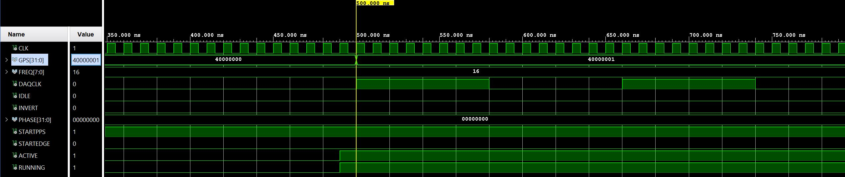
Rising edge on 1 PPS
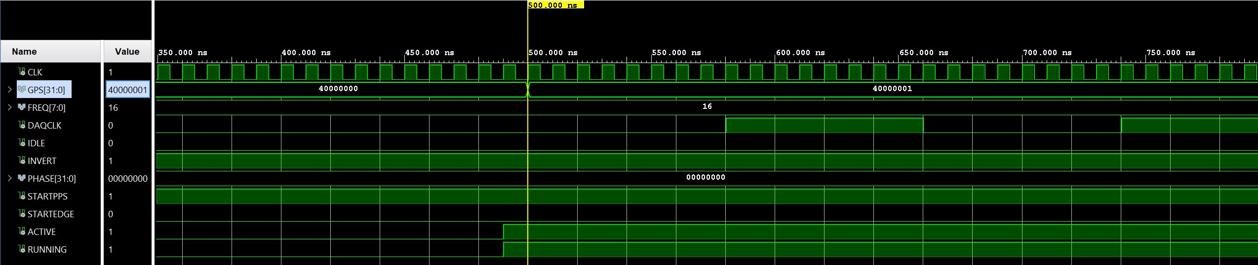
Rising edge on half cycle after 1 PPS
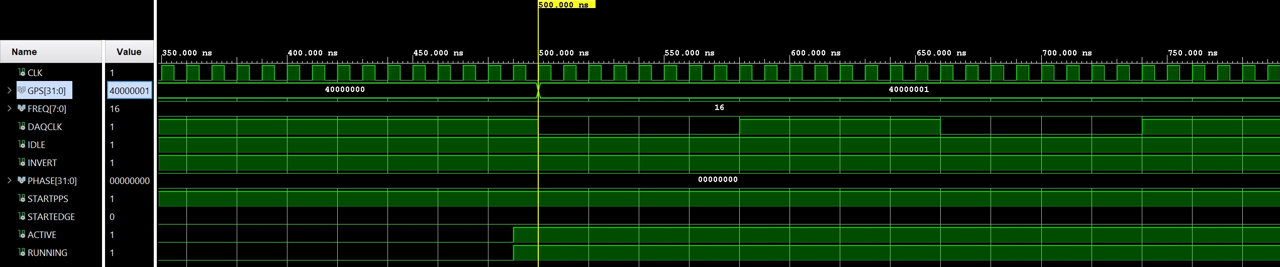
Falling edge on 1 PPS
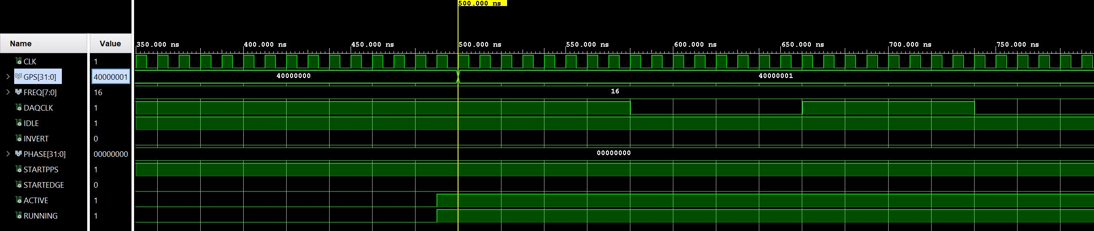
Falling edge on half cycle after 1 PPS
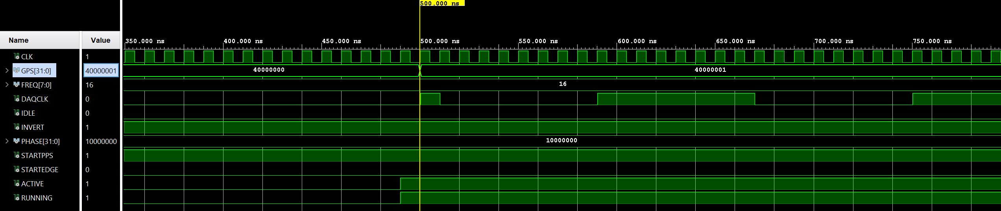
Rising edge with a phase shift of 22.5º. Has a false transition at 1 PPS
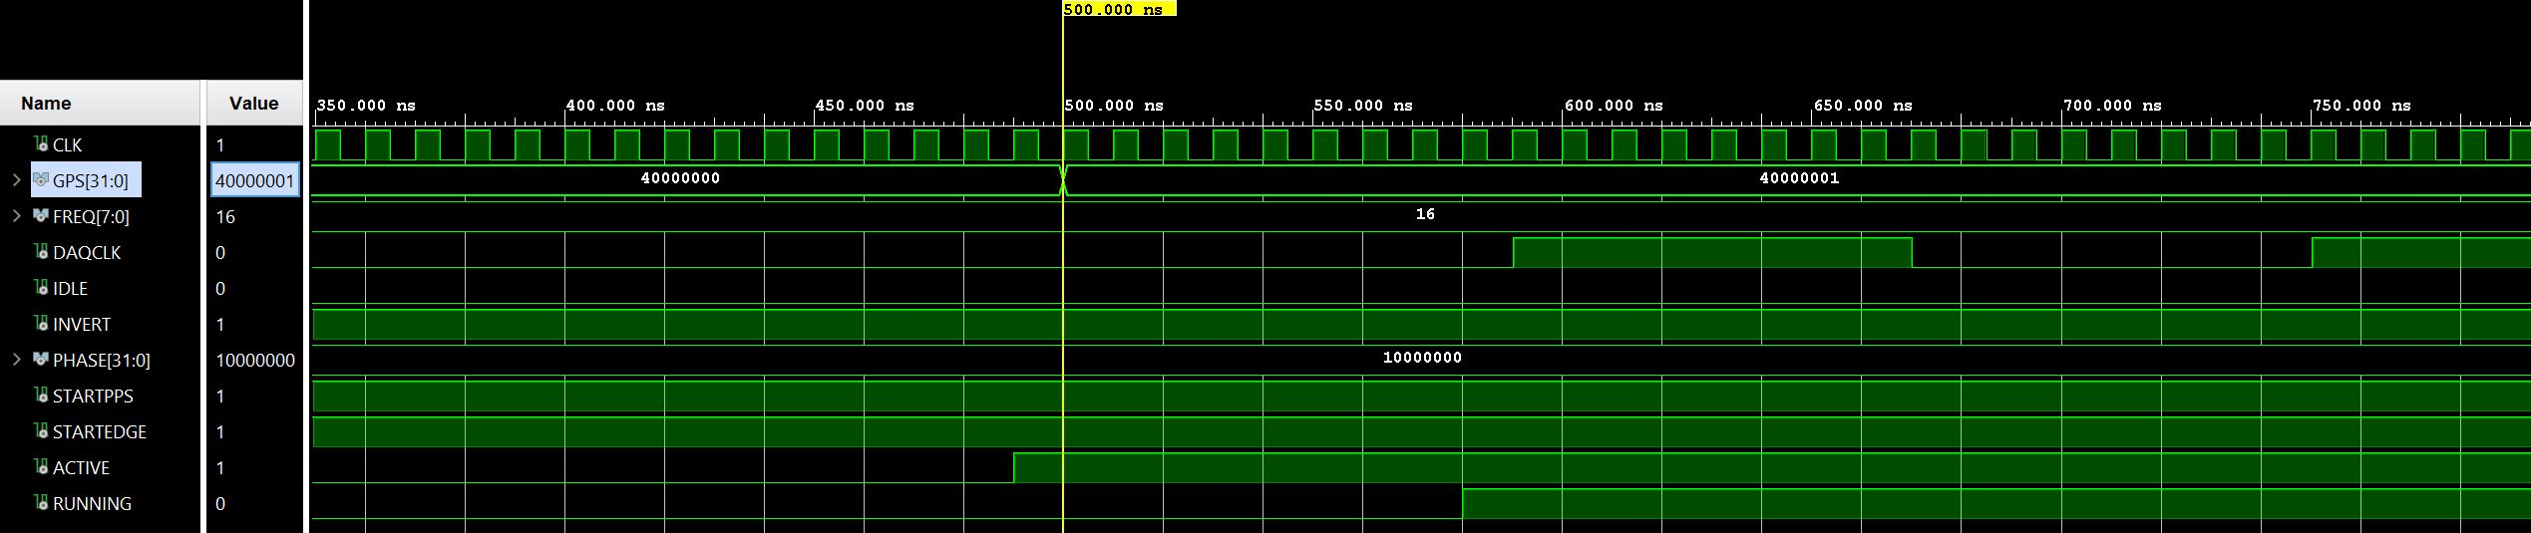
Rising edge with a phase shift of 22.5º and no false transition at 1PPS

