LIGO HANFORD OBSERVATORY
PO BOX 159
RICHLAND WA 99352

TEL: 509.372.8106
FAX: 509.372.8137

MEMORANDUM

DATE: May 3, 2021

TO: | Electronics
FROM: | Daniel Sigg
SUBJECT: | Modifications to the ISS second loop servo
Refer to: | LIGO- E2100162-v1

This modifications are applied to the “Outer Loop ISS Chassis,” D1600229, which includes version 3 of the “ISS Outer Loop Back Board,” D1600298, and version 3 of the “Outer Loop ISS Transimpedance Board,” D1600193.
Resistors are metal film, capacitors need to be NP0/COG or metal film.

Change 1 (back board):
Connect feedback of the open Op Amp U2B to the negative input and ground the positive input.
U2B → connect output to -input, ground +input
Change 2:
Increase the gain of the sum by increasing R32 to 10K (from 1K).
R32 → 10 kΩ

Change 3:
Swapped the corresponding OpAmp U3 from OP27 to OP37 (faster).
U3 → OP37

Change 4:
Decrease the gain in the readback of ERR2 after the sum by 10 by changing R62 in the SUM signal block from 4.53K to 45.3K.
R62 → 45.3 kΩ

Change 5:
Decreased the analog excitation input gain by 10 by increasing R33 to 100K from 10K.
R33 → 100 kΩ

Change 6:
Decreased the digital excitation input gain by 10 by increasing R77 to 100K from 10K.
R77 → 100 kΩ

Change 7:
Change the ISS second loop error point readback, ERR1, to before the servo loop switch. Cut the top trace between TP25 (Sum Fast PE) and R36 (input summing node) below the via, and add a jumper between TP25 and the via next to pin 1 of K1 (photodiode group select)
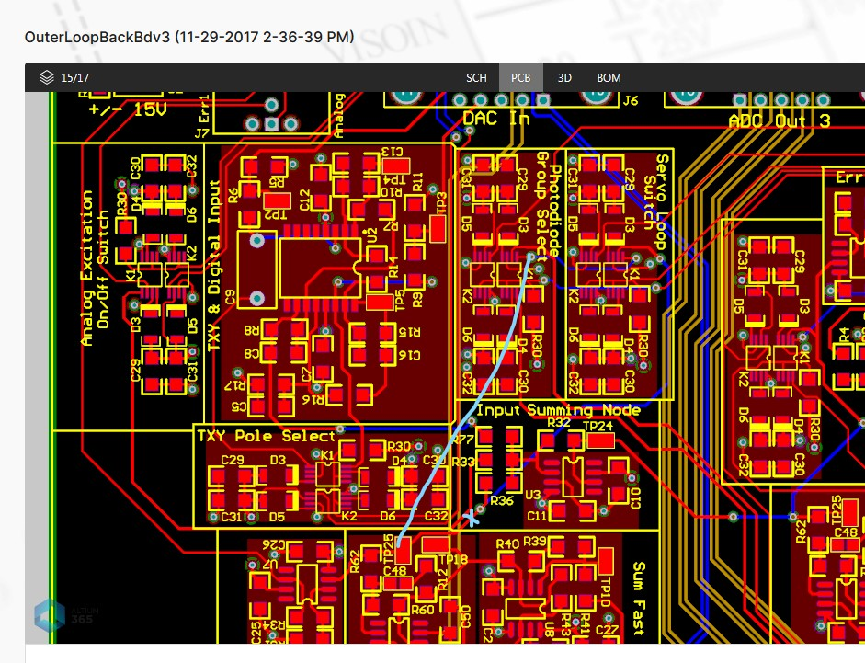

BOM (for 1 board):
Qty | Item | Distributor | Description
1 | OP37GSZ-REEL7CT-ND | Digi-Key | U3, OP37
1 | P10KBCCT-ND | Digi-Key | R32, 10kΩ, 0.1%
2 | P100KBCCT-ND | Digi-Key | R32, 100kΩ, 0.1%
1 | P45.3KBCCT-ND | Digi-Key | R32, 45.3kΩ, 0.1%
1 |  |  | Jumper wire

