APPROVALS | DATE | REV | DCN NO. | BY | CHECK
AUTHOR: Y. Michimura | 20-Apr-2023 | V1
CHECKED:
APPROVED:

Description
Plano-concave mirror (PMC2) and plano-plano mirrors (PMC1, PMC3) @ 2050nm

Material
Infrasil

Dimensions

Diameter: 1.00 inch ± 0.01 inch
Thickness (at edges):
0.125 inch ± 0.01 inch (for PMC2)
0.25 inch ± 0.01 inch (for PMC1, PMC3)
Wedge: 1 deg
Chamfers: minimal to prevent chipping (goal of < 0.25 mm width)

Radius of Curvature (ROC):
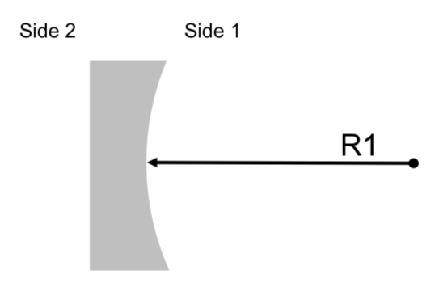
Fig1: Schematic picture of the plano-concave optics E2000544-v1-X. This picture has the only purpose of identifying the ROC of the optic and the two sides.

Side 1 Radius of Curvature values below are defined over the central 80% of diameter

PMC2, Side 1: RoC 1.000 m ± 0.003 m (concave)
PMC1,3, Side 1: flat
PMC1,2,3 Side 2: flat

Surface Roughness & Quality, Surface Figure
Side 1: Super-polished
Less than λ/10 PV at 632.8 nm over central 80% of diameter
Less than 1 Angstrom RMS over central 80% of diameter
There shall be no scratches, sleeks or point defects within the central 80% of diameter
10-5 scratch-dig outside central 80% of diameter

Side 2: Commercial-polish
Less than λ/5 PV at 632.8 nm over central 80% of diameter
Less than 5 Angstrom RMS over central 80% of diameter
20-10 scratch-dig outside central 80% of diameter

Edges and Bevels: Commercial-polish

Table 1 Certification Data Requirements
Specification | Test Method | Frequency of Inspection | Data Delivered
Physical Dimensions | Visual Inspection | 100% | Diameter, Thickness, Bevel dimension, Wedge angle.
Side and Bevel Polish | Visual Inspection | 100% | Inspection Report included with Certification
Scratches and Point defects | Visual Inspection | 100% | Hand sketch including scratch/pit dimensions
Surface Figure | Interferometry | 100% | Surface Map
Surface Errors - Low Spatial Frequency | Interferometry | 100% | Surface Map
Surface Errors - High Spatial Frequency | High resolution Surface Map | 100% | Surface maps for 3 central locations. Numerical values included with Certification
Orientation: For the purpose of full surface phase maps the substrate shall be oriented such that the point of minimum thickness shall be at the top center of the data.

Format: All Data shall be delivered according to Table 1. In addition to the hard copy an electronic data set of the phase maps shall be delivered in either ASCII or Vision.OPD format.

Coating definitions (4 in total)

All coatings should cover at least central 85% diameter.
AR0 and AR45 can be in same coating run if both requirements are met.

HR0
- Description: Pre mode cleaner end mirror
- Angle of incidence: 6.8± 0.5°
- Ion Beam Sputtered coating
- T =500 ± 50ppm @ 2050 nm, for s-polarization

BS45
- Description: Pre mode cleaner input and output coupler
- Angle of incidence: 41.6± 0.5°
- Ion Beam Sputtered coating
- T =4000 ± 40ppm @ 2050 nm, for s-polarization

AR0
- Description: Anti-reflection coating for 0 degrees
- Angle of incidence: 6.8± 0.5°
- Ion Beam Sputtered coating
- R < 300ppm @ 2050 nm, for s-polarization

AR45
- Description: Anti-reflection coating for 45 degrees
- Angle of incidence: 41.6± 0.5°
- Ion Beam Sputtered coating
- R < 300ppm @ 2050 nm, for s-polarization

Deliverables

Name: “PMC1/PMC3”
  - Qty 4
  - 1.00 inch ± 0.01 inch dia., 0.25 inch ± 0.01 inch thick
  - Side 1: Flat, BS45 coating
  - Side 2: Flat, AR45 coating
  - Arrow engraved on barrel at thickest part of wedge point to Side 1
Special note: all three units must be coated in the same coating to minimize difference between optic reflectivity.

Name: “PMC2”
  - Qty 2
  - 1.00 inch ± 0.01 inch dia., 0.125 inch ± 0.01 inch thick
  - Side 1: ROC = 1.000 m ± 0.003 m (concave), HR0 coating
  - Side 2: Flat, AR0 coating
  - Arrow engraved on barrel at thickest part of wedge point to Side 1

- Spectrophotometry data for coatings (in form of CSV file of measured values, not a processed plot)
  - AR0: measured reflection at or close to 6.8° AOI
  - AR45: measured reflection at 41.6° AOI (both polarizations)
  - HR0 coating: measured reflection and transmission at or close to 6.8° AOI
  - HR45 coating: measured reflection and transmission at 41.6° AOI (both polarizations)

Serial numbers and marks
- Each optic shall be laser engraved on the barrel of the optic for in-vacuum use — no pencil marks shall be present
- Each optic shall be labelled as follows:
  - “E2300115-v1-NNN SN0x HR 2050nm”
  - with ‘NNN’ the unit name letter designator given above
  - with ‘x’ starting at 1 for each type

Explicit labels

- E2300115-v1-PMC1/PMC3 SN01 HR 2050nm
- E2300115-v1-PMC1/PMC3 SN02 HR 2050nm
- E2300115-v1-PMC1/PMC3 SN03 HR 2050nm

- E2300115-v1-PMC2 SN01 HR 2050nm
- E2300115-v1-PMC2 SN02 HR 2050nm

